CSC 3320: System Level Programming

Lab4 Out-of-Lab Assignment

Dang Truong

ID# 002420309

4b.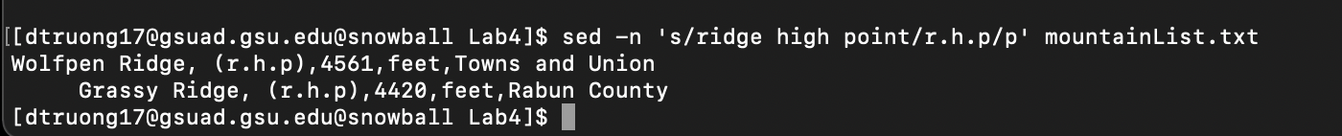

4c. -n in sed is to suppress automatic printing of pattern space

4d. outputs lines containing text ‘ridge high point by replacing this text with ‘r.h.p’ without printing pattern space.

15. sed -E 's/,.\*,/,/' mountainList.txt