CSC 3320 System Level Programming

Lab 5 In-lab Assignment

Dang Truong

ID# 002420309

1. The command gave an error massage, -bash: $: command not found
2. The command gave an error massage, -bash: $: command not found
3. 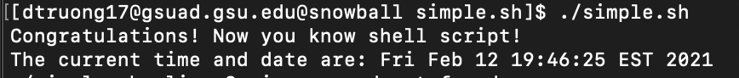
4. -n option in echo command does not append a new line at the end, it suppresses the default new line character at the end.
5. double quote and single quote are not comment but it’s used for printing the content inside of the quote.
6. # is used for comment line in bash, a script may specify #!/bin/bash on the first line, means that the script should always be run with bash.
7. 5 directories can be found in the output.
8. No error found in step 9, we added our directory to the $PATH and we can execute without ‘./’ as this is in our path.
9. The variable which we added was temporary, so after logged out of terminal and reopened it we lost the path and we only have the default path.
10. Yes, there is an error because terminal now can not find the command since the path variable does not have this directory. We have to use ‘./’ and the filename to execute the director or add this path to PATH directory again.