**Xây dựng ứng dụng dùng AGL 7**

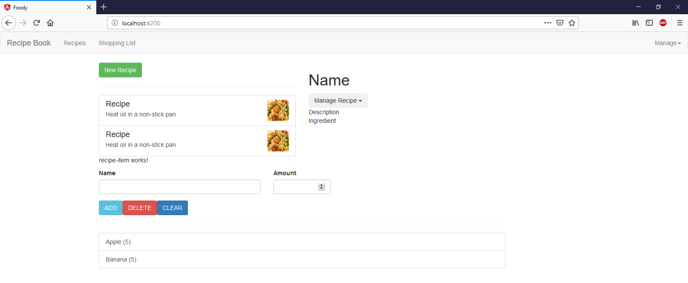

***Cây Thư mục***

|  |  |
| --- | --- |
|  |  |
|  |  |
| ng g c recipes –spec false | |
| ng g c recipes/recipe-list –spec false | |
| Install bootraps: npm I –save bootstrap@3 | |
| Kết quả: app.module.ts | |
|  | |
| app.component.html | |
|  | |
| header.component.ts | |
|  | |
| header.component.html | |
|  | |
| Recipes (folder) | |
| recipe.model.ts | |
|  | |
| recipes.component.html | |
|  | |
| recipes.component.ts | |
|  | |
| recipe-detail(folder) | |
| recipe-detail.component.html | |
|  | |
| recipe-detail.component.ts | |
|  | |
| recipe-list(folder) | |
| recipe-list.component.html | |
|  | |
| recipe-list.component.ts | |
|  | |
| shopping-list (Folder) | |
| shopping-list.component.html | |
|  | |
| shopping-list.component.ts | |
|  | |
| ingredient.model.ts | |
|  | |
| shopping-edit(Folder) | |
| shopping-edit.component.ts | |
|  | |
| shopping-edit.component.html | |
|  | |