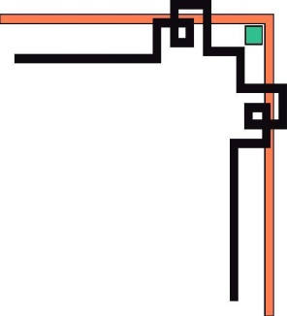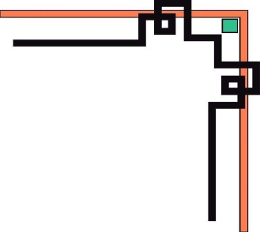



**eProject**

**Building Website with HTML5**

***Supervisor: Group 2:***

Ong Thi My Linh Student1058383 LU MINH THONG

Student1058384 DANG TUAN HUY

Student1058389 TRUONG PHU NGAN

**I. PROBLEM DEFINITION**

***(Form No. 1/eProjects/Ver1.0)***

1. ***Problem definition:***

Currently, applying of theories and skills to the real case are the main demand of current student. Unfortunately, there are some causes such as busy working and studying time, disadvantages place and other factors that affect applying skills and knowledge to real situation. Therefore, our teams decide to develop learning website to support learning, discussing topicexchanging IT experiences between students, IT guest and professional IT professor.

The students do not have time to get to class. Conditions geographical remoteness is a reason hinder directly to the classroom.The difficulties, questions about technology problems can’t solve.

Website will operate continuously, help for students or those who wish to learn, exchange experiences all the time.People from anywhere, any age if you have passion technologies can participate in learning, exchange of experience on this website.The need to learn, share, discuss difficult issues will be resolved through the website forum.

**II. CUSTOMER REQUIREMENT SPECIFICATION(CRS)**

***(Form No. 2/eProjects/CRS/Ver1.0)***

***Client:*** Royal Educational Academy.

**Business/Project Objective:**

Through the website everyone will register their favorite courses to expand knowledge.

The website will support online learning for students, helping them save time and tuition costs.

Any questions concerning academic issues will be answered staff as soon there.

* ***Modeling requirements of customer:***
  + - 1. **Use case Diagram:**

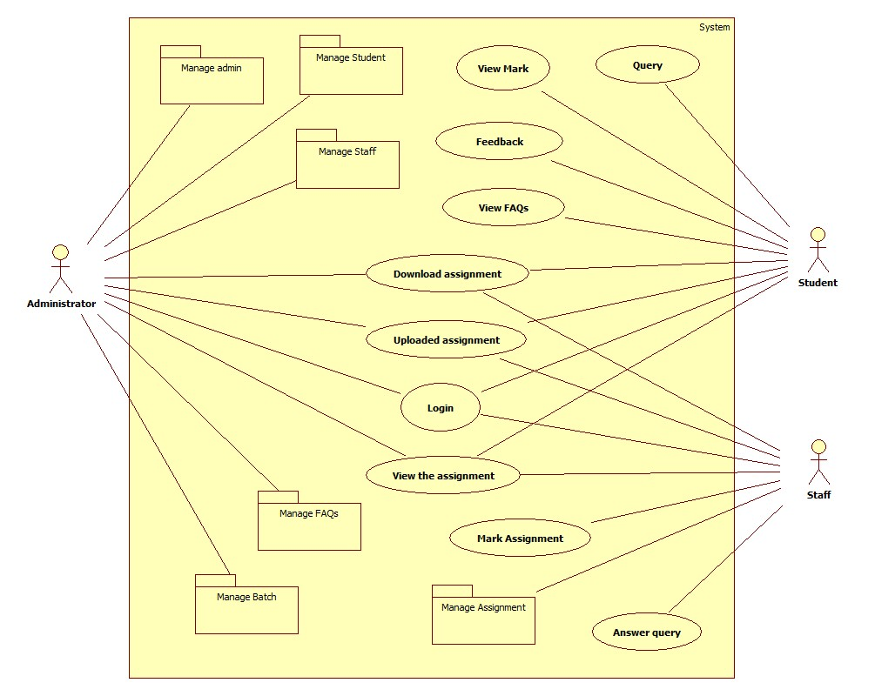

* + - 1. **Actor Description:**

|  |  |  |  |
| --- | --- | --- | --- |
| **No.** | **Actor** | **Use case** | **Description** |
| 1. | Administrator | Manage Admin | This model allows Administrator to manage information of admin consist of add new admin, update information of admin and delete admin. |
| 2. | Manage Staff | This model allows Administrator to manage information of staff consist of add new staff, update information of staff and delete staff. |
| 3. | Manage Student | This model allows Administrator to manage information of student consist of add new student, update information of student and delete student. |
| 4. | Manage Batch | This model allows Administrator to manage information of batch consist of add new batch, update information of batch and delete batch. |
| 5. | Manage FAQs | This model allows Administrator to manage information of FAQs consist of add new FAQs, update information of FAQs and delete FAQs. |
| 6. | Login | This module is compulsory, only when logging, the administrator has the right to manipulate other functions under administrator rights on the site. |
| 7. | Download Assignment | This model allows Administrator to manage content of assignment before downloaded document. |
| 8. | Upload Assignment | This model allows Administrator upload assignment. |
| 9. | View Assignment | This model allows Administrator view assignment before student has been completed assignment. |
| 10. | Staff | Login | This module is compulsory, only when logging, the staff has the right to manipulate other functions under staff rights on the site. |
| 11. | Manage Assignment | This model allows Administrator to manage information of assignment consist of add new assignment, update information of assignment and delete assignment. |
| 12. | Mark Assignment | This module allows the staff scoring of student assignments, and then staff will upload scoring for students to see. |
| 13. | Download Assignment | This is the module allows staff to download assignments, and then scoring it. |
| 14. | Upload Assignment | This model allows the staffs upload assignment after scoring complete. |
| 15. | View Assignment | This model allows staff view assignment to scoring it. |
| 16. | Answer Query | This model allows staff answer questions that student has send. |
| 17. | Student | Login | This module is compulsory, only when logging, the student has the right to manipulate other functions under student rights on the site. |
| 18. | Download Assignment | This is the module allows student to download assignments, and then to do it. |
| 19. | Upload Assignment | This model allows the student upload assignment after complete it. |
| 20. | View Assignment | This model allows student view assignment to do it. |
| 21. | View Mark | This model allows student view mark of assignment that they were done. |
| 22. | View FAQs | This model allows student view **Frequently Asked Questions in website.** |
| 23. | Query | This is a model that allows students to send questions frequently asked questions in the learning process. |
| 24. | Feedback | This is a model allows student to send feedback. |

* + - 1. **Use case Description:**

**3.1 Manage Admin:** This model allows Administrator to manage information of admin consist of add new admin, update information of admin and delete admin.

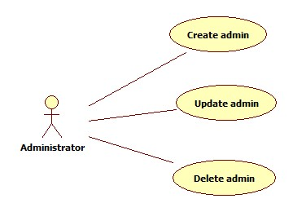

**3.3.1. Create Admin**

* Objective: Account is created and can be used with admin the user.
* Input: username, full name, birthday, gender, phone number, address.
* Output: A new admin will be created and saved in system.

**3.1.2. Update Admin:**

* + - Objective: Update admin’s information.
    - Input: full name, birthday, gender, phone number, address.
    - Output: New information will be updated in the system.

**3.1.3. Delete Admin**

* + - Objective: Delete admin account.
    - Input: Admin’s account.
    - Output: Account is deleted in system.

**3.2 Manage Staff:**This model allows Administrator to manage information of staff consist of add new staff, update information of staff and delete staff.

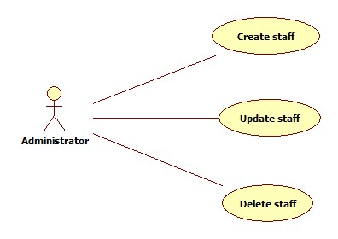

**3.2.1.    Create staff:**

* + - * Objective: Account is created and can be used with staff the user.
      * Input: Roll, user name, full name, birthday, gender, phone number, address.
      * Output: A new staff has been created and saved to the system.

**3.2.2. Update staff:**

* + - * Objective: Update staff’s information.
      * Input: Roll, user name, full name, birthday, gender, phone number, address.
      * Output: New information will be updated in the system.

**3.2.3.   Delete staff:**

* + - * Objective: Delete staff.
      * Input: staff code.
      * Output: Staff is deleted in system.
  1. **Manage Student:**This model allows Administrator to manage information of student consist of add new student, update information of student and delete student.

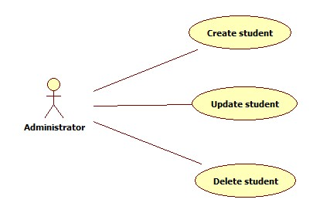

**3.3.1. Create student:**

* + - * Objective: Account is created and can be used with student the user.
      * Input: Roll, user name, full name, birthday, gender, phone number, address.
      * Output: A new student has been created and saved to the system.

**3.3.2. Update student:**

* + - * Objective: Update student’s information.
      * Input: Roll, user name, full name, birthday, gender, phone number, address.
      * Output: New information will be updated in the system.

**3.3.3 Delete student:**

* + - * Objective: Delete student’s accounts.
      * Input: student code.
      * Output: Account is deleted in system.

**3.4. Manage Batch:**This model allows Administrator to manage information of batch consist of add new batch, update information of batch and delete batch.

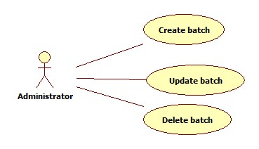

**3.4.1.    Create batch:**

* + - * Objective: Creating a new batch.
      * Input: Batch code, batch name, semester, year.
      * Output: A new course is created and saved to the system.

**3.4.2. Update batch:**

* + - * Objective: Update batch’s information.
      * Input: Batch code, batch name, semester, year.
      * Output: New batch’s information will be updated in the system.

**3.4.3.  Delete batch:**

* + - * Objective: Delete batch.
      * Input: batch code.
      * Output: batch will be deleted in system.

**3.5. Manage FAQs:**This model allows Administrator to manage information of FAQs consist of add new FAQs, update information of FAQs and delete FAQs.

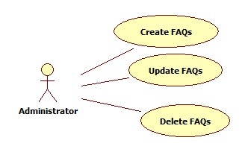

**3.5.1. Create FAQs:**

* + - * Objective: Create common questions of students and staff about the system or wonder when an error occurs.
      * Input: question, answer.
      * Output: Create questions and answers will be saved in the system.

**3.5.2. Update FAQs:**

* + - * Objective: Updated questions and answer FAQs.
      * Input: question, answer.
      * Output: Updated the question and answer into system.

**3.5.3.     Delete FAQs:**

* + - * Objective: Delete questions and answers is no longer used
      * Input: question, answer.
      * Output: FAQs will be deleted in system.
      * Output: Answer questions from students and staff

**3.6. Login:**This module is compulsory, only when logging, the staff has the right to manipulate other functions under staff rights on the site.

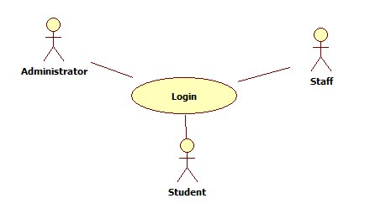

**3.6.1.  Login:**

* + - * Objective: Login into the system to use the functionality of the system as admin.
      * Input: username, password.
      * Output: User authentication.

**3.7. Download Assignment:**This model allows Administrator to manage content of assignment before downloaded document.

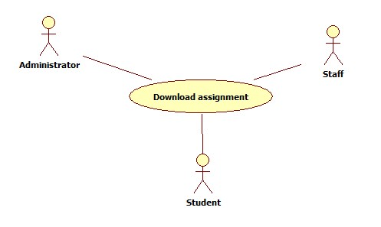

**3.7.1. Download assignment:**

* Objective: Download to see student's assignments.
* Input: assignment file.
* Output: Assignment file is downloaded.

**3.8.Upload Assignment:** This model allows Administrator upload assignment.

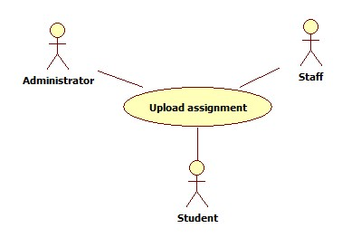

**3.8.1 Uploaded assignment:**

* + - * Objective: Upload assignment to student reference.
      * Input: assignment file.
      * Output: Assignment file is uploaded.

**3.9 View Assignment:**This model allows staff view assignment to scoring it.

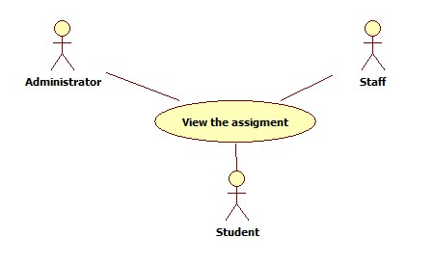

**3.9.1 View the assignment:**

* + - * Objective: View the student's test.
      * Input: must download assignment.
      * Output: Can view the student's test

**3.10. Manage Assignment:**This model allows Administrator to manage information of assignment consist of add new assignment, update information of assignment and delete assignment.

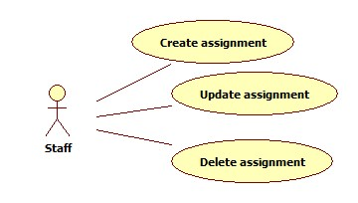

**3.10.1. Create Assignment:**

* + - * Objective: Create assignment for student.
      * Input: Assignment file.
      * Output: A new assignment is created.

**3.10.2. Update Assignment:**

* + - * Objective: Edit content of assignment.
      * Input: Assignment file.
      * Output: Content of assignment is updated.

**3.10.3. Delete Assignment**

* Objective: Delete assignment.
* Input: Assignment file.
* Output: Assignment deleted in system.

**3.11. Mark Assignment:** This module allows the staff scoring of student assignments, and then staff will upload scoring for students to see.

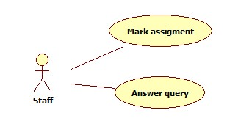

**3.11.1 Mark Assignment:**

* + - * Objective: Input score of the assignment by students.
      * Input: Student name, staff name, assignment name, mark.
      * Output: Save mark to system.

**3.12 Answer Query:** This model allows staff answers questions that student has send.



**3.12.1 Answer Query:**

* + - * Objective: Answer a question of students.
      * Input: Answer.
      * Output: Content of query consist of question and answer.

**3.13.**

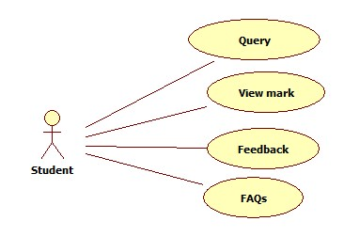

**3.13.1View Mark:** This model allows student view mark of assignment that they were done.

* Objective: Students will see the mark of subject which they have registered.
* Input:Student name, staff name, assignment name, mark.
* Output: Transcripts.
  + 1. **Query:** This is a model that allows students to send questionsfrequently asked questions in the learning process.
       - Objective: The question when questions or difficulties in learning process.
       - Input: query, student name.
       - Output: The question will be saved in system.

**3.12.3 Feedback:** This is a model allows student to send feedback.

* Objective: Get feedback of students.
* Input: Feedback.
* Output: Feedback will be send and save in system.

**3.12.4. FAQs:**This model allows student view **Frequently Asked Questions in website.**

* Objective: See some frequently asked questions.
* Input: FAQs.
* Output: The questions and answers taken from the system.

**Expected involved in the application**

* ***Expected Delivery Dates***

Project Start Date: 20-Feb-2014

Project Submission Date :20-Mar-2014

* ***List of Deliverables***

Documents handed over:

* + - * Manual installation.
      * User guide manual.

Application:

* + - * Development application.
      * Application source code.

**Hardware and Software Requirements:**

|  |  |  |
| --- | --- | --- |
|  | **Server** | **Client** |
| **Hardware** | * CPU: core due or higher. * HDD: 1GB free space or more. * RAM: 2GB or higher. * Network card. | * CPU: core due or higher. * HDD: 1GB or higher. * RAM: 1GB or higher. * Network card. |
| **Software** | * Windows XP or higher. * MS SQL Server 2008 or higher. * Glassfist 3.1.2. * Internet Explorer 9 or higher. * Google chrome. * Firefox 3 or higher | * Windows XP or higher. * Internet Explorer 9 or higher. * Google chrome. * Firefox 3 or higher. |
| **Technology and Programming tool** | * Netbean 7.1.2. * Type 4 JDBC Driver for MS SQL Server 2008. * PrimeFaces 4.0, JSF 2.0 amd Java EE5. * Balsamiq Mockups 2.2.19. | |

**III. ARCHITECTURE & DESIGN OF THE PROJECT**

**(Form No.3/eProjects/Design/Ver1.0)**

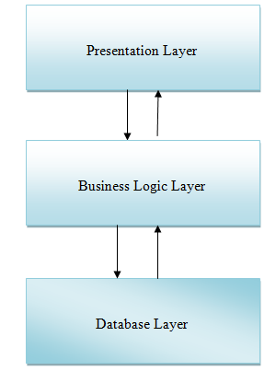

**Web-Based Distributed 3-Tier Architecture of the Project**

**IV.TASK SHEET**

*(Form No. 8/eProjects/TS/Ver1.0)*

|  |  |  |  |  |  |  |
| --- | --- | --- | --- | --- | --- | --- |
| **Project Ref.**  **No: 1** | **Project Title: Suportive Learning** | **Activity Plan Prepared By:**  Student 729716 NHAN NGUYEN THANH | | **Date of Preparation Activity Plan:**  **20-Feb-2014** | | |
| **Sr.**  **No** | **Task** | **Planned Start Date** | **Actual Start Date** | **Actual Days** | **Team Mate Names** | **Status** |
| ***Document*** | | | | | | |
| 1 | Problem definition | 20-02-2014 | 21-02-2014 | 1 | Group | complete |
| 2 | Customer requirement specification | 21-02-2014 | 21-02-2014 | 1 | Student 729723 QUY VO THI THANH | complete |
| 3 | General usecase | 22-02-2014 | 22-02-2014 | 2 | Student729716 NHAN NGUYEN THANH | complete |
| ***Usecase details*** | | | | | | |
| 4 | Manage Admin | 23-02-2014 | 23-02-2014 | 1 | Student729722 QUAN NGO TRUNG | complete |
| 5 | Manage FAQs | 1 | complete |
| 6 | View Assigment | 1 | complete |
| 7 | Feedback | 1 | complete |
| 8 | Login | 23-02-2014 | 23-02-2014 | 1 | Student 729723 QUY VO THI THANH | complete |
| 9 | Manage Student | 1 | complete |
| 10 | Mark assigment | 1 | complete |
| 11 | FAQs | 1 | complete |
| 12 | Manage Batch | 23-02-2014 | 23-02-2014 | 1 | Student729687 HOANG PHAM THANH | complete |
| 13 | Manage Staff | 1 | complete |
| 14 | Download Assigment | 1 | complete |
| 15 | Upload Assigment | 23-02-2014 | 23-02-2014 | 1 | Student 729716 NHAN NGUYEN THANH | complete |
| 16 | Manage Assigment | 1 | complete |
| 17 | Answer query | 1 | complete |
| 18 | View mark | 1 | complete |
| ***Activity Diagram*** | | | | | | |  |  |  |  |  | complete |
| 19 | Manage Admin | 23-02-2014 | 24-02-2014 | 2 | Student729722 QUAN NGO TRUNG | complete |
| 20 | Manage FAQs | 2 | complete |
| 21 | View Assigment | 1 | complete |
| 22 | Feedback | 1 | complete |
| 23 | Login | 23-02-2014 | 24-02-2014 | 1 | Student 729723 QUY VO THI THANH | complete |
| 24 | Manage Student | 2 | complete |
| 25 | Mark assigment | 1 | complete |
| 26 | FAQs | 1 | complete |
| 27 | Manage Batch | 23-02-2014 | 24-02-2014 | 2 | Student729687 HOANG PHAM THANH | complete |
| 28 | Manage Staff | 2 | complete |
| 29 | Download Assigment | 1 | complete |
| 30 | Upload Assigment | 23-02-2014 | 24-02-2014 | 1 | Student 729716 NHAN NGUYEN THANH | complete |
| 31 | Manage Assigment | 2 | complete |
| 32 | Answer query | 1 | complete |
| 33 | View mark | 1 | complete |
| ***Inputs provided by the client*** | | | | | | |  |  |  |  |  | complete |
| 34 | Manage Admin | 24-02-2014 | 25-02-2014 | 2 | Student729722 QUAN NGO TRUNG | complete |
| 35 | Manage FAQs | complete |
| 36 | View Assigment | complete |
| 37 | Feedback | complete |
| 38 | Login | 24-02-2014 | 25-02-2014 | 2 | Student 729723 QUY VO THI THANH | complete |
| 39 | Manage Student | complete |
| 40 | Mark assigment | complete |
| 41 | FAQs | complete |
| 42 | Manage Batch | 24-02-2014 | 25-02-2014 | 2 | Student729687 HOANG PHAM THANH | complete |
| 43 | Manage Staff | complete |
| 44 | Download Assigment | complete |
| 45 | Upload Assigment | 24-02-2014 | 25-02-2014 | 2 | Student 729716 NHAN NGUYEN THANH | complete |
| 46 | Manage Assigment | complete |
| 47 | Answer query | complete |
| 48 | View mark | complete |
| 49 | Form 2 | 26-02-2014 | 27-02-2014 |  | Student 729723 QUY VO THI THANH | complete |
| 50 | Database design/ structure | 28-02-2014 | 02-03-2014 |  | Group | Not complete |
| 51 | ERD | 02-02-2014 | 02-03-2014 |  | Student 729716 NHAN NGUYEN THANH | Not complete |
|  |  |  |  |  |  |  |

