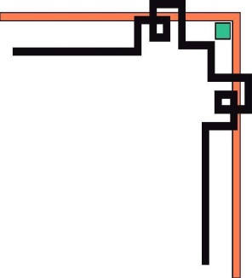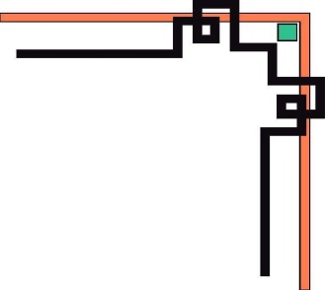



**eProject**

**Building Website with HTML5**

***Supervisor: Group 2:***

Ong Thi My Linh Student1058383 LU MINH THONG

Student1058384 DANG TUAN HUY

Student1058389 TRUONG PHU NGAN

**I. PROBLEM DEFINITION**

Project Start Date: 07-Feb-2018

Project Submission Date: 16-Mar-2018

***(Form No. 1/eProjects/PS/Ver1.0)***

AutoWorld is a company that deals with all types of cars and motors. They started off with a company in collaboration with "GOOD YEAR” and then build up their own establishment. They have different showrooms for different brands at various locations in the city and because of their services they have attracted a vast number of Customers in very short duration of time.

Many times, people make calls in the office for getting the information as:

1. Which latest car models are available?
2. What are the salient features of ‘Accord’?
3. Price list for the cars.
4. What about the warranty / insurance of the car?
5. Which is better model: Corolla/Civic/Wagon R?
6. What are the available modes of payment?

And many more like these. The company has tie-up with certain banks in the city with the help of these it assists customers in arranging for the loan. The loan amount is fixed and it is 60% of the price.

The company aims to break new ground by harnessing the power of technology and revolutionizing processes to make car ownership for the customers a truly enjoyable and hassle-free experience.

So taking into consideration the expanding business, the company planned to host the primary information via AutoWorld.com, an Internet Gateway to car dealership.

You are supposed to create a website for them with the below mentioned requirement specifications.

The website is to be developed for the Windows Platform using HTML5, JavaScript and Geolocation. The site should work well in all leading browsers including Chrome, IE, Firefox etc.

**II. CUSTOMER REQUIREMENT SPECIFICATION(CRS)**

***(Form No. 2/eProjects/PS/Ver1.0)***

***Client:*** Educational Academy.

**Business/Project Objective:**

***AutoWorld.com*** needs to be constructed considering following requirements:

1. Home page which will brief about the company, also design a suitable logo and include it on home page, you may display the logo on all the pages in the site.
2. A menu which will include all the functions implemented in the site.
3. The user should be able to locate the dealers based on the car brands. e.g. Honda, Suzuki, Ford etc.
4. A catalogue should be provided which will help the users to have a look at car’s image and clicking on the same will display the details about it. The details include features, price, location of the dealer etc.
5. There should be a page for contacting to the company which will include the address, phone and email address. Address of the Company should be displayed

using GeoLocation API (eg. GoogleMaps) and the email address which when clicked will invoke the local mail client from where they can send an email.

1. Site should also include the page that will give the information about the warranty schemes on the cars. The scheme will be different for the different brands. You are free to develop your own warranty schemes.
2. There should be a page which will list the banks/organizations which provide finance to purchase from AutoWorld. Clicking on the name of the company, user should be redirected to another page which will give the detailed information about the finance scheme. This information will include the details like the maximum amount which customer will get, interest rate, duration in which the amount can be repaid and the installment to be paid and also the terms and conditions.
3. The site should also include the comparison of different cars (same as well as different brands)
4. The user should be able to search the cars based on companies and price.
5. The information about various cars can be picked up from the internet.
6. The site should have appropriate look and feel suitable to company’s reputation

and status.

**Expected involved in the application**

* ***Expected Delivery Dates***

Project Start Date: **07-Feb-2018**

Project Submission **16-Mar-2018**

* ***List of Deliverables***

Documents handed over:

* + - * Manual installation.
      * User guide manual.

Application:

* + - * Development web application.
      * Application source code.

**Hardware and Software Requirements:**

|  |  |
| --- | --- |
|  | **Hardware and Software Requirements** |
| **Hardware** | * + Intel Core i3 Processor or Higher   + 1GB Ram or higher   + Color SVGA   + 80 GB Hard Disk space   + CD-ROM or DVD ROM driver | |
| **Software** | * + Windows 8, 8.1, 10 or higher   + HTML5 and Java script supporting browser   + Boostrap 3 libraries from getboostrap.com, jquery plugins, Visual Code, Atom or other HTML editor | |
| **Scope of the Work (in brief)** | * The Objective of this program is to give a sample project to work on real life projects. These applications help you build a larger more robust application. * The objective is not to teach you JavaScript/Dreamweaver but to provide you with a real life scenario and help you create basic applications using the tools. * You can revise the chapters before you start with the project. * This project is meant for students who have completed the module of HTML5. These programs should be done in the Lab sessions with assistance of the faculty if required. * It is very essential that a student has a clear understanding of the subject. Students should go through the project and solve the assignments as per requirements given. * Details: * Home page which will brief about the company, also design a suitable logo and include it on home page, you may display the logo on all the pages in the site. * A menu which will include all the functions implemented in the site. * The user should be able to locate the dealers based on the car brands. e.g. Honda, Suzuki, Ford etc. Using Bootstrap tooltips * A catalogue should be provided which will help the users to have a look at car’s image and clicking on the same will display the details about it. The details include features, price, location of the dealer etc. * There should be a page for contacting to the company which will include the address, phone and email address. Address of the Company should be displayed using GeoLocation API (eg. GoogleMaps) and the email address which when clicked will invoke the local mail client from where they can send an email. * Site should also include the page that will give the information about the warranty schemes on the cars. The scheme will be different for the different brands. You are free to develop your own warranty schemes. * There should be a page which will list the banks/organizations which provide finance to purchase from AutoWorld. Clicking on the name of the company, user should be redirected to another page which will give the detailed information about the finance scheme. This information will include the details like the maximum amount which customer will get, interest rate, duration in which the amount can be repaid and the installment to be paid and also the terms and conditions. * The site should also include the comparison of different cars (same as well as different brands). Using boostraps model * The user should be able to search the cars based on companies and price. Using Angular JS. * The information about various cars can be picked up from the internet. * The site should have appropriate look and feel suitable to company’s reputation and status. * Register Page with model Boostrap 3 * Login Page with model Boostraps 3 | |

**III. ARCHITECTURE & DESIGN OF THE PROJECT**

***(Form No. 3/eProjects/PS/Ver1.0)***

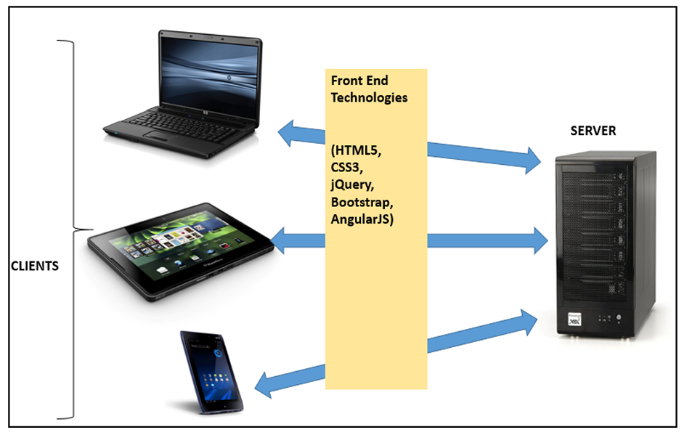

**IV. SITE MAP:**

***(Form No. 4/eProjects/PS/Ver1.0)***

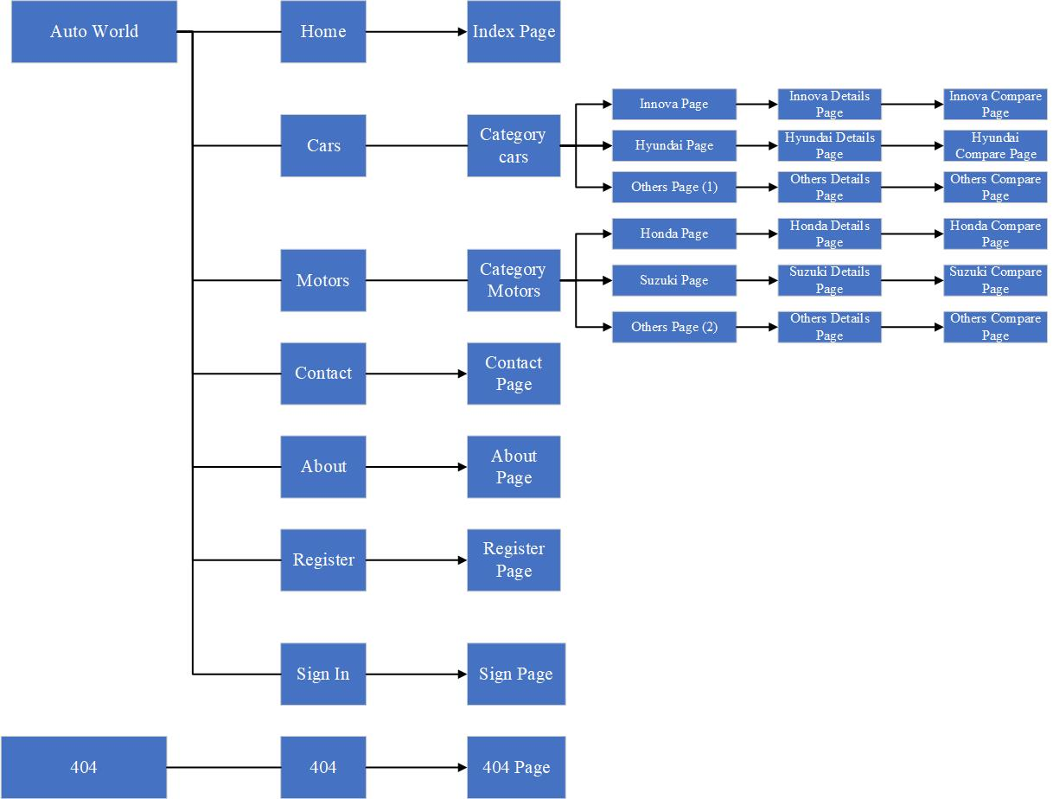

**IV.TASK SHEET**

***(Form No. 5/eProjects/PS/Ver1.0)***

|  |  |  |  |  |  |  |  |  |
| --- | --- | --- | --- | --- | --- | --- | --- | --- |
| **Project Ref. No: 1**  **Ep/Advertisement Portal Management System/01** | | **Project Title:** | **Activity Plan Prepared By:** | **Date of Preparation of Activity Plan:**  Project Start Date: 07-Feb-2018 | | | | |
| **Sr.No.** | **Task** | **Actual Start Date** | **Actual Days** | **Team Mate Names** | **Status** | **Total Status** |
| 1 | **PROBLEM DEFINITION** | **Document (AutoWorld)** | Student1058383 LU MINH THONG  Student1058384 DANG TUAN HUY | 07-Feb-2018 | 26-Feb-2018 | Student1058384 DANG TUAN HUY | 50% | Complete |
| Student1058383 LU MINH THONG | 50% |
| **CRS** | 07-Feb-2018 | 26-Feb-2018 | Student1058384 DANG TUAN HUY | 50% | Complete |
| Student1058383 LU MINH THONG | 50% |
| **ARCHITECTURE & DESIGN OF THE PROJECT** | 07-Feb-2018 | 26-Feb-2018 | Student1058384 DANG TUAN HUY | 50% | Complete |
| Student1058383 LU MINH THONG | 50% |
| **SITE MAP** | 07-Feb-2018 | 26-Feb-2018 | Student1058384 DANG TUAN HUY | 50% | Complete |
| Student1058383 LU MINH THONG | 50% |
|  |  |  |  |  |  |
| 2 | **Horizontal Menu** | **Home Page** | Student1058383 LU MINH THONG | 07-Feb-2018 | 09-Feb-2018 | Student1058384 DANG TUAN HUY | 50% | Complete |
| Student1058383 LU MINH THONG | 50% |
| **Header** |  |  | Student1058384 DANG TUAN HUY | 50% | Complete |
| Student1058383 LU MINH THONG | 50% |
| **Slider** |  |  | Student1058384 DANG TUAN HUY | 50% | Complete |
| Student1058383 LU MINH THONG | 50% |
| **Logo** |  |  | Student1058384 DANG TUAN HUY | 50% | Complete |
| Student1058383 LU MINH THONG | 50% |
| **Featured Products** |  |  | Student1058384 DANG TUAN HUY | 50% | Complete |
| Student1058383 LU MINH THONG | 50% |
| **News Products** |  |  | Student1058384 DANG TUAN HUY | 50% | Complete |
| Student1058383 LU MINH THONG | 50% |
|  |  |  |  |  |  |
|  |  |  |  |  |  |  |  |  |
|  |  |  |  |  |  |  |  |  |
|  |  |  |  |  |  |  |  |  |

