Advanced Computing for Science Department

Data Intensive Systems Group

Staff

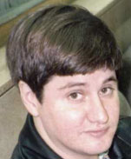

*Dan Gunter*

*Research Scientist*

[*DKGunter@lbl.gov*](mailto:DKGunter@lbl.gov)

*(510)495-2504*

[*http://acs.lbl.gov/~dang/*](http://acs.lbl.gov/~dang/)

Dan Gunter is the group lead for the Data Intensive Systems group. He specializes in distributed and parallel systems design and performance analysis. His research includes distributed workflows, network performance, visual analysis techniques, and complex data integration. He maintains the NetLogger open source application monitoring software. Past research includes work on scientific collaboration tools, protocol benchmarking on Emulab, and work on the Distributed Parallel Storage System, a predecessor to GridFTP.

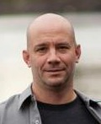

*Josh Boverhof*

*Computer Systems Engineer*

[*JRBoverhof@lbl.gov*](mailto:JRBoverhof@lbl.gov)

*(50)560-1525*

[*http://acs.lbl.gov/~boverhof/*](http://acs.lbl.gov/~boverhof/)

Josh Boverhof is a Computer Systems Engineer with emphases on development of science gateways, python-based cyberinfrastructure, and science cyberinfrastructure. He has worked extensively on grid and web technologies.

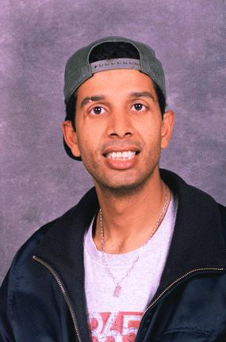

*Abdelilah Essiari*

*Computer Systems Engineer*

[*AEssiari@lbl.gov*](mailto:AEssiari@lbl.gov)

*(510)486-6670*

[*http://acs.lbl.gov/~aes/*](http://acs.lbl.gov/~boverhof/)

Abdelilah Essiari is a Computer Systems Engineer with an emphasis on science cyberinfrastructure development, workflow tools, and network security protocols.



*Monte Goode*

*Computer Systems Engineer*

[*MMGoode@lbl.gov*](mailto:MMGoode@lbl.gov)

*(510)486-6670*

[*http://acs.lbl.gov/~mgoode/*](http://acs.lbl.gov/~boverhof/)

Monte Goode is a software engineer currently working on cyberinfrastructure for the sciences, most recently focusing on data integration, storage and analysis for network monitoring and workflow systems, with an current focus on current non-relational database tools. Before that he participated in a collaboration with the Berkeley Water Center at UC Berkeley with an emphasis on environmental informatics and helped to build the Fluxdata.org International Soil Carbon Network datastore. Previous projects include contributions to the National Fusion Grid and the MyProxy Credential Management Service. He received a MLIS in Library and Information Science from the University of Texas at Austin in 1996 and his fifteen plus year career includes work in both academic and commercial environments.

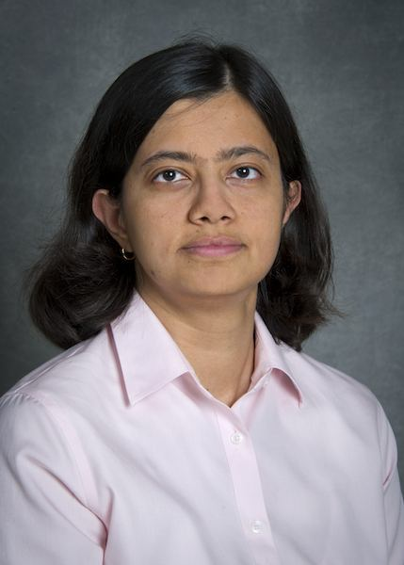

*Lavanya Ramakrishnan*

*Research Scientist*

*LRamakrishnan@lbl.gov   
(510)486-4384*

[*http://acs.lbl.gov/~lavanya/*](http://acs.lbl.gov/~lavanya/)

Lavanya Ramakrishnan is a scientist in the Advanced Computing for Science department at Lawrence Berkeley National Lab. Her research interests are in software tools for computational and data-intensive science. Currently, she is actively engaged in projects exploring programming templates for data analysis workflow composition and data management techniques for elastic transient environments. She is also involved in projects evaluating cloud and big data technologies such as Hadoop and NoSQL databases for scientific applications and performance, energy and fault-tolerance trade-offs in infrastructure strategies. Ramakrishnan has also worked closely with scientists from multiple domains including bioinformatics, biomedical science, storm-surge modeling, weather modeling, high-energy physics and light source facilities. Lavanya has previously worked as a research staff member at Renaissance Computing Institute and MCNC in North Carolina. She has masters and doctoral degrees from Indiana University and a bachelor degree in computer engineering from VJTI, University of Mumbai. She joined LBL as an Alvarez Postdoctoral Fellow in 2009.



*Taghrid Samak*

*Postdoctoral Researcher*

*TSamak@lbl.gov   
(510)486-2410*

[*http://acs.lbl.gov/~taghrid/*](http://acs.lbl.gov/~taghrid/)

Taghrid Samak joined the Lab as a Postdoctoral Researcher in 2010. Her PhD work was in developing novel algorithms for distributed network policy configuration. Her emphasis is on "data science" at the intersection of statistical algorithms and computing, in the context of important scientific problems. She has developed workflow failure prediction algorithms, fingerprinting HPC codes, and two projects with the LBNL Joint Genome Institute: predicting protein function and genome assembly errors.

Joint Appointments and Affiliates

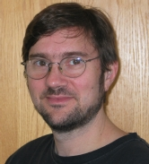

*Vern Paxson   
Faculty Affiliate*[*VEPaxson@lbl.gov*](mailto:VEPaxson@lbl.gov)

*(510) 666-2882*

[*http://www.aciri.org/vern/*](http://www.aciri.org/vern/)

Vern Paxson is an associate professor on the faculty of the Electrical Engineering and Computer Sciences Department at the University of California, Berkeley. He holds joint appointments at the Lawrence Berkeley National Laboratory, where he has been a staff member since 1985, and since 1999 at the International Computer Science Institute in Berkeley, where he is a senior scientist. Prof. Paxson’s research focuses on Internet attacks and defenses, and network and Defenses, which pursues a variety of research efforts in detecting and blocking networkborne attacks. He cofounded and served on the steering committees of the ACM Internet Measurement Conference, the ACM Workshop in Rapid Malcode, and the USENIX Workshop on Large-Scale Exploits and Emergent Threats. He has served as program chair or co-chair of ACM SIGCOMM, USENIX Security, IEEE Symposium on Security and Privacy, and ACM HotNets, and as an Area Director of the Internet Engineering Task Force. He is an ACM Fellow and recipient of the 2008 ACM Grace Murray Hopper Award for his work on Internet measurement, and has twice been a co-recipient of the IEEE Communications Society William R. Bennett Prize Paper award, and of the USENIX Lifetime Achievement award.



*Robin Sommer*

*Researcher*[*RSommer@lbl.gov*](mailto:RSommer@lbl.gov)

*(510) 486-7504*

[*http://www.icir.org/robin/*](http://www.icir.org/robin/)

Robin Sommer is a staff researcher at the International Computer Science Institute in Berkeley, and he is also a member of the Advanced Computing for Science Department at the Lawrence Berkeley National Laboratory. His research focus is network security monitoring in operational high-performance settings, and he is one of the core developers of the opensource Bro network intrusion detection system. Dr. Sommer received a Ph.D. from the Technical University of Munich in Germany, and post-doc fellowships from the German Academic Exchange Service as well as from the DHS-funded Institute for Infrastructure Protection. He has participated in program committees for conferences and workshops, and he chaired the 2007 “Conference on the Detection of Intrusions & Malware, and Vulnerability Assessment”.

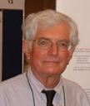

*Fredric Gey*

*Faculty Affiliate*

*gey@berkeley.edu*

*(510)486-5171*

<http://ucdata.berkeley.edu/gey.html>

Fredric Gey is an information scientist atUC Data Archive & Technical Assistance(UC DATA) within theInstitute for the Study of Societal Issues (ISSI), University of California, Berkeley**.**



*Christian Kreibich*

*Affiliate*

[*christian@icir.org*](mailto:christian@icir.org)

*(510)486-7078*

Christian Kreibich received his Diplom in Computer Science in 2002, from Technische Universitat Munchen, Germany. He completed the Ph.D. program at the University of Cambridge Computer Laboratory with advisor Jon Crowcroft. He begain working for ICIR in 2006, and is currently a staff research scientist. His research focuses on topics in network architecture, distributed systems, and network security.

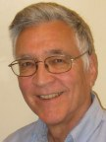

*John McCarthy*

*Affiliate*

*JLMcCarthy@lbl.gov*

*(510)841-7875*

John L. McCarthy was a Computer Scientist at the Lawrence Berkeley National Laboratory (LBNL) from 1980 to 2003. He graduated from Stanford University in 1964 and received his Ph.D. in History from Yale University in 1970, where he taught American History and quantitative methods for historical research for six years. In 1974 he moved to the Survey Research Center (SRC) at the University of California, Berkeley, where he directed data analysis and educational services and helped develop UNIX-based tools for computer-assisted survey research as well as a public opinion survey information retrieval system for the Congressional Research Service. Throughout his career, John's major interests have included information systems design, metadata management, user interfaces, and collaborative software.  Since retirement, John has also been working on voting integrity and election auditing issues as volunteer with the Verified Voting Foundation and VerifiedVoting.org.



*Frank Olken   
Affiliate (Staff Scientist)   
FOlken@lbl.gov   
(510)495-2905*

Frank Olken is a database researcher at LBNL. For the past 3 years he has been detailed to the National Science Foundation in the Computer and Information Science and Engineering Directorate,Information and Intelligent Systems Division, Information Integration and Informatics program as a program director. Immediately prior to this assignment at the NSF he worked on the XMDR metadata registry project. This involved standards development for the ISO/IEC 11179 metadata registry standard and development of the XMDR prototype metadata registry. His other standards work included the W3C RDF language standard and the W3C XML Schema Language standard. He has also worked on random sampling from databases. Dr. Olken received his PhD. from UC Berkeley in Computer Science.