

**<<HR MANAGEMENT>>**

**Software Requirement Specification**

**Instructor: Nguyễn Trung Kiên**

**Author: Nguyễn Ngọc Nam – HE131010**

**Vũ Hải Đăng - HE150264**

**Nguyễn Huy Tùng - HE150305**

**Lê Nguyên Hùng - HE141720**

**Ngô Quốc Bảo - HE150436**

**Lê Khả Chính - HE151217**

**Class: SE1514-NET**

– Hanoi, January 2022 –

Table of Contents

I. Overview **4**

1. Introduction 4

2. System Functions 4

a. Screen Flow 4

b. Screen Details 4

c. User Authorization 5

d. Non-Screen Functions 8

3. Common Requirements 8

II. Functional Requirements **8**

<< Home Screen >> 8

a.<< Home Logged-in >> 8

a.1 << Setting List Page >> 8

a.2 << User Profile Page >> 9

b.<< not logged - in>> 10

b.1 << login Page >> 10

b.2 << register Page >> 10

2. << Login function/ forgot password >> 11

a. << Login >> 11

b. << Forgot password function >> 12

3. << Register >> 13

a. << Register >> 13

4. << Settings List>> 15

a. << Show list of settings >> 15

b. << Search >> 15

5. << Setting Details>> 16

a. << Add profile >> 16

b. <<Edit profile>> 17

6. << User profile >> 17

a. << User profile >> 17

b. << Change password >> 18

# I. Overview

## 1. Introduction

HR manager is a new human resource management system that replaces manual human resource management processes. The system makes management easier. The system is expected to grow over several releases. And finally will assist companies in managing HR issues.

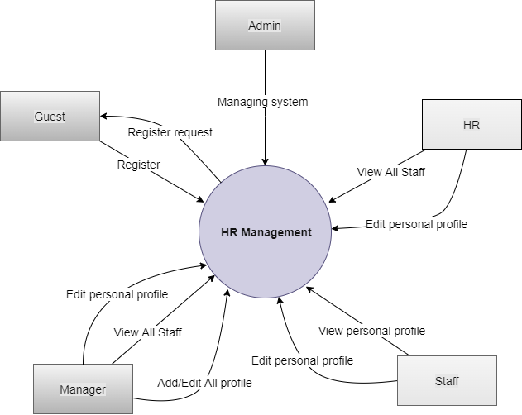

## 2. System Functions

#### a. Screen Flow

*[This part shows the system screens and the relationship among screens. You can draw the Screens Flow for the system in the form of diagram as below]*

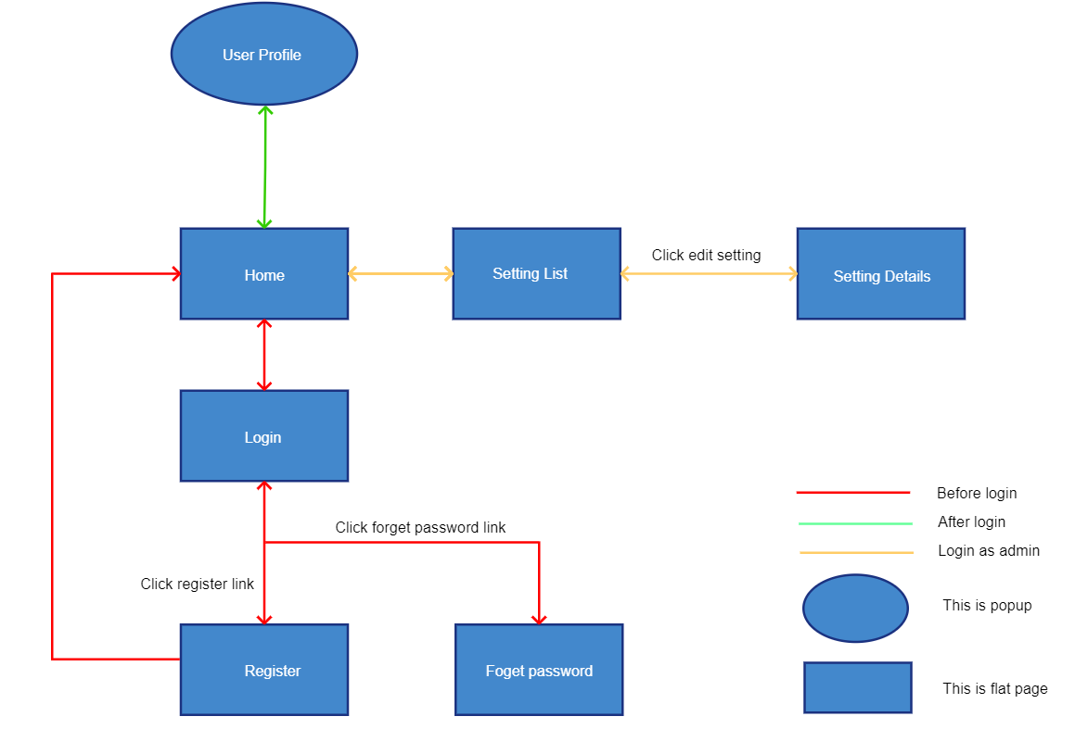

#### b. Screen Details

*[Provide the descriptions for the screens in the Screens Flow above]*

| **#** | **Feature** | **Screen** | **Description** |
| --- | --- | --- | --- |
| 1 | Connect to the function | Home screen | With header, footer, main menu (full application menu). List out existing user information in the database. Links to User Login & User Register if not logged in. Links to User Profile pop-up and to the Settings List page (if logged-in user is admin) |
| 2 | Login account | User login | Enter username or email, password. Links to Forget Password & User Register.  Forget password: user to enter username & email to receive current password via email |
| 3 | Register account | User register | Enter full name, email, user-name, password, confirm password  UserName & Email is unique  Verify email required |
| 4 | Manage list | Settings list | Show list of settings (id, type name, setting name, setting value, status)  The users can search the list by setting name or value; filter by setting type name, status  Type name is read from a config (or xml) file by setting type_id  From this list, user can choose to activate/deactivate, add or edit setting  The page is paginated |
| 5 | Create/edit setting | Setting details | Allow user to input setting information for adding/editing: type name (combo-box), setting name, setting value, status (radio button), description (text area, HTML format)  Type names are read from config (or xml) file, type_id is stored in the database then. |
| 6 | Edit information | User profile | Pop-up, allow user to view & edit their registered information + upload/change avatar image |
| 7 | … |  |  |

#### c. User Authorization

*[Provide the system roles authorization to the system features (down to screens, and event to the screen activities if applicable) in the table form as below – replace Role1, Role2,… with the specific system user role names]*

| **Screen** | Guest | Staff | Manager | HR | Admin |
| --- | --- | --- | --- | --- | --- |
| Home | X | X | X |  |  |
| Blogs List | x | x | x |  |  |
| Blog Details | X | X | X |  |  |
| User Register | X | X | X |  |  |
| User Login | X |  |  |  |  |
| Password Reset | X | X |  |  |  |
| User Profile | X | X |  |  |  |
| Password Change | X | X |  |  |  |
| Requests List |  | X |  |  |  |
| Request Details |  | X |  |  |  |
| Staff Feedback | X | X |  |  |  |
| Assigned Requests |  | X | X |  |  |
| Request Response |  | X |  |  |  |
| Feedbacks List |  | X |  |  |  |
| Timesheets List |  | X |  |  |  |
| Timesheet Details |  | X |  |  |  |
| Timesheets Review |  | X |  |  |  |
| Absence Requests |  | X |  |  |  |
| Absence Details |  | X |  |  |  |
| Absences Review |  |  | X |  | X |
| Projects List |  |  | X |  | X |
| Project Details |  |  | X |  | X |
| HR Allocation |  |  | X |  | X |
| Allocation Details |  |  | X |  | X |
| Users List |  |  | X |  | X |
| User View/Edit |  |  | X |  | X |
| New User |  |  |  | X | X |
| Contract Details |  |  |  | X |  |
| Groups List |  |  |  | X |  |
| Group Details |  |  |  | X |  |
| Posts List |  |  |  | X |  |
| Post Details |  |  |  | X |  |
| Sliders List |  |  |  | X |  |
| Support Types List |  |  |  |  | X |
| Support Type Details |  |  |  |  | X |
| Settings List |  |  |  |  | X |
| Setting Details |  |  |  |  | X |

In which:

* Role1: <<Guest User>>
* Role2: <<Staff>>
* Role3: <<Manager>>
* Role4: <<HR>>
* Role5: <<Admin>>

#### d. Non-Screen Functions

*[Provide the descriptions for the non-screen system functions, i.e batch/cron job, service, API, etc.]*

| **#** | **Feature** | **System Function** | **Description** |
| --- | --- | --- | --- |
| 1 | <<Feature Name>> | <<Function Name1>> | <<Function Name1 Description>> |
| 2 | … |  |  |

## 3. Common Requirements

*<<fill here with all the common requirements...>>*

# II. Functional Requirements

## << Home Screen >> Lê Nguyên Hùng

### a.<< Home Logged-in >>

### a.1 << Setting List Page >>

| Trigger | User clicks the “Setting List” button. |
| --- | --- |
| Precondition | **Logged-in** |
| Description | User redirect to tab Setting List |
| Details | 1. User must Logged - in 2. User clicks the “ Setting List ” button. 3. Page redirect to Setting List Page |
| Exception | if Setting List failed redirect to Home Screen |
| Postcondition | redirect to Setting List page successfully |

### 

### a.2 << User Profile Page >>

| Trigger | User clicks the “User Profile” button. |
| --- | --- |
| Precondition | **Logged-in** |
| Description | User redirect to tab User Profile |
| Details | 1. User must Logged - in 2. User clicks the “ User Profile ” button. 3. Page redirect to User Profile Page |
| Exception | if User Profile failed redirect to Home Screen |
| Postcondition | redirect to User Profile page successfully |

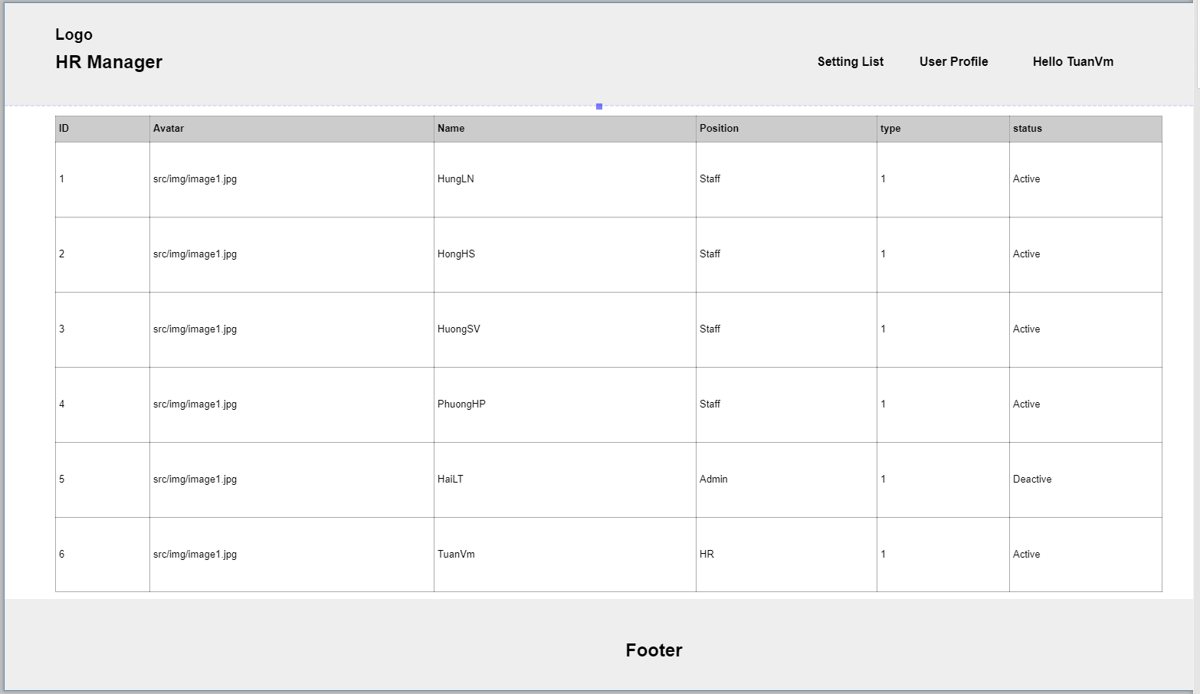

### 

### 

### 

### 

### b.<< not logged - in>>

### b.1 << login Page >>

| Trigger | User clicks the “Login” button. |
| --- | --- |
| Precondition | **None** |
| Description | User redirect to tab Login |
| Details | User clicks the “ login ” button.  Page redirect to login Page |
| Exception | if login page failed redirect to Home Screen |
| Postcondition | redirect to login page successfully |

### 

### b.2 << register Page >>

| Trigger | User clicks the “Register” button. |
| --- | --- |
| Precondition | **None** |
| Description | User redirect to tab Register |
| Details | User clicks the “ Register” button.  Page redirect to Register Page |
| Exception | if Registerpage failed redirect to Home Screen |
| Postcondition | redirect to Registerpage successfully |

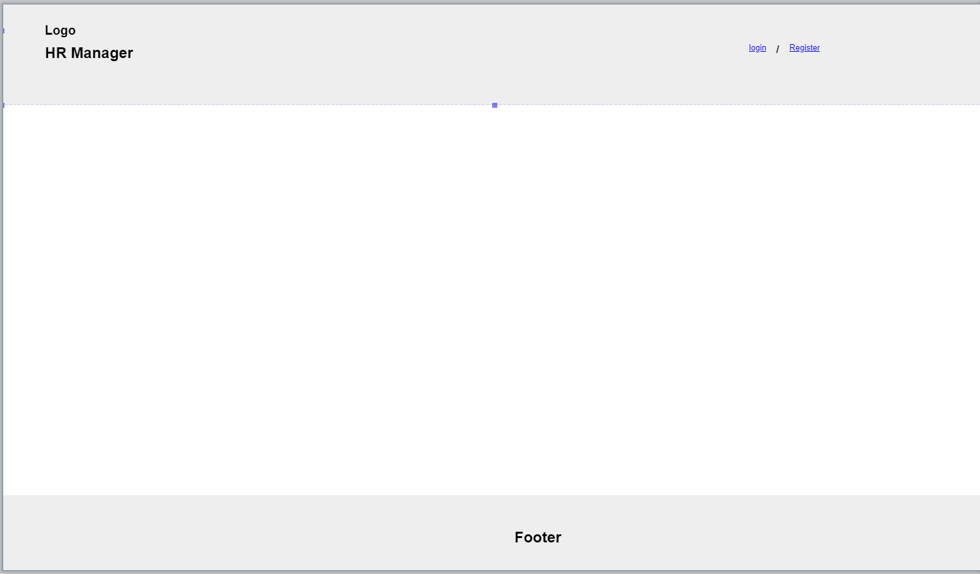

## 2. << Login function/ forgot password >> Ngô Quốc Bảo

### a. << Login >>

| Trigger | User clicks the “Login” button. |
| --- | --- |
| Precondition | User already has an account |
| Description | Users must be logged in to access the website |
| Details | When users do not have an account or have a login link to a certain page of the web, they will be required to log in to be able to access that page.  If the user does not have an account, the registration can be  hidden and automatically redirected to the registration page (Explained more  in the registration section).  If the user already has an account but fails to log in, the user  can click forgot password and then will be redirected to the forgot password  page to continue.  If you have successfully logged in, you can go to the web. |
| Exception | If the user enters the wrong information, the user will be asked to re-enter it |
| Postcondition | User successfully logged in |

# 

### b. << Forgot password function >>

After the user presses forgot password:

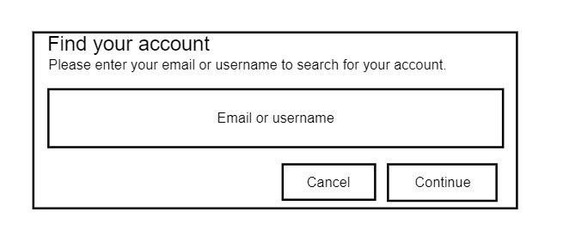

| Trigger | User clicks the “forgot password”. |
| --- | --- |
| Precondition | Forgot password and need to get it back |
| Description | User needs to retrieve password |
| Details | Go to the forgot password page and proceed to ask the user to enter their email or username to retrieve a new password.  New password will be emailed. |
| Exception | If the user enters the wrong username or the wrong email, the password cannot be retrieved |
| Postcondition | The user has recovered his password and returns to the login page |

## 3. << Register >> Vũ Hải Đăng

### a. << Register >>

| Trigger | User clicks the “Register” button. |
| --- | --- |
| Precondition | Non |
| Description | User must register to be a member of HR management system |
| Details | 1. User clicks the “Register” button. 2. User enter full name, email, user-name, password, confirm password. 3. System check 2 password is identical, username & email is unique, verify email. 4. A new account is created for user. 5. System keeps user information in database. |
| Exception | If user enter invalid information, system notifies user and return to the registration screen. |
| Postcondition | User become a member of HR management system |

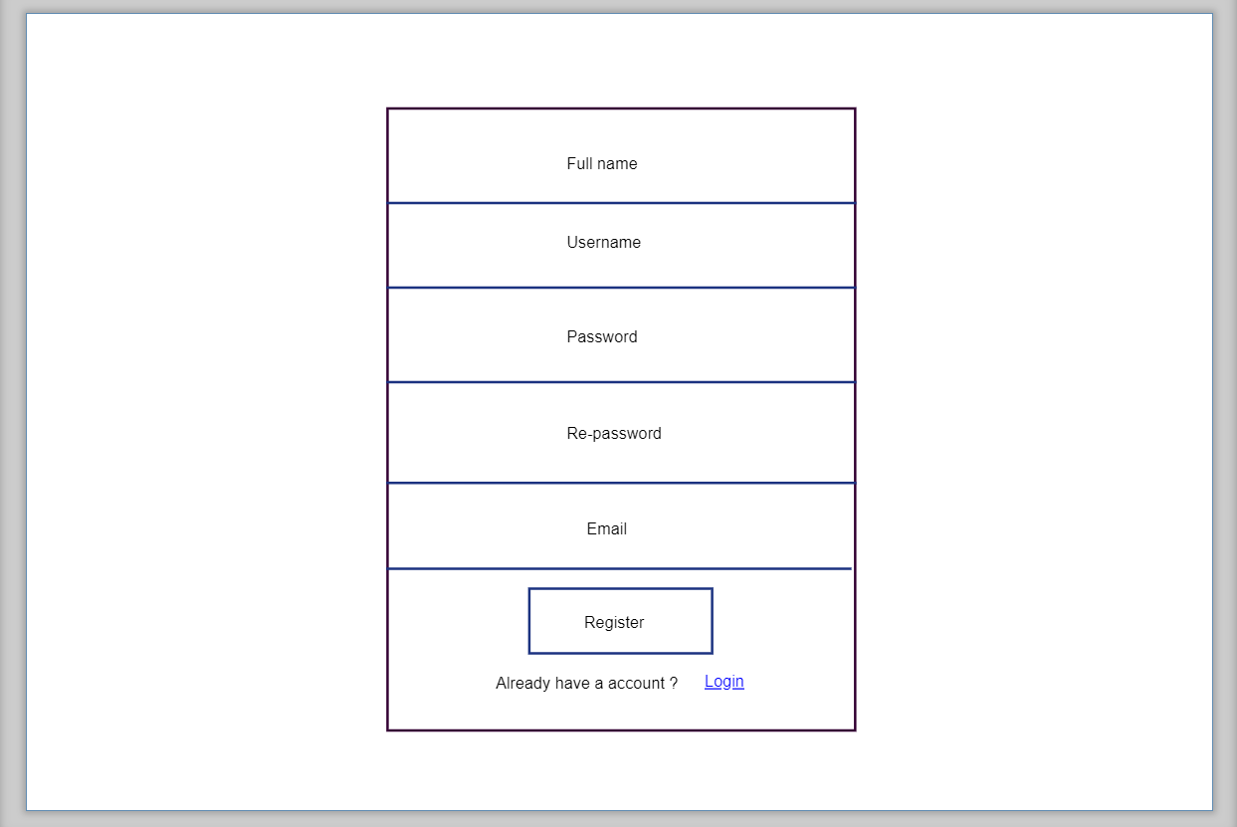

## 4. << Settings List>> Lê Khả Chính

### a. << Show list of settings >>

• Function trigger: when admin login the system

• Function description: Display all the accounts in database

• Function Details: provide explanation for the data, validation, business logics, functionalities of the function so that admin can control the system.

### b. << Search >>

• Function trigger: when admin input setting name or value, filter by setting type name, status

• Function description: Search the list satisfy the input

* *Screen layout:*

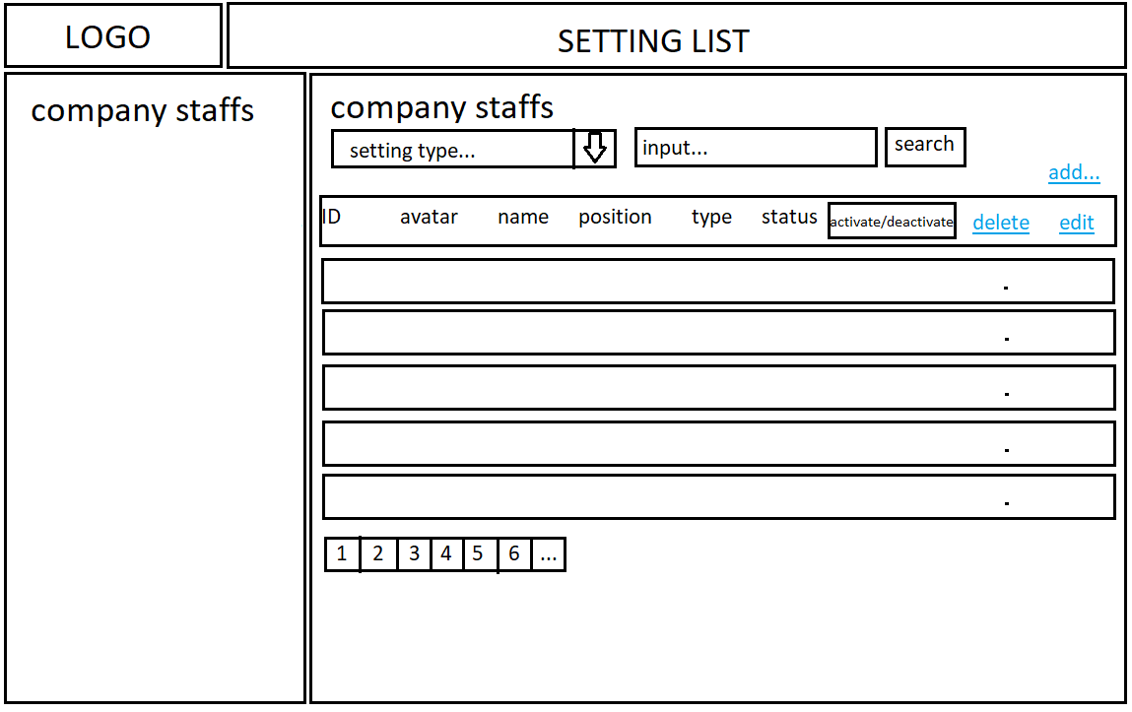

## 5. << Setting Details>> Nguyễn Ngọc Nam

### a. << Add profile >>

| Trigger | User clicks on button add new in screen. |
| --- | --- |
| Precondition | Non |
| Description | Admin can add new user information to the system. |
| Details | Admin click on button add new.  Admin enter new user information  Verify information  Click “OK” or “Cancer” button.  The system will add new user to the database. |
| Exception | If the user enters the wrong characters, the system will notify the user and re-enter |
| Postcondition | User information updated to system database |

# 

### b. <<Edit profile>>

| Trigger | Admin click on button edit info. |
| --- | --- |
| Precondition | Non |
| Description | Admin can edit user information to the system. |
| Details | Admin click on button edit in row.  Admin enter new user information  Verify information  Click “OK” or “Cancer” button.  The system will edit new user info to the database. |
| Exception | If the user enters the wrong characters, the system will notify the user and re-enter |
| Postcondition | User information updated to system database |

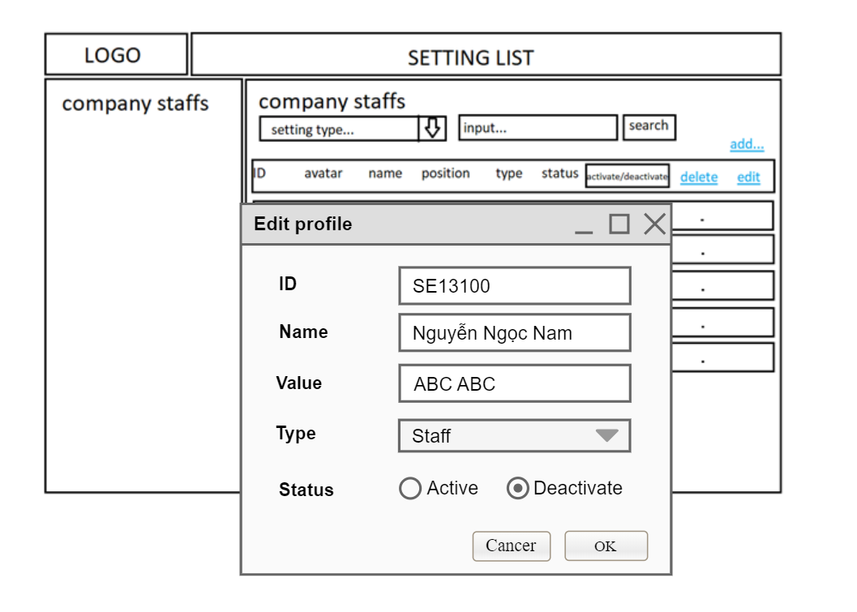

## 6. << User profile >> Nguyễn Huy Tùng

### a. << User profile >>

| Trigger | User clicks on their avatar. |
| --- | --- |
| Precondition | Non |
| Description | User can edit their information in order to having the most correct profile. |
| Details | * User clicks on their avatar. * User could change their avatar, dob, sex, phone number, address and change password by click at the text have the label which proportional * To verify the sureness of user, they have to fill correct password of their account * Click “Save” button. * System change user information in database. |
| Exception | If user enter wrong password, system notifies user and return to the user profile screen. |
| Postcondition | User information updated to system database and so does their user profile when checking again. |

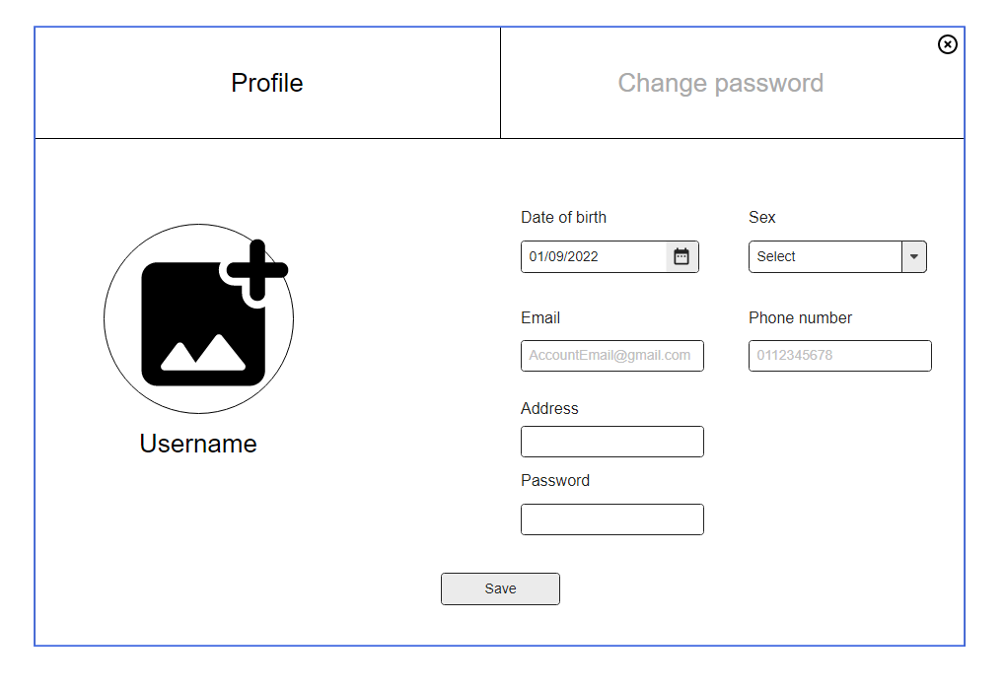

### b. << Change password >>

### 

| Trigger | User clicks on the “change password” on profile menu. |
| --- | --- |
| Precondition | Non |
| Description | User can change their password. |
| Details | * User clicks on the “change password” on profile menu * User could change their password * To verify the sureness of user, they have to fill correct old password and re-enter new password * Click “Save” button. * System change user information in database. |
| Exception | If user enter wrong old password or confirm password, system notifies user and return to the user profile change password screen. |
| Postcondition | User password updated to system database. |

