* Add pair of virtual COM (COM1, COM2)

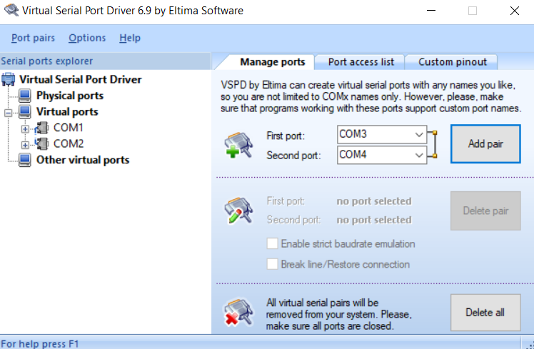

* Open HTerm, select Port and Baud rate, then Connect

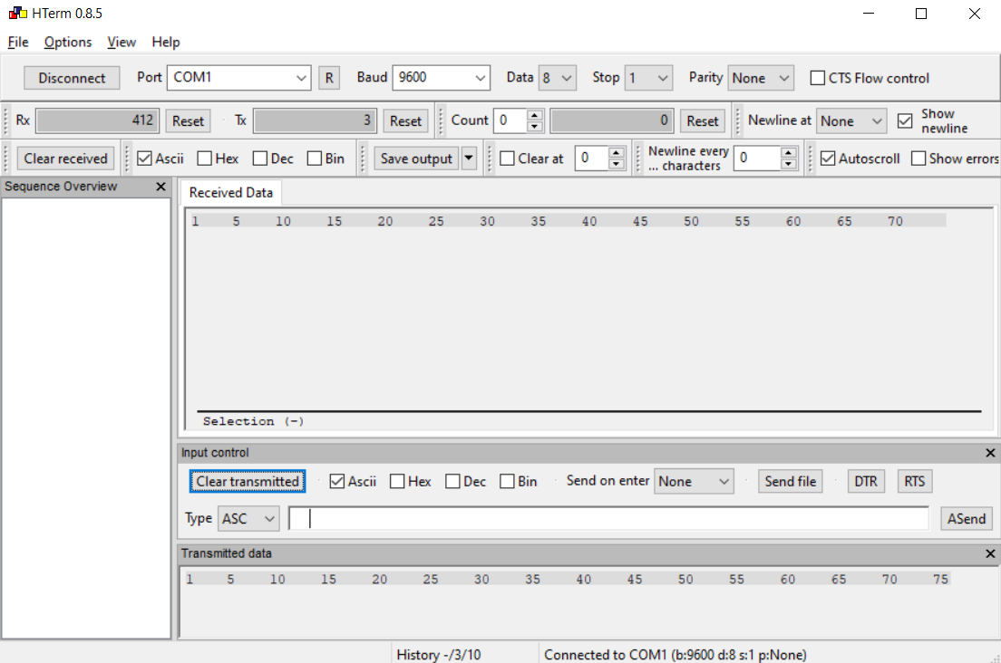

* Open Proteus and Run the simulation