First, create new project. Type name of your project and choose device. Theme is optional. Then click Create. Auth token is sent to your gmail account, you use it for connection between ESP8266 and Blynk.

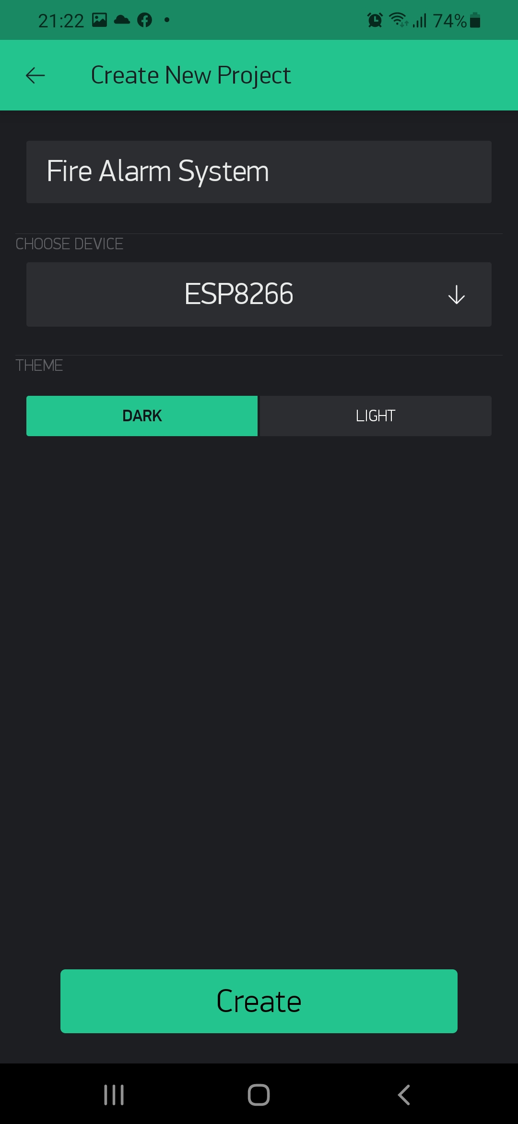

Use Widget Box to get some widgets for project. First, to display gas concentration, you can use Gauge widget. In settings, you choose V1 (Virtual 1), the value is from 0 to 1023.

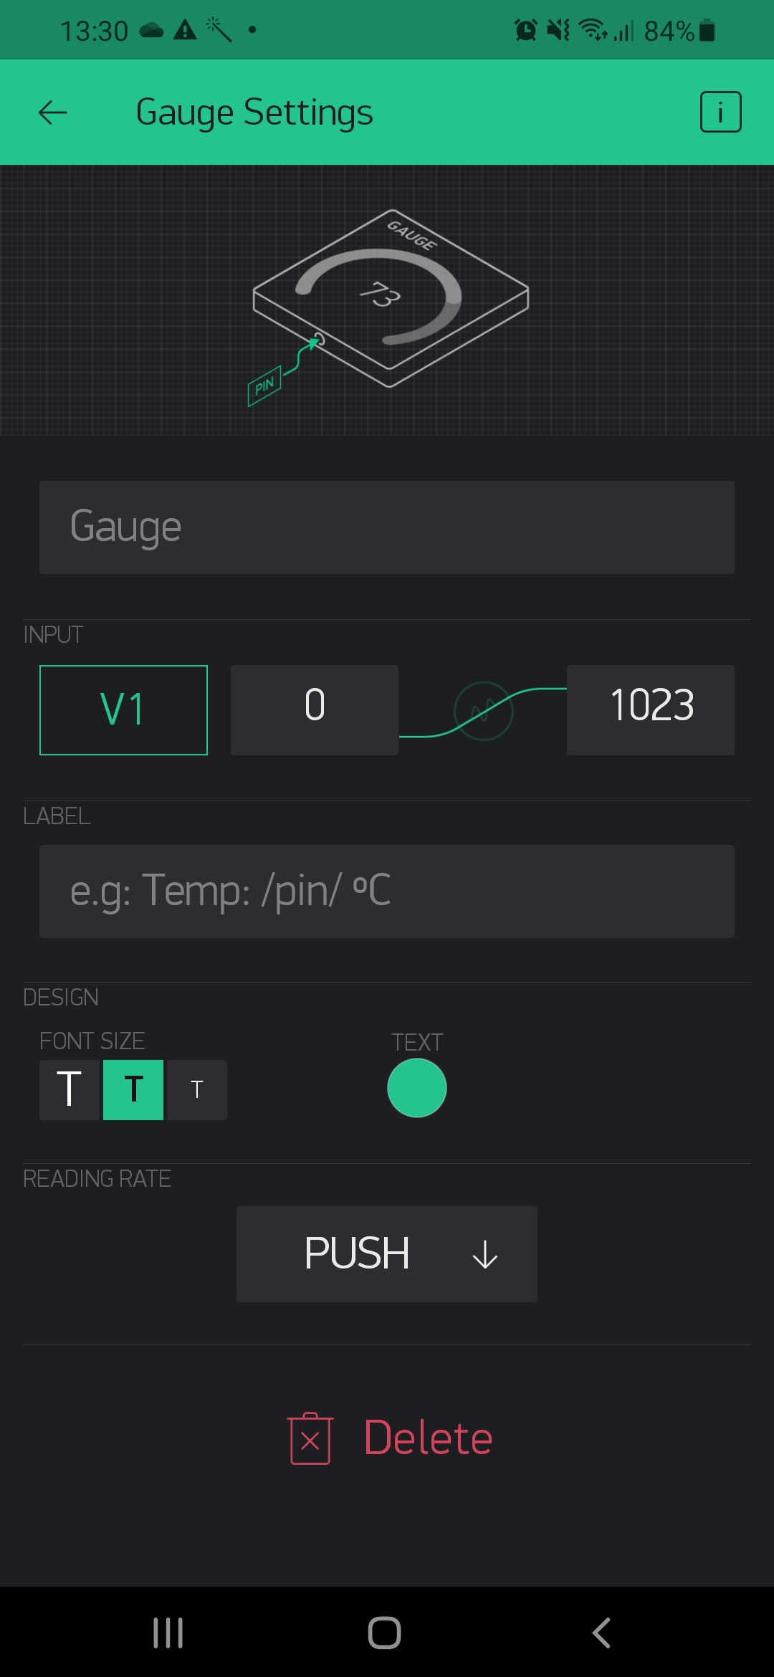

Next, use Notification widget for warning. Set priority to HIGH.

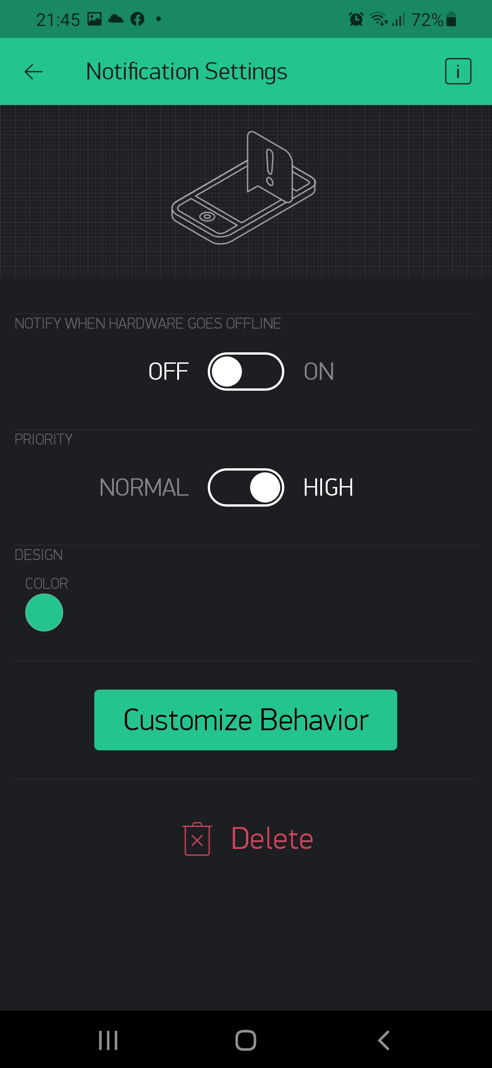

Next, set up events by Eventor widget. In settings, you can add new event, set condition to display notification, edit your warning.

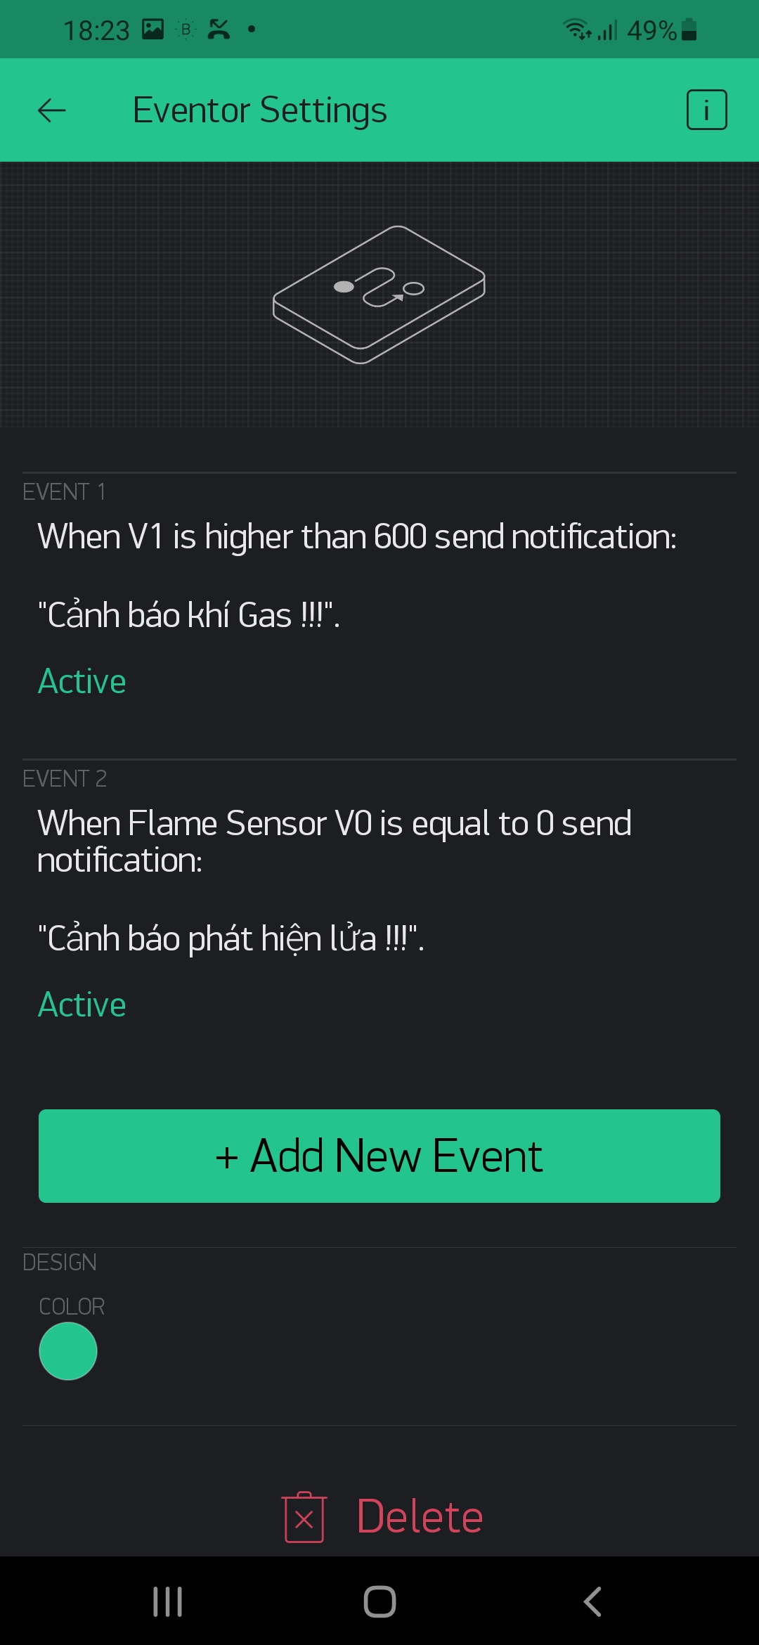

Finally, we have an user interface.

