**Desription:**

* Read ADC value.
* Print to SWV ITM Data Console.

**Config:**

* Default setting

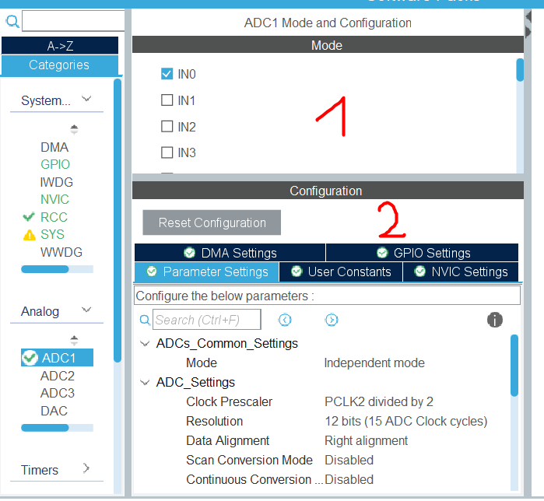

* Enable interrupt (in case using interrupt)

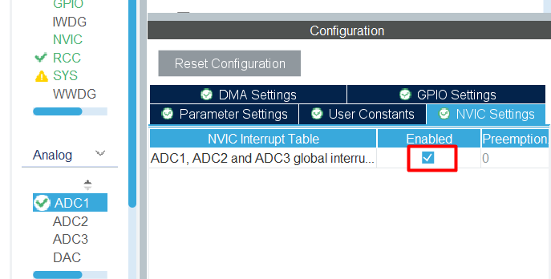

**Connection:**

* Use PA0 pin as ADC channel

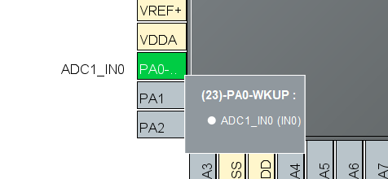

* Connect variable resistor to MCU as below:

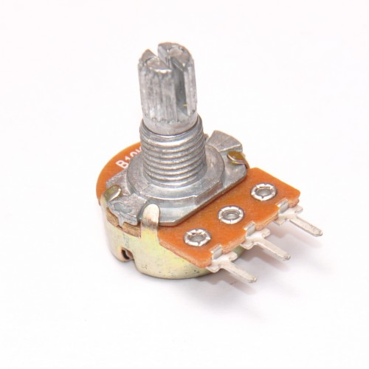

VCC

PA0

GND

**Debug with SWV to test this program**

More detail at README.md