**Desription:**

* Read ADC value.
* Print to Hercules.

**Connection:**

* Use PC1 pin as ADC channel. More detail about channels at below:
  + ADC1, ADC2:
    - IN1 - IN7 : PA1 - PA7
    - IN8 - IN9 : PB0 - PB1
    - IN10 – IN15 : PC0 – PC5
  + ADC3:
    - IN1 – IN3 : PA1 – PA3
    - IN10 – IN13 : PC0 – PC3
* Connect variable resistor to MCU as below:

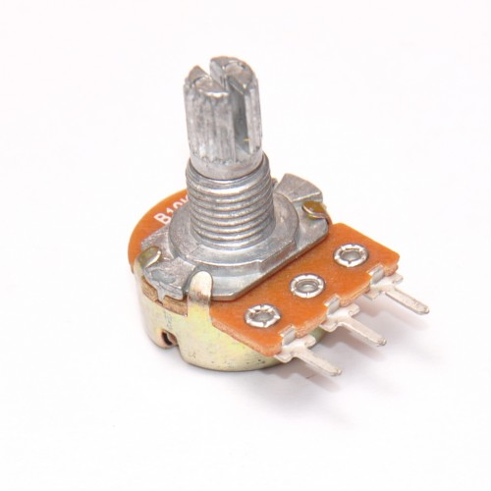

VCC

PC1

GND

* Connect UART to MCU as below:

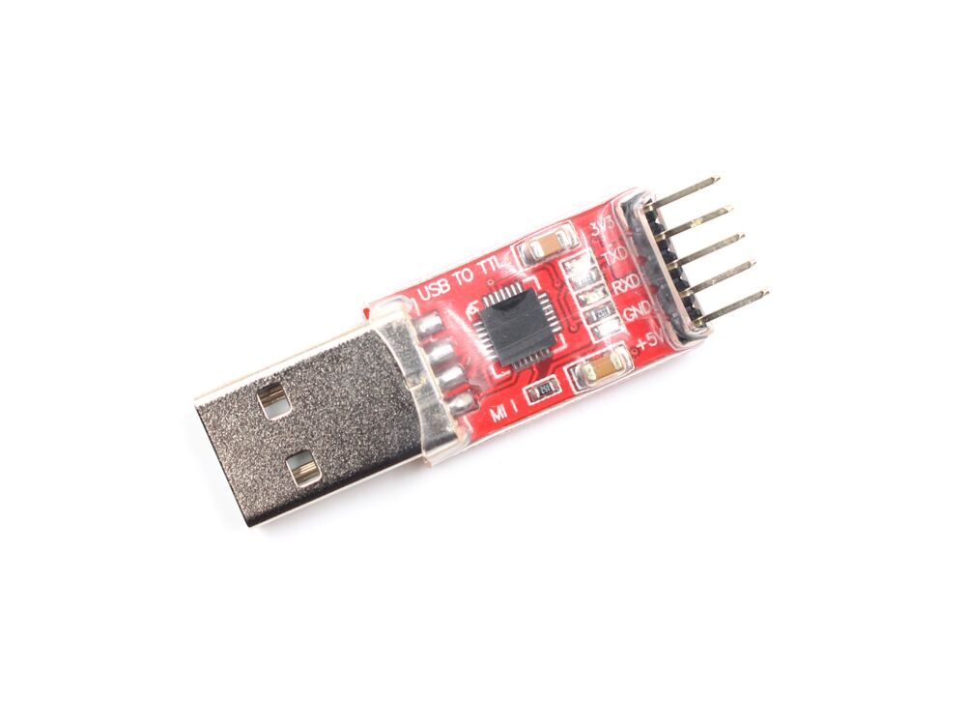



PD5

+ PD5 (USART2 TX) connects RXD of USB

+ USB connects PC

* Connect Hercules:

+ Check port of USB

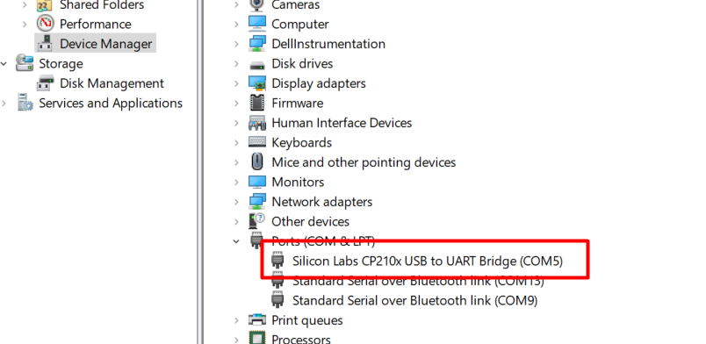

+ Open port

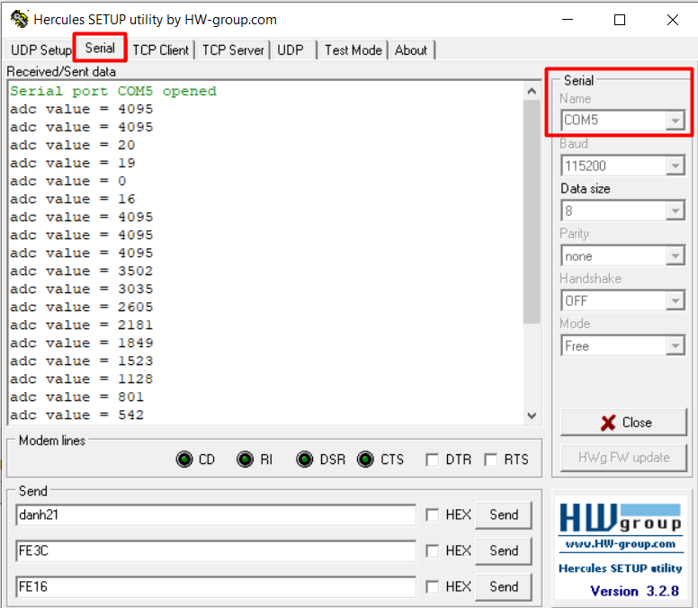

**Reference**

<https://www.youtube.com/watch?v=q8XSsTDAUiM>