**Desription:**

-       Read RCC clock frequency.

-       Print to SWV ITM Data Console.

**Config:**

Check clock frequency in .ioc file

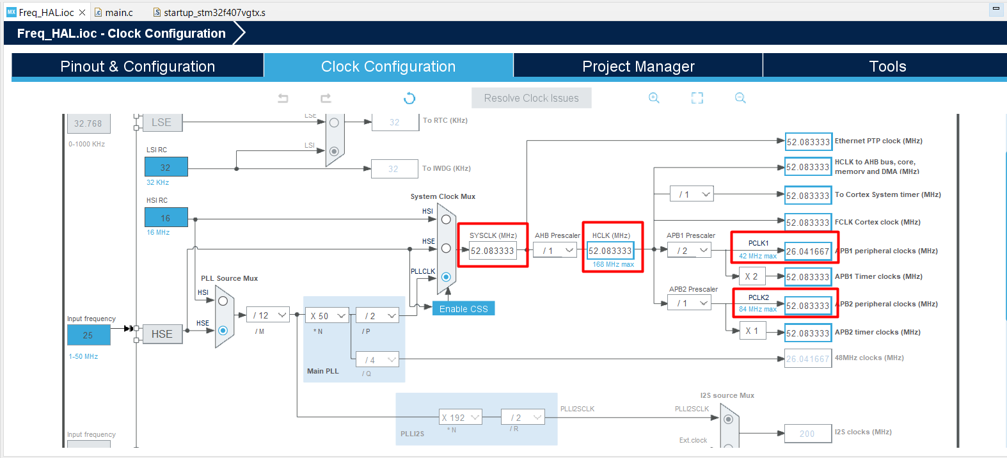

**Debug with SWV to test this program**

More detail at README.md

