**Desription:**

* Measure clock frequency.

**Config:**

* In main.c:

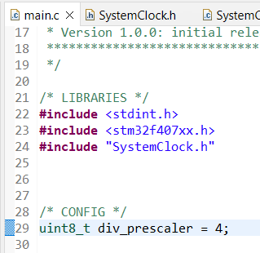

* + Choose division by 2/3/4/5

**Connection:**

* Connect logic analyzer to PC by USB cable
* Connect logic analyzer to STM32 board as below:
  + CH1 --- PA8 (MCO1)
  + GND --- GND
* Open Sigrok PulseView, select device with driver **fx2lafw**, then run wave simulation

**Result:**

* HSI clock frequency is 16MHz, divided by 4 🡪 result on PA8 pin is 4MHz

