**Desription:**

* Use button to switch task to turn ON/OFF 3 leds sequentially.
* Use Mutex to avoid accessing to resource at the same time

**Config:**

* Config debug

* Use user leds connected to the I/O PD14, PD13, PD12 of the STM32F407VGT6.

* Use built-in button on board:

* Setup FreeRTOS config, enabe preemtion to test Mutex

* Create tasks:

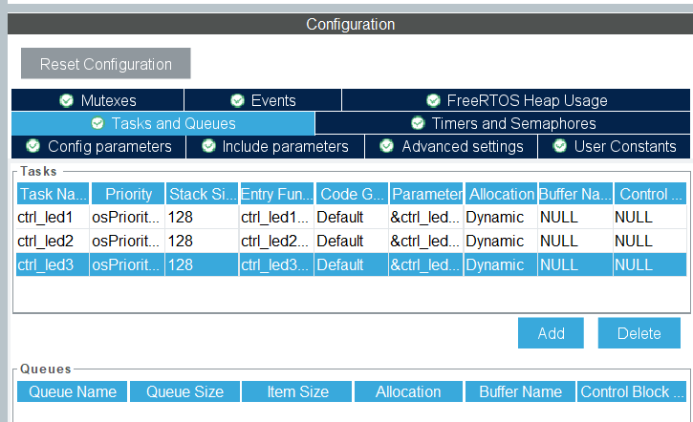

* Create Mutex:

**Debug with SWV to test this program**

More detail at README.md

