**Desription:**

* Toggle led by pressing button.

**Config:**

* In main.c:

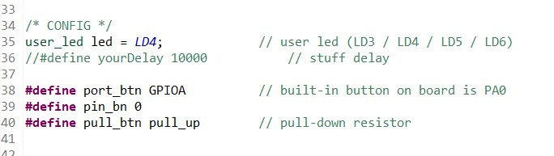

* + choose any user led from LD3 -> LD6
  + choose port, pin for your button (e.g. I use built-in button) and select pull up/down
* In Led.h:

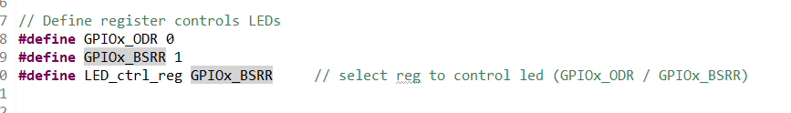

* + choose ODR or BSRR register to set bit for control led