**Desription:**

* Display data on LCD 20x4.
* Use I2C protocol.

**Config:**

* I2C1 setting:

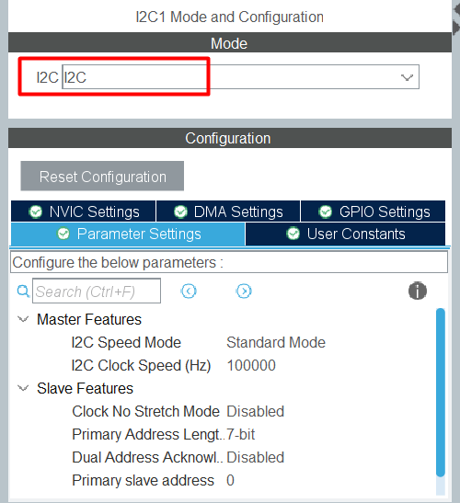

**Connection:**

* Connect I2C module to MCU as below:

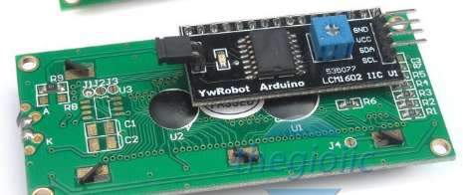

+ PB7 (I2C1 SDA) connects SDA pin

+ PB6 (I2C1 SCL) connects SCL pin

+ 5V connects VCC pin

+ GND connects GND pin