**Desription:**

* Press button to toggle led.

**Config:**

* Use user LD3 connected to the I/O PD13 of the STM32F407VGT6.

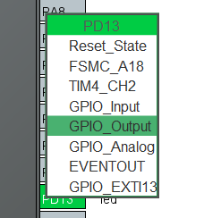

* Use user button connected to the I/O PA0 of the STM32F407VG (external interrupt).

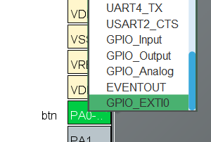

* Enable external interrupt for PA0

