**Desription:**

* Once reset MCU, then press button, led will be ON.
* After about 5s (config timeout as below), MCU resets and led will be OFF.

**How to calculate timeout:**

timeout = prescaler * reload value / frequency of LSI clock

**Config:**

For example, timeout = 256 * 625 / 32000 = 5s

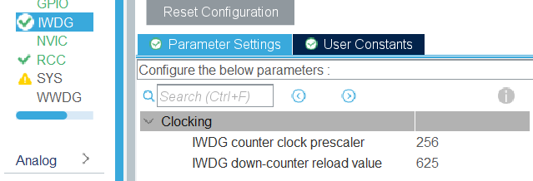

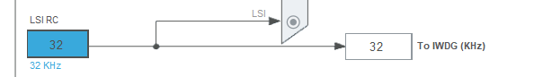

**Reference:**

[**https://tapit.vn/su-dung-watchdog-timer-tren-mcu-stm32f103c8t6/#google_vignette**](https://tapit.vn/su-dung-watchdog-timer-tren-mcu-stm32f103c8t6/#google_vignette)