**Desription:**

* Toggle led by pressing button.

**Config:**

* Use user LD3 connected to the I/O PD13 of the STM32F407VGT6.

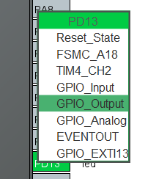

* Use user and wake-up button connected to the I/O PA0 of the STM32F407VG.

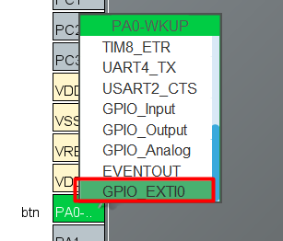

* Config external interrupt

