**Desription:**

* Blinking led using timer.

**Formula:**

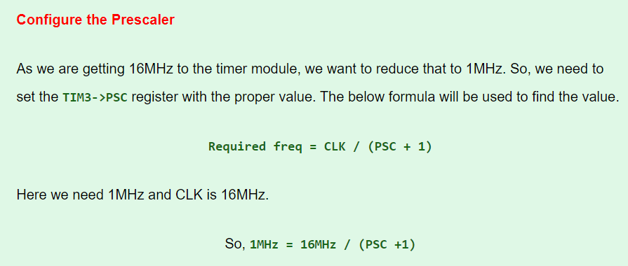

**Config:**

In main.c:

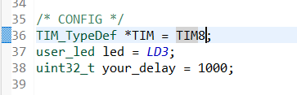

* you can select any timer from TIM1 -> TIM14
* choose any user led from LD3 -> LD6
* config your period for blinking (<= auto-reload value)

**Reference**

<https://embetronicx.com/tutorials/microcontrollers/stm32/simple-stm32-timer-tutorial-bare-metal-with-registers/>