**Desription:**

* Display date and real time from previous operation on LCD.
* Turn on led to alarm when clock reaches to threshold.

**Config:**

* Use user LD3 connected to the I/O PD13 of the STM32F407VGT6.

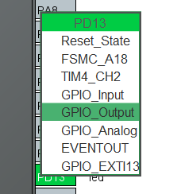

* Set clock for RTC:

* Activate RTC:

* Set initial date, time and alarm time:

* Enable interrupt for RTC alarm:

* Activate I2C1 for communication to LCD:

**Connection:**

* Connect I2C module to MCU as below:

+ PB7 (I2C1 SDA) connects SDA pin

+ PB6 (I2C1 SCL) connects SCL pin

+ 5V connects VCC pin

+ GND connects GND pin