**Desription:**

* Blink led periodically by applying upcounting and interrupt mode.

**Config:**

* Use user LD3 connected to the I/O PD13 of the STM32F407VGT6.

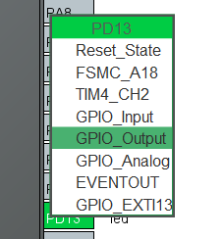

* Config for timer1, explain more details as below:

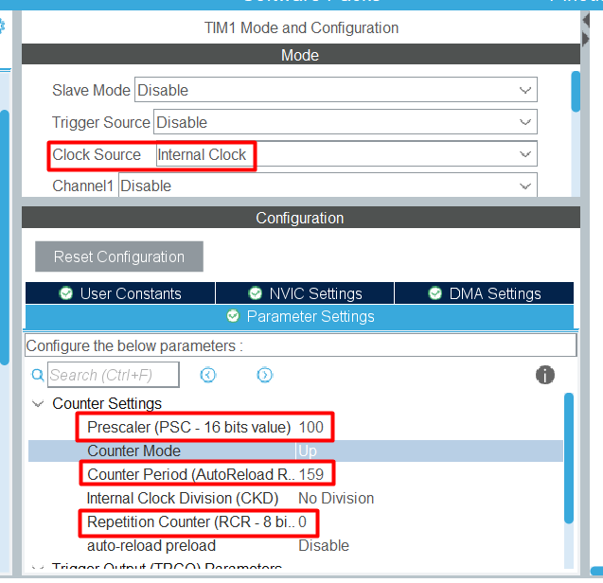

* Background: the update event is generated after upcounting is repeated for the number of times programmed in the repetition counter register plus one (RCR+1). At here, I config **repetition counter is 0**, this means update event is generated once upcounting counter overflow (after 1 upcounting overflow, 1 update event is generated).

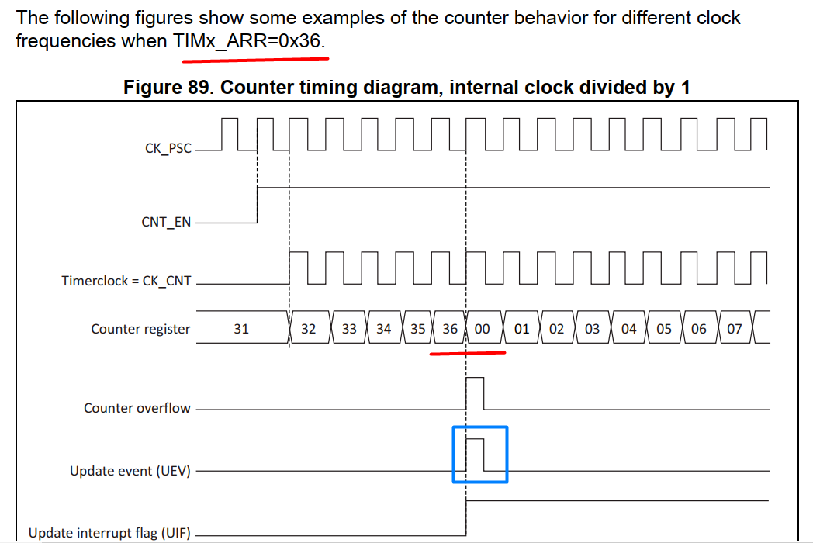

* First, we calculate frequency of timer clock (frequency of **peripheral clock** divided by **prescaler**). Then, inverse this value is period of 1 pulse timer clock. Finally, multiply this value to total pulse clock (from 0 to **ARR** value) before 1 upcounting overflow. So, I apply formulas as below:

**Update event period** = (1 / $\frac{Peripheral clock}{Prescaler}$) * (Auto reload value + 1)

* Because timer1 uses APB2 bus, take note frequency as below (**Peripheral clock = 16,000,000**):

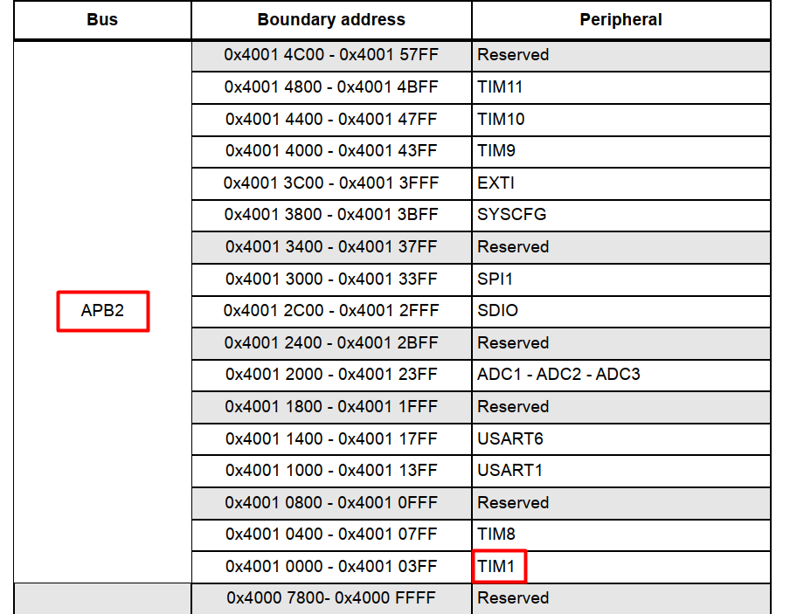

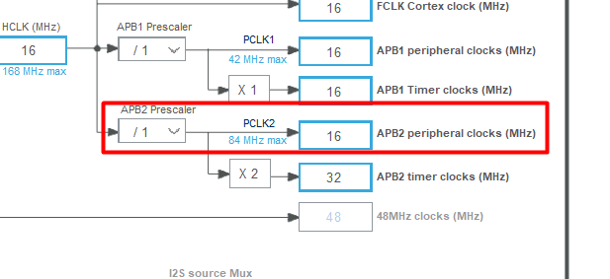

* I want to set interrupt event with period elapsed is 1ms (**Update Event period = 0.001**)
* PSC is **100** and ARR is **159**
* Enable interrupt for timer1:

