**Desription:**

* Blinking led periodically.

**Config:**

* In main.c:

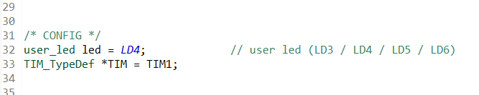

* + choose any user led from LD3 -> LD6
  + choose any timers from TIM1->TIM14
* In Led.h:

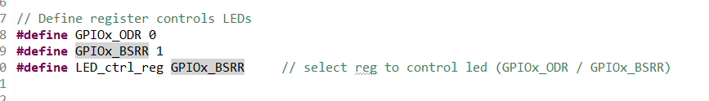

* + choose ODR or BSRR register to set bit for control led