**Desription:**

* Read command from user and return correspondig code.

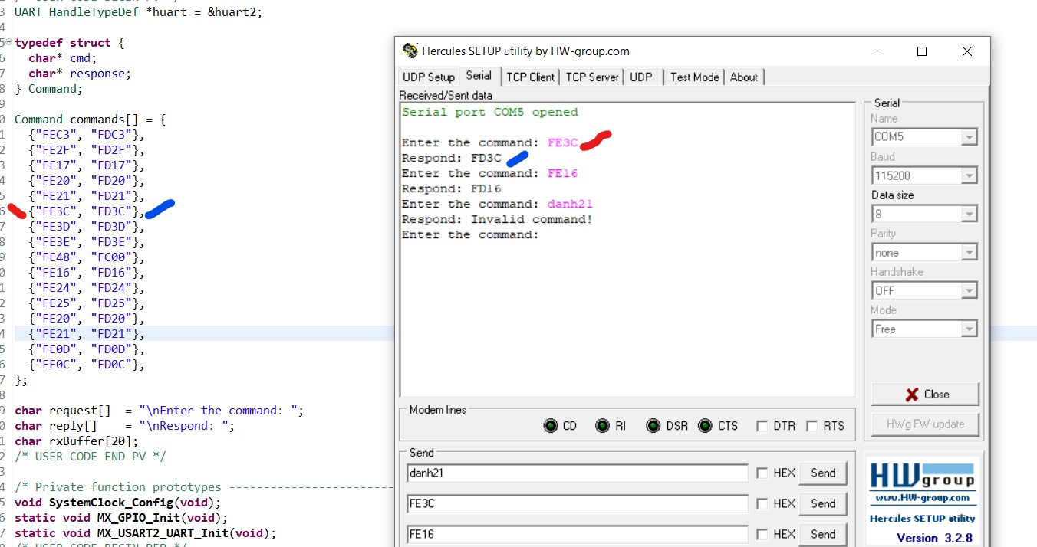

* Use UART protocol.

**Config:**

* USART2 setting:

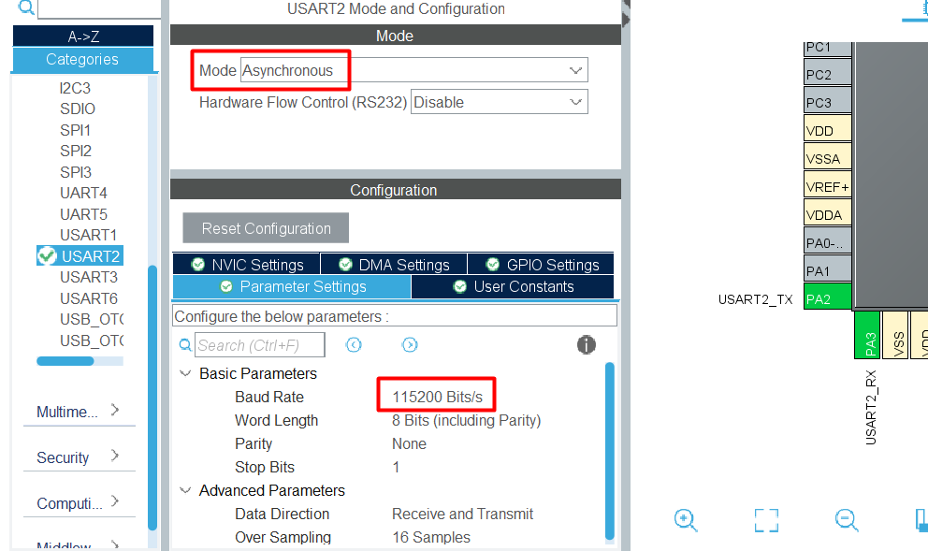

**Connection:**

* Connect UART to MCU as below:

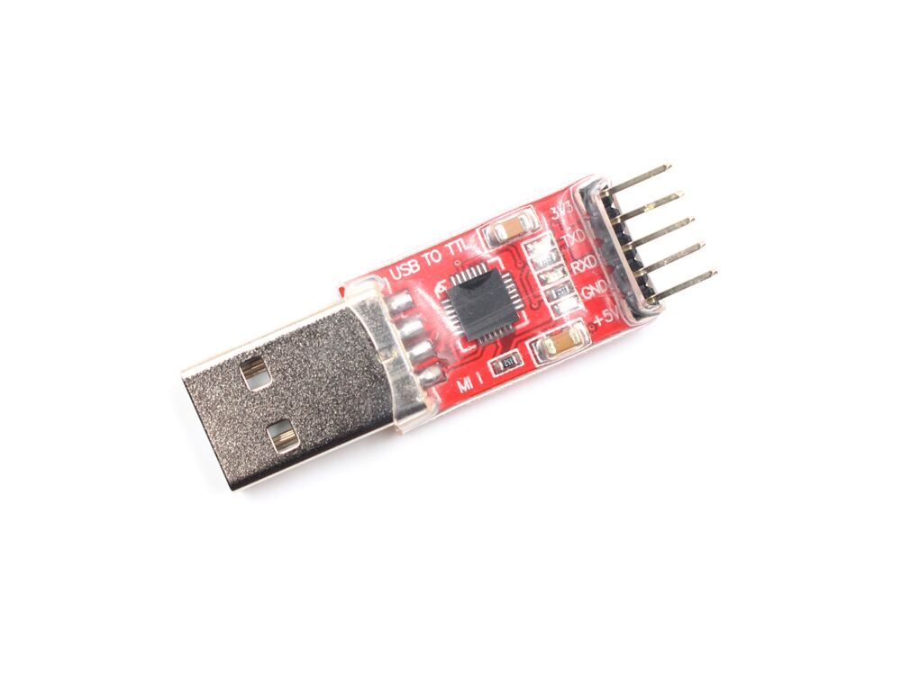



PA2

+ PA2 (USART2 TX) connects RXD of USB

+ USB connects PC

* Config Hercules:

+ Check serial port

+ Specify baud rate

