**Desription:**

* Print data to Hercules by UART.

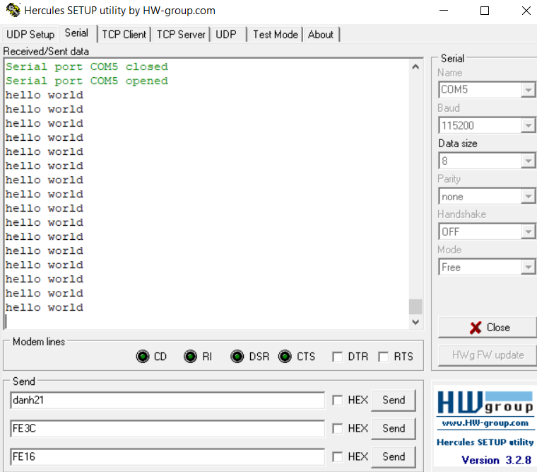

**Config:**

* Config your USART and TIM:

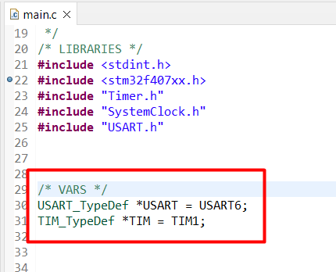

* Select any timer from TIM1 -> TIM14
* Select any USART (USART1/2/3/6 , UART4/5)
  + USART1_TX – PB6
  + USART2_TX – PD5
  + USART3_TX – PD8
  + UART4_TX – PC10
  + UART5_TX – PC12
  + USART6_TX – PC6

**Connection:**

* Connect UART to MCU as below:

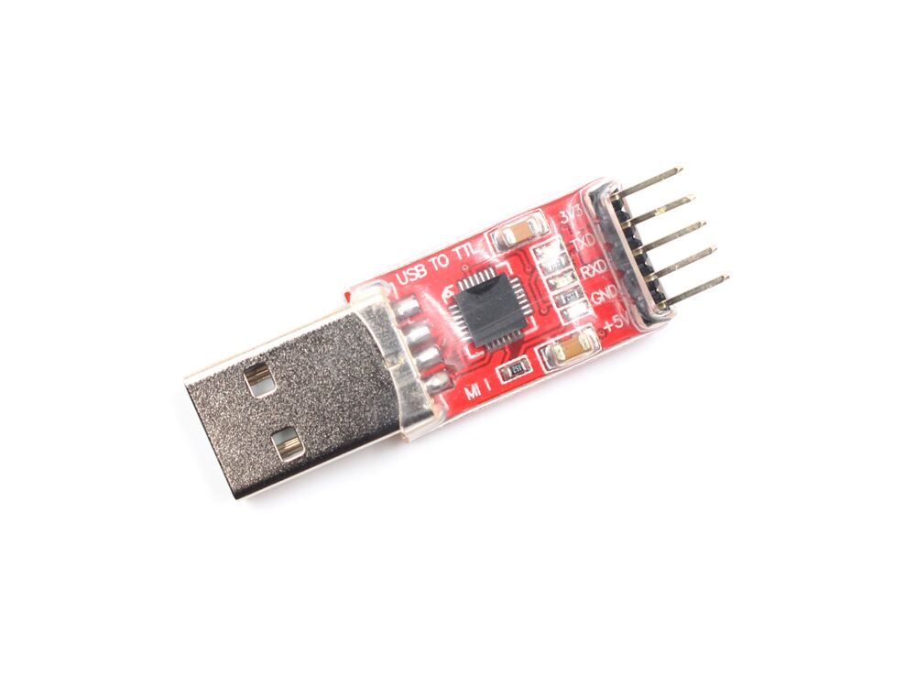



PC6

+ PC6 (USART6_TX) connects RXD of USB

+ USB connects PC

* Config Hercules:

+ Check serial port (e.g. COM5)

+ Specify baud rate to 115200