**Desription:**

* We have threshold as timeout window: (Tmin – Tmax)
* If refresh WWDG in range of above threshold, MCU doesn’t reset, led keeps ON. Otherwise, MCU resets and blinking led

**Formulas:**

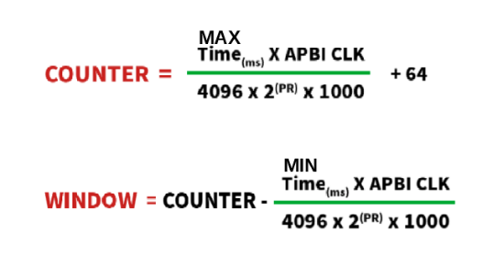

**Config:**

* Select prescaler, Tmax (max time) and Tmin (min time) first.

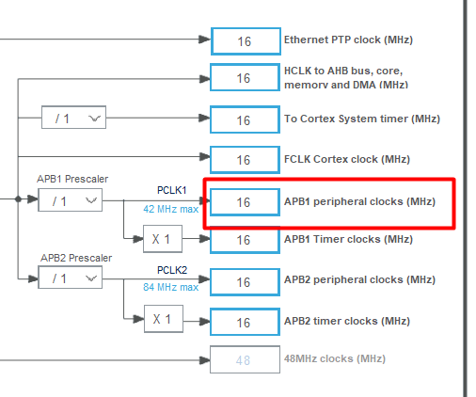

* Counter = $\frac{45 * 16,000,000}{4096 * 8 * 1000}+64$ = 85.97
* Window = 85.97 - $\frac{35 * 16,000,000}{4096 * 8 * 1000}$ = 68.88

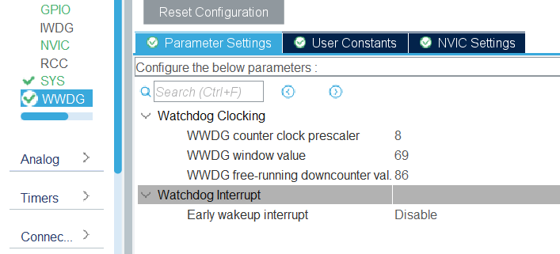

**Note:**

* WWDG is initialized after startup code related to led

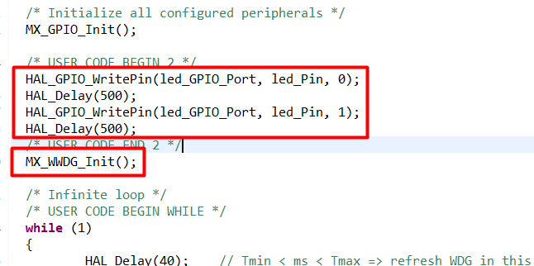

**Reference:**

[**https://controllerstech.com/iwdg-and-wwdg-in-stm32/#google_vignette**](https://controllerstech.com/iwdg-and-wwdg-in-stm32/#google_vignette)