**SCORE**

|  |  |  |  |
| --- | --- | --- | --- |
| CRITERIA | CONTENT | PRESENT | TOTAL |
| SCORE |  |  |  |

ASSESSMENT OF THE TEACHERS:

………………………………………………………………………………………………………………………………………………………………………………………………………………………………………………………………………………………………………………………………………………………………………………………………………………………………………………………………………………………………………………………………………………………………………………………………………………………………………………………………………………………………………………………………………………………………………………………………………………………………………………………………………………………………

………………………………………………………………………………………………

………………………………………………………………………………………………

………………………………………………………………………………………………

………………………………………………………………………………………………

………………………………………………………………………………………………

………………………………………………………………………………………………

***Actknowledgement***

*We would like to sincerely thank the High Quality Training Department, Ho Chi Minh City University of Technical Education for creating favorable conditions for us to study and complete this project.*

*We would like to express our deep gratitude to Lectur er (Dr) Huynh Xuan Phung for giving us wholehearted guidance and guidance during the implementation process.*

*We would like to thank the attention and help of friends during the implementation.*

*Although I have tried to complete the project within the scope and ability to allow but certainly inevitable shortcomings.*

*We hope to receive the sympathy, suggestions and devoted guidance of teachers and friends.*

TP.HCM, ngày 23 tháng 06 năm 2020

Nhóm sinh viên thực hiện

Phạm Quang Danh-18110004

Huỳnh Văn Hạnh -18110012

**Table of Contents:**

# **Chapter 1: Program Overview……………………………………**

## General Introduction

## Software specification

# **Chapter 2: Plan……………………………………………………**

## Subdivision at work:

# **Chapter 3: Software Design………………………………………**

## Algorithm

## Design Class

# **Chapter 4: Install and Test…………………………………………**

# **Chapter 5: Conclusion and Development…………………………**

Reference Material

## **Chapter 1 : Program Overview**

1. *Genneral Introduction*

Request: Manage readable document (like Kinlde)

* Manage readable document : include all of document that can read like : word(.doc), pdf (.pdf),…

Analysis : Creat database to save information and use control datagridview on winform to show data for user, use Richtextbox and Itext Sharp to read word and pdf file…

1. *Software Specfication*

* Program help open and read document. In addition, user can manage document through a collection with some features : add, edit, delete, note,..
* Input : File Document (link, ID user, name ,..)
* Output : List of information about documents which is opened by user.
* Requested by the proposed project.
* Adopt object Oriented programming and new software technologies.
* Lightweight software, stable running.
* Tool and Technology used:

Entity framework

Visual studio 2019 (.NET framework)

Microsoft SQL server management studio 18

**Chapter 2 : Plan**

1. *Subdivision at work*

|  |  |  |  |
| --- | --- | --- | --- |
| ID | Student name | Desciption work | % Contribute |
| 18110004 | Phạm Quang Danh | -Design Program  -Write code  -Design 3 layer model  -Design and connect to database | 60% |
| 18110012 | Huỳnh Văn Hạnh | -Design user interface,form  -Design database  -Make report | 40% |

**Chapter 3 : Software Design**

**How to do :**

Need to solve 2 importance problem :

*First* : How to show a document on form

Solution : use Open File Dialog to open document and get link, use richtextbox to show the content of that file.

*Second* : Save and change information from form to database and upload data to form.

Solution : use SQL server 2019 to save information of user and document, use entityframework query to load data rom database to form and use datagridview to show data.

**Design :**

|  |  |  |  |
| --- | --- | --- | --- |
| **STT** | **Name** | **Code** | **Function** |
| **1** | **Controllers** | | |
|  |  | 1.void addDoc(string filename, string link)  2.void Edit(int i, string s1, string s2, int s3)  3.void delete(int ID1)  4.DataTable laybang(string caulenh) | Make changes while in use, update to the Database and then bring data are changed back to Datagridview. |
| **2** | **Models** | | |
|  | Documents | namespace Manage_Document  {  using System;  using System.Collections.Generic;    public partial class Document  {  public int ID { get; set; }  public string Ten { get; set; }  public string LinkImage { get; set; }  public string Link { get; set; }  public Nullable<int> IsRead { get; set; }  }  } | Basic information of a document |
| 3 | **Views** | | |
|  | frmHomePage |  |  |
| 1 | btnBrowse |  | Choose the file can read on your computer.When you click OK this button will save it to your library of this app after that save filename and link of this document to database. |
| 2 | BtnRefresh |  | When you click on Refresh, this button will load all data from database and upload to datagridview of your library |
| 3 | btnLoad |  | This button will load all file you have read before |
| 4 | btnSearch |  | Search in Library and show on Search view |
|  | frmDetails |  | This form will show all properties of your file |
| 1 | btnOpenFile |  | This button will open the document through link which get from datagridview |
| 2 | btnDelete |  | This button will delete the row selected on datagridview |
| 3 | btnUpdate |  | This button will update all change about this file include : name and pictureNote |
| 4 | btnClearNote |  | This button will delete the old bitmapNote and show while note |
|  |  |  |  |

**Method:**

|  |  |  |  |
| --- | --- | --- | --- |
| STT | Name | Code | Function |
| 1 | AddDoc |  | This method used to add new document to Document table in database |
| 2 | Edit |  | Method used to edit properties of this file in datebase |
| 3 | Delete |  | Method to delete data in both of database and datasource of listview |
| 4 | laybang |  | This method used to search data from database and show it |

**Design Database:**

|  |  |  |
| --- | --- | --- |
| **TT** | **Name of Table** | **Purpose** |
| 1 | Document | Save information of file which is opened by user |

|  |  |  |  |
| --- | --- | --- | --- |
| **TT** | **Field** | **Type** | **Purpose** |
| 1 | ID | Int | Save ID |
| 2 | Ten | Nvarchar(100) | Save name of document |
| 3 | LinkImage | Nvarchar(100) | Save link of bitmapnote in picture box |
| 4 | Link | Nvarchar(100) | Save link of document |
| 5 | IsRead | Int | Check :Are user read this file or not? |

Document table :

**Design Interface:**

Form for contact with user

User can add file from their computer and save on this app. They can search what they save and know what they read.

Form to show all detail of one file like: Name , Link , ID , Note

User can Open file to read and change Name and Note of this file or delete file.

**Chapter 4 : Test**

Form main of this program

Left side is all document user have added to their library

Right side is all file what user open to read or list of user search

### 1.Test Function add : we have 2 new document are added

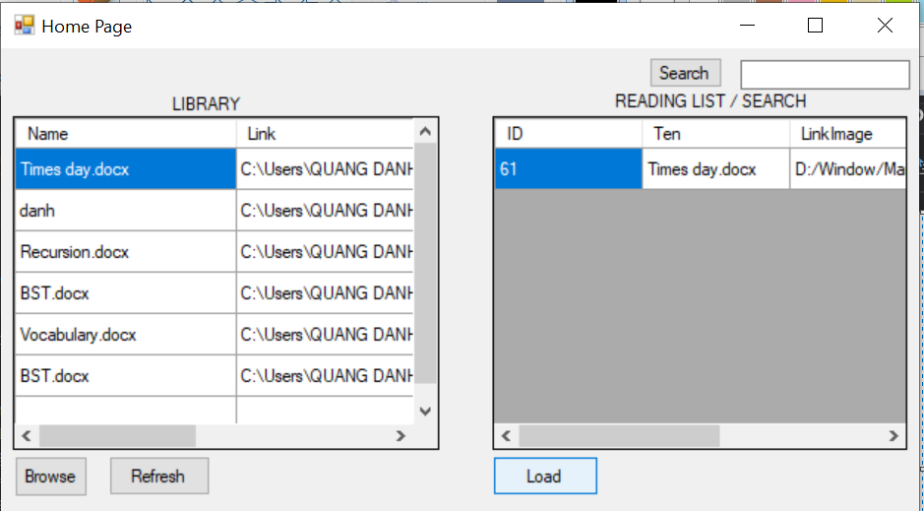

### 2.Test Function Delete : We can see Document Vocabulary.docx is deleted

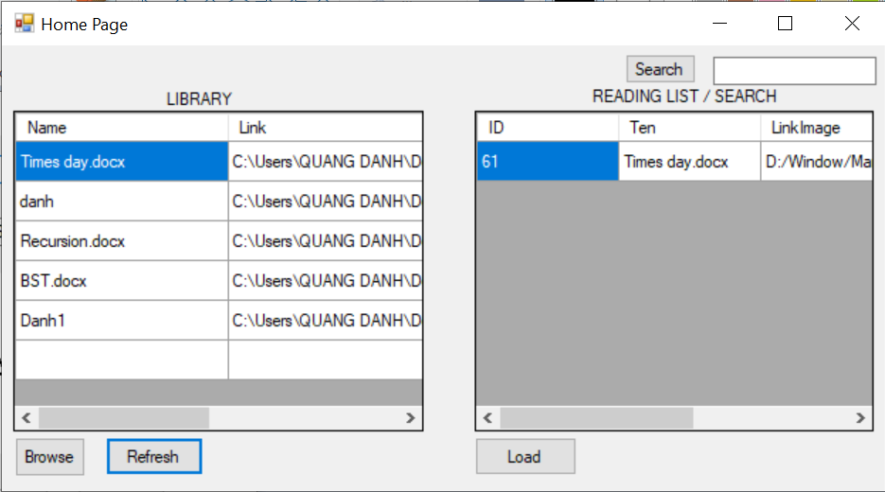

### 3.Test Function Update : Name of document BST are changed to Danh1 and this file have some Note

### 5.Test Function Search : We can see when user search letter “s” in Search textbox, all document have letter “s” are displayed.

**Chapter 5 : Development**

* Improve the interface.
* Can add user and save document of each user.
* Can open many type of document: .pdf , .txt, …..
* Can edit the content of document.
* Develop the program similar to the Kindle of Amazon

Reference Material

[1]Entity Framework (Microsoft) <https://docs.microsoft.com/en-us/ef/>

[2] C#: Learn C# in One Day and Learn It Well. C# for Beginners with Hands-on Project. (Learn Coding Fast with Hands-On Project Book 3) Kindle Edition by Jamin Chan <https://www.amazon.com/Beginners-Hands-Project-Coding-Project-ebook/dp/B016Z18MLG>

[3]C# 8.0 and NET.Core 3.0 – Modern Cross Platform Development Fourth Edition(2019).pdf

[4] Documentation windown forms’ on Website Microsoft <https://docs.microsoft.com/en-us/dotnet/framework/winforms/>