1 Move Jars to ResSim program jar/ext directory. There are now additional dependencies, and the FIRO_TSEnsemble library has been updated to an official Version 1.

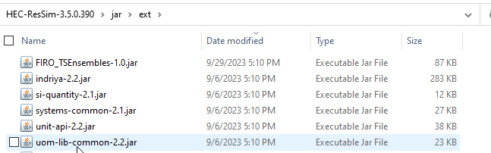

2 copy “HEC-ResSim.config” and rename to “HEC-ResSimHeadless.config”

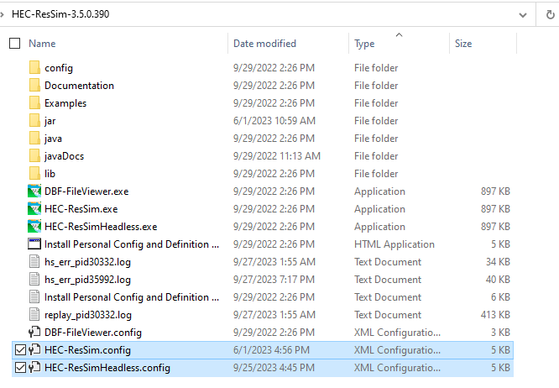

3 change mainclass on line 24 to “hec.rss.server.RssRMIServer”

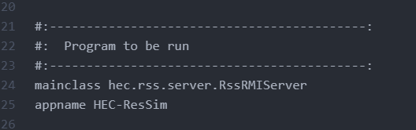

4 copy “HEC-ResSim.exe” and rename to “HEC-ResSimHeadless.exe”

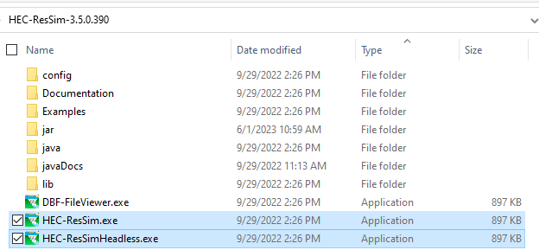

5 edit EnsembleMemberShuffle.bat

* Point at correct location of ResSim program
* Call “HecResSimHeadless.exe” before python script.

General Notes:

1. SQLITE dbs now have regulated hindcasts from FOLSOM-POOL FLOW-IN. Previously was FOLSOM FLOW-IN.
2. SqliteDBs now live in “models/R703F3_SOU_RR_20230717/shared/EMS_DBs” – I have updated the model to look in the correct location
3. Hardcoded “200,250,300,350,400,450,500” in the ensemble tab in the alternative editor
4. SQLITE databases now have a location name of “FOLSOM-POOL”
5. Updated all state variables to look for databases in the correct location
6. Limited randomization dates to ranges specified in action plan
7. Set up script to process 3-realizaions and 500-shuffles for each pattern-aep combination
8. Updated headless script to use HEC-ResSim server. See method “configureResSim” in jython script.