Isabella WCM Update Forecast Generation Vignette

Daniel Hamill

January 12, 2022

Table of Contents

Isabella Forecast Structure 1

Data Transformation 2

Forecasts 2

Errors 5

Forecast Generation Procedure 8

## Isabella Forecast Structure

The structure of the “official” B120 forecasts for Isabella Lake is shown in @fig:fig1. The term “offical” is used to qualify the forecasts provided each water year beginning of each month from February through May. There are “unoffical” forecasts that are issued mid-month or later in the snowmelt season if applicable for the water year (WY). The B120 forecasts for Isabella lake phycically represent snowpack in the headwaters and are produced using a multiple linear regression model. The city of Bakersfield has models for dry, normal, and wet water years. There have not been any significant changes in forecast methodology betweeen 1976 and present and are concidered having similar quality/accuracy.

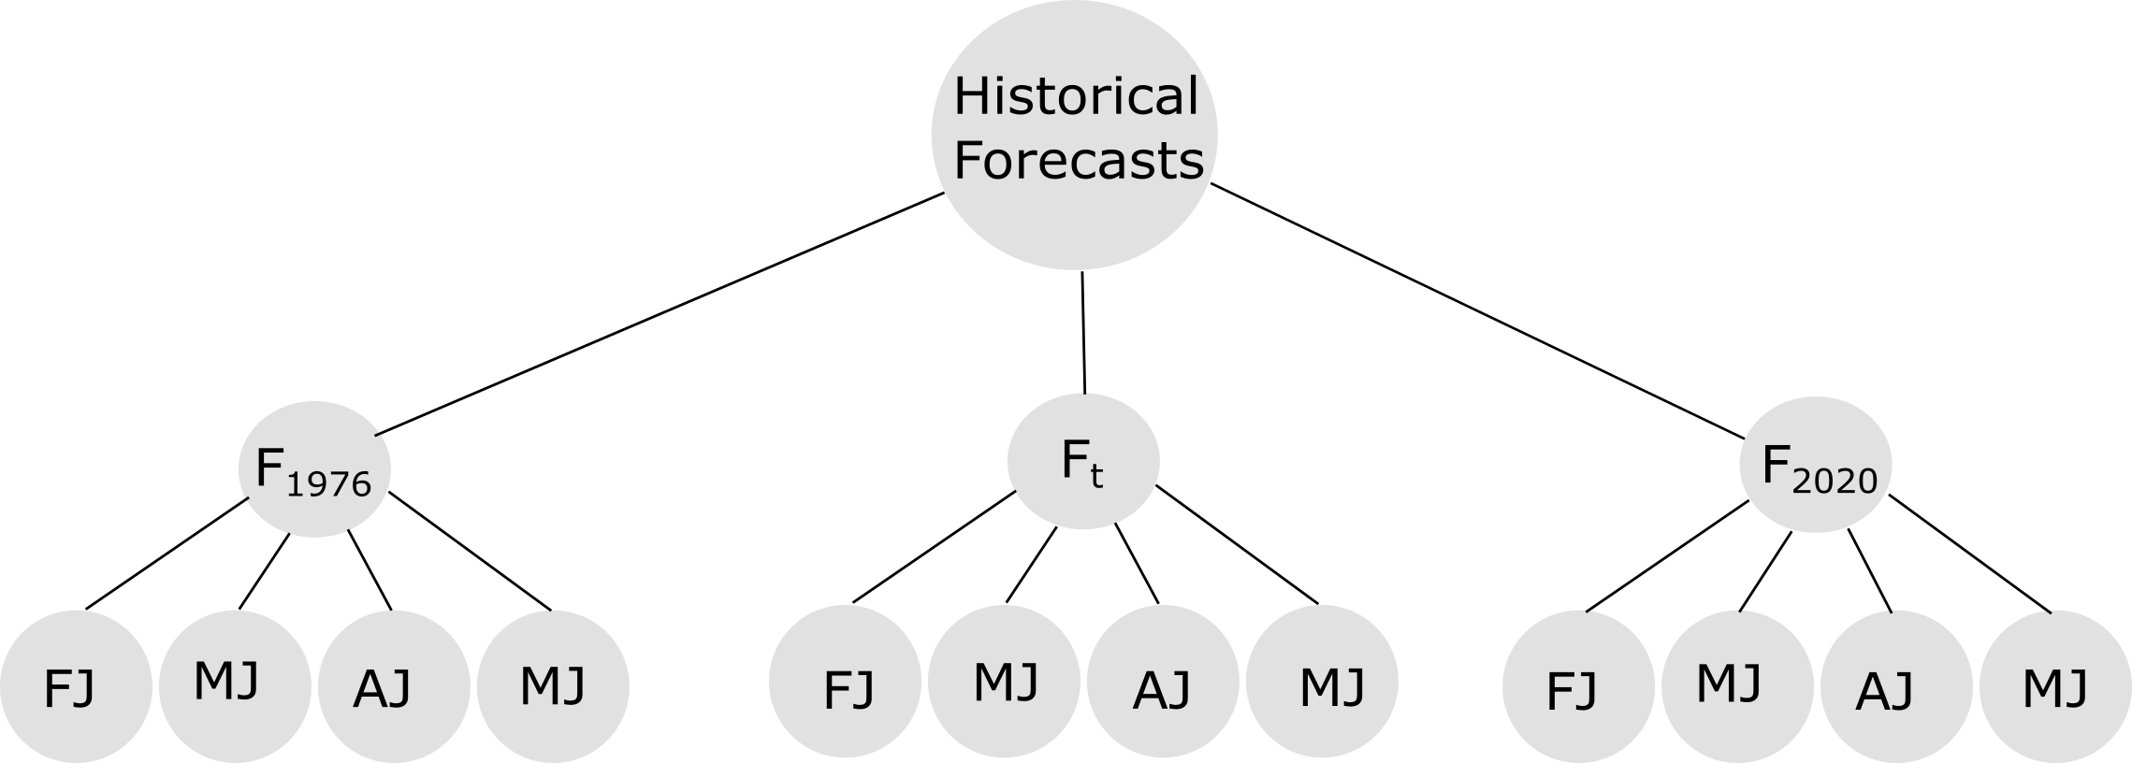

The Structure of B120 Forecasts for Isabella Dam

The historical forecasts from WY 1976 to WY 2020 are included in this analysis.The forecast for a water year () is described as a sequence month-to-July runoff projections for the calendar months (), February (), March (), April (), and May (). The forecast window gets successively smaller. A forecast has a 5-month forecast window (February - July), whereas a forcast window has a 4-month forecast window (March to July). The sequence of forecast volumes for a water year can be described in Equation @eq:eq1:

{#eq:eq1}

## Data Transformation

In this section we describe the data analysis required to model the forecasts at Isabella for synthetic events.

### Forecasts

A historical analysis of the month-to-July runoff volume forecast () found the errors have a positive skew. The distributions of the z-scores () of the untransformed (raw) month-to-July runoff volumes is shown below:

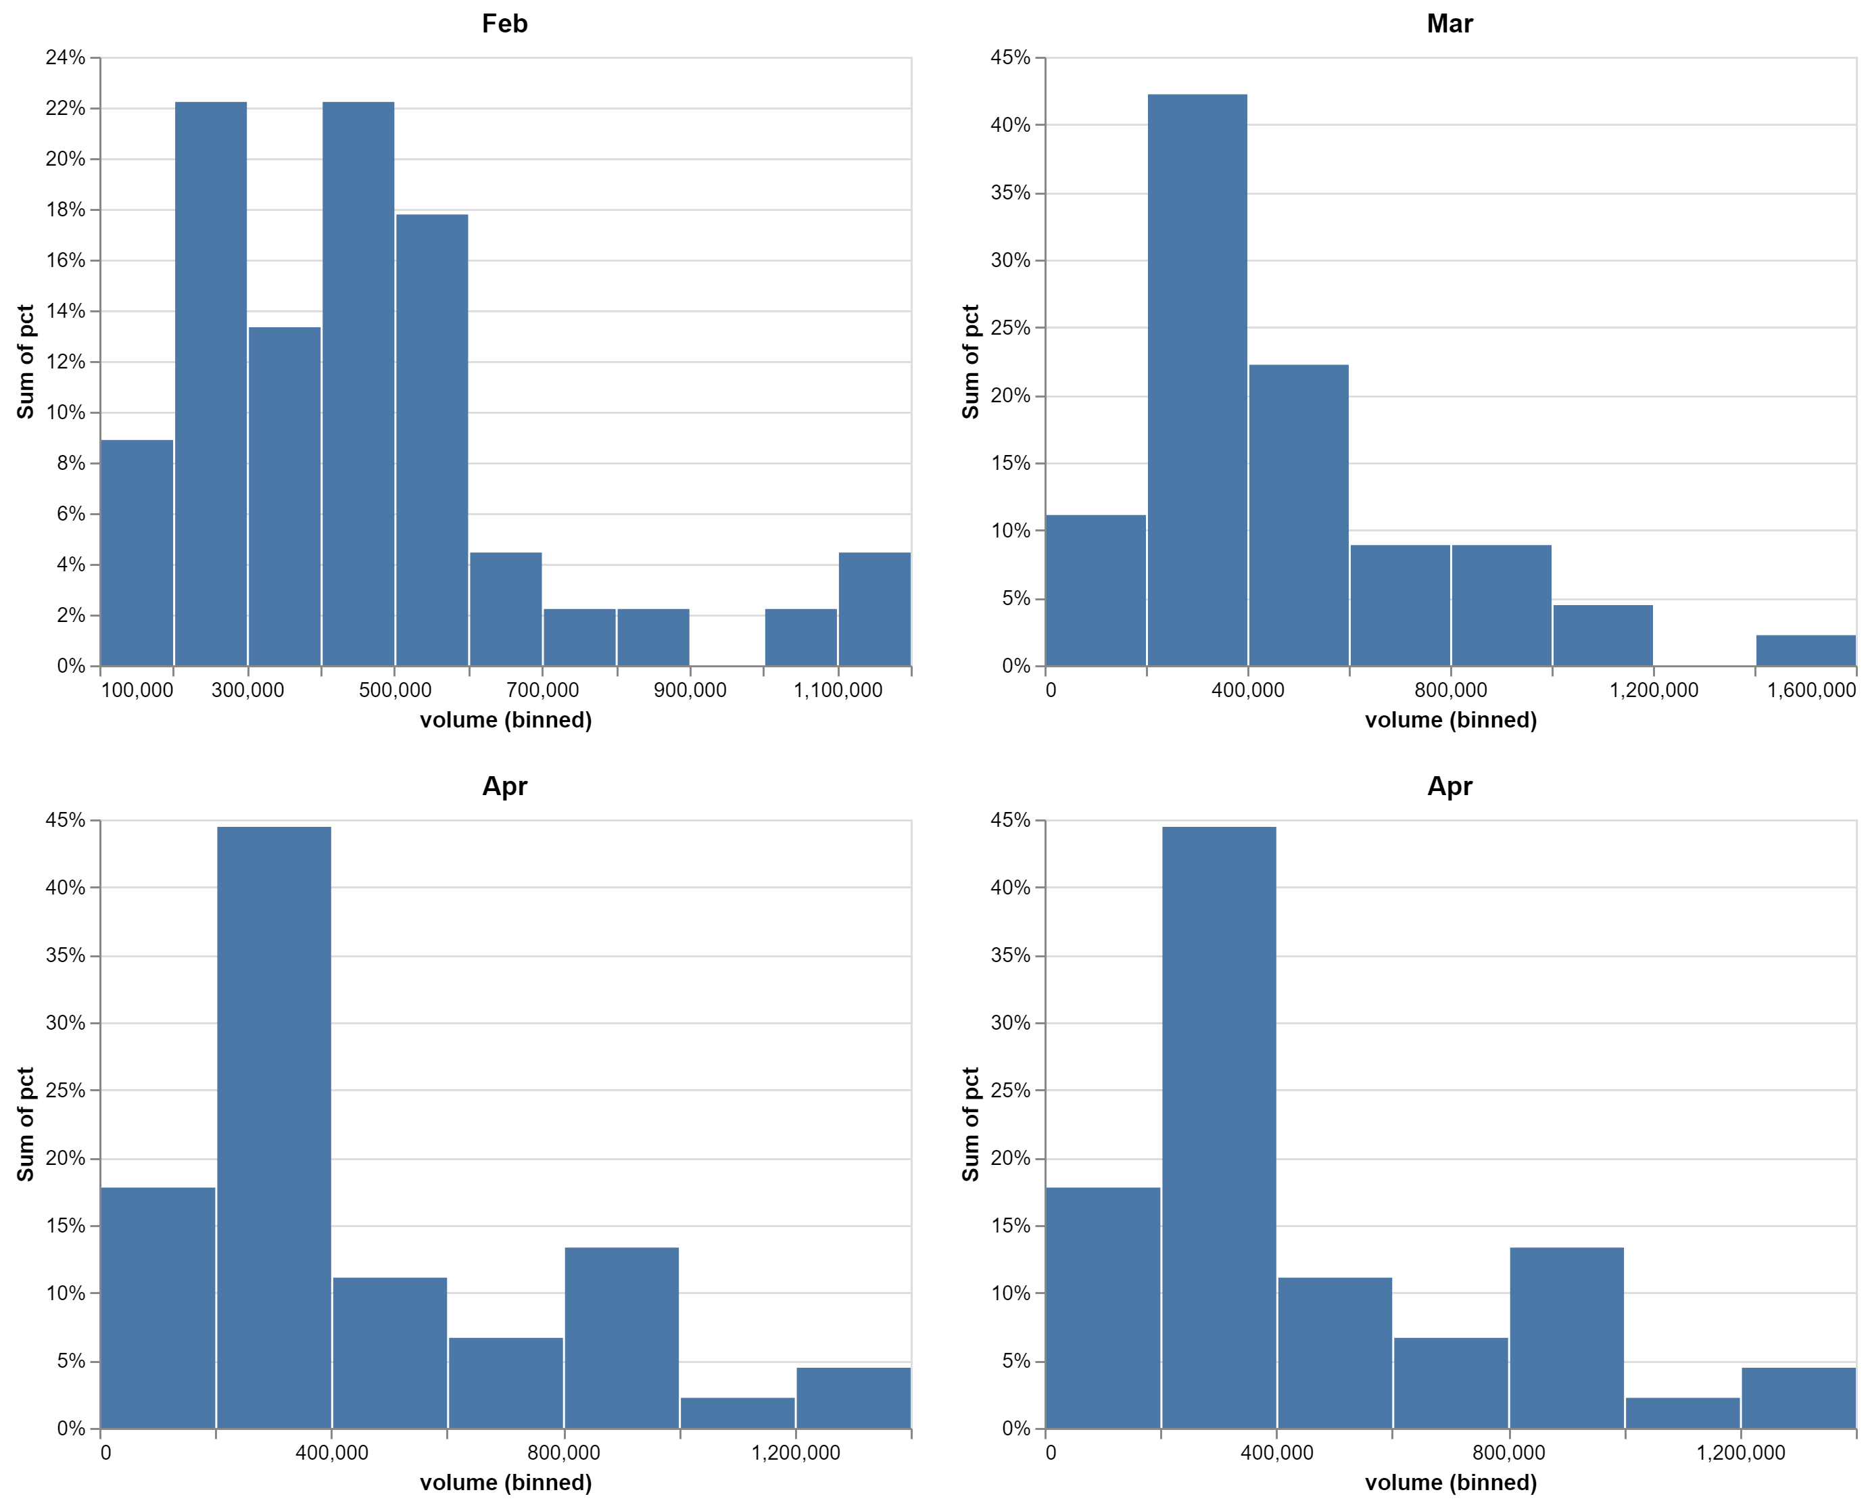

Isabella month-to-July inflow distributions.

From a computation perspective, it is desirable to model the forecast runoff volumes as normally distributed. The [Box Cox power transformation](https://en.wikipedia.org/wiki/Power_transform#Box%E2%80%93Cox_transformation) was evaluated to determine if the normal assumption could be used in this forecast generation model. The Box Cox transformation is a fitted model that varies by the model parameter . The model was fitted for each month-to-July using value obtained from maximum log-likelihood algorithm encoded within the python library [scipy](https://docs.scipy.org/doc/scipy/reference/reference/generated/scipy.stats.boxcox.html).

|  |  |
| --- | --- |
| Month-July |  |
| FebJ | -0.134082 |
| MarJ | -0.00535718 |
| AprJ | 0.0590321 |
| MayJ | 0.102959 |

[Probability plots](https://en.wikipedia.org/wiki/P%E2%80%93P_plot) of the untransformed (raw) and Box Cox transformed forecast runoff provide a graphical assessment of the empirical data and any proposed transformations. A probability plot consists of two series, 1) a cumulative distribution of specified theoretical distribution and 2) a cumulative distribution of the empirical data. The closer the data scale to following a 1:1 ratio, the closer the empirical data follow the specified theoretical distribution. For all month-to-July forecast windows, the Box-Cox transformed values more closely follow the line of perfect agreement with a theoretical normal distribution.

|  |  |
| --- | --- |
|  |  |
|  |  |

Probability plots showing how the raw (untransformed) and box cox transformed month-to-July volumes compare against a normal distribution.

The distribution of the Box Cox transformed z-values also appear more symmetrical (i.e., normal) than the untransformed (raw) runoff volumes shown above.

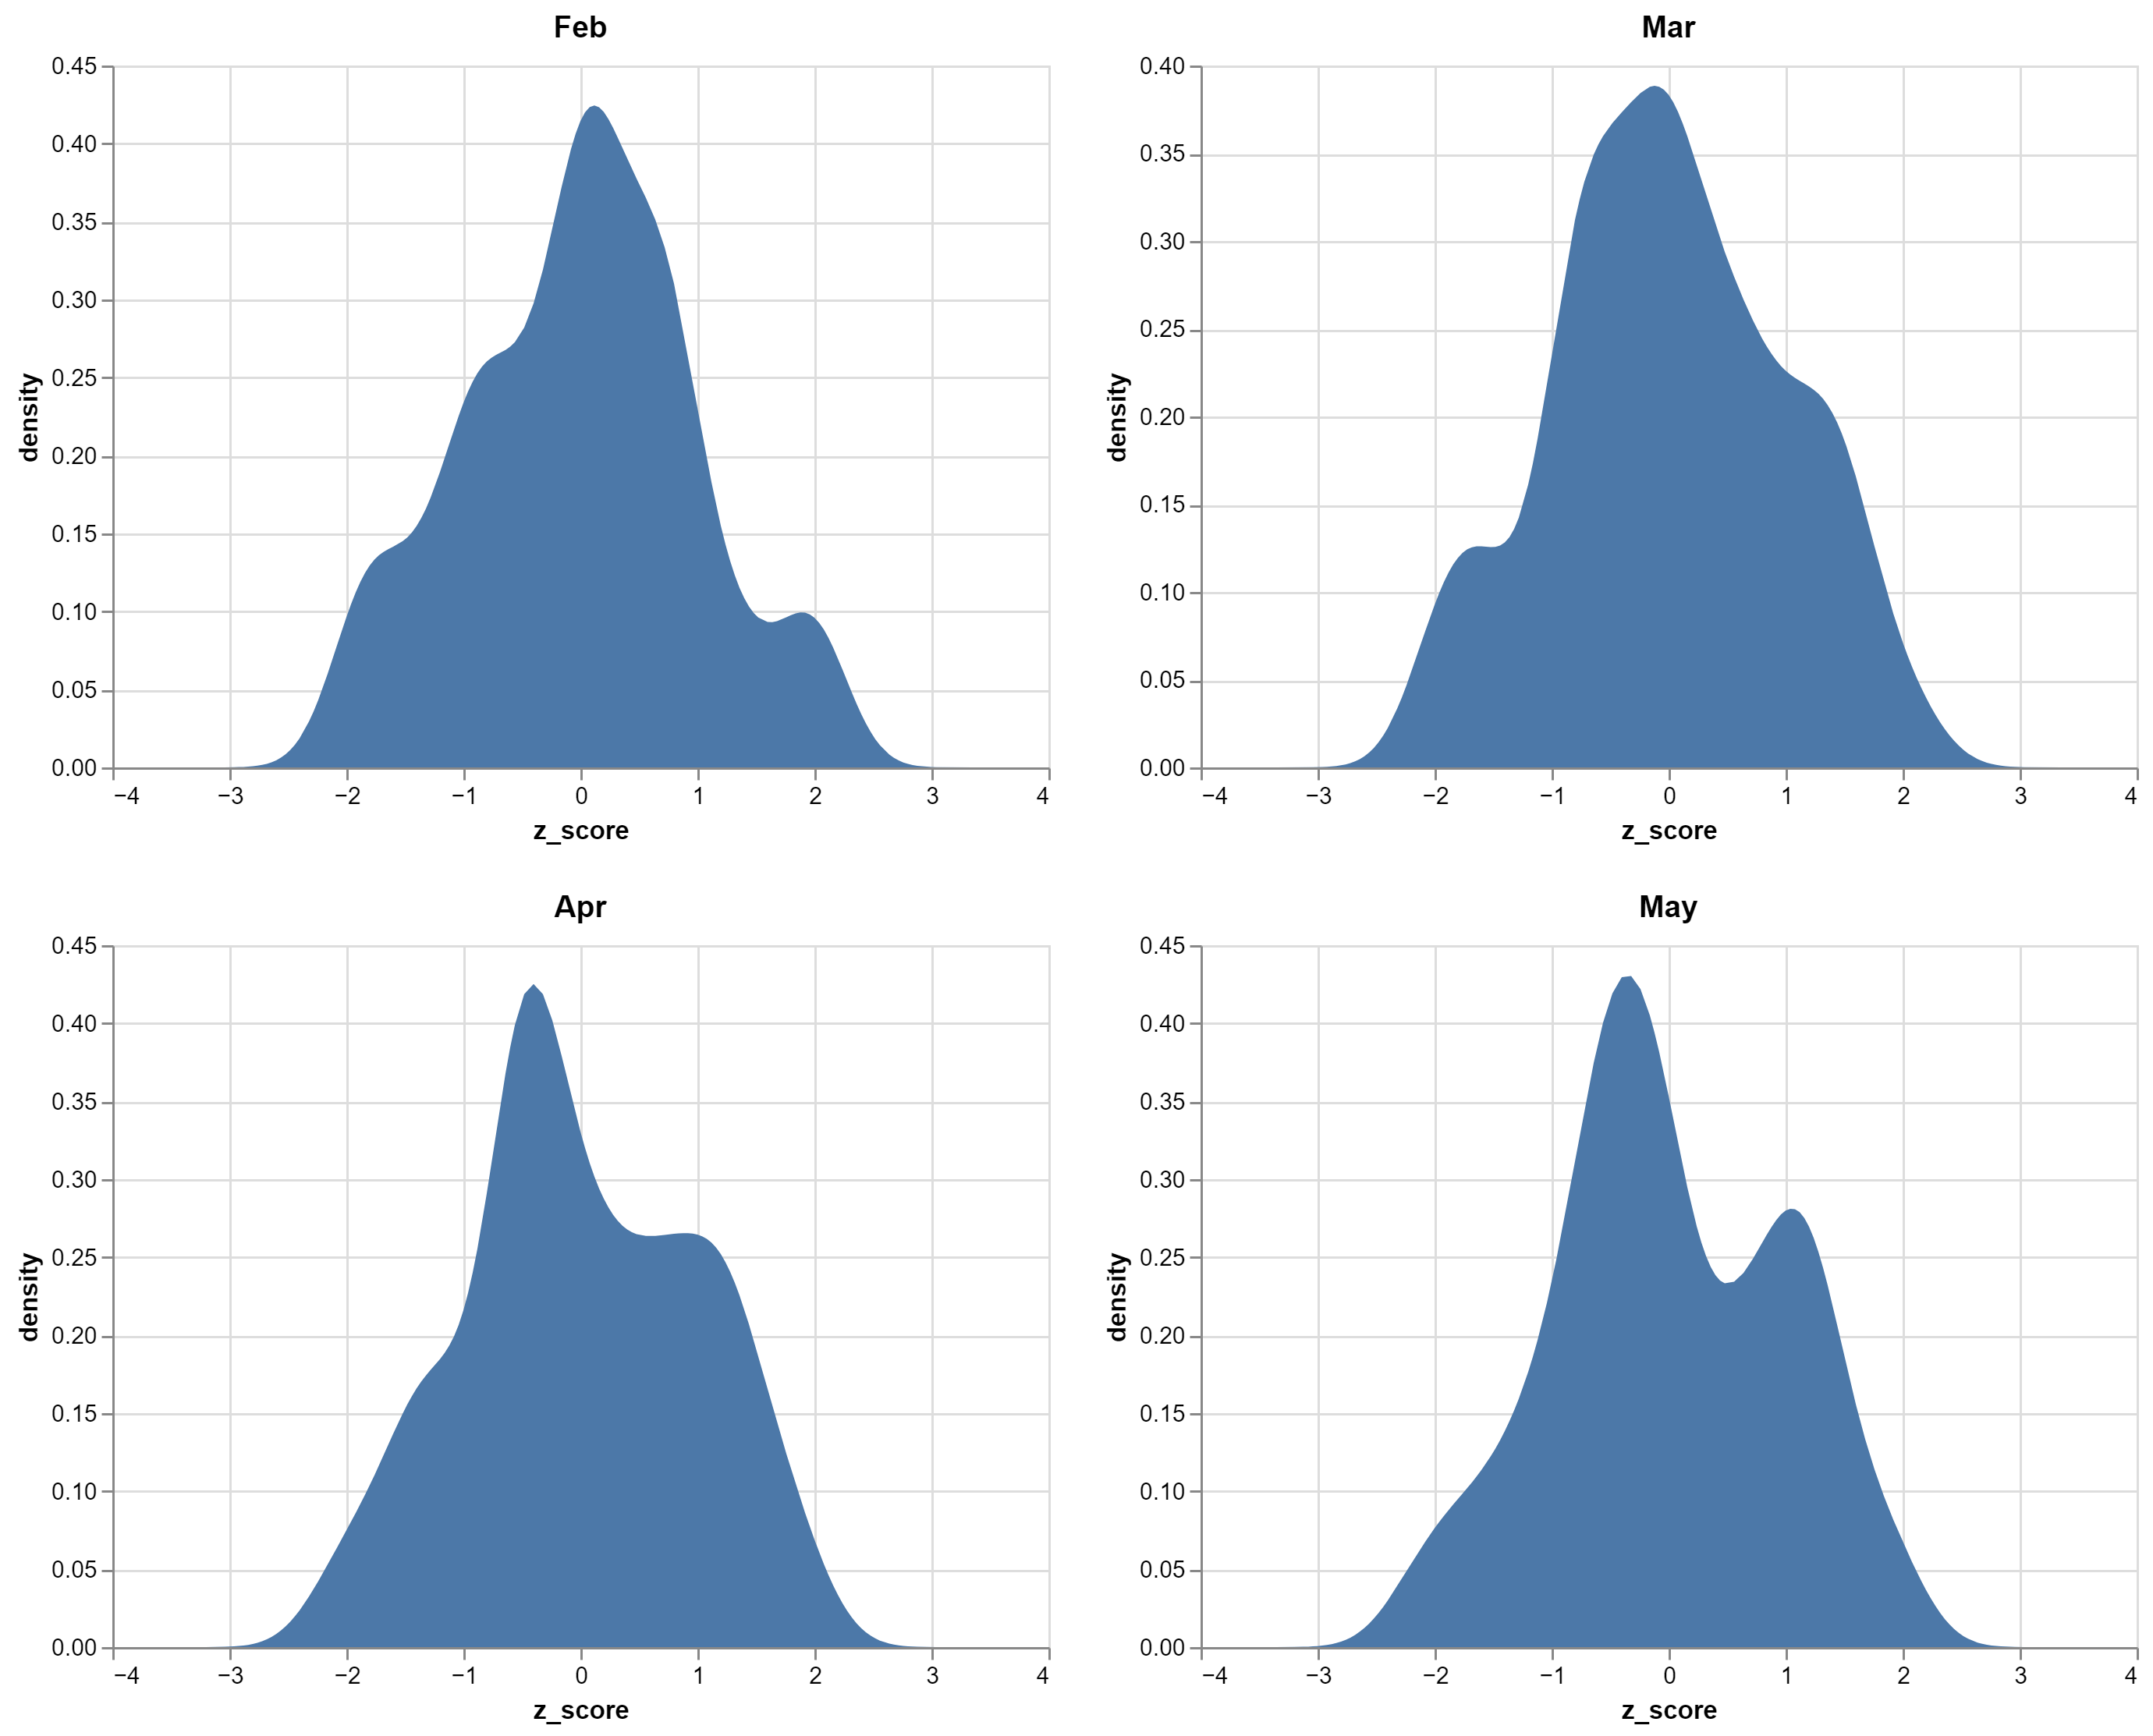

Isabella month-to-July box cox transformed distributions.

The statistical moments of the untransformed (raw) month-to-July and Box Cox transformed forecast runoff volumes are tabulated below.

|  |  |  |  |  |  |  |  |  |
| --- | --- | --- | --- | --- | --- | --- | --- | --- |
|  | BoxCox Kurtosis | Skew | Variance | Mean | Date2Volume Kurtosis | Skew | Variance | Mean |
| Feb | -0.431 | 0.009 | 0.008 | 6.131 | 1.718 | 1.375 | 5.49e+10 | 446422 |
| Mar | -0.613 | 0.001 | 0.352 | 12.415 | 0.981 | 1.214 | 8.96e+10 | 461422 |
| Apr | -0.744 | -0.011 | 2.584 | 19.007 | 0.543 | 1.132 | 1.05+11 | 440222 |
| May | -0.655 | -0.019 | 9.800 | 25.245 | 0.963 | 1.253 | 8.07e+10 | 342489 |

Notably, the Box Cox transformed data have skew values close to zero, which suggest the transformed data can be modeled using a normal distribution.

|  |  |  |
| --- | --- | --- |
| Dataset | Statistic | Value |
| boxcox | kurtosis | **-0.664** |
|  | skew | **-0.002** |
|  | variance | 2.55641 |
|  | mean | 14.262 |
| Date2Volume | kurtosis | 1.746 |
|  | skew | 1.404 |
|  | variance | 6.072e+10 |
|  | mean | 323663 |

### Errors

The actual month-to-July inflows provide a way to quantify the accuracty of the B120 forecasts for Isabella lake. The difference between the forecasted runoff volumes and the observed runoff volume () provides an estimate of forecast error (, Equation {@eq:eq2}).

{#eq:eq2}

Below is a density plot showing the bimodal distribution of the month-to-July forecast errors. The bimodal distribution is a result that some forecasts underpredict the actual ruoff volumes, while others can overpredict.

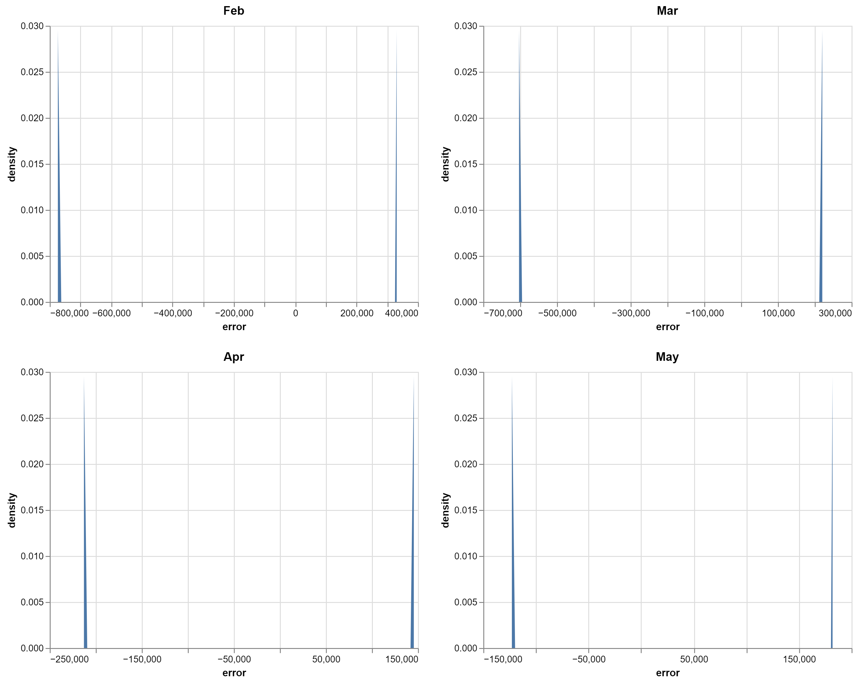

Disbturution of mont-to-July forecast volume errors.

A log-tranfrom of the month-to-July forecasat and actual volumes provides a way to normalize the volumes before the forecast error is calcualted. The difference between the log-transformed mont-to-July forecast volumes and log-transformed month-to-July actual volumes is termed and their desntisy are shown below.

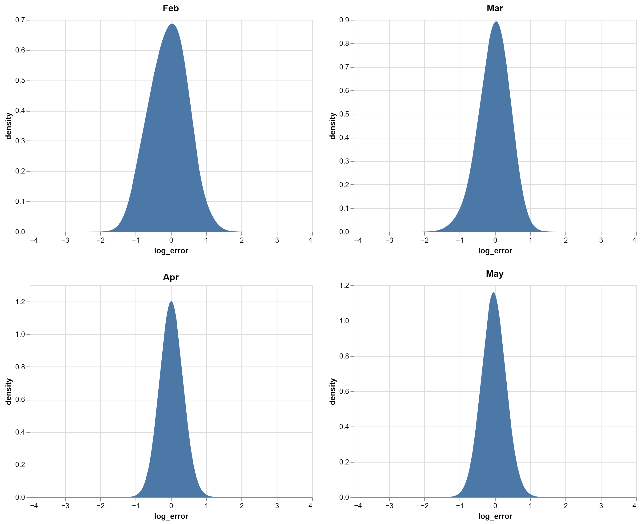

Distribution of month-to-July actual volume log-errors.

The statistical moments of the data for each month-to-July forecast window are tabulated below.

|  |  |  |  |  |  |
| --- | --- | --- | --- | --- | --- |
| month | mean | variance | skew | kurtosis | standard error |
| Feb | -0.068 | 0.219 | -0.084 | -0.5 | 3.141 |
| Mar | -0.021 | 0.119 | -0.683 | 0.693 | 2.289 |
| Apr | 0.014 | 0.021 | 0.296 | 0.867 | 0.959 |
| May | -0.034 | 0.032 | 0.381 | 1.546 | 1.208 |
| Average | -0.0343 | 0.0943 | 0.097 | 0.446 | 1.929 |

The probability plots comparing each of the month-to-July is shown below:

|  |  |
| --- | --- |
|  |  |
|  |  |

Probability plots showing how close the data follow a normal distribution.

## Forecast Generation Procedure

To simulate reservoir operations for Isabella Dam, the reservoir model requires the following inputs:

* Inflow Hydrograph
* Forecast Time Series
* Irrigation Demands

The inflow hydrographs are developed using the hydrologic sampler are considered inputs to the forecast generation procedure. The forecast generation model described here is developed following an [autoregressive lag-1 (AR1)](https://otexts.com/fpp2/AR.html) model described by:

{#eq:eq3}

The first term of the AR1 model () is the starting point for the calculation and is calculated directly from the inflow hydrograph for the current month-to-July forecast window . The second term of the AR1 equation is called the persistence term where the difference between the forecast from the previous month and current is scaled by the model parameter . An estimate of for each month-to-July forecast is calculated as the lag-1 autocorrelation the time series of successive forecasts:

{#eq:eq4}

Where - is a set of lag-1 correlation metrics for each month-to-July forecast window. - is the time series of all forecasts for the current forecast window. - is the time series of all forecasts from the previous forecast window.

By definition ranges between -1 and 1. A value close to 1 indicates successive forecasts will scale following an a direct proportionality, whereas a value close to -1 indicates forecast volumes scale following an inverse proportionality. The set of model parameters can be thought as a set of successive lag-1 autocorrelation metrics.

The forecast generation procedure is completed in the following steps.

1. Accept Event Seed from HEC-WAT
   * The seed allows for reproducible examples and used to initialize the random number generation for the forecast generation algorithm.
2. Generate a sequence of uniform numbers from a normal distribution. By definition the uniform numbers range between 0 and 1 and can be thought as a probability. The random numbers are generated using a type of pseudorandom number generator described by the [Mersenne Twister](https://en.wikipedia.org/wiki/Mersenne_Twister) algorithm.
3. Convert the generated random numbers from step 1 to inverse normal using the empirical algorithm. The values from this algorithm represent forecast volumes scales linearly by the and (e.g. z-value).

* #Get z-score from random variable  
  # Inverse Normal distribution approximation (Z-score from cumulative probability)  
  # https://www.johndcook.com/blog/python_phi_inverse/  
  # based on algorithm given in "Handbook of Mathematical Functions" by Abramowitz and Stegun  
  c = [2.515517, 0.802853, 0.010328]  
  d = [1.432788, 0.189269, 0.001308]  
    
  #note: log is base e by default if no base is specified  
  if random_val < 0.5:  
   t = (-2 * log(random_val)) ** 0.5  
   num = (c[2] * t + c[1]) * t + c[0]  
   den = ((d[2] * t + d[1]) * t + d[0]) * t + 1.0  
   z = - (t - (num/den))  
  else:  
   t = (-2 * log(1.0 - random_val)) ** 0.5  
   num = (c[2] * t + c[1]) * t + c[0]  
   den = ((d[2] * t + d[1]) * t + d[0]) * t + 1.0  
   z = (t - (num/den))
* When the inverse normal algorithm is ran for all of the from step 2, we have a sequence of inverse normal values.

1. Calculate the a sequence of AR1 .

* auto_corr_z_vals = [0,0,0,0]  
  for i in len(z_vals[1:]):  
   if i == 0:  
   #No persistance term for inital calculation  
   val = z_{init} + random_error  
   auto_corr_z_scores[i] = val  
   else:  
   #Include persistance term  
   val = z_score[i] + phi_hat[i]*(z_vals[i] -z_vals[1+1]) + random_error  
   auto_corr_z_scores[i] = val

1. Backtransform the AR(1) sequence of z-scores using the box-cox transformation described by:
2. Convert the backtransformed z-scores using and .