DATA ENGINEERING PORTFOLIO PROJECT – DANIEL HARIG
Credit Risk
Data Pipeline
An end-to-end Bronze → Silver → Gold analytics workflow
Containerized ingestion, Spark transformation, partitioned Parquet storage, Gold-layer aggregation, and executive reporting in Power BI.
BRONZE | SILVER | GOLD
Raw CSV in S3-compatible storage | Cleaned, typed, partitioned Parquet | Business-ready risk metrics
Prepared as a technical project walkthrough and interview-ready case study

1. Project at a Glance
Objective Build a production-style local data pipeline that transforms raw credit-risk records into decision-ready portfolio metrics and an interactive Power BI report.

Business questions
- How do interest rates, borrower income, and risk categories relate to default performance?
-Majority of Money is within 10%-15% range with a high-risk count. Although this may look like poor performance if you highlight 40-60K and 60K-80K within the Income Bucket Slicer there is a great profile on Low-Risk Loan Counts. Under 40K Income is where your performance dips.

- Where is the greatest concentration of loan count and total loan dollars?
-2/3’s of loans are in Grade A/B and Roughly 60% of loan currency lies within those grades.

Architecture
Raw CSV → Python/boto3 → LocalStack S3 (Bronze)
→ PySpark cleansing → partitioned Parquet (Silver)
→ PySpark aggregation → risk summary (Gold)
→ CSV export → Power BI executive + tabular pages

Technology stack
Technology | Role in the project
Python + boto3 | Creates the bucket and uploads the source CSV.
Apache Spark / PySpark | Cleans, transforms, aggregates, and exports the data.
Docker Compose | Runs Spark and LocalStack as repeatable containerized services.
LocalStack / S3A | Provides an AWS S3-compatible development environment.
Parquet | Stores Silver and Gold data efficiently with loan-grade partitioning.
Power BI + Power Query | Builds the semantic layer, buckets, slicers, and dashboard.
DAX | Calculates weighted portfolio KPIs and interactive measures.

2. Project Structure and Runtime Flow
The repository keeps infrastructure, transformation scripts, generated reporting files, and documentation in clearly separated locations. This structure makes the project easy to run, explain, and publish.
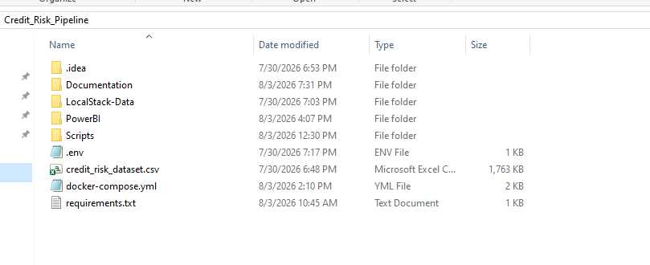
Windows project directory showing Docker configuration, source dataset, scripts, Power BI output, LocalStack data, environment settings, and documentation.

Key project components
- docker-compose.yml — defines the LocalStack and Spark services.
- Scripts/ — contains upload, Silver ETL, Gold aggregation, and export jobs.
- LocalStack-Data/ — preserves local S3-compatible state across restarts.
- PowerBI/ — receives the exported Gold CSV used by the report.
- Documentation/ — stores portfolio and project-supporting material.
- Credit Risk Dashboard.pbix — contains the two-page Power BI report.
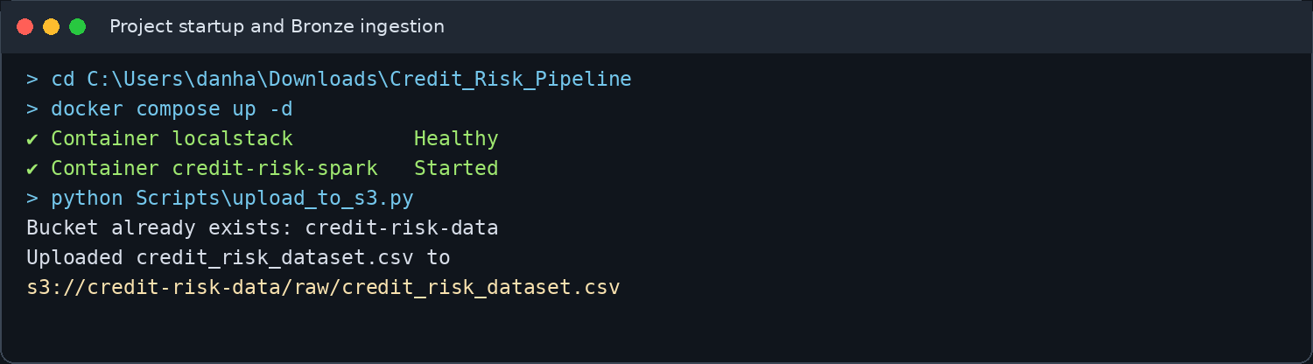
Representative execution evidence recreated from the verified project commands and outputs: container startup and Bronze ingestion.

3. Pipeline Execution Evidence
The command-line sequence shows the data moving through the medallion layers and into the reporting folder. Long dependency-resolution output is intentionally omitted so the evidence focuses on the business-relevant milestones.
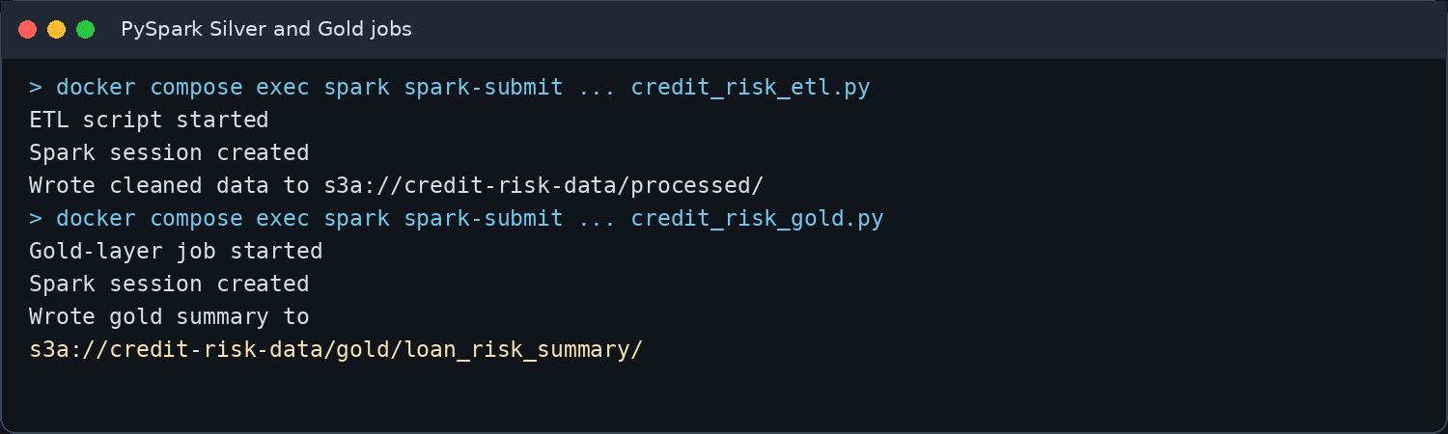
Spark creates the cleaned Silver layer and aggregated Gold layer.
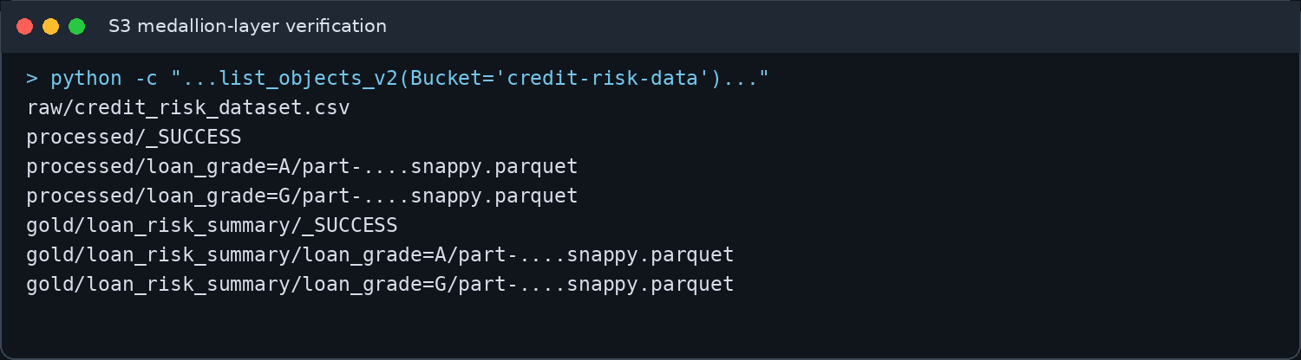
S3 object keys confirm raw, processed, and Gold assets, including completion markers and grade partitions.
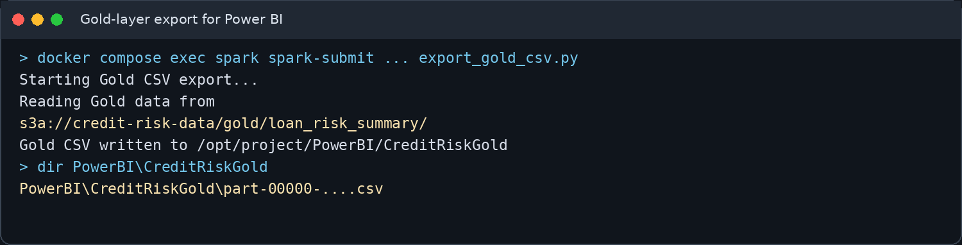
The Gold Parquet summary is exported to a CSV in the Docker-mounted Power BI folder.

4. Step-by-Step Implementation

Step 1 — Prepare the source dataset
The project starts with a borrower-level credit-risk CSV. The source contains attributes such as borrower income, loan amount, loan intent, interest rate, loan grade, income-to-loan ratio, and loan status.
- Input file: credit_risk_dataset.csv
- Source grain: one record per loan/borrower observation
- Primary target: a repeatable local cloud-style pipeline
Data modeling note The final Gold dataset is aggregated by loan grade, risk bucket, and loan intent. It is a snapshot of the supplied dataset; it is not monthly because the source contains no reporting or origination date.

Step 2 — Upload the raw file to the Bronze layer
The upload script uses boto3 to connect to LocalStack on port 4566, creates the credit-risk-data bucket when necessary, and uploads the raw CSV under raw/credit_risk_dataset.csv.
python Scripts\upload_to_s3.py
s3://credit-risk-data/raw/credit_risk_dataset.csv
- Preserves the raw source as the Bronze layer.
- Uses test credentials and path-style S3 access for LocalStack.
- Separates ingestion from downstream transformation logic.

Step 3 — Build the Silver layer with PySpark
Spark reads the Bronze CSV through the S3A connector, validates and converts data types, derives risk attributes, and writes clean Parquet files to the processed prefix.
docker compose exec spark /opt/spark/bin/spark-submit \
+ --packages org.apache.hadoop:hadoop-aws:3.4.2,software.amazon.awssdk:bundle:2.29.52 \
+ /opt/project/Scripts/credit_risk_etl.py
- Output: s3a://credit-risk-data/processed/
- Storage format: Snappy-compressed Parquet
- Partition strategy: loan_grade=A through loan_grade=G

Step 4 — Build the Gold risk summary
The Gold job reads the Silver Parquet data and groups it by loan grade, risk bucket, and loan intent. It produces reusable business metrics for reporting.
Gold field | Business meaning
total_loans | Count of loans in the segment
defaulted_loans | Sum of loans marked as defaulted
default_rate_pct | Defaulted loans divided by total loans
total_loan_amount | Total dollar exposure
avg_loan_amount | Average loan size
avg_interest_rate | Average interest rate
avg_person_income | Average borrower income
high_default_flag | Flags segment default rates at or above 25%
s3a://credit-risk-data/gold/loan_risk_summary/
loan_grade=A/part-....snappy.parquet
...
loan_grade=G/part-....snappy.parquet

Step 5 — Export Gold data for Power BI
A dedicated Spark export job reads the Gold Parquet dataset, coalesces the result to a single partition, and writes a header-enabled CSV into a Docker-mounted PowerBI folder.
docker compose exec spark /opt/spark/bin/spark-submit \
+ --packages org.apache.hadoop:hadoop-aws:3.4.2,software.amazon.awssdk:bundle:2.29.52 \
+ /opt/project/Scripts/export_gold_csv.py
PowerBI\CreditRiskGold\part-00000-....csv
Troubleshooting outcome The S3A 403 issue was resolved by aligning the export session with the working Gold configuration. A later PATH_NOT_FOUND error identified that LocalStack had restarted with an empty data volume, so the Bronze → Silver → Gold sequence was rebuilt.

5. Power BI Executive Overview
The Executive Overview page summarizes portfolio exposure and risk through a small set of interactive visuals. Weighted DAX measures are used instead of averaging already-aggregated percentages.
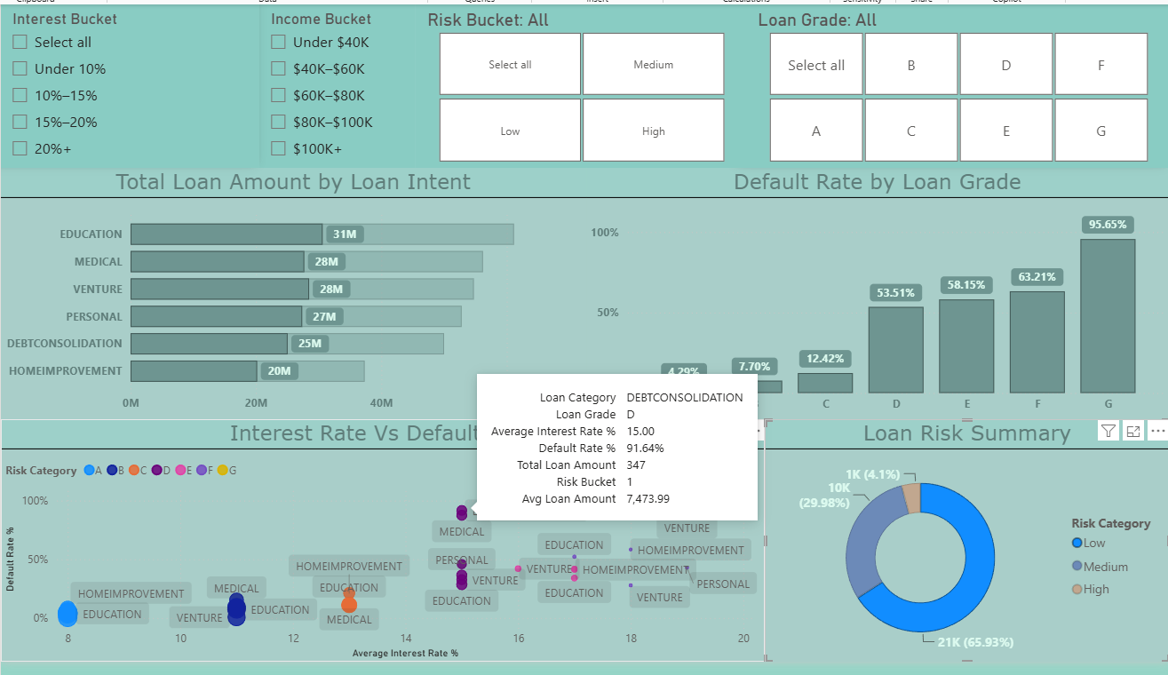
Executive Overview: loan exposure, default performance, grade segmentation, and interactive risk distribution.

Visual design
- Horizontal bar chart: total loan amount by loan intent.
- Column chart: weighted default rate by loan grade.
- Scatter/bubble chart: average interest rate versus default rate, colored by loan grade.
- Donut chart: total loans by Low, Medium, and High risk bucket.
- Slicers: interest bucket, income bucket, risk bucket, and loan grade.

6. Interactive Risk Analysis
The dashboard supports focused analysis by filtering the entire report. The example below isolates High-risk records, causing each visual to recompute within that segment.
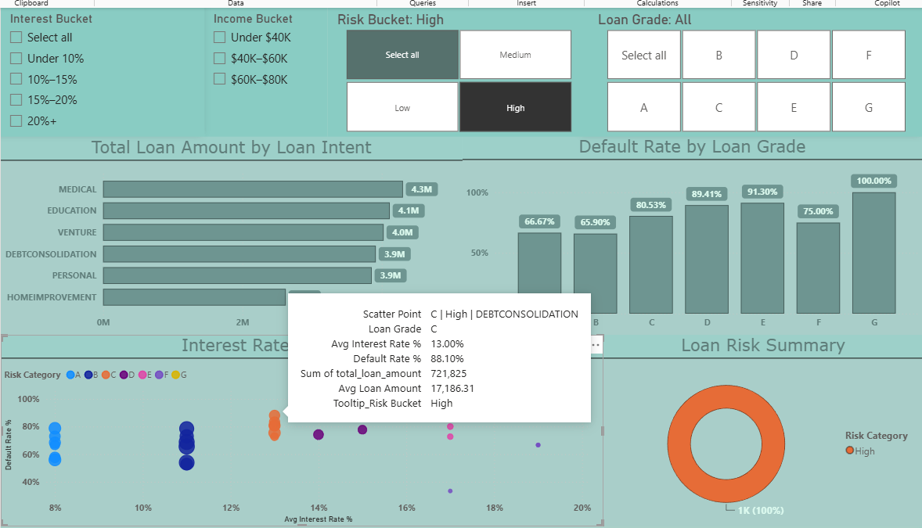
High-risk filter applied: the donut becomes 100% High, while the intent, grade, and scatter visuals recalculate for the selected population.

How to interpret the highlighted point
For Grade C / High risk / Debt Consolidation, the tooltip shows a 13% average interest rate, an 88.10% default rate, $721,825 in total loan amount, and a $17,186 average loan amount.
$721,825 ÷ $17,186.31 ≈ 42 loans
88.10% × 42 loans ≈ 37 defaulted loans
Validation The relationship among total loan amount, average loan amount, implied loan count, and default rate is internally consistent for this filtered segment.

7. Report Definition Overviews and Features
The second report page provides the details behind the visuals and DAX utilized. It is intended for analysts, reviewers, and interviewers who want to inspect segment-level results rather than only summary graphics.

Recommended matrix design
Matrix area | Fields
Rows | Loan Grade → Risk Bucket → Loan Intent
Values | Total Loans, Paid Loans, Defaulted Loans, Default Rate
Exposure | Total Loan Amount and Average Loan Amount
Borrower profile | Average Interest Rate and Average Borrower Income
Formatting | Centered values, data bars, and default-rate color scale

Power Query enhancements
- Income Bucket with a numeric sort column.
- Interest Rate Bucket with a numeric sort column.
- Loan Amount and Loan Count buckets for segment analysis.
- Default Rate Band for isolating healthy, concerning, and distressed segments.
- Title-cased risk values: Low, Medium, and High.
Portfolio role This page complements the visual summary by exposing the underlying segment metrics in a structured, reviewable format. Together, the two report pages support both executive storytelling and detailed analytical validation.

Key DAX principles
Default Rate =
DIVIDE([Defaulted Loans], [Total Loans], 0)
Average Interest Rate % =
DIVIDE([Weighted Average Interest Rate], 100, 0)
The overall default rate is calculated from totals. It should not be produced by averaging default_rate_pct across Gold rows, because that would give small and large segments equal weight.

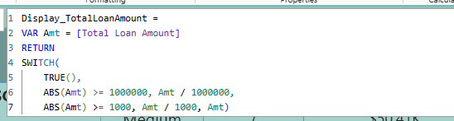
Utilized Dynamic Labeling between Thousands and Millions to have a cleaner, more functional report for the end user when toggling filters on Detailed Risk Analysis Page for Total Loan Amount.

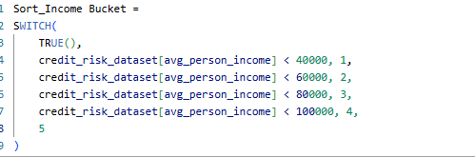
Implemented Bucket Categories to create convenient filtering between income information. The chart above showcases how you will want to sort your slicer to the income ranges are in numerical order.

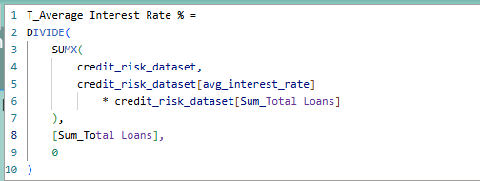
Average Interest Rate % between all loans.
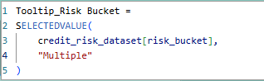
Tool Tip Risk Selection. This was primarily meant for the ScatterPlot ToolTip as there is a ton of useful breakdown information within each unit and gives you a better picture of the default vs interest rate. One insight I came to find was that it provided as a helpful resource to make sure each bubble is an individual loan

8. Project Order and Quality Assurance

Report QA:
Within the Power BI Report I utilized Power Query to produce new columns within the report. Ensuring these functioned properly and the Columns/Measures within Power BI were important for data governance and validation practices. The biggest challenge within this report for quality assurance was developing the right pieces for the Scatter Plot to represent one individual loan financial loan per group (Education, Medical, Home Improvement). Example below of a QA Check within the company on True Values having a Higher Default Rate percentage that equates to 25%.

High Risk Comparison vs Loan Size
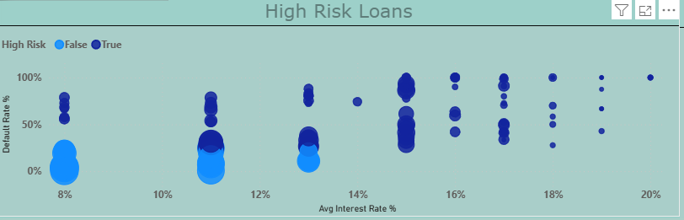

Run order
- Start services: Run docker compose up -d from the project root.
- Upload Bronze: Run python Scripts\upload_to_s3.py.
- Create Silver: Submit credit_risk_etl.py through Spark.
- Create Gold: Submit credit_risk_gold.py through Spark.
- Export reporting file: Submit export_gold_csv.py through Spark.
- Refresh report: Load or refresh the generated part-00000 CSV in Power BI.

Quality checks
Check | Acceptance criterion
Bronze exists | raw/credit_risk_dataset.csv is visible in the bucket.
Silver complete | processed/_SUCCESS exists with A–G grade partitions.
Gold complete | gold/loan_risk_summary/_SUCCESS exists with A–G partitions.
Metrics reconcile | Total = Paid + Defaulted; amount ÷ average amount approximates count.
Filters interact | Selecting a risk or income bucket recalculates all report visuals.
No false time claim | Report is labeled as a dataset snapshot, not a monthly trend.

Power BI Showcase

Credit Risk Overview
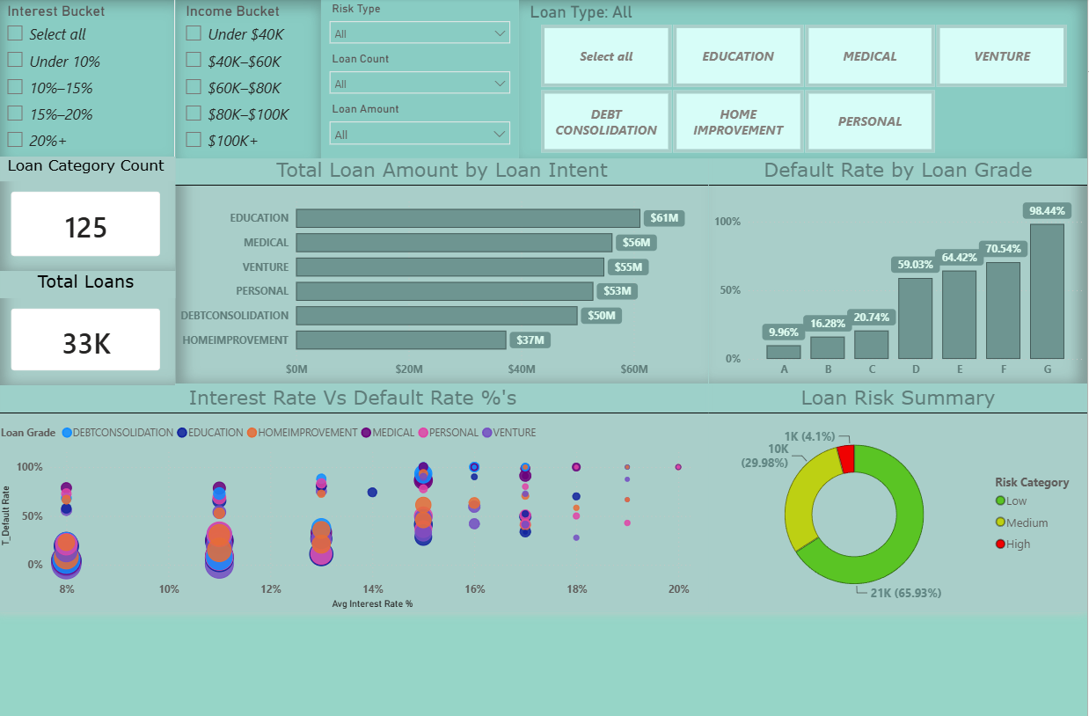

Detailed Risk Analysis
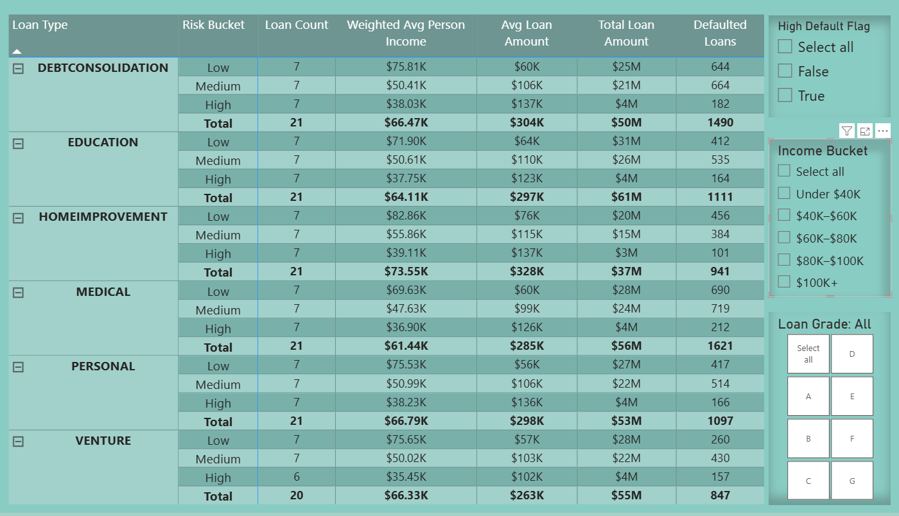

9. Portfolio Wrap-up
Project statement Built an end-to-end credit-risk analytics pipeline using Python, Docker, LocalStack S3, PySpark, partitioned Parquet, and Power BI. Implemented Bronze, Silver, and Gold layers and delivered a two-page report for portfolio exposure, default performance, and detailed segment analysis.

What this project demonstrates
- Cloud data-lake concepts through S3-compatible object storage.
- Distributed transformations and aggregations with PySpark.
- Medallion architecture and partitioned Parquet design.
- Containerized local development with Docker Compose.
- Metric-layer discipline through weighted DAX calculations.
- Business storytelling through executive and tabular Power BI pages.
- Practical debugging across credentials, S3 endpoints, persistence, and file paths.

Overview
Developed a containerized credit-risk data pipeline using Python, PySpark, Docker, and LocalStack S3; implemented Bronze/Silver/Gold layers with partitioned Parquet and delivered an interactive two-page Power BI dashboard for loan exposure and default-risk analysis.

Discussion Points
- Why Parquet and partitioning were chosen for analytical reads.
- Why default rates and average interest rates require weighted measures.
- How LocalStack reproduced AWS S3 development patterns without cloud cost.
- How the pipeline was debugged and made reproducible after container restarts.
- How report filters move users from portfolio-level KPIs to targeted risk segments.

