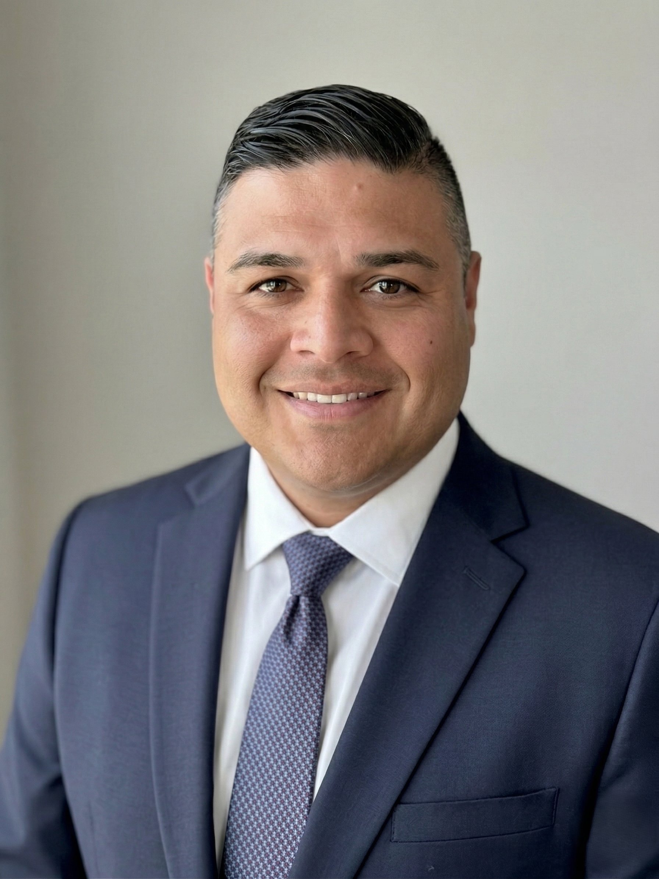  Contact Information  📍 Houston, United States  📞 832-830-5599  ✉ dan.hinojosa@gmail.com  🔗 linkedin.com/in/danhinojosa  Skills  • Cloud & Infrastructure  • Security & API  • AI & Data Science  • Agile & Hybrid Delivery  • Observability & Reliability  • Mortgage Domain  • Financial & Vendor Mgmt  • Team Leadership  Certifications  • AWS Cloud Practitioner  • AI Airtable App Builder  Education  • BBA, Mgmt Information Systems  • University of Houston  Languages  • English  • Spanish | DANIEL HINOJOSA  TECHNOLOGY PROFESSIONAL  ■ PROFILE  An accomplished, results-oriented business technology leader with demonstrated success in business transformation solutions, enterprise application architecture, and software development. Expertise in overseeing technology improvement initiatives, aligning information services with business goals, increasing reliability, maximizing productivity, and introducing system efficiency.  ■ EXPERIENCE  Technical Program Manager  Dark Matter Technologies / Black Knight Financial Services  Feb 2016 — May 2025  - Served as Enterprise Program Manager for large-scale mortgage platform implementations at Tier-1 financial institutions (JPMorgan Chase, Wells Fargo, Bank of America, Equifax, Mastercard), partnering with VP- and Director-level sponsors to define program scope, align strategic objectives, and drive delivery through all phases of the program lifecycle.  - Managed end-to-end program financials, resource plans, and delivery timelines for mortgage LOS (Empower) and API Exchange platform programs; created master program schedules, dependency maps, and cross-team sequencing across large onshore and offshore teams.  - Directed modernization of legacy mortgage lender integrations to AWS serverless architecture (Lambda, API Gateway) with OAuth 2.0 and JWT, reducing integration deployment timelines by 35% and improving platform scalability for high-volume origination workflows.  - Led program-level release planning, go-live readiness, and post-implementation stabilization, coordinating cross-functional go/no-go activities and providing hypercare support to executive stakeholders.  Application Developer Lead  AIG VALIC  Sep 2006 — Feb 2016  - Delivered end-to-end technology solutions for Call Center and Financial Advisor platforms, aligning IT roadmap execution with business priorities and bridging cross-functional communication between IT and business stakeholders.  - Spearheaded development of a dynamic pricing engine that boosted revenue by 15% through enhanced pricing optimization, connecting technical delivery to measurable business outcomes.  - Led migration of legacy AS/400 systems to modern .NET, Oracle, and WebSphere architecture, authored comprehensive technical documentation, functional UI specs, and user training materials.  Technical Support Team Lead  Getronics IT Solutions and Services  Jul 2001 — Sep 2006  - Led 24/7 enterprise support operations for a team of 12 engineers, consistently achieving 99% SLA targets through proactive monitoring, root-cause analysis, and ITIL service operation principles.  - Managed team scheduling, performance, escalations, and continuous improvement initiatives across onsite and remote environments, establishing operational discipline informing program governance.  Independent Consultant  Family First ER — AI Claims Processor  Aug 2025 — Dec 2025  - Conceived, architected, and delivered a production-ready AI-powered claims processing application; ingests ERA files and EOB insurance claims PDFs using NLP to automate extraction of CPT remark codes and CAS adjustment codes, reducing claim triage time from 1–2 days to under 90 seconds.  AGT Unlimited — AI Maintenance Ticketing System  Dec 2025 — Feb 2026  - Built a mobile and web-based automated maintenance ticketing system using Airtable AI App Builder to track technician work orders, service requests, and resolution status; implemented real-time dashboards and AI-assisted categorization.

