THE UNIVERSITY OF DANANG
VIETNAM - KOREA UNIVERSITY OF INFORMATION AND COMMUNICATION TECHNOLOGY
──────── ⁂ ────────
LAB REPORT
VLSI DESIGN LAB
VLSI BACK END – FULL CUSTOM DESIGN
Lab 3: CMOS Inverter • Lab 4: CMOS NAND • Lab 5: CMOS D Flip-Flop
SkyWater SKY130 technology (130 nm, 1.8 V)
Instructor: Ho Anh Trang, MSc
Student: ……………………………………
Student ID: ……………………………………
Class: ……………………………………
Da Nang, September 2026

TABLE OF CONTENTS
CHAPTER 1. INTRODUCTION 2
CHAPTER 2. LAB 3 – CMOS INVERTER 3
2.1. Circuit design 3
2.2. Test bench 4
2.3. Simulation result 6
CHAPTER 3. LAB 4 – CMOS NAND 9
3.1. Circuit design 9
3.2. Test bench 10
3.3. Simulation result 11
CHAPTER 4. LAB 5 – CMOS D FLIP-FLOP 15
4.1. Circuit design 15
4.2. Test bench 17
4.3. Simulation result 18
CHAPTER 5. CONCLUSION 21
REFERENCES 22
APPENDIX. NETLISTS AND TEST BENCH 23
A. Inverter netlist – lab3/netlist/inv.spice 23
B. NAND netlist – lab4/netlist/nand.spice 24
C. D flip-flop netlist – lab5/netlist/dff.spice 24
D. Inverter transient test bench – lab3/tb/tb_tran.sp 25

CHAPTER 1. INTRODUCTION
The VLSI back end – Full custom design part of the course requires designing, simulating and verifying logic elements at the transistor level in three labs: Lab 3 – CMOS Inverter, Lab 4 – CMOS NAND, and Lab 5 – CMOS D Flip-Flop. As specified in the assignment, each lab consists of three parts, which also form the structure of each chapter in this report:
- Circuit design – the transistor-level schematic and device sizing.
- Test bench – the verification circuit: supplies, stimuli, loads and measurements.
- Simulation result – simulation results compared against theory.
Since no Cadence license was available, the labs use an equivalent open-source tool flow together with the real process design kit (PDK) of the SkyWater foundry:
Table 1.1. Tools used versus the tools suggested in the assignment
Suggested tool | Tool used | Purpose
Cadence Virtuoso | xschem 3.4.7 | Schematic capture, symbols, netlisting
Spectre / LTspice | ngspice-47 | DC, transient and parametric simulation
Foundry PDK | SkyWater SKY130 | Transistor models, device symbols

Table 1.2. Common simulation conditions for all three labs
Parameter | Value
Technology | SkyWater SKY130, 130 nm, 1.8 V core devices
NMOS / PMOS | sky130_fd_pr__nfet_01v8 / sky130_fd_pr__pfet_01v8
V_{DD}; L | 1.8 V; L = 0.15 µm for every transistor
Corner, temperature | TT (typical–typical), 27 °C
Models | libs.tech/combined (continuous), with ad/as/pd/ps diffusion parameters
Delay thresholds | 50 % V_{DD} = 0.9 V (t_{p}); 10 %–90 % (t_{r}, t_{f})
Input edge time | 20 ps

All schematics were drawn hierarchically in xschem. The netlists generated by xschem were cross-checked against the netlist of each cell (connectivity and sizes match 100 %), and both netlists give identical simulation results.

CHAPTER 2. LAB 3 – CMOS INVERTER

2.1. Circuit design
A CMOS inverter consists of a pull-up PMOS (connected to V_{DD}) and a pull-down NMOS (connected to GND). The gates are tied together as the input and the drains are tied together as the output: out = in'. In either static state one transistor is off, so no DC current flows from V_{DD} to GND. Figure 2.1 shows the schematic in xschem. The PMOS body is tied to V_{DD} and the NMOS body to V_{SS}. The cell has a symbol, inv.sym, which is reused in Lab 5.
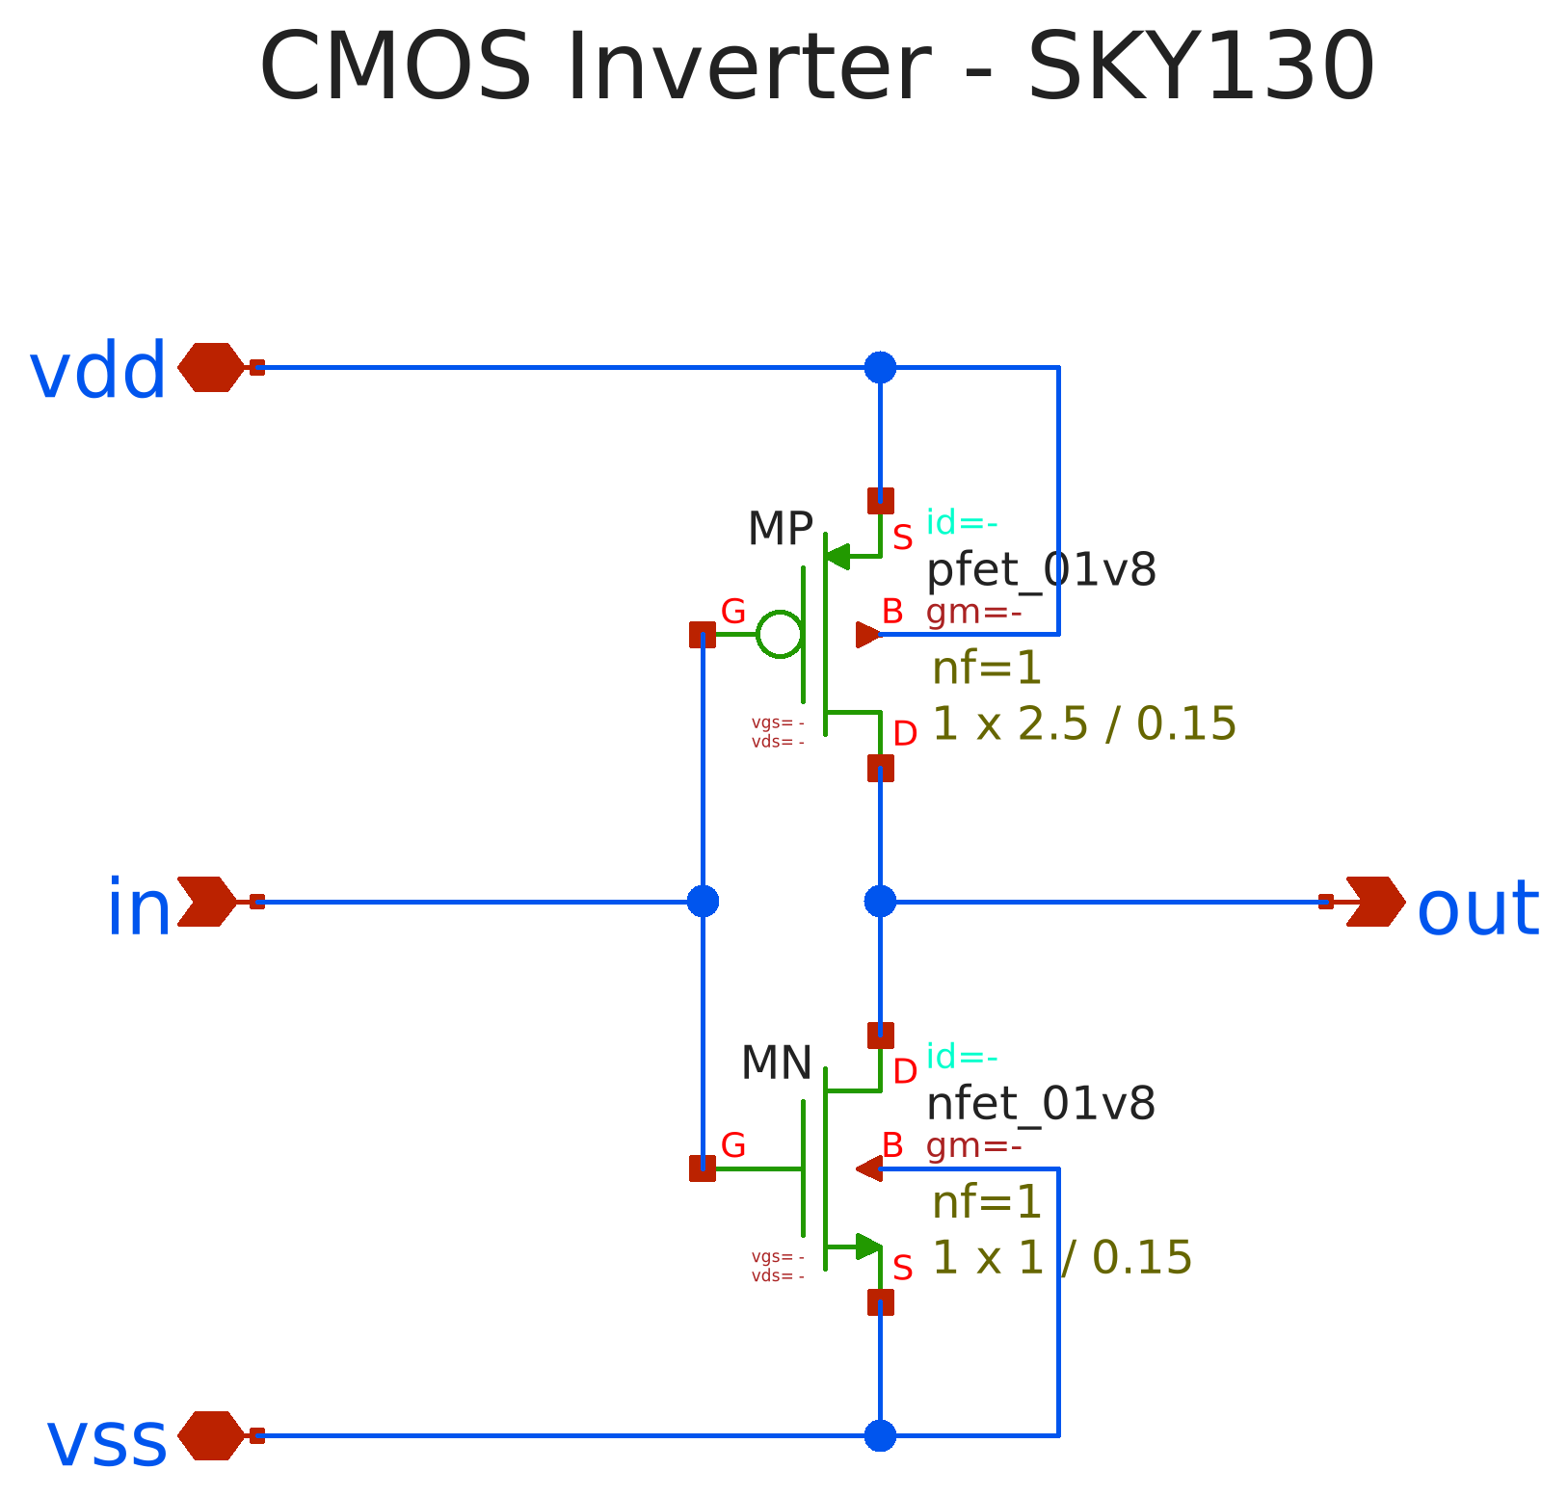
Figure 2.1. CMOS inverter schematic (inv.sch)
Sizing. Hole mobility is lower than electron mobility, so the PMOS must be wider than the NMOS to balance the two edges and to place the switching threshold V_{M} near V_{DD}/2. The ratio was chosen by simulation: W_{n} was fixed at 1 µm and W_{p} was swept from 1 to 6 µm (10 fF load).
Table 2.1. W_{p} sweep used for sizing (W_{n} = 1 µm, C_{L} = 10 fF)
W_{p} (µm) | V_{M} (V) | t_{pHL} (ps) | t_{pLH} (ps)
1.0 | 0.836 | 31.7 | 80.2
1.5 | 0.857 | 33.0 | 56.2
2.0 | 0.872 | 34.3 | 44.5
2.5 | 0.884 | 35.5 | 37.6
3.0 | 0.893 | 36.8 | 33.0
3.5 | 0.900 | 38.0 | 29.5
4.0 | 0.906 | 39.1 | 26.9
5.0 | 0.917 | 41.5 | 23.4
6.0 | 0.929 | 43.7 | 21.0

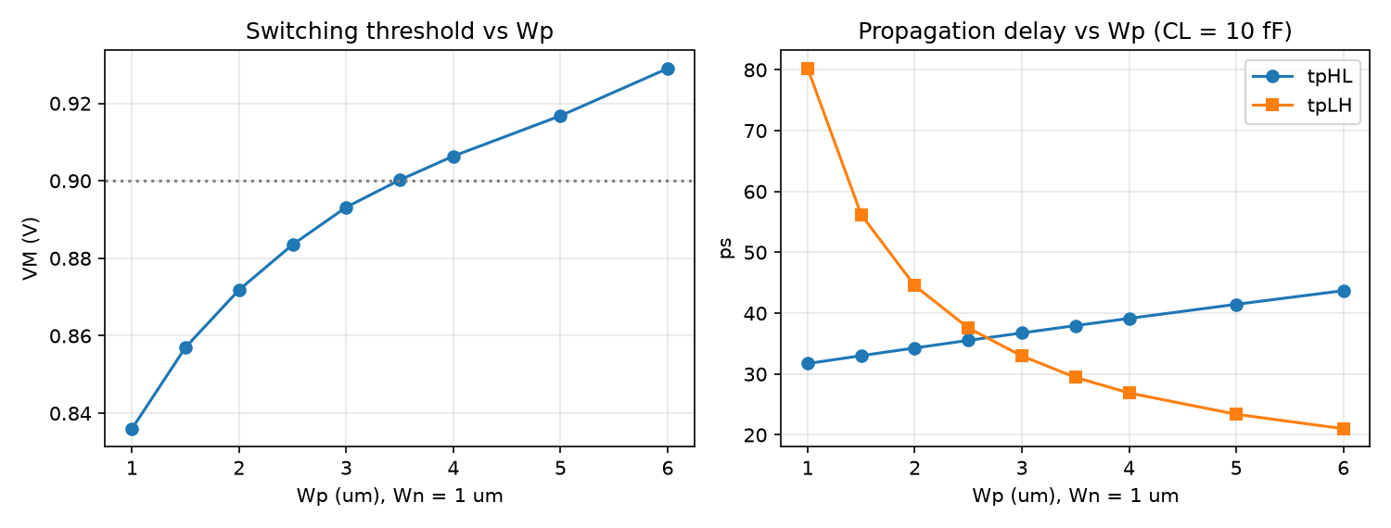
Figure 2.2. Switching threshold and propagation delay versus W_{p}
W_{p} = 2.5 µm (W_{p}/W_{n} = 2.5) was chosen. It is the sweep point where t_{pHL} and t_{pLH} are closest (2.0 ps apart, versus 3.8 ps at 3 µm), and V_{M} = 0.884 V is already close to V_{DD}/2. Reaching exactly V_{M} = 0.9 V would need W_{p} ≈ 3.5 µm, which increases area and input capacitance by 40 % for little benefit.
Table 2.2. Inverter transistor sizes
Transistor | Type | W (µm) | L (µm) | Body
MP | pfet_01v8 | 2.5 | 0.15 | V_{DD}
MN | nfet_01v8 | 1.0 | 0.15 | V_{SS}

2.2. Test bench
The test bench (Figure 2.3) instantiates the inverter symbol with a 1.8 V V_{DD} supply, a 0/1.8 V input pulse (20 ps edges, 2 ns period, 500 MHz) and a load capacitor C_{L} = 10 fF, roughly equivalent to a fan-out of a few gates. The CORNER block loads the SKY130 models. The SIM block holds the simulation commands and the .meas statements.
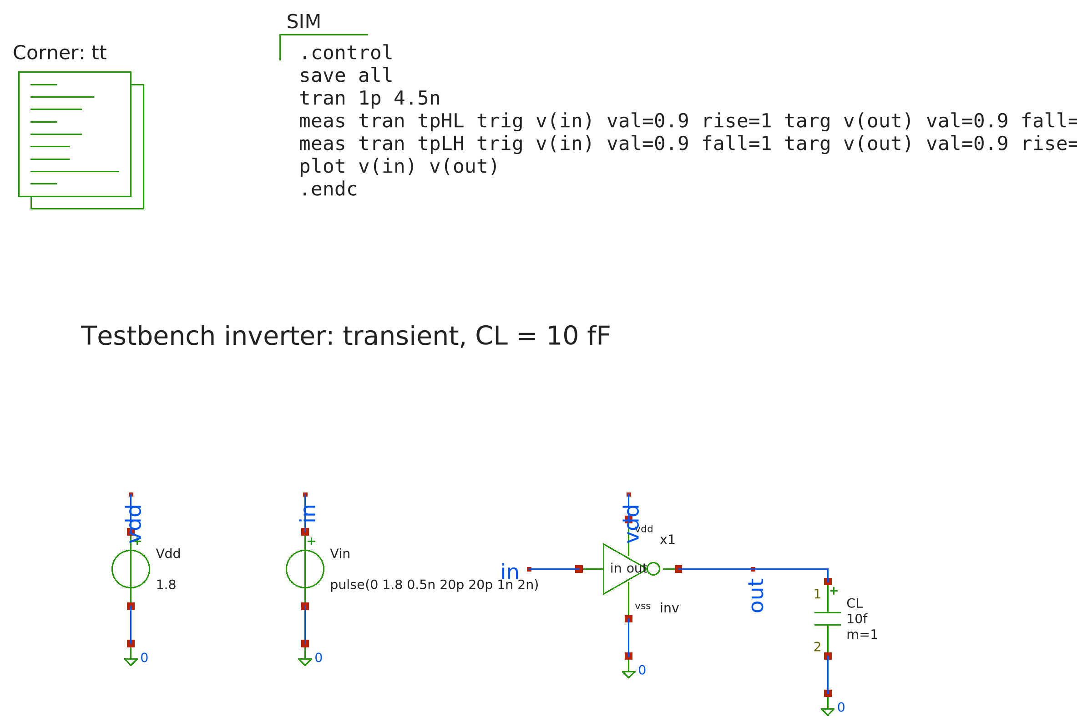
Figure 2.3. Inverter test bench (tb_inv.sch)
Table 2.3. Analyses in the Lab 3 test benches
Test bench | Analysis | Measured quantities
tb_sizing | DC + transient, W_{p} sweep | V_{M}, t_{pHL}, t_{pLH} versus W_{p}
tb_vtc | DC: V_{in} 0 → 1.8 V, 1 mV step | VTC, V_{IL}, V_{IH}, V_{OL}, V_{OH}, noise margins NM_{L}, NM_{H}, short-circuit current
tb_tran | Transient 4.5 ns, 1 ps step; C_{L} sweep 2–100 fF | t_{pHL}, t_{pLH}, t_{r}, t_{f}, power, delay versus load

V_{IL} and V_{IH} are measured at the two points where dV_{out}/dV_{in} = −1 (the derivative is computed with deriv()). The noise margins are NM_{L} = V_{IL} − V_{OL} and NM_{H} = V_{OH} − V_{IH}.

2.3. Simulation result

a) DC transfer characteristic
Table 2.4. Inverter DC analysis results
Parameter | Value | Parameter | Value
V_{M} | 0.884 V | V_{OH} | 1.747 V
V_{IL} | 0.754 V | V_{OL} | 0.076 V
V_{IH} | 1.005 V | NM_{L} | 0.679 V (38 % V_{DD})
Peak gain | 11.51 | NM_{H} | 0.741 V (41 % V_{DD})
Peak short-circuit current | 31.0 µA

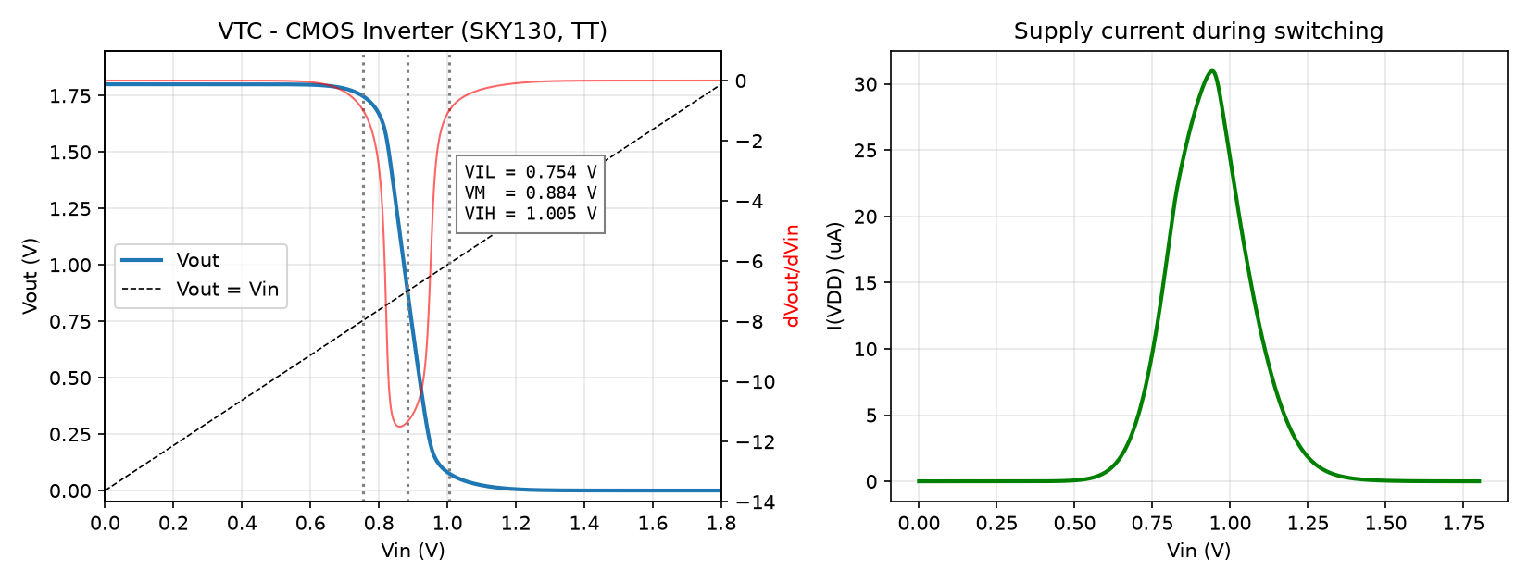
Figure 2.4. Voltage transfer characteristic (left) and supply current during switching (right)
- The VTC switches very sharply, with a peak gain |A_{v}| ≈ 11.5 at V_{M}, and the output swings rail to rail outside the transition region. The noise margins NM_{L} = 0.679 V and NM_{H} = 0.741 V are nearly balanced because V_{M} = 0.884 V is close to V_{DD}/2.
- Supply current is significant only for 0.5 V < V_{in} < 1.3 V (both transistors on), peaking at 31 µA near V_{M}. At both logic levels the current is practically zero, as expected for static CMOS logic.

b) Transient response
Table 2.5. Transient results (C_{L} = 10 fF, f = 500 MHz)
Parameter | Value | Parameter | Value
t_{pHL} | 35.54 ps | t_{r} (10–90 %) | 63.81 ps
t_{pLH} | 37.57 ps | t_{f} (90–10 %) | 47.89 ps
Average t_{p} | 36.55 ps | P_{avg} (measured) | 21.71 µW
 |  | C_{L}·V_{DD}²·f | 16.20 µW

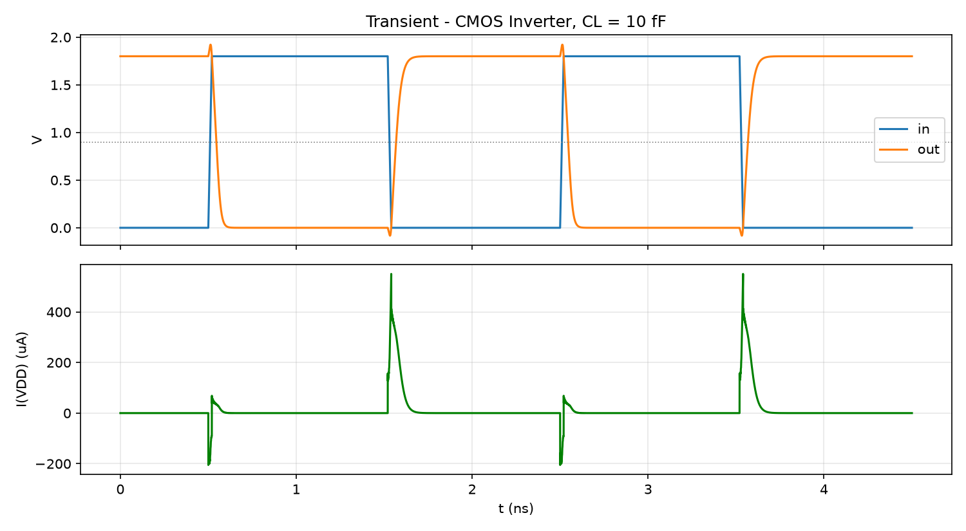
Figure 2.5. Input, output and supply current waveforms of the inverter
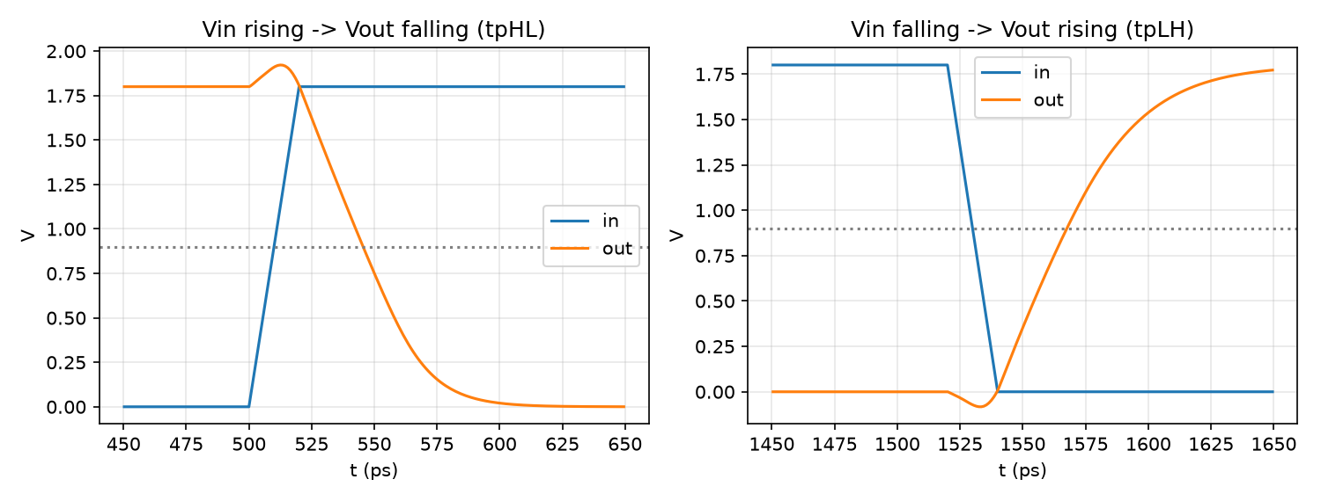
Figure 2.6. Zoom on the falling (t_{pHL}) and rising (t_{pLH}) output edges
- The output correctly inverts the input, and t_{pHL} ≈ t_{pLH} (2.0 ps apart), which meets the sizing goal.
- The measured power (21.71 µW) is about 34 % higher than C_{L}·V_{DD}²·f (16.20 µW). The difference comes from the short-circuit current during switching and from the inverter's own parasitic capacitance.
- The small overshoot above 1.8 V and undershoot below 0 V when the input switches are caused by Miller coupling through C_{gd}. The supply current peaks on the rising output edge, when the PMOS charges C_{L}.

c) Delay versus load
Table 2.6. Propagation delay versus load capacitance C_{L}
C_{L} (fF) | t_{pHL} (ps) | t_{pLH} (ps)
2 | 17.8 | 18.0
5 | 24.7 | 25.5
10 | 35.5 | 37.6
20 | 56.8 | 61.3
50 | 120.1 | 131.9
100 | 225.2 | 249.0

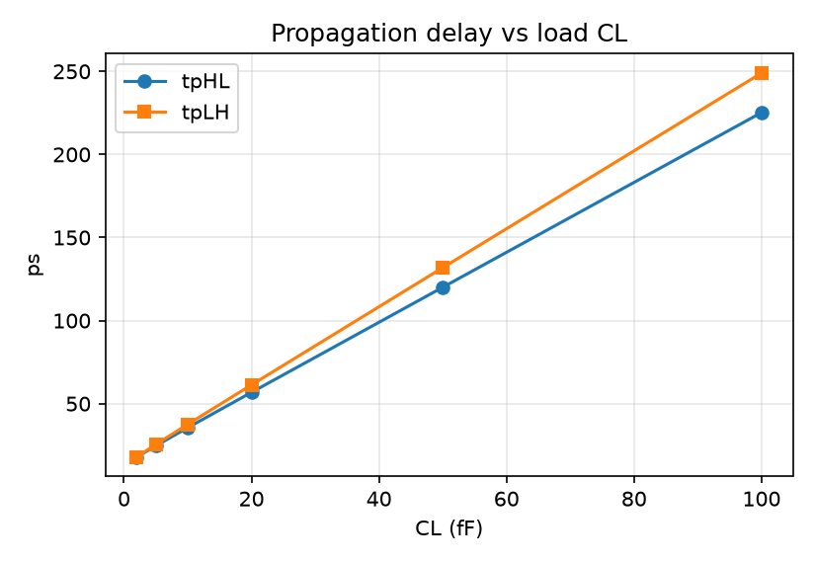
Figure 2.7. Propagation delay versus load capacitance
The delay increases linearly with C_{L}, as predicted by t_{p} ≈ 0.69·R_{eq}·(C_{int} + C_{L}). The slope is ≈ 2.23 ps/fF, giving R_{eq} ≈ 3.2 kΩ. The intercept (≈ 14 ps) is the intrinsic delay caused by the parasitic capacitance.
Remarks. The inverter works correctly: its VTC is nearly symmetric (V_{M} = 0.884 V), the noise margins are ≥ 0.68 V, the delays are balanced (t_{p} ≈ 36.6 ps at 10 fF) and the static power is practically zero, in agreement with static CMOS theory.

CHAPTER 3. LAB 4 – CMOS NAND

3.1. Circuit design
The CMOS NAND gate has a pull-up network of two parallel PMOS and a pull-down network of two series NMOS, the two networks being duals of each other: y = (a·b)'. The output goes low only when both NMOS conduct (a = b = 1). If either input is 0, a PMOS pulls the output high.
Table 3.1. Truth table and transistor states
a | b | MPA | MPB | MNA | MNB | y
0 | 0 | On | On | Off | Off | 1
0 | 1 | On | Off | Off | On | 1
1 | 0 | Off | On | On | Off | 1
1 | 1 | Off | Off | On | On | 0

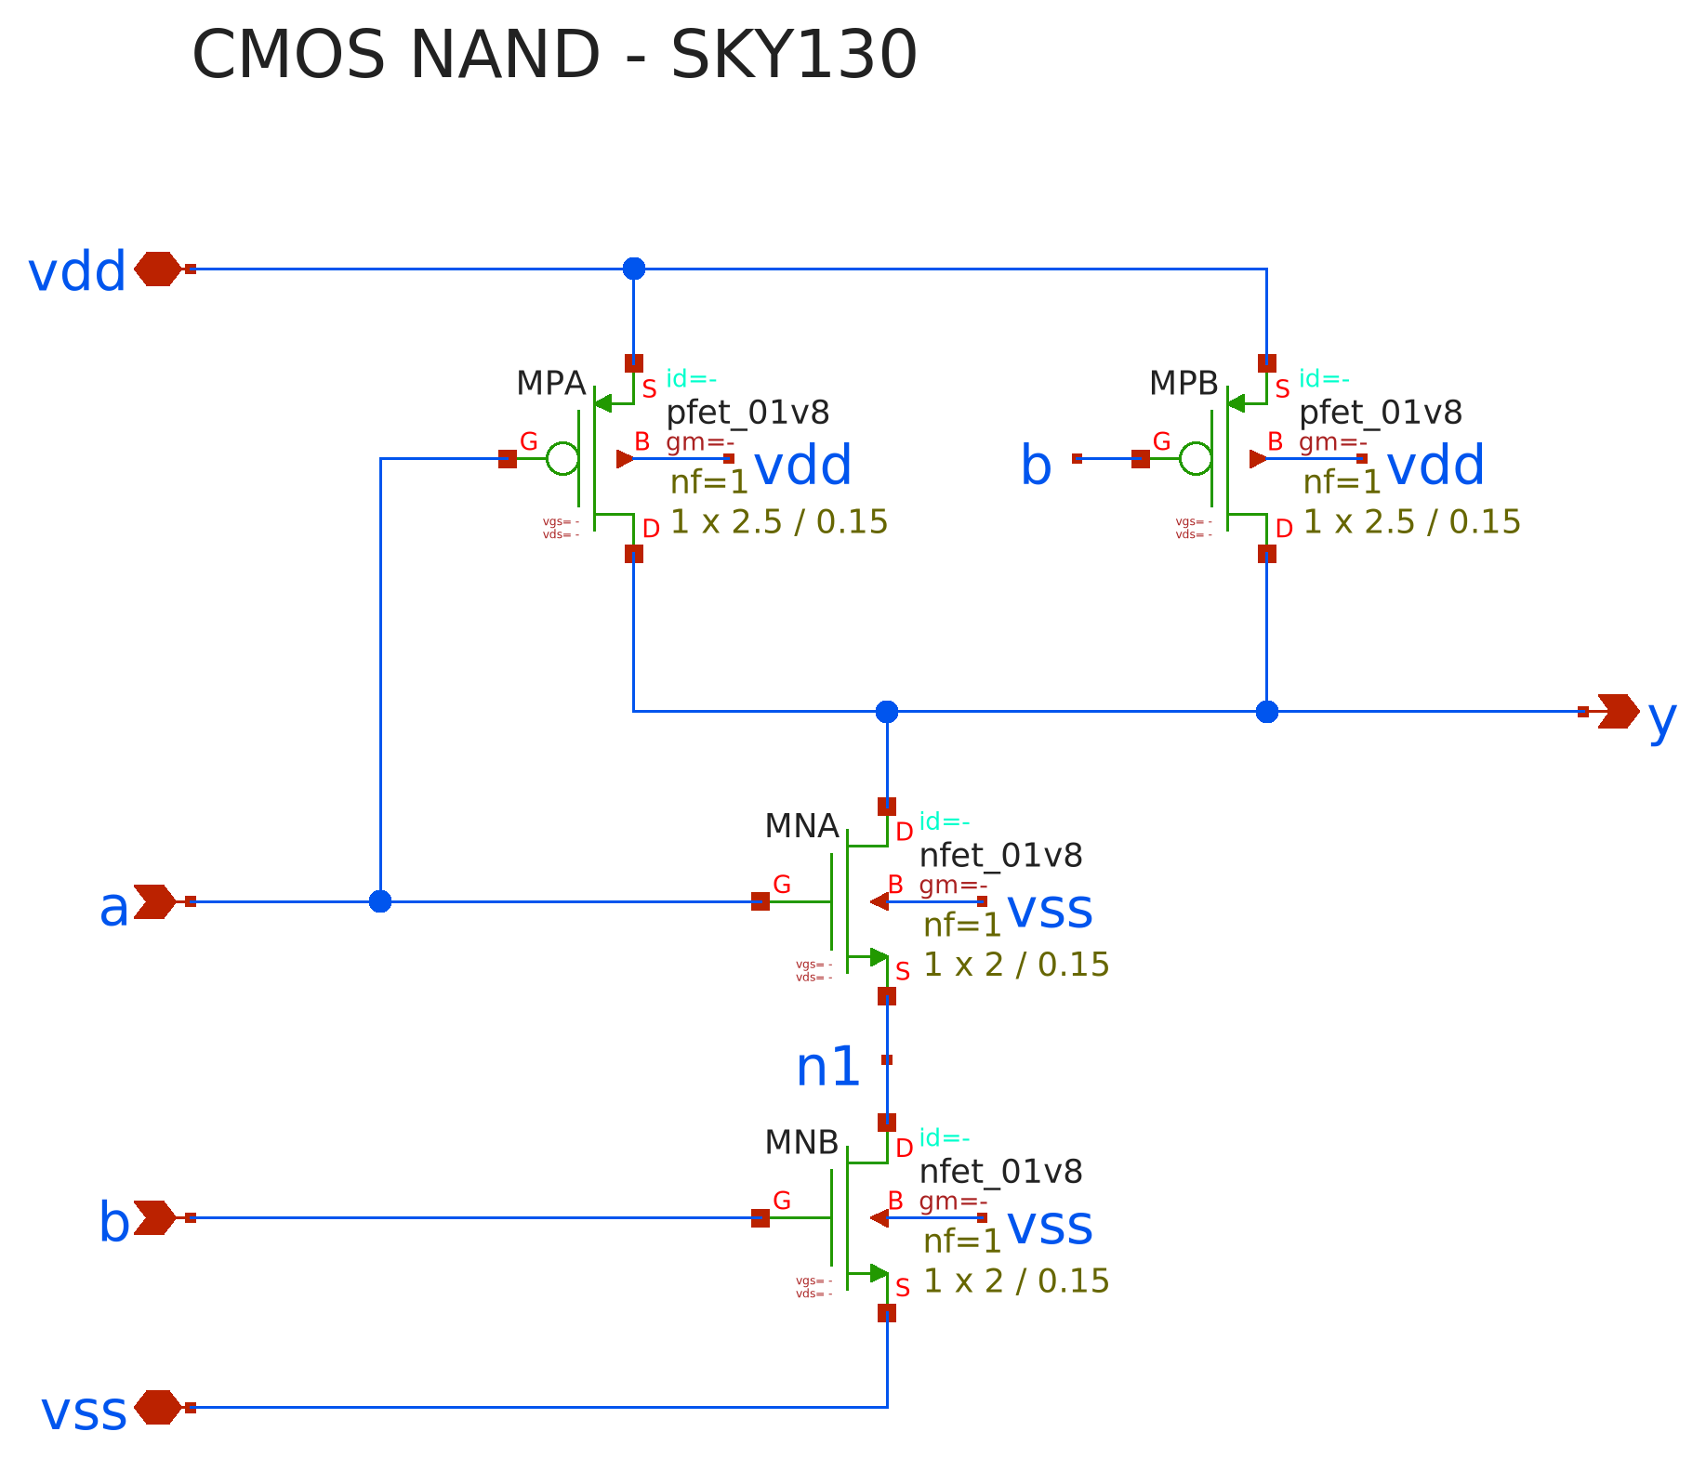
Figure 3.1. CMOS NAND schematic (nand.sch)
Sizing follows the reference inverter of Lab 3. The resistances of the two series NMOS add up, so each NMOS is made twice as wide (W_{n} = 2 µm) to match the pull-down resistance of the reference inverter. For the parallel PMOS the worst case is a single PMOS conducting, so W_{p} = 2.5 µm is kept. MNA (input a) sits next to the output, MNB (input b) next to GND, and the node between them is n1.
Table 3.2. NAND transistor sizes
Transistor | Type | Position | W (µm) | L (µm)
MPA | pfet_01v8 | parallel, gate a | 2.5 | 0.15
MPB | pfet_01v8 | parallel, gate b | 2.5 | 0.15
MNA | nfet_01v8 | series, next to output, gate a | 2.0 | 0.15
MNB | nfet_01v8 | series, next to GND, gate b | 2.0 | 0.15

3.2. Test bench
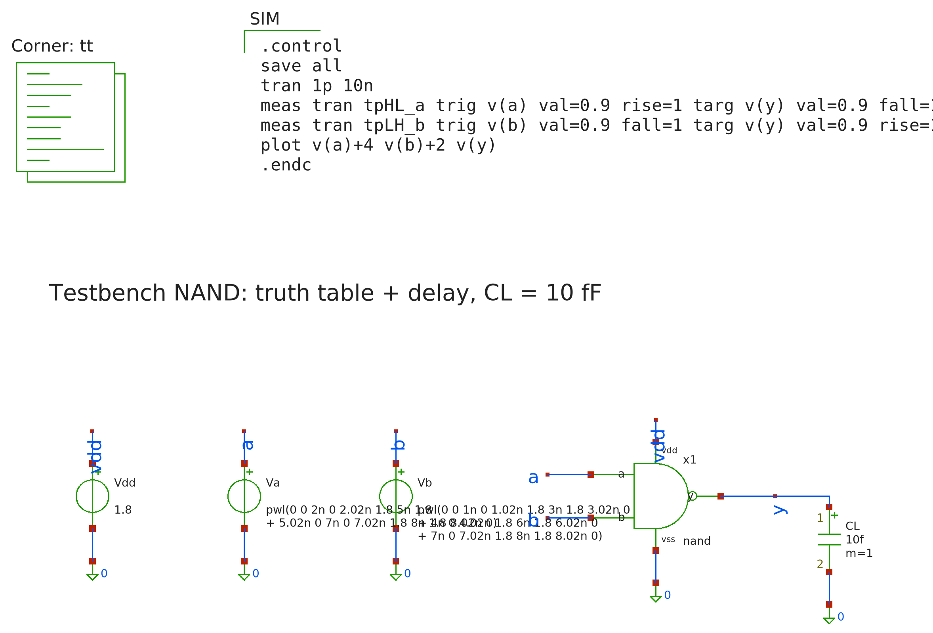
Figure 3.2. NAND test bench (tb_nand.sch)
Transient: two PWL sources with 1 ns time slots, 20 ps edges and a 10 fF load. The input sequence covers all 4 combinations to check the truth table. It is ordered so that only one input changes at a time (except for the two edges where a and b switch together), which allows the delay of each input to be measured separately (Table 3.3). The output is sampled at the end of each slot and compared with the truth table.
Table 3.3. Stimulus sequence and edges used for delay measurement
Time | Event | Measured quantity
2 ns | a rises, b = 1 | t_{pHL}(a)
3 ns | b falls, a = 1 | t_{pLH}(b)
4 ns | b rises, a = 1 | t_{pHL}(b)
5 ns | a falls, b = 1 | t_{pLH}(a)
7 ns | a and b rise together | t_{pHL}(ab)
8 ns | a and b fall together | t_{pLH}(ab)

DC: three NAND instances are simulated at once for three cases: sweep a (b = 1), sweep b (a = 1) and sweep a = b. For each case V_{M}, V_{IL}, V_{IH} and the noise margins are measured.

3.3. Simulation result

a) Truth table check
Table 3.4. Output sampled at the end of each time slot
t (ns) | a | b | y (V) | y logic | Expected | Result
0.8 | 0 | 0 | 1.800 | 1 | 1 | Pass
1.8 | 0 | 1 | 1.800 | 1 | 1 | Pass
2.8 | 1 | 1 | 9.0e-7 | 0 | 0 | Pass
3.8 | 1 | 0 | 1.800 | 1 | 1 | Pass
4.8 | 1 | 1 | 9.0e-7 | 0 | 0 | Pass
5.8 | 0 | 1 | 1.800 | 1 | 1 | Pass
6.8 | 0 | 0 | 1.800 | 1 | 1 | Pass
7.8 | 1 | 1 | 9.0e-7 | 0 | 0 | Pass
9.8 | 0 | 0 | 1.800 | 1 | 1 | Pass

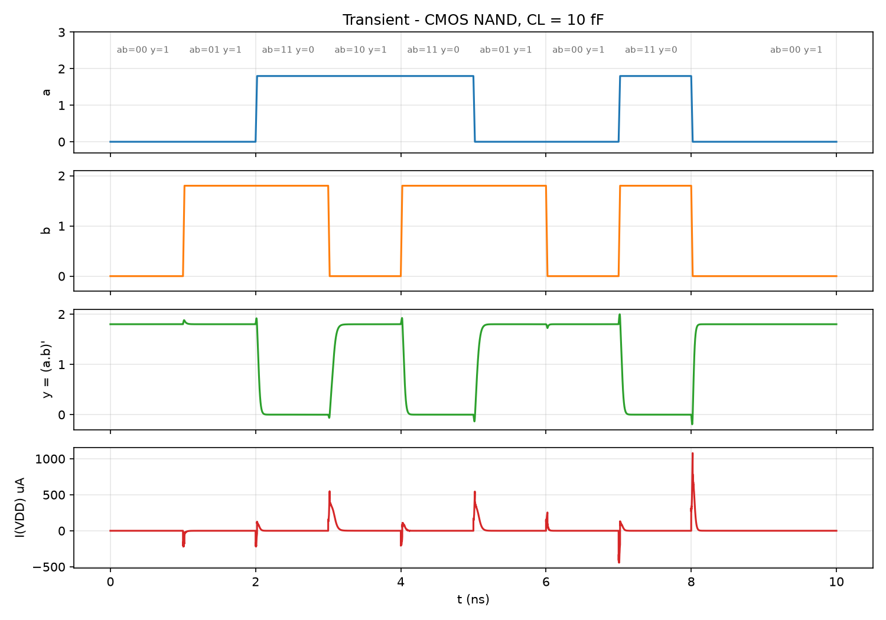
Figure 3.3. Waveforms of inputs a, b, output y and supply current
The output matches the NAND truth table for every combination and swings fully rail to rail.

b) DC transfer characteristic
Table 3.5. NAND VTC for each input combination (V)
Case | V_{M} | V_{IL} | V_{IH} | NM_{L} | NM_{H}
Sweep a (b = 1) | 0.841 | 0.706 | 0.951 | 0.626 | 0.796
Sweep b (a = 1) | 0.831 | 0.721 | 0.938 | 0.636 | 0.812
Sweep a = b | 0.924 | 0.813 | 1.051 | 0.734 | 0.698

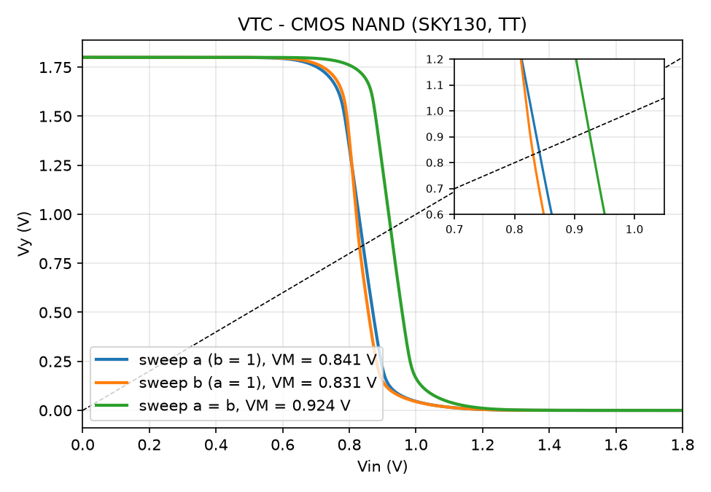
Figure 3.4. NAND VTC for the three switching cases
- Sweep a = b gives the highest V_{M} (0.924 V): both parallel PMOS fight the two series NMOS, so the pull-up is twice as strong and a higher V_{in} is needed to flip the output.
- Sweep a has a slightly higher V_{M} than sweep b (0.841 versus 0.831 V). MNA is the upper transistor and its source is node n1 > 0, so it suffers from the body effect: V_{th} increases and MNA becomes weaker.
- The noise margins are ≥ 0.63 V (about 35 % of V_{DD}) in every case.

c) Propagation delay
Table 3.6. Delay versus switching input (C_{L} = 10 fF)
Switching input | t_{pHL} (ps) | t_{pLH} (ps)
Only a (b = 1) – MNA next to output | 33.06 | 44.46
Only b (a = 1) – MNB next to GND | 37.32 | 54.93
a and b together | 37.71 | 26.71

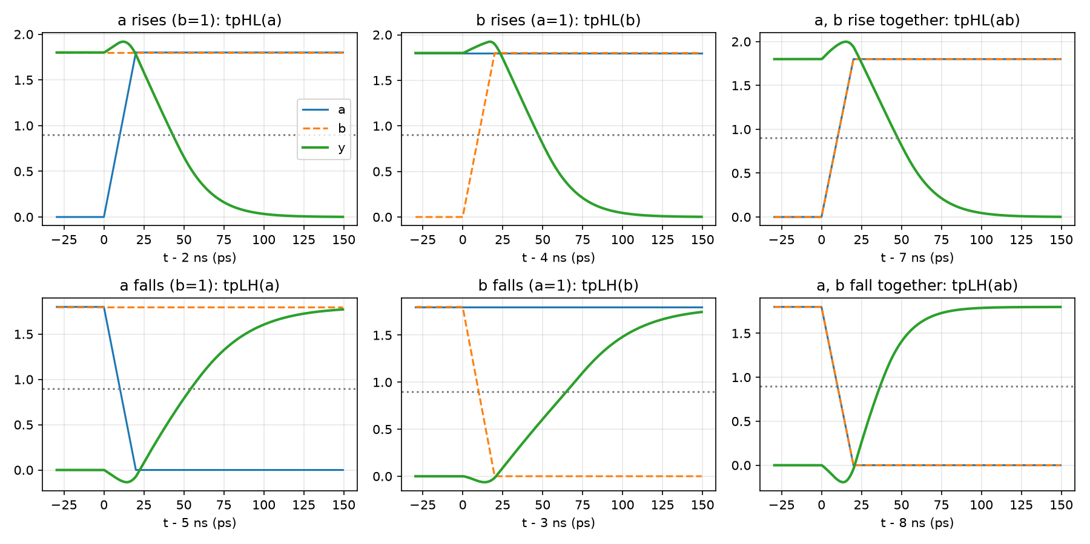
Figure 3.5. Zoom on the six edges used for delay measurement
- t_{pHL}(a) < t_{pHL}(b): when a arrives last, MNB is already on and has discharged n1, so only the output capacitance has to be discharged. When b arrives last, n1 has been charged to about V_{DD} − V_{th} through MNA and must be discharged as well. Hence the latest-arriving signal should drive the transistor closest to the output.
- t_{pLH}(a) < t_{pLH}(b): when b falls (a = 1), MNA stays on, so the rising output also has to charge n1. When a falls, MNA turns off and isolates n1.
- t_{pLH}(ab) is the smallest (26.7 ps) because both PMOS pull up together. t_{pHL}(ab) is the largest of the t_{pHL} values (37.7 ps) because both PMOS still conduct partially during the transition.
Remarks. The NAND gate follows its truth table with rail-to-rail output levels; the average power is 16.95 µW. Thanks to W_{n} = 2 µm the pull-down delay is comparable to the Lab 3 inverter (t_{pHL} = 35.5 ps). The worst-case pull-up delay is larger (54.9 ps when b switches) because the output carries the drain capacitance of the second PMOS and node n1.

CHAPTER 4. LAB 5 – CMOS D FLIP-FLOP

4.1. Circuit design
A positive-edge-triggered D flip-flop is built from two latches in series that operate on opposite clock phases: the master is transparent when clk = 0 and the slave is transparent when clk = 1. The two latches are never transparent at the same time, so Q changes only on the rising edge: Q(next) = D. Each latch uses transmission gates (TG), an NMOS in parallel with a PMOS driven by complementary clocks, which pass both logic levels without a V_{th} drop.
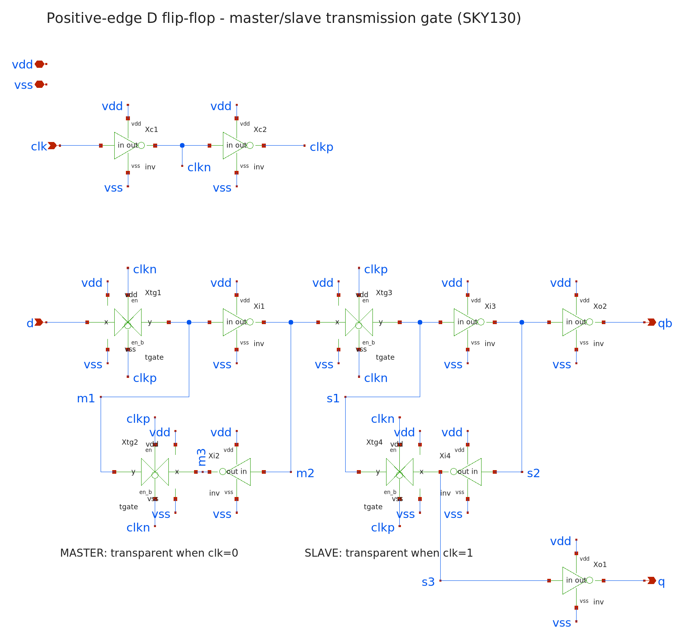
Figure 4.1. Master–slave transmission-gate D flip-flop schematic (dff.sch)
The design is hierarchical, with 12 instances of two sub-cells: inv (reused from Lab 3, W_{n}/W_{p} = 1/2.5 µm) and tgate (Figure 4.2: 1 µm NMOS in parallel with 2.5 µm PMOS), for a total of 24 transistors.
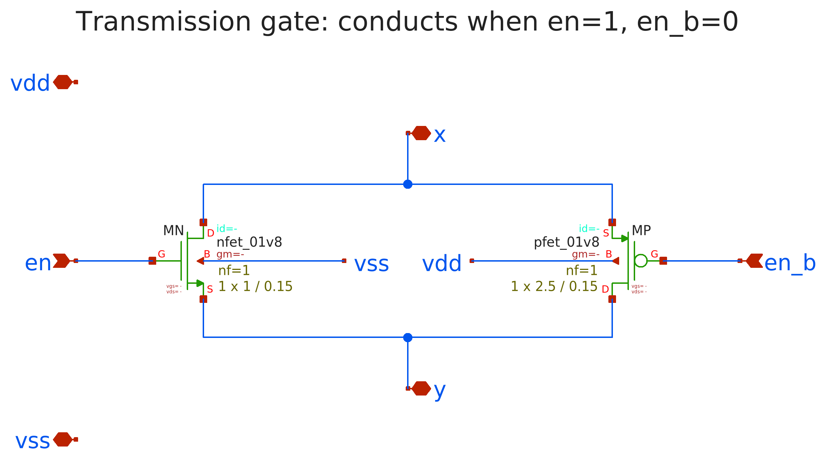
Figure 4.2. Transmission gate schematic (tgate.sch)
Table 4.1. Function of the instances in the D flip-flop
Instance | Cell | Connection | Function
Xc1, Xc2 | inv | clk → clkn → clkp | Local complementary clocks
Xtg1 | tgate | d → m1, open when clk = 0 | Master input
Xi1, Xi2 | inv | m1 → m2 → m3 | Master storage loop
Xtg2 | tgate | m3 → m1, open when clk = 1 | Closes master feedback
Xtg3 | tgate | m2 → s1, open when clk = 1 | Slave input
Xi3, Xi4 | inv | s1 → s2 → s3 | Slave storage loop
Xtg4 | tgate | s3 → s1, open when clk = 0 | Closes slave feedback
Xo1, Xo2 | inv | s3 → q, s2 → qb | Output buffers, isolate storage nodes from the load

Logic values at the nodes: m2 = s1 = D', s2 = D, s3 = D', so q = D and qb = D'. The two local clock inverters give the TGs a complementary clock pair with little skew. The two output inverters prevent an external load from disturbing the feedback loops.

4.2. Test bench
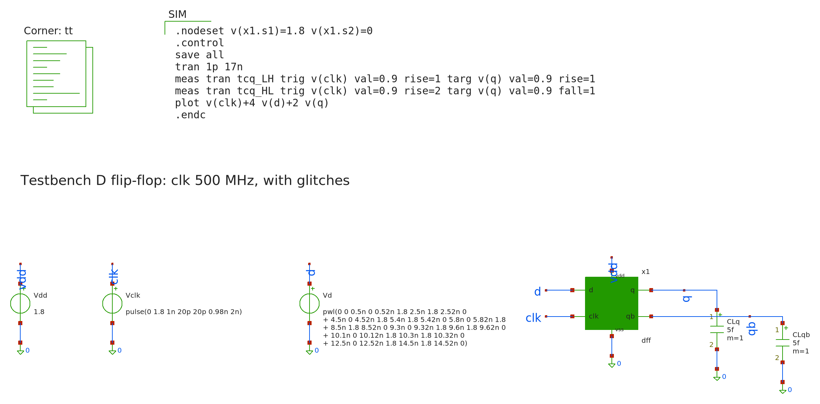
Figure 4.3. D flip-flop test bench (tb_dff.sch)
Functional test: 500 MHz clock (2 ns period, rising edges at 1, 3, …, 15 ns) with a 5 fF load on q and qb. D is chosen so that the sequence 1 0 1 1 0 0 1 0 is sampled at the 8 rising edges, with three glitches added to show that the flip-flop responds only to the clock edge (Table 4.2). The test bench also measures the clock-to-Q delay (t_{cq}) and the average power.
Table 4.2. Glitches on D and expected behavior
Glitch | Time | clk | Expected
D: 1 → 0 → 1 | 5.4–5.8 ns | 1 | Master is holding; Q unchanged (stays 1)
D: 0 → 1 → 0 | 9.3–9.6 ns | 1 | Master is holding; Q unchanged (stays 0)
D: 0 → 1 → 0 | 10.1–10.3 ns | 0 | Master follows but the glitch ends before the 11 ns edge; Q stays 0

Setup/hold measurement: a second test bench sweeps the time at which D changes around the clock edge in 5 ps steps (foreach loop with alterparam). There are four cases, setup and hold, each measured with D rising (capturing 1) and D falling (capturing 0), for a total of 76 simulations. D is considered captured correctly when Q reaches the right value and t_{cq} does not increase by more than 10 % over its nominal value.

4.3. Simulation result

a) Functional check
Table 4.3. Automatic check: Q during the cycle after each edge must equal D at the edge
Edge (ns) | D at edge | Expected Q | Measured Q (V) | Result
1 | 1 | 1 | 1.800 | PASS
3 | 0 | 0 | 4.7e-7 | PASS
5 | 1 | 1 | 1.800 | PASS
7 | 1 | 1 | 1.800 | PASS
9 | 0 | 0 | 4.7e-7 | PASS
11 | 0 | 0 | 4.7e-7 | PASS
13 | 1 | 1 | 1.800 | PASS
15 | 0 | 0 | 4.7e-7 | PASS

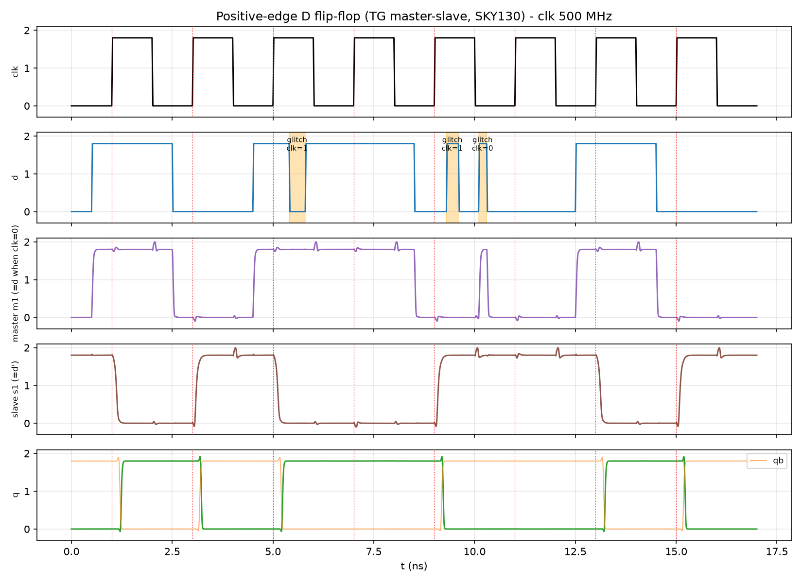
Figure 4.4. Functional waveforms of the D flip-flop (shaded areas are the glitches on D)
All 8 edges PASS. The master node m1 follows D while clk = 0, including the glitch at 10.1 ns, and is locked while clk = 1, so the glitches at 5.4 ns and 9.3 ns do not get in. Q changes only on rising edges, and none of the three glitches affects Q.

b) Clock-to-Q delay and power
Table 4.4. t_{cq} and power (500 MHz clock, 5 fF load)
Parameter | Value
t_{cq} (Q rising) | 230.8 ps
t_{cq} (Q falling) | 213.9 ps
Average power | 76.41 µW

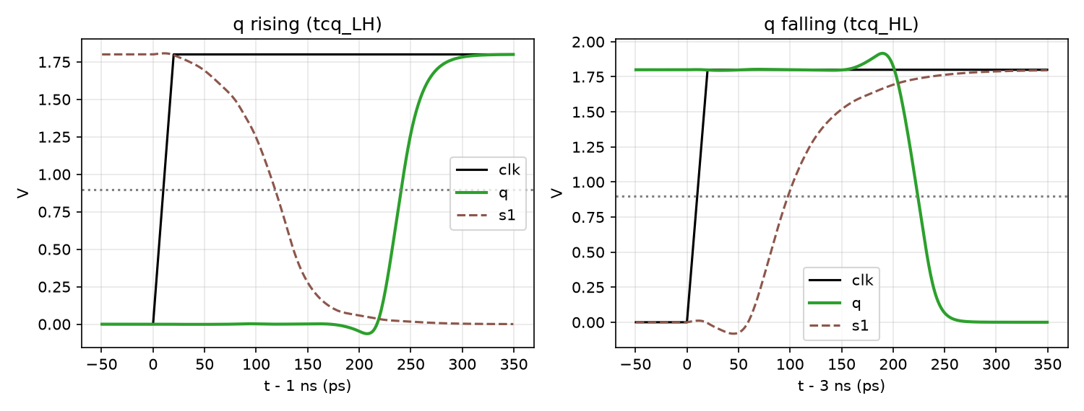
Figure 4.5. Clock-to-Q delay for Q rising (left) and Q falling (right)
t_{cq} ≈ 214–231 ps, equivalent to about 6 inverter stages (2 clock inverters → TG3 → Xi3 → Xi4 → Xo1). The power of 76.41 µW is much higher than that of an inverter because the clock buffers and the 4 TGs switch on every clock cycle, even when D does not change.

c) Setup and hold time
Table 4.5. Setup and hold results (criterion: t_{cq} increase of 10 %)
 | D rising (capture 1) | D falling (capture 0) | Conclusion (worst case)
Nominal t_{cq} | 230.8 ps | 213.9 ps | —
Setup | 0 ps | 20 ps | t_{setup} ≈ 20 ps
Hold | 5 ps | 40 ps | t_{hold} ≈ 40 ps

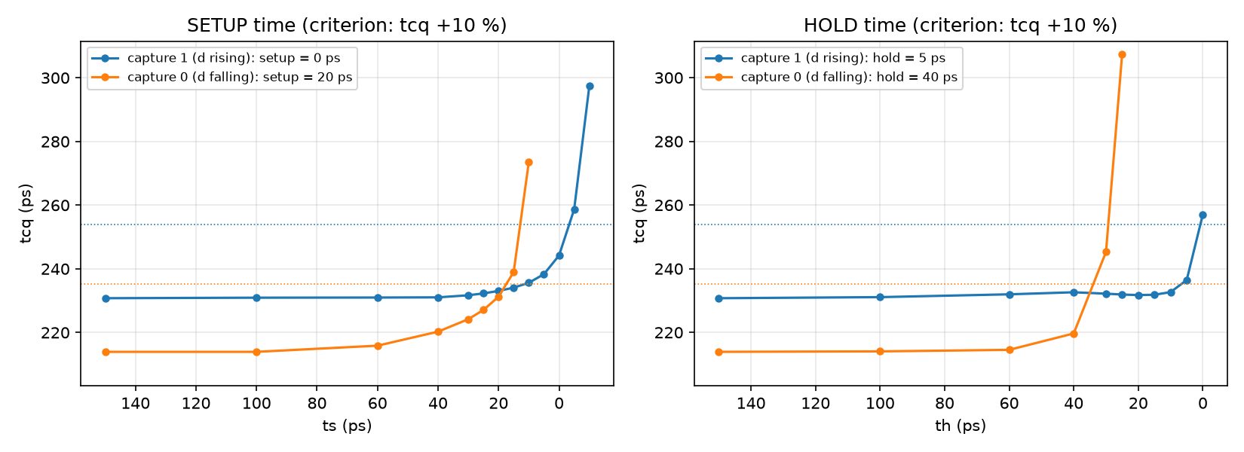
Figure 4.6. t_{cq} versus the time D changes relative to the clock edge: setup (left), hold (right)
- The closer D changes to the clock edge, the larger t_{cq} becomes, because the master latch has not settled before it closes. If D arrives too late, the flip-flop captures the wrong value. The curves show the steep "wall" predicted by theory.
- Setup is small (0/20 ps) and hold is positive (40 ps): TG1 does not close exactly at the clock edge but two inverter delays later, after clkn/clkp switch. D can therefore arrive right at the edge, but it must be held for a short time after it. The sampling window is ≈ 60 ps.
Remarks. The 24-transistor D flip-flop works correctly: it samples D on the rising edge and ignores changes of D away from the edge. Key figures at TT/27 °C/1.8 V: t_{cq} ≈ 231 ps, t_{setup} ≈ 20 ps, t_{hold} ≈ 40 ps, power ≈ 76 µW at 500 MHz.

CHAPTER 5. CONCLUSION
Table 5.1. Summary of the three labs (TT, 27 °C, 1.8 V)
Lab | Circuit design | Test bench | Simulation result
3 | Inverter, 2 transistors, W_{n}/W_{p} = 1/2.5 µm | DC, transient, W_{p} and C_{L} sweeps | V_{M} = 0.884 V; NM ≥ 0.68 V; t_{p} = 36.6 ps @ 10 fF
4 | NAND, 4 transistors, W_{n} = 2 µm, W_{p} = 2.5 µm | Transient over 4 combinations, DC for 3 cases | Truth table correct; V_{M} = 0.831–0.924 V; worst-case delay 54.9 ps
5 | Master–slave TG DFF, 24 transistors | Function + glitches, setup/hold sweep | 8/8 PASS; t_{cq} = 231 ps; setup/hold = 20/40 ps

All three circuits were designed at the transistor level as hierarchical schematics in xschem, verified with test benches that measure results automatically, and simulated in ngspice with the real SKY130 process models. The simulation results confirm that the circuits work correctly and agree with theory: sharp DC characteristics with large noise margins; delays that depend on sizing, load and transistor position; and a flip-flop that samples correctly on the rising edge with reasonable timing parameters.
Limitations: the results are pre-layout simulations at the TT corner and 27 °C; setup/hold values have a 5 ps resolution.

REFERENCES
[1] Ho Anh Trang, VLSI Design Lab (lecture slides), Vietnam - Korea University of Information and Communication Technology.
[2] J. M. Rabaey, A. Chandrakasan, B. Nikolić, Digital Integrated Circuits: A Design Perspective, 2nd ed., Prentice Hall, 2003.
[3] N. H. E. Weste, D. M. Harris, CMOS VLSI Design: A Circuits and Systems Perspective, 4th ed., Addison-Wesley, 2011.
[4] SkyWater Technology, SkyWater SKY130 PDK Documentation, https://skywater-pdk.readthedocs.io
[5] H. Vogt et al., Ngspice User's Manual, version 47.
[6] S. F. Schippers, XSCHEM Manual, https://xschem.sourceforge.io/stefan/xschem_man/xschem_man.html

APPENDIX. NETLISTS AND TEST BENCH
This appendix lists the SPICE netlists of the cells (circuit design) and one example test bench. The netlists generated by xschem from the schematics match these netlists in connectivity and sizing.

A. Inverter netlist – lab3/netlist/inv.spice
* ============================================================
* Lab 3 : CMOS Inverter - SKY130 (1.8 V core device)
*
* vdd
* |
* |---+
* in ---o| MP (pfet_01v8, W=wp, L=l)
* |---+
* |
* +------- out
* |
* |---+
* in -----| MN (nfet_01v8, W=wn, L=l)
* |---+
* |
* vss
*
* Sizes are in um (the PDK sets .option scale=1e-6).
* ============================================================
* ad/as/pd/ps/nrd/nrs: area, perimeter and resistance of the diffusion regions
* (same formulas as the xschem symbols, 0.29 um = S/D region length).
.subckt inv in out vdd vss params: wn=1 wp=2.5 l=0.15
XMP out in vdd vdd sky130_fd_pr__pfet_01v8 W={wp} L={l}
+ ad={wp*0.29} as={wp*0.29} pd={2*(wp+0.29)} ps={2*(wp+0.29)} nrd={0.29/wp} nrs={0.29/wp}
XMN out in vss vss sky130_fd_pr__nfet_01v8 W={wn} L={l}
+ ad={wn*0.29} as={wn*0.29} pd={2*(wn+0.29)} ps={2*(wn+0.29)} nrd={0.29/wn} nrs={0.29/wn}
.ends inv

B. NAND netlist – lab4/netlist/nand.spice
* ============================================================
* Lab 4 : CMOS NAND - SKY130 (1.8 V core device)
*
* vdd vdd
* | |
* |---+ |---+
* a ----o| MPA b-o| MPB (2 parallel PMOS)
* |---+ |---+
* | |
* +-----+------+
* |
* +-------- y = (a.b)'
* |
* |---+
* a ------------| MNA (2 series NMOS)
* |---+
* | n1
* |---+
* b ------------| MNB
* |---+
* |
* vss
*
* Sizing (um): 2 series NMOS -> Wn = 2 x 1 = 2, so the pull-down
* resistance equals the reference inverter (Wn=1). Parallel PMOS -> keep
* Wp = 2.5 (worst case: only 1 PMOS on, same as the reference inverter).
* ============================================================
* ad/as/pd/ps/nrd/nrs: area, perimeter and resistance of the diffusion regions
* (same formulas as the xschem symbols, 0.29 um = S/D region length).
.subckt nand a b y vdd vss params: wn=2 wp=2.5 l=0.15
XMPA y a vdd vdd sky130_fd_pr__pfet_01v8 W={wp} L={l}
+ ad={wp*0.29} as={wp*0.29} pd={2*(wp+0.29)} ps={2*(wp+0.29)} nrd={0.29/wp} nrs={0.29/wp}
XMPB y b vdd vdd sky130_fd_pr__pfet_01v8 W={wp} L={l}
+ ad={wp*0.29} as={wp*0.29} pd={2*(wp+0.29)} ps={2*(wp+0.29)} nrd={0.29/wp} nrs={0.29/wp}
XMNA y a n1 vss sky130_fd_pr__nfet_01v8 W={wn} L={l}
+ ad={wn*0.29} as={wn*0.29} pd={2*(wn+0.29)} ps={2*(wn+0.29)} nrd={0.29/wn} nrs={0.29/wn}
XMNB n1 b vss vss sky130_fd_pr__nfet_01v8 W={wn} L={l}
+ ad={wn*0.29} as={wn*0.29} pd={2*(wn+0.29)} ps={2*(wn+0.29)} nrd={0.29/wn} nrs={0.29/wn}
.ends nand

C. D flip-flop netlist – lab5/netlist/dff.spice
* ============================================================
* Lab 5 : CMOS D Flip-Flop (master-slave, transmission gate,
* positive-edge triggered) - SKY130 1.8 V
*
* clk --[INV]-- clkn --[INV]-- clkp (local complementary clocks)
*
* MASTER (transparent clk=0) SLAVE (transparent clk=1)
*
* d --[TG1]--+--[INV]--+--[TG3]--+--[INV]--+--[INV]-- qb
* clk=0 | m1 | m2 clk=1 s1 | s2
* | | | |
* +--[TG2]--[INV]--+ +--[TG4]--[INV]--+
* clk=1 m3 clk=0 s3
* s3 --[INV]-- q
*
* m2 = d', s1 = m2 = d', s2 = d, s3 = d'
* q = inv(s3) = d qb = inv(s2) = d'
* The two output inverters isolate the storage nodes from the load.
*
* Total: 2 clock INV + 4 TG + 4 core INV + 2 output INV = 24 transistors
* ============================================================

* ---- Inverter (same as Lab 3: Wn = 1, Wp = 2.5) ----
* ad/as/pd/ps/nrd/nrs: area, perimeter and resistance of the diffusion regions
* (same formulas as the xschem symbols, 0.29 um = S/D region length).
.subckt inv in out vdd vss params: wn=1 wp=2.5 l=0.15
XMP out in vdd vdd sky130_fd_pr__pfet_01v8 W={wp} L={l}
+ ad={wp*0.29} as={wp*0.29} pd={2*(wp+0.29)} ps={2*(wp+0.29)} nrd={0.29/wp} nrs={0.29/wp}
XMN out in vss vss sky130_fd_pr__nfet_01v8 W={wn} L={l}
+ ad={wn*0.29} as={wn*0.29} pd={2*(wn+0.29)} ps={2*(wn+0.29)} nrd={0.29/wn} nrs={0.29/wn}
.ends inv

* ---- Transmission gate: conducts when en=1 (en_b=0) ----
.subckt tgate x y en en_b vdd vss params: wn=1 wp=2.5 l=0.15
XMN x en y vss sky130_fd_pr__nfet_01v8 W={wn} L={l}
+ ad={wn*0.29} as={wn*0.29} pd={2*(wn+0.29)} ps={2*(wn+0.29)} nrd={0.29/wn} nrs={0.29/wn}
XMP x en_b y vdd sky130_fd_pr__pfet_01v8 W={wp} L={l}
+ ad={wp*0.29} as={wp*0.29} pd={2*(wp+0.29)} ps={2*(wp+0.29)} nrd={0.29/wp} nrs={0.29/wp}
.ends tgate

* ---- Positive-edge D flip-flop ----
.subckt dff d clk q qb vdd vss
* local clocks
Xc1 clk clkn vdd vss inv
Xc2 clkn clkp vdd vss inv
* master latch
Xtg1 d m1 clkn clkp vdd vss tgate
Xi1 m1 m2 vdd vss inv
Xi2 m2 m3 vdd vss inv
Xtg2 m3 m1 clkp clkn vdd vss tgate
* slave latch
Xtg3 m2 s1 clkp clkn vdd vss tgate
Xi3 s1 s2 vdd vss inv
Xi4 s2 s3 vdd vss inv
Xtg4 s3 s1 clkn clkp vdd vss tgate
* output buffers
Xo1 s3 q vdd vss inv
Xo2 s2 qb vdd vss inv
.ends dff

D. Inverter transient test bench – lab3/tb/tb_tran.sp
* ============================================================
* Lab 3 - Testbench 3: transient response
* Input pulse 0/1.8 V, tr = tf = 20 ps, period 2 ns.
* Load CL = 10 fF (~ fan-out of a few gates).
* Measures: tpHL, tpLH, tp, tr (10-90 %), tf (90-10 %), average power.
* Then sweeps CL to show that delay grows linearly with load.
* ============================================================
.include ../netlist/sky130_models.spice
.include ../netlist/inv.spice

Vdd vdd 0 1.8
Vin in 0 pulse(0 1.8 0.5n 20p 20p 1n 2n)
X1 in out vdd 0 inv wn=1 wp=2.5
CL out 0 10f

.control
tran 1p 4.5n
meas tran tpHL trig v(in) val=0.9 rise=1 targ v(out) val=0.9 fall=1
meas tran tpLH trig v(in) val=0.9 fall=1 targ v(out) val=0.9 rise=1
meas tran tf trig v(out) val=1.62 fall=1 targ v(out) val=0.18 fall=1
meas tran tr trig v(out) val=0.18 rise=1 targ v(out) val=1.62 rise=1
meas tran IAVG avg i(Vdd) from=0.5n to=4.5n
let tp = (tpHL + tpLH)/2
let PAVG = -IAVG*1.8
let EDYN = 10f*1.8*1.8
let PDYN = EDYN*500e6
echo
echo "============= TRANSIENT RESULTS - INVERTER (CL = 10 fF) ============="
print tpHL tpLH tp tr tf PAVG PDYN
echo "===================================================================="
wrdata tran.dat v(in) v(out) i(Vdd)

* ---- Load (CL) sweep ----
echo "# CL(fF) tpHL(ps) tpLH(ps)" > load.dat
foreach cl 2 5 10 20 50 100
let cval = $cl*1e-15
alter CL = $&cval
tran 1p 4.5n
meas tran a trig v(in) val=0.9 rise=1 targ v(out) val=0.9 fall=1
meas tran b trig v(in) val=0.9 fall=1 targ v(out) val=0.9 rise=1
let hl = a*1e12
let lh = b*1e12
echo "$cl $&hl $&lh" >> load.dat
end
shell cat load.dat
.endc
.end

