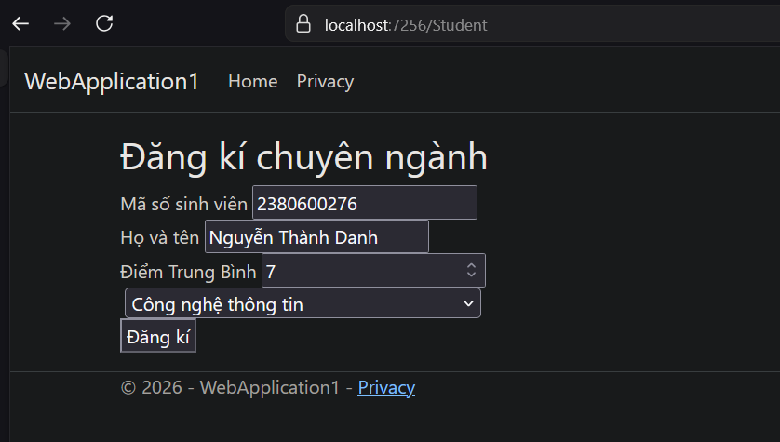
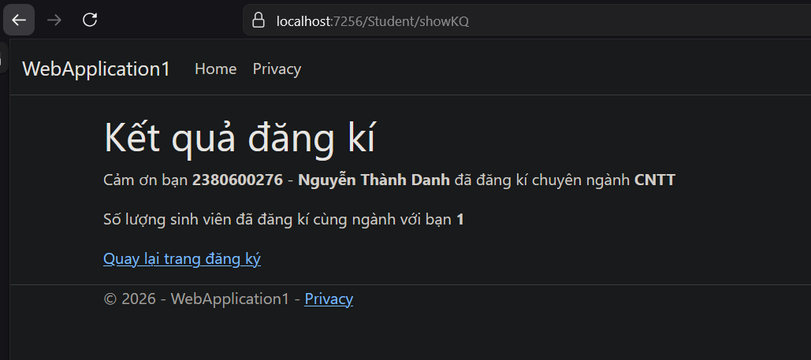
https://drive.google.com/drive/folders/1i0yqzMXpo2TvH8bjEfG6Z1_uAIdJoV_t?usp=drive_link

