Static signal analysis consists in the analysis of inertial
signals assuming that the subject measured is in a static posture, so that only gravity
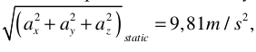
would be measured by an accelerometer, i.e.

, where
a x , a y , a z are accelerations measured in the three axis of the triaxial accelerometer

One axis will be the primary source of data. This is the axis whose direction is towards the ground when the wearer is in stand still condition.

There are three classifiers to be implemented and used.

PT Classifier → Y Classifier → SiSt classifier

Following the hierarchy of classifiers, when a window acquisition is completed, a
STFT is firstly performed in order to consider whether a PT has occurred or not. Then, YW (window average value of Y axis) is analysed.
The accuracy of the algorithm depends greatly on how the posture positions (Sit, Lie, Stand) are classified using data.

