Daniel Pham

260 526 252

Artificial Intelligence

Homework #3

**Only partially completed.**

**Question 1: Designing a Bayes Net.**

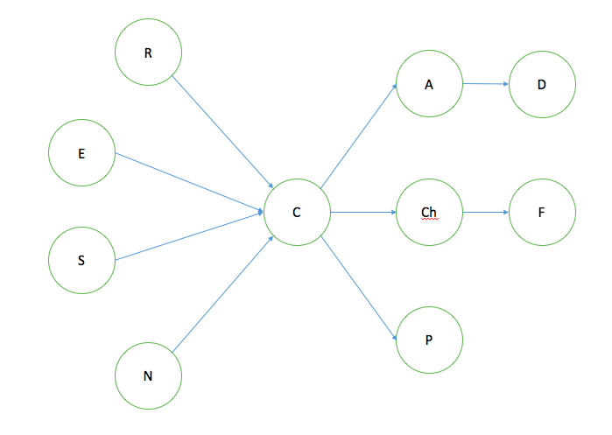

P(R) = .90

P(E) = .60

P(S) = 0.17

P(N) = 0.70

P(C) = .40

P(C | R, E, S N)

P(P) =

P(P | C) =

P(Ch) =

P(Ch | C)

P(F) =

P(F | Ch)

P(A) =

P(A | C)

P(D) =

P(D | A)

References:

<http://www.cancer.ca/en/cancer-information/cancer-101/cancer-statistics-at-a-glance/?region=on>

**Question 2: Inference in a Bayes Net.**

(a) P(rush_hour, sirens)

**Question 3: Variable Elimination.**

Pick an ordering: rush_hour, bad_weather, accident, traffic_jam, sirens

Initialize:

P(R), P(B), P(A | B), P(T | R, B, A), P(S | A), 𝛿(R, 1)

Eliminate R: mR(T, B, A) = ∑r P(r) P(T | r, B, A) 𝛿(r, 1)

~~P(R),~~ P(B), P(A | B), ~~P(T | R, B, A)~~, P(S | A), ~~𝛿(R, 1)~~

* P(B), P(A | B), P(S | A), mR(T, B, A)

Eliminate B: mB(A, T) = ∑b P(b) P(A | b) mR(T, b, A)

~~P(B),~~ ~~P(A | B),~~ P(S | A), ~~m~~~~R~~~~(T, B, A)~~

* P(S | A) mB(A, T)

Eliminate A: mA(S, T) = ∑a P(S | a) mB(a, T)

~~P(S | A)~~ ~~m~~~~B~~~~(A, T)~~

* mA(S, T)

Eliminate T: mT(S) = ∑t mA(S, t)

~~m~~~~A~~~~(S, T)~~

* mT(S)