Daniel Pham

260 526 252

Artificial Intelligence

Homework #4

Question 1: Learning Bayes Net parameters

Probability of finding mosquitoes in the surroundings.

* + P(M) = 0.24

Prob of diagnosing zika given that there are mosquitoes.

* + P(Z | M) = 0.48

Prob of zika if no mosquitoes.

* + P(Z | !M) = 0

Prob of fever symptoms given a zika diagnosis.

* + P(F | Z) = 0.55

Prob of fever symptoms given no zika diagnosis.

* + P(F | !Z) = 0.09

Prob of rash symptoms given a zika diagnosis.

* + P(R | Z) = 0.41

Prob of rash symptoms given no zika diagnosis.

* + P(R | !Z) = 0.24
  1. Weights

wM1=0 = , wM1=1, wZ2=0, wZ2=1.

* 1. Bernoulli variable
     + P(F | Z) = 0.50
     + P(F | !Z) = 0.33
  2. Uniform distribution
     + A
  3. Gaussian distribution
     + A

Question 2: Hidden Markov Models

1. Model

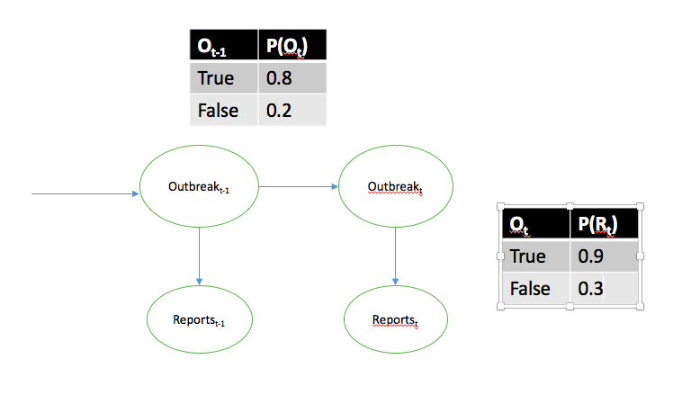

1. {No, No, Yes}

|  |  |  |  |
| --- | --- | --- | --- |
|  | 1 | 2 | 3 |
| p | 0.015 |  |  |
| a |  |  |  |

Fill in first column:

P(N | St = p) * P(St = p) = 0.3 * 0.05 = 0.015

Fill in second column:

P(N | S2 = p) ( P(S2 = p | S1 = p) * ap, 1 + P(S2 = p | S1 = a) * aa, 1) =

1. Probability of sequence and outbreak