MINISTRY OF EDUCATION AND TRAINING

HCMC UNIVERSITY OF TECHNOLOGY AND EDUCATION

FACULTY FOR HIGH QUALITY TRAINING

~~~~~~*~~~~~~



**FINAL PROJECT**

Attendance Application

*Course : Object-oriented software design*

*Lecturer: Dr Huynh Xuan Phung*

*Group 3: Hoàng Ngọc Bảo Trân 18110057*

*Phạm Quang Danh 18110004*

*Phan Ngọc Bảo Tuyền 18110062*

Ho Chi Minh, May 2021

## Current status analysis:

Each semester has nearly 500 subject classes. Each class can have up to 100-150 students. Every day, teachers who go to class must open a monitoring board to take attendance.

Lecturers do not know the number of students absent in each study shift, daily, weekly or monthly. But leaders need to understand the situation of students to have specific solutions.

At the end of each semester, open the monitoring sheet to count the number of absent periods of students, calculate the attendance score manually => waste time for the teacher.

In fact, the management of absentee students at universities of education and training. The room is also manual and ineffective in management. The current management work is mainly done manually, it takes a lot of time. The need for a management system would be the best option for dealing with the current situation. Through the process of research and analysis, it shows the ineffectiveness of the current management process, raises new requirements for student management and behavior classification, thereby proposing solutions to overcome the current difficulties in order to improve the effectiveness in management at the university and accelerate the process of applying computerization in student management at the University of Science and Technology.

**Software introduction:** Attendance application based on student's location, each subject will have its own classroom location. Students entering the classroom (in a pre-set location set by the instructor) can take attendance.

Request :

**• Storing information:**

· Student and lecturer information.

· Student learning schedule, Lecture schedule of lecturers.

· Teaching information as well as the teacher's teaching history.

· Attendance for students and teachers to take attendance.

Statistics reports on school with permission and without permission (time in and out of class, how many minutes late)

Reporting: Course Report, Student Report, Class Report.

**•Search :**

· Look up subjects

· Look up the number of excused / unexcused absences

· Look up student / lecturer information

· Look up classrooms

**• Output:**

Number of absences per term in a subject.

Summary of study program, suggestions for the next semester

* Week 05.

**Division (user): Student ID: IE**

|  |  |  |  |  |  |
| --- | --- | --- | --- | --- | --- |
| 1 | Attendance | Manage student/teacher |  |  |  |
|  | Searching | Manage student/school | • Student learning information as well as learning history.  • Teaching information as well as teacher's teaching history.  • Grades of Students and Teachers.  • Classing for students  • Academic results  • Reports: Course Reports, Student Reports, Class Reports |  |  |
| 3 | Report | Manage student | • Reports: Course Reports, Student Reports, Class Reports |  |  |

**Division (user):** adminstrator **ID: CA**

|  |  |  |  |  |  |
| --- | --- | --- | --- | --- | --- |
| **OD** | **Function** | **Type** | **Constraint/ Formula Code** | **Form code** | **Notes** |
| 1 | Search Infomation | Manage student/teacher | Search student/teacher function is based on information, namely:   * Name * ID |  |  |
| 2 | Edit | Manage student/teacher | Edit infomation function needs: |  |  |
| 3 | Print result of student | Manage student | Print function needs:   * student details * Score |  |  |
| 4 | Report | Manage student/teacher/parents | Chat with admin |  |  |

**Division (user): Parent ID: MA**

|  |  |  |  |  |  |
| --- | --- | --- | --- | --- | --- |
| **OD** | **Function** | **Type** | **Constraint/ Formula Code** | **Form code** | **Notes** |
| 1 | Search infomation | Manage product | Search based on information, namely:   * Name * ID |  |  |
| 2 | Report | Manage student/teacher/school | * Chat with admin |  |  |

**Division (user): teacher ID: SD**

|  |  |  |  |  |  |
| --- | --- | --- | --- | --- | --- |
| **OD** | **Function** | **Type** | **Constraint/ Formula Code** | **Form code** | **Notes** |
| 1 | Attendance | Manage student |  |  |  |
| 3 | Searching | Manage student | View teacher's schedule flexibly  • Student admissions  • Timely registration for teaching schedule  • Academic results  • View the number of sessions taught and the number of absences |  |  |

* **System functional requirements:**

**Decentralization:**

|  |  |  |  |
| --- | --- | --- | --- |
| **ID** | **Contents** | **Description** | **Notes** |
| 1 | Role management | - Administrator holds the roles  - Teachers are enabled to take attendance, students must take attendance within a certain time and place  - Parents have the right to see teacher information, and their children |  |

### Non-functional requirements:

* **User related:**

|  |  |  |  |  |
| --- | --- | --- | --- | --- |
| **ID** | **Contents** | **Criteria** | **Description** | **Note** |
| 1 | Software can be updated and modified to adapt the trend of customers as well as the requirements of managing of the owners. | Resilience |  |  |
| 2 | Graphic User-Interface:   * User-friendly. * Easy manipulation. * Feature buttons are laid out simple, convenient and visible. * Functional windows can interact with each other, provide users with efficiency. | Usability |  |  |
| 3 | * Database is kept secure and easy to be accessed. * The system operates stable, reliable and instant response. | Efficiency |  |  |
| 4 | * Computers in the network can share the resources though installed software. * Software can meet the requirements of users without making silo effect. | Compatibility |  |  |

* **Staff-related:**

|  |  |  |  |  |
| --- | --- | --- | --- | --- |
| **ID** | **Contents** | **Criteria** | **Description** | **Note** |
| 1 | * The module, source code and other proportion of the system can be reused for latter projects. * The source code can be recycled and applied for other programs without changing the cores. | Reusability |  |  |

* **Quality**

|  |  |  |  |  |
| --- | --- | --- | --- | --- |
| **ID** | **Contents** | **Criteria** | **Description** | **Note** |
| 1 | The search information student/teacher function is convenient and visible. | Convenience | Support the keyword-like searching. |  |
| 2 | Allow edit information based on Excel file (CSV)  UI Design is unity. | Compatibility |  |  |
| 3 | Processing time is acceptable | Effectiveness | Support QR Code Scanner. |  |

# **USE CASE MODELING**

## **Define Use Case Actor and Function**

|  |  |
| --- | --- |
| **Actor** | **Features** |
| **Student** | * Login * Register * Search information * View Calendar * Attendance * History attendance * View notification * Edit personal information * Location * Face recognition |
| **Teacher** | * Login * Register * Search information * View Calendar * Send notification * Face regconition * Manage Student * Manage Class * Edit personal information |
| **Administrator** | * Login * Register * Search information * View Calendar * History attendance * Manage Class * Manage Teacher * Manage Student |

## **Function Description**

### Student

|  |  |  |
| --- | --- | --- |
| **Order** | **Feature** | **Description** |
| 1 | Login | Allow customers to log in to the system |
| 2 | Register | Allow Student to create an account to log into the system |
| 3 | Search information | Allow Student to search for cources, teacher, student. |
| 4 | View calendar | Allow Student view their schedule |
| 5 | Attendance | Allow Student check attendance |
| 6 | History attendance | Allow Student view what class they join or don’t join |
| 7 | View notification | Allow Student follow notification of teacher |
| 9 | Face recognition | Allow App can confirm right person use this account |
| 10 | Edit personal information | Allow customers to change personal information (password/ address) |

### Teacher

|  |  |  |
| --- | --- | --- |
| **Order** | **Feature** | **Description** |
| 1 | Login | Allow Teacher to log in to the system |
| 2 | Register | Allow Teacher to create an account to log into the system |
| 3 | Search information | Allow Teacher to search for cources, teacher, student. |
| 4 | View calendar | Allow view their schedule |
| 5 | Manage Student | Allow Teacher can view student history |
| 6 | Manage Class | Allow Teacher edit class room, add and delete student in class |
| 7 | Sent notification | Allow Teacher sent notification for student |
| 8 | Face recognition | Allow App can confirm right person use this account |
| 9 | Edit personal information | Allow customers to change personal information (password/ address) |

### 1.2.3. Administrator

|  |  |  |
| --- | --- | --- |
| **Order** | **Feature** | **Description** |
| 1 | Login | Allow Admin to log in to the system |
| 2 | View calendar | Allow view all schedule Class |
| 3 | Search information | Allow Teacher to search for cources, teacher, student. |
| 3 | Face recognition | Allow App can confirm right person use this account |
| 4 | Manage Class | Allow add, edit, delete, view class information |
| 5 | Manage Teacher | Allow add, edit, delete, view teacher information |
| 6 | Manage Student | Allow add, edit, delete, view student information |

## Use Case Diagram

### Use Case Diagram

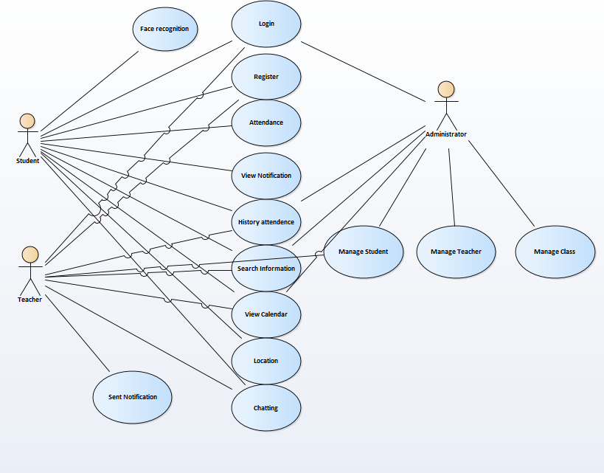

*Figure 1. Usecase diagram*

### Use Case Specification

#### Login

|  |  |
| --- | --- |
| **Name** | Log In |
| **Brief Description** | The way user website logins |
| **Actor(s)** | Student/Teacher/Admin login into system |
| **Flow of Events** | |
| **Basic Flow** | |
| This usecase starts when the user wants to access the system   1. Student/Teacher/Admin select “Login” function on the system 2. The system displays the “Login” page 3. Student/Teacher/Admin enter the correct username and password then click "Log in" 4. The system will return user to Homepage. | |
| **Alternate Flows** | |
| **Title** | **Description** |
| Enter the wrong login information | 1. If the Student/Teacher/Admin enters an invalid password:  1.1. The system will ask the user to re-enter the password.   * The system determined the password is incorrect. * The system provides options for Student/Teacher/Admin to retrieve a forgotten password.   2. If the user enters an invalid username:   * Error system. |
| **Pre-Conditions** | |
| **Title** | **Description** |
|  | Student/Teacher/Admin already has an account on the system |
| **Post-Conditions** | |
| **Title** | **Description** |
| Success | Log in successful, the user accesses the system. |
| Failure | Log in failed, the users cannot log in. |
| **Extension Points** | |
| None | |

#### Register

|  |  |
| --- | --- |
| **Name** | Register |
| **Brief Description** | The way students/teacher creates an account |
| **Actor(s)** | Students - teacher |
| **Flow of Events** | |
| **Basic Flow** | |
| This Student/Teacher/Admin starts when the customer chooses the function to register   1. Customer chooses the "Register" function in the system. 2. The system displays "Register’’ page with information about username, password, phone number, email, address. 3. Customer fills out the above information and press the "Register" button. 4. The notification system has successfully register. | |
| **Alternate Flows** | |
| **Title** | **Description** |
| Fill out the information missing | 1. The system requires re-fill and full information in the "Register" page. |
| **Pre-Conditions** | |
| **Title** | **Description** |
|  | Student/Teacher/Admin successfully connected to the system |
| **Post-Conditions** | |
| **Title** | **Description** |
| Success | Register successful, Students/Teacher create account successfully. |
| Failure | Register failed, Student/teacher create account failure. |
| **Extension Points** | |
| None | |

#### Attendance

|  |  |
| --- | --- |
| **Name** | Attendance |
| **Brief Description** | The way student and teacher check attendance |
| **Actor(s)** | Students - teacher |
| **Flow of Events** | |
| **Basic Flow** | |
| This usecase starts when the users chooses the function to a   1. Student login in the system 2. The system displays the information of student/teacher. Then they choose subject. 3. Next, they check face recognition 4. Customer fills out the above information and press the " OK " button. 5. The notification system has successfully when information input is correct. | |
| **Alternate Flows** | |
| **Title** | **Description** |
| Fill out the information missing | 1. The system requires re-fill and full information of users |
| **Pre-Conditions** | |
| **Title** | **Description** |
|  | The users successfully login into the website. |
| **Post-Conditions** | |
| **Title** | **Description** |
| Success | Attendance successful. |
| Failure | Attendance failed. |
| **Extension Points** | |
| None | |

#### View Notice

|  |  |
| --- | --- |
| **Name** | View Notice |
| **Brief Description** | The way user view notice |
| **Actor(s)** | Students/teacher |
| **Flow of Events** | |
| **Basic Flow** | |
| This usecase starts when the customer chooses the function to view information ò notice   1. User chooses the " notification " function in the system. | |
| **Alternate Flows** | |
| **Title** | **Description** |
| Customer clicks "Cancel" button | 1. The system returns the customer to the “notification” page. |
| **Pre-Conditions** | |
| **Title** | **Description** |
|  | User successfully accessed into the” notification” page. |
| **Post-Conditions** | |
| **Title** | **Description** |
| Success | View successfully |
| Failure | View failed, user cann’t view notification failure. |
| **Extension Points** | |
| None | |

#### Location

|  |  |
| --- | --- |
| **Name** | Location |
| **Brief Description** | The way admin and teacher view location of part of attendance |
| **Actor(s)** | Student and teacher |
| **Flow of Events** | |
| **Basic Flow** | |
| This student and teacher starts want to check location on time   1. Student chooses the type to check location. 2. Customer clicks "Yes" button. 3. The notification system has successfully check location. | |
| **Alternate Flows** | |
| **Title** | **Description** |
| Customer clicks "No" button | 1. The system returns to the "Manage cart" page. |
| **Pre-Conditions** | |
| **Title** | **Description** |
|  | User successfully accessed into the “Manage cart” page. |
| **Post-Conditions** | |
| **Title** | **Description** |
| Success | Check location successful. |
| Failure | Check location failed. |
| **Extension Points** | |
| None | |

#### Search information

|  |  |
| --- | --- |
| **Name** | Search information |
| **Brief Description** | The way teacher/Admin can search information |
| **Actor(s)** | Teacher/Admin |
| **Flow of Events** | |
| **Basic Flow** | |
| This usecase starts when the teacher/admin chooses the function to search information   1. Customer access Information cart 2. Customer clicks "Search Information " button. 3. Search Information in system has successfully. | |
| **Alternate Flows** | |
| **Title** | **Description** |
| Customer clicks “Information " button | 1. The system returns the manager to the "Information " page. |
| **Pre-Conditions** | |
| **Title** | **Description** |
|  | Students/ Teacher successfully accessed into the “Information cart” page. |
| **Post-Conditions** | |
| **Title** | **Description** |
| Success | Search successful, teacher and admin view information successfully |
| Failure | The user cann’t be found |
| **Extension Points** | |
| None | |

#### Search product

|  |  |
| --- | --- |
| **Name** | Search product information |
| **Brief Description** | The way customer search product information |
| **Actor(s)** | Customer |
| **Flow of Events** | |
| **Basic Flow** | |
| This usecase starts when the customer chooses the function to search product information   1. Customer chooses the "Search product" function in the system. 2. The system displays “Search product" page. 3. Customer enter information and press the "Search" button. 4. The system displays product information according to the keyword entered. | |
| **Alternate Flows** | |
| **Title** | **Description** |
| The seller enters a keyword that is not in the database | 1. Notification system doesn't have the kind of product that user looking for |
| **Pre-Conditions** | |
| **Title** | **Description** |
|  |  |
| **Post-Conditions** | |
| **Title** | **Description** |
| Success | Search successful, customer search product information successfully. |
| Failure | Search failed, customer search product information failure. |
| **Extension Points** | |
| None | |

#### Chatting

|  |  |
| --- | --- |
| **Name** | Chatting |
| **Brief Description** | The way Students/ Teacher choose the order chatting method |
| **Actor(s)** | Students/ Teacher |
| **Flow of Events** | |
| **Basic Flow** | |
| This usecase starts after the Students/ Teacher choose the chatting method.   1. Students/ Teacher chooses the button "Chatting" in the system. Then, student will get ID from admin. 2. Students/ Teacher clicks “ start “ to begin | |
| **Alternate Flows** | |
| **Title** | **Description** |
| Customer clicks "No" button | 1. The system returns the manager to the "Manage cart" page. |
| **Pre-Conditions** | |
| **Title** | **Description** |
|  | Users successfully accessed into the “Chatting ” page. |
| **Post-Conditions** | |
| **Title** | **Description** |
| Success | Chatting successful. |
| Failure | Cann’t connect |
| **Extension Points** | |
| None | |

#### View calendar

|  |  |
| --- | --- |
| **Name** | View calendar |
| **Brief Description** | The way student and teacher view calendar |
| **Actor(s)** | Students/ Teacher |
| **Flow of Events** | |
| **Basic Flow** | |
| This usecase starts when the users chooses the function to View calendar   1. Students/ Teacher choose the product that they want to read more detail 2. The system redirects Students/ Teacher to the view calendar detail | |

#### Edit personal information

|  |  |
| --- | --- |
| **Name** | Edit personal information. |
| **Brief Description** | The way admin edit personal information |
| **Actor(s)** | Admin |
| **Flow of Events** | |
| **Basic Flow** | |
| This usecase starts when the user chooses the function to edit personal information.   1. User chooses the "Edit personal information" function in the system. 2. The system displays “Edit personal information” form. 3. User re-enter new information and clicks "Change" button. 4. The notification system has successfully change information. | |
| **Alternate Flows** | |
| **Title** | **Description** |
| User confirmation of new information failed | 1. The system requires the user to enter a new information. |
| **Pre-Conditions** | |
| **Title** | **Description** |
|  | User successfully logged into the system. |
| **Post-Conditions** | |
| **Title** | **Description** |
| Success | Change successful, user change information successfully. |
| Failure | Change failed, user change information failure. |
| **Extension Points** | |
| None | |

**User sequence login**

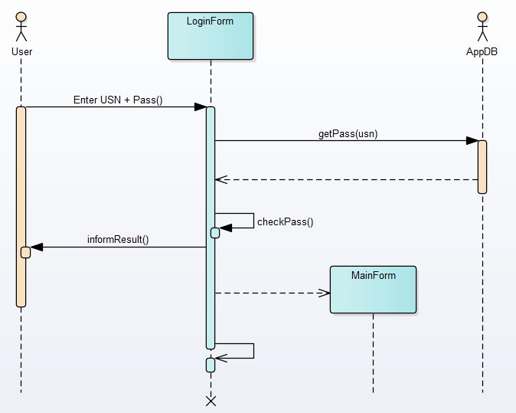

**User sequence sign up**

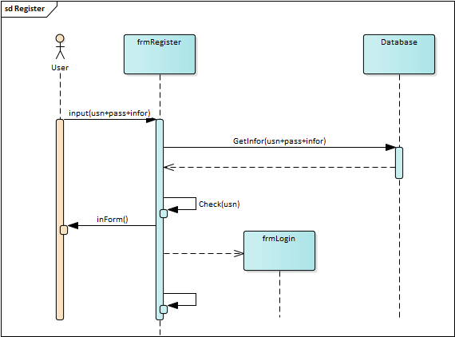

**User sequence sign in**

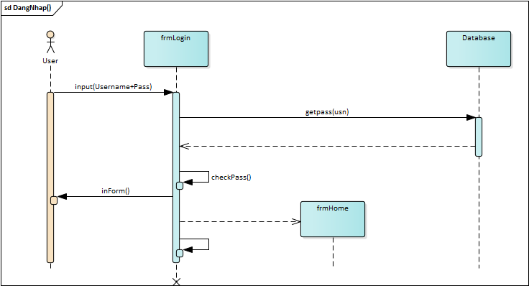

**User sequence attendance**

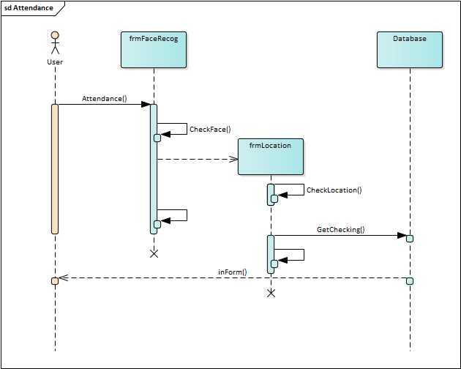

**User sequence calendar**

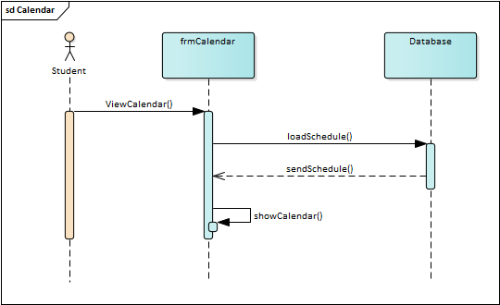

**User sequence Chatting**

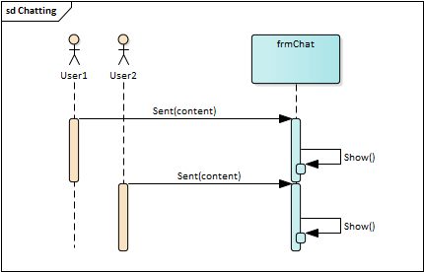

**User sequence History Attendance**

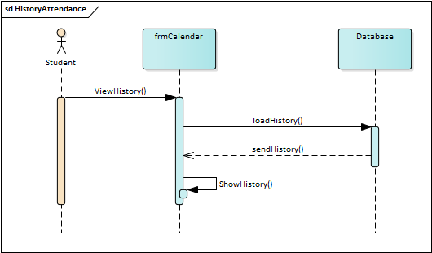

**User sequence Location**

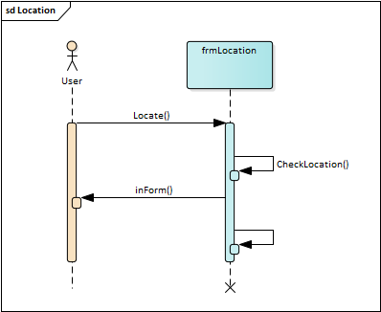

**User sequence Manage Class**

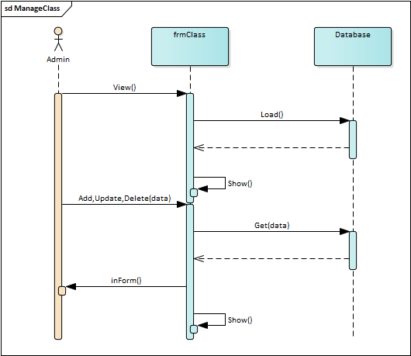

**User sequence Manage Student**

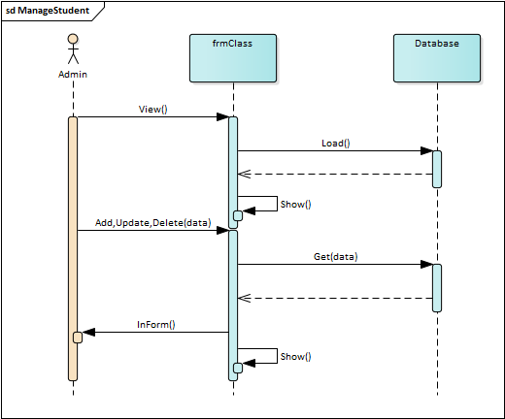

**User sequence Manage Teacher**

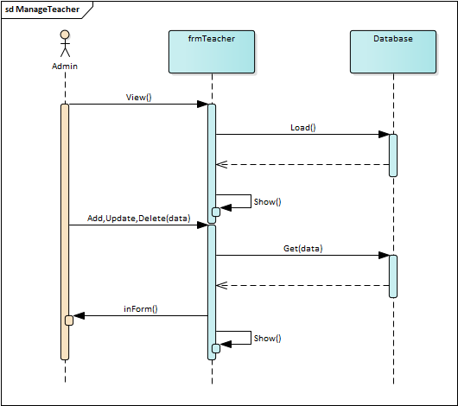

**User sequence Notification**

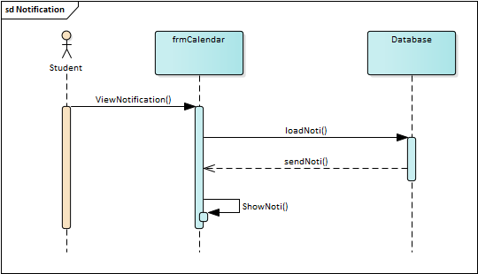

**User sequence search**

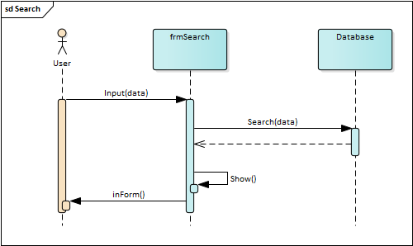

**User sequence Sent Noti**

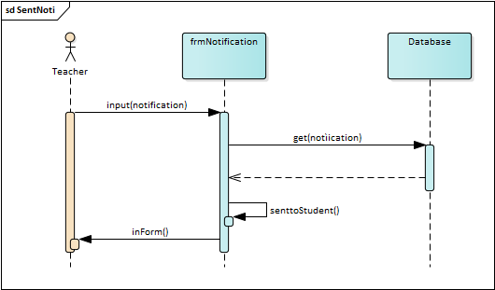

### [**Week 06: Database Design**](https://fhqutex.hcmute.edu.vn/course/view.php?id=6199#section-6)

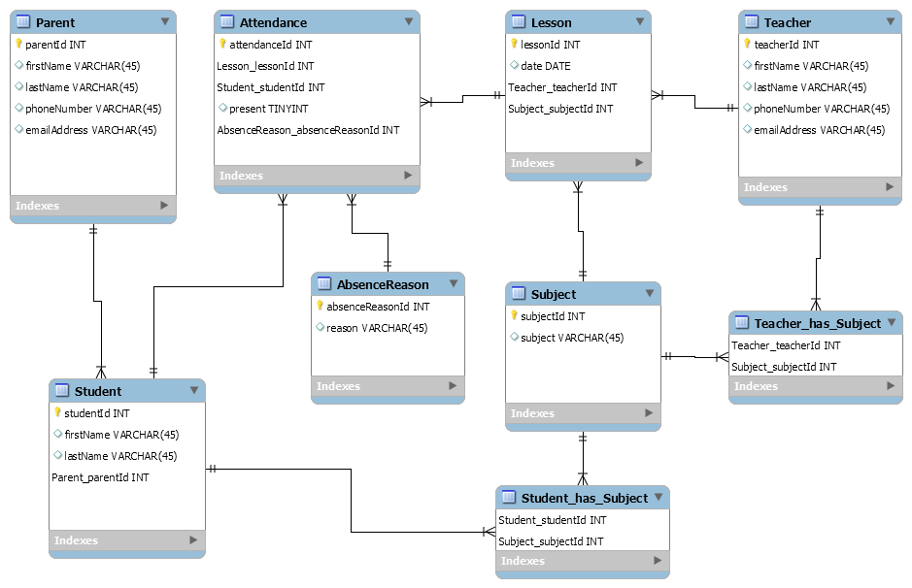

System evolution

*Our recommended “student management software” for schools, training centers, universities. Before we do anything, we do a thorough research on the problems we encountered. We have taken a careful look at how to create an error-free management system, student attendance, as well as different functions for different users depending on their perks.*

***TeacherKit*** *application supports devices on iOS, Windows operating systems. With TeacherKit you have 4 convenient types of reports including: class diagram, seat chart and score, student list.*

*TeacherKit is a very convenient software for teachers, schools, students and students' parents to easily organize classes and manage students. TeacherKit helps to record student attendance, expressions, and behavior for each student in just a few taps. In addition, when using TeacherKit, teachers can manage the number of students, note negative and positive actions of students and teachers can also communicate with parents about the student's capacity to help parents. mothers care more about their children's learning.*

***Remind*** *is an application designed based on the mobile device platform, friendly with iOS and Android operating systems, making the process convenient and smooth.*

*Remind's outstanding features:*

*Notice about lessons*

*Text messaging, documents, presentations*

*Teachers can send SMS messages in two-way or one-way mode to students*

*Helping teachers interact and support students effectively*

# **Chapter: Appendices**

**8.1 Application Requirements**

|  |  |
| --- | --- |
| **Operating system** | Windowns XP, Windowns 7, ios, android |
| **Front end** | Microsoft Visual Basic 6.0 |
| **Database** | Microsoft Access 2003 |
| **Connectivity** | ActiveX Data Object |
| **Report** | Data Report |

**8.2 Hardware Requirements**

|  |  |
| --- | --- |
| **RAM** | 512MB or higher |
| **Hard Disk** | 10GB or higher |
| **Conputer Processor** | Pentium IV |
| **Clock Speed** | 700 MHZ Processor |

# **Chapter : DESIGN PATTERN**

* Based on our sequence, class and state diagram our group choose five patterns to implement: Singleton, Builder, Factory, Bridge

1. **Sign in using Singleton Pattern**

**Why we choose this pattern and it characteristic:**

* In singleton which can only create one instance but people can login to the system simultaneously more than one.

C# code Demo

class Login

{

private static Login instance = new Login();

string user = "taikhoan";

string pass = "matkhau";

private Login()

{

}

public static Login getInstance()

{

return instance;

}

public void checkUser(string username, string password)

{

do

{

if (username == user && password == pass) { }

else

{

Console.WriteLine("Wrong please type again");

Console.WriteLine("Type Username");

username = Console.ReadLine();

Console.WriteLine("Type Password");

password = Console.ReadLine();

}

} while (username != user && password != pass);

Console.WriteLine("Login successful");

}

}

class Program

{

static void Main(string[] args)

{

//SINGLETON

Login.getInstance().checkUser("taikhoan", "matkhaau");

}

}

1. **Register uses Builder Pattern**

**Why we choose this pattern and it characteristic:**

* Builder is a creational design pattern that separate the construction of a complex object from its representation so that the same construction process can create different representations.
* The Builder provides the interface for building form depending on the login information. The ConcreteBuilders are the specific forms for each type of user. The Product is the final form that the application will use in the given case and the Director is the application that, based on the login information, needs a specific form.

C# code Demo

public class User

{

private string id;

private string firstName;

private string lastName;

private string dayOfBirth;

private string currentClass;

private string phone;

private string email;

private bool isTeacher;

public User(string id, string firstName, string lastName, string dayOfBirth, string currentClass, string phone, string email, bool isTeacher)

{

this.id = id;

this.firstName = firstName;

this.lastName = lastName;

this.dayOfBirth = dayOfBirth;

this.currentClass = currentClass;

this.phone = phone;

this.email = email;

this.isTeacher = isTeacher;

}

}

class ConcreteBuilder : UserBuilder

{

private string id;

private string firstName;

private string lastName;

private string dayOfBirth;

private string currentClass;

private string phone;

private string email;

private bool isTeacher;

public UserBuilder setId(string id)

{

this.id = id;

return this;

}

public UserBuilder setFirstName(string firstName)

{

this.firstName = firstName;

return this;

}

public UserBuilder setLastName(string lastName)

{

this.lastName = lastName;

return this;

}

public UserBuilder setDayOfBirth(string dayOfBirth)

{

this.dayOfBirth = dayOfBirth;

return this;

}

public UserBuilder setCurrentClass(string currentClass)

{

this.currentClass = currentClass;

return this;

}

public UserBuilder setPhone(string phone)

{

this.phone = phone;

return this;

}

public UserBuilder setEmail(string email)

{

this.email = email;

return this;

}

public UserBuilder setIsTeacher(bool isTeacher)

{

this.isTeacher = isTeacher;

return this;

}

public User build()

{

if (id != null)

{

Console.WriteLine("Register with Id: " + id.ToString());

}

if (firstName != null)

{

Console.WriteLine("Register with first name: " + firstName.ToString());

}

if (lastName != null)

{

Console.WriteLine("Register with last name: " + lastName.ToString());

}

if (dayOfBirth != null)

{

Console.WriteLine("Register with date of birth: " + dayOfBirth.ToString());

}

return new User(id, firstName, lastName, dayOfBirth, currentClass, phone, email, isTeacher);

}

}

public interface UserBuilder

{

UserBuilder setId(string id);

UserBuilder setFirstName(string firstName);

UserBuilder setLastName(string lastName);

UserBuilder setDayOfBirth(string dayOfBirth);

UserBuilder setCurrentClass(string currentClass);

UserBuilder setPhone(string phone);

UserBuilder setEmail(string email);

UserBuilder setIsTeacher(bool isTeacher);

User build();

}

class Program

{

static void Main(string[] args)

{

//BUILDER

var userBuilder = new ConcreteBuilder()

.setFirstName("Hoang")

.setLastName("Tran")

.setDayOfBirth("07/11/200");

Console.WriteLine(userBuilder.build());}}

1. **Notification uses Bridge Pattern**

**Why we choose this pattern and it characteristic:**

* The bridge pattern applies when there is a need to avoid permanent binding between an abstraction and an implementation and when the abstraction and implementation need to vary independently. Using the bridge pattern would leave the client code unchanged with no need to recompile the code.

C# code Demo

public abstract class Account

{

protected Notification notification;

public Account(Notification notification)

{

this.notification = notification;

}

public abstract void addNotification();

}

public class TeacherAccount : Account

{

public TeacherAccount(Notification notification) : base(notification)

{

}

public override void addNotification()

{

Console.Write("I'm a teacher and when i add noti, it will show: ");

notification.addNotification();

}

}

public class StudentAccount : Account

{

public StudentAccount(Notification notification) : base(notification)

{

}

public override void addNotification()

{

Console.Write("I'm a student and when i add noti, it will show: ");

notification.addNotification();

}

}

public class TeacherNotification : Notification

{

public void addNotification()

{

Console.WriteLine("Teacher adding notification!");

}

}

public class StudentNotification : Notification

{

public void addNotification()

{

Console.WriteLine("Student adding notification!");

}

}

public interface Notification

{

void addNotification();

}

class Program

{

static void Main(string[] args)

{

//BRIDGE

Account teacherAccount = new TeacherAccount(new TeacherNotification());

Account studentAccount = new StudentAccount(new StudentNotification());

teacherAccount.addNotification();

studentAccount.addNotification();

}}

1. **Add Subject uses Factory method Pattern**

**Why we choose this pattern and it characteristic:**

* It defines an interface for creating an object, but leaves the choice of its type to the subclasses, creation being deferred at run-time
* Because when create news Subject we wants its Subject to be the ones to specific the type of a newly created Object

C# code Demo

public class TeacherSubject : Subject

{

public void addSubject(string subjectName)

{

Console.WriteLine("Add subject: " + subjectName);

}

}

public class StudentSubject : Subject

{

public void addSubject(string subjectName)

{

Console.WriteLine("You couldn't add subject, because you're a student! Don't try it again!");

}

}

public interface Subject

{

void addSubject(string subjectName);

}

public class SubjectFactory

{

private SubjectFactory()

{

}

public static Subject getAccount(AccountType accountType)

{

switch (accountType)

{

case AccountType.TEACHER:

return new TeacherSubject();

case AccountType.STUDENT:

return new StudentSubject();

default:

return new StudentSubject();

}

}

}

class Program

{

static void Main(string[] args)

{

//FACTORY

Console.WriteLine("Add subject with teacher's account!");

Subject teacherAccount = SubjectFactory.getAccount(AccountType.TEACHER);

teacherAccount.addSubject("Mathematics");

Console.WriteLine("Add subject with student's account!");

Subject studentAccount = SubjectFactory.getAccount(AccountType.STUDENT);

studentAccount.addSubject("Mathematics");

}

}

public enum AccountType

{

TEACHER, STUDENT

}