Group 03

Hoàng Ngọc Bảo Trân 18110057 – Team leader

Phạm Quang Danh 18110004

Phan Ngọc Bảo Tuyền 18110062

User usecase login

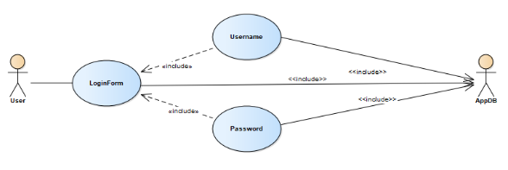

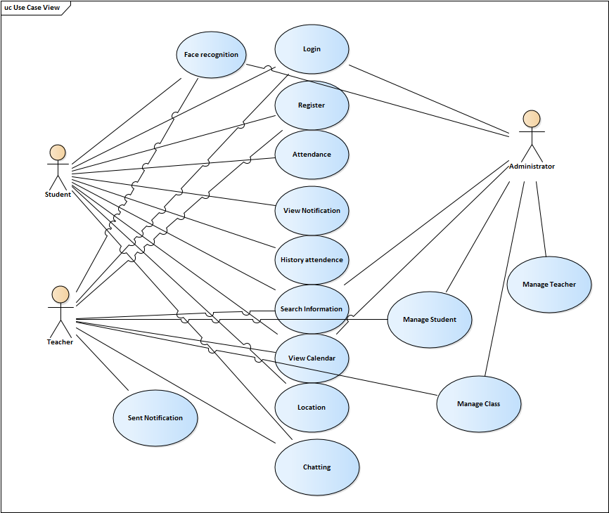

|  |  |
| --- | --- |
| MHC_PMS Transfer data | |
| Actors | Student, Teacher, Parents, School |
| Description | Web platform**:** HCMUTE is easy in managing students  Mobile app Platform**:** Parents, Students and Teachers  Group software functionality**:** Student admissions for students, faculty, and parental management  Function: Login, logout, register  • Advanced features  • Display new class list, Visually enrolled class. Easy search support.  • Display schedules and students can actively view school schedules easily. Class, Schedule can be updated flexibly.  • Notices from the school (change of school schedule, change of location, change of teacher, promotions, tuition discount when paying by Course,...)  • Detailed learning results  • Apply for leave from school right on the software with a quick review period  • View school announcements, school schedules  • View transcripts, transcripts, student academic results  • Send reviews and comments to schools, teacher  • Academic results  • View the number of sessions taught and the number of absences |
| Data | Student information, teachers, study results, attendance, school schedule updates. |
| Stimulus | On time, at the right place (eg school, classroom) |
| Response | Confirmation that PRS has been updated |
| Comments | Secure student, faculty, information access and GPS information |