Exercise 63:

**Operating Mechanism:**

1. **Condition Evaluation**: The if statement evaluates the condition provided.
2. **Decision Making**:
   * If the condition is true, the block of code inside the if statement is executed.
   * If the condition is false, the block is skipped.

**Flowchart:**

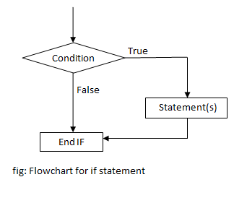

**Example:**

temperature = 30

if temperature > 25:

print("It's a hot day.")

In this example, if the temperature is greater than 25, the message "It's a hot day." will be printed.

**Explanation:**

* The condition temperature > 25 is evaluated.
* If true, print("It's a hot day.") is executed.
* If false, nothing happens, and the program continues after the if block