Exercise 64:

**Operating Mechanism:**

1. **Condition Evaluation**: The if statement evaluates the condition.
2. **Decision Making**:
   * If the condition is true, execute the if-block.
   * If the condition is false, execute the else-block.

**Flowchart:**

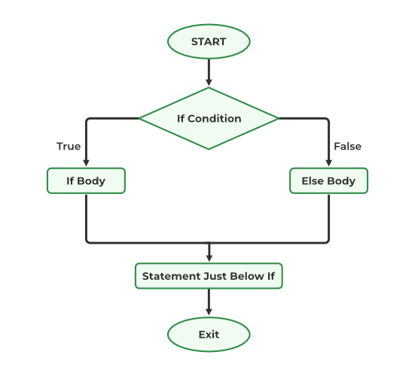

**Example:**

temperature = 20

if temperature > 25:

print("It's a hot day.")

else:

print("It's not a hot day.")

**Explanation:**

* The condition temperature > 25 is evaluated.
* If true, print("It's a hot day.") is executed.
* If false, print("It's not a hot day.") is executed.