Exercise 65:

**Operating Mechanism:**

1. **Evaluate Condition**: Check if the condition is true or false.
2. **Decision Making**:
   * If the condition is true, evaluate and assign expression-1.
   * If the condition is false, evaluate and assign expression-2.

**Flowchart:**

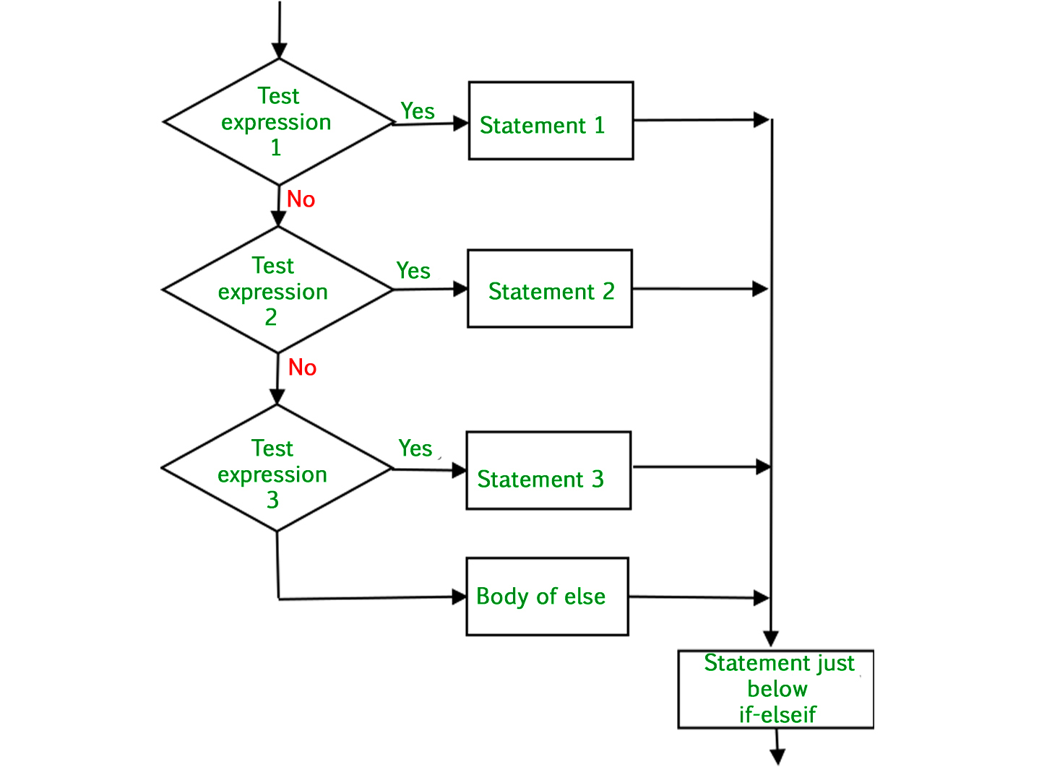

**Example:**

temperature = 20

weather = "hot" if temperature > 25 else "cool"

print(weather)

**Explanation:**

* The condition temperature > 25 is evaluated.
* If true, "hot" is assigned to weather.
* If false, "cool" is assigned to weather.
* In this example, weather will be "cool" because the condition is false.