

Event registration system

P3: Requirements Specifications



team 2

Vignesh Dhanabal

Huyen Nguyen

Quyen Nguyen

Daniel Sethuraman

**P3:  Requirements Specifications**

1. **Executive Summary**

The Event Registration System is supposed to assist staff at Oklahoma State University’s Family Resource Center (FRC) to manage event registration more effectively. It is supposed to be an online platform to replace the current paper-based registration system. In order to develop the new system, we collect the requirement inputs from the FRC staffs. As a result, we gain better understanding about how the current system is working and what they expect in the new system, at least for the upcoming field trip event for children.

Different kinds of diagrams are used in order to get the basic requirements for the new system. Below is the list of the diagrams that are used in the requirements analysis phase.

1.         Behavioral modeling:

1.1.   Use case diagram

1.2.   Expanded Use case narratives

1.3.   Context diagram

2.         Process modeling: Data Flow Diagram (DFD)

3.         Data modeling: Entity Relationship Diagram (ERD)

4.         Object modeling: UML Class diagram

Use case diagrams and narratives allow us to identify the main activities that users can interact with the system. Process modeling, in particular the Data flow diagram, is useful for identifying the order of activity and how processes are connected to one another. The data modeling helps with organizing the system’s data. Since this is a software system, UML Class diagram is used to support software development.

1. **Revised Cost**

Apart from the costs to visit the client, there are other costs for software developers. It takes about 2 months to complete the system, so the costs associated with this process should be the salary for the web/app developer. Other than that, software is free for us to use.

1. **Revised Schedule**

We add more tasks to illustrate the schedule of the whole project.

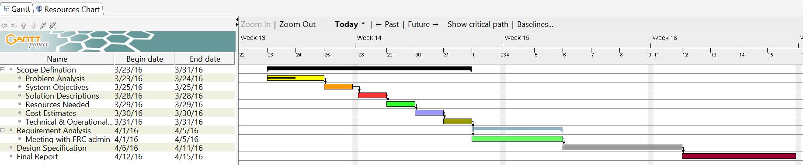

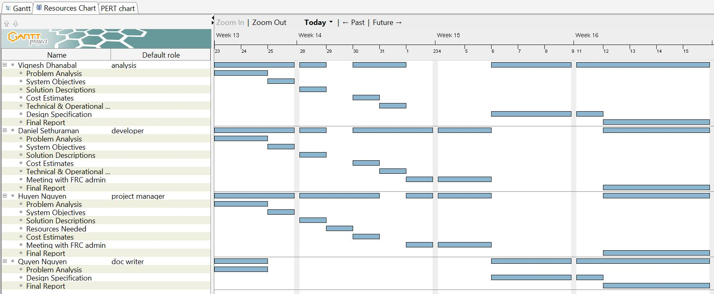

1. **Behavioral modeling**

4.1. Use case diagram

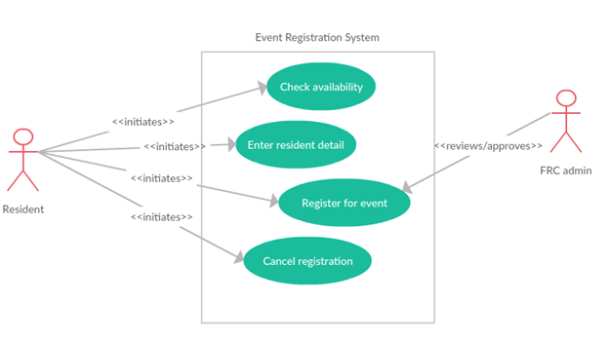

4.2. Expanded Use case narratives

|  |  |  |
| --- | --- | --- |
| **Use Case ID:** | UC1 | **Use Case Type:**  **Business Requirements:**  **System Analysis: ☑** |
| **Use Case Name:** | Check availability |
| **Created By:** | Daniel S |
| **Date Created:** | 03/23/2016 |
| **Priority:** | Medium |
| **Primary Business Actor:** | Resident | |
| **Primary System Actor:** | Resident | |
| **Other Participant Actor:** | None | |
| **Other Interested Stakeholder:** | None | |
| **Description:** | The resident accesses the registration portal to check the availability of seats for the event | |
| **Precondition:** | The resident should have a child of age 4 or more | |
| **Trigger:** | The use case is initiated when the resident clicks to check the availability | |
| **Typical Course of Events:** | **Actor Action** | **System Response** |
| Step 1: Resident open browsers  Step 2: Resident navigates to FRC URL  Sep 4: Resident checks the count of available seats by clicking the right button | Step 3: System responses by displaying the FRC event portal  Step 5: System responses by displaying the availability count |
| **Alternate Courses:** | Alt-Step 5: If the system does not response for the availability checking, the resident can call the FRC front desk and request for availability. | |
| **Conclusion:** | The use case concludes when the resident receives the event availability information. | |
| **Post condition:** | The resident proceeds to enter their personal detail if there are seats available for the event. | |
| **Business Rule:** | The resident must be OSU student and have a valid CWID | |
| **Implementation Constraints and Specifications:** | Use case must be available for to residents 24/7  Frequency of use: Once per registration | |
| **Assumptions:** | The resident is a computer literate and knows how to navigate to the event registration portal. | |
| **Open Issues:** | None | |

|  |  |  |
| --- | --- | --- |
| **Use Case ID:** | UC2 | **Use Case Type:**  **Business Requirements:**  **System Analysis: ☑** |
| **Use Case Name:** | Enter resident detail |
| **Created By:** | Daniel S |
| **Date Created:** | 03/23/2016 |
| **Priority:** | High |
| **Primary Business Actor:** | Resident | |
| **Primary System Actor:** | Resident | |
| **Other Participant Actor:** | None | |
| **Other Interested Stakeholder:** | None | |
| **Description:** | The resident provides their personal information to the system | |
| **Precondition:** | The resident should have checked the availability | |
| **Trigger:** | The use case is initiated when the resident enters personal information | |
| **Typical Course of Events:** | **Actor Action** | **System Response** |
| Step 1: Resident open browsers  Step 2: Resident navigates to FRC URL  Sep 4: Resident enters his/her personal detail | Step 3: System responses by displaying the FRC event portal  Step 5: System responses by recording the detail |
| **Alternate Courses:** | None | |
| **Conclusion:** | The use case concludes when the resident finishes filling personal information. | |
| **Post condition:** | The resident proceeds to register for the event. | |
| **Business Rule:** | The resident must be OSU student and have a valid CWID | |
| **Implementation Constraints and Specifications:** | Use case must be available for to residents 24/7  Frequency of use: Once per registration | |
| **Assumptions:** | The resident is a computer literate and knows how to navigate to the event registration portal. | |
| **Open Issues:** | None | |

|  |  |  |
| --- | --- | --- |
|  |  | **Use Case Type:**  **Business Requirements:**  **System Analysis: ☑** |
| **Use Case Name:** | Register for event |
| **Created By:** | Daniel S |
| **Date Created:** | 03/23/2016 |
| **Priority:** | High |
| **Primary Business Actor:** | Resident | |
| **Primary System Actor:** | Resident | |
| **Other Participant Actor:** | Participant | |
| **Other Interested Stakeholder:** | FRC admin | |
| **Description:** | The resident submits the registration form | |
| **Precondition:** | The resident has entered all requested details in the form | |
| **Trigger:** | The use case is initiated when the resident enters participant information | |
| **Typical Course of Events:** | **Actor Action** | **System Response** |
| Step 1: Resident open browsers  Step 2: Resident navigates to FRC URL  Sep 4: Resident enters participant information for the event  Step 6: Resident submit the registration | Step 3: System responses by displaying the FRC event portal  Step 5: System responses by recording the detail  Step 7: System responses by recording the submission |
| **Conclusion:** | The use case concludes when the resident submits the registration for the event. | |
| **Post condition:** | The resident gets a confirmation page about their registration | |
| **Business Rule:** | The resident must be OSU student and have a valid CWID | |
| **Implementation Constraints and Specifications:** | Use case must be available for to residents 24/7  Frequency of use: Once per registration | |
| **Assumptions:** | The resident is a computer literate and knows how to navigate to the event registration portal.  The resident has entered all the requested details. | |
| **Open Issues:** | None | |

|  |  |  |
| --- | --- | --- |
|  |  | **Use Case Type:**  **Business Requirements:**  **System Analysis: ☑** |
| **Use Case Name:** | Cancel registration |
| **Created By:** | Daniel S |
| **Date Created:** | 03/23/2016 |
| **Priority:** | Medium |
| **Primary Business Actor:** | Resident | |
| **Primary System Actor:** | Resident | |
| **Other Participant Actor:** | None | |
| **Other Interested Stakeholder:** | None | |
| **Description:** | The resident clicks the cancel registration form button | |
| **Precondition:** | The resident has entered the cancellation request details in the form | |
| **Trigger:** | The use case is initiated when the resident clicks to cancel the registration | |
| **Typical Course of Events:** | **Actor Action** | **System Response** |
| Step 1: Resident open browsers  Step 2: Resident navigates to FRC URL  Sep 4: Resident enters cancellation detail  Step 6: Resident clicks cancel button | Step 3: System responses by displaying the FRC event portal  Step 5: System responses by recording the detail  Step 7: System responses by recording the cancellation |
| **Conclusion:** | The use case concludes when the resident clicks the cancel button | |
| **Post condition:** | The resident gets a confirmation page about their cancellation | |
| **Business Rule:** | The resident must be OSU student and have a valid CWID | |
| **Implementation Constraints and Specifications:** | Use case must be available for to residents 24/7  Frequency of use: Once per cancellation | |
| **Assumptions:** | The resident is a computer literate and knows how to navigate to the event registration portal.  The resident has entered all the cancellation details. | |
| **Open Issues:** | None | |

4.3. Context diagram

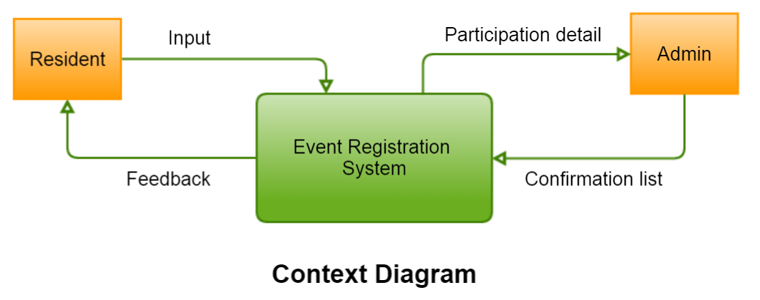

1. **Process modeling with DFDs**

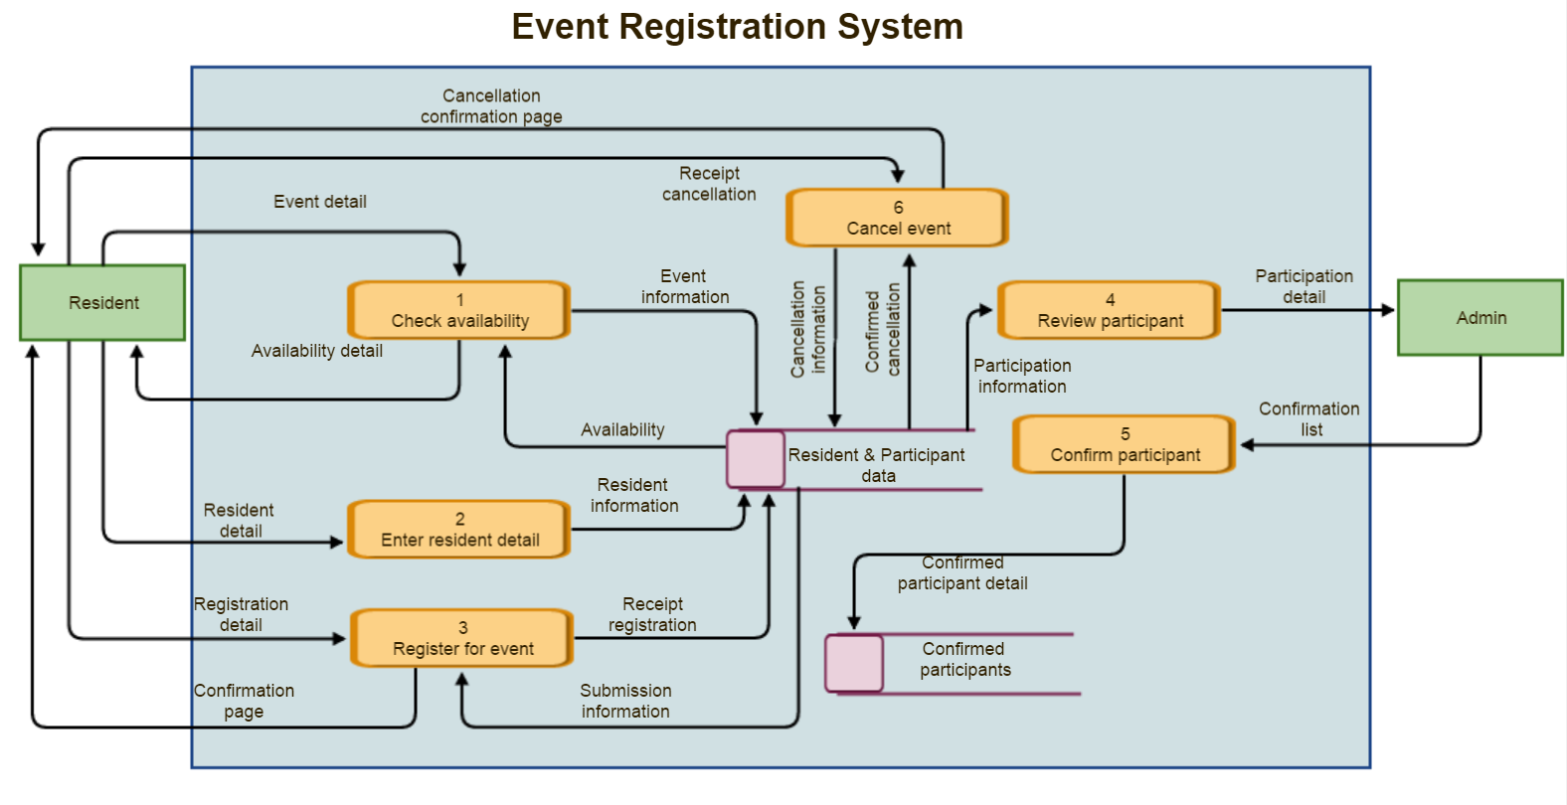

Notes:

* Input (Context diagram) = Event detail + Resident detail + Registration detail + Receipt cancellation (DFD level 2)
* Feedback (Context diagram) = Availability detail + Confirmation page + Cancellation confirmation page

1. **Data modeling with ERDs**

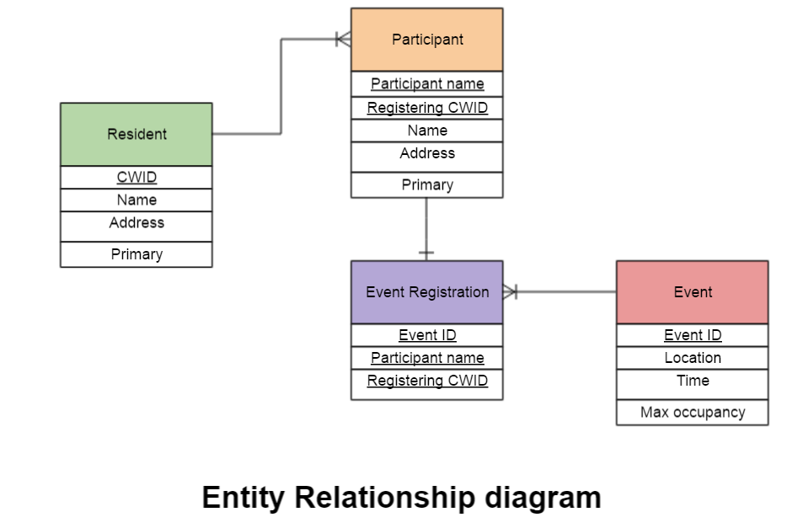

1. **Object modeling with UML – class diagram**

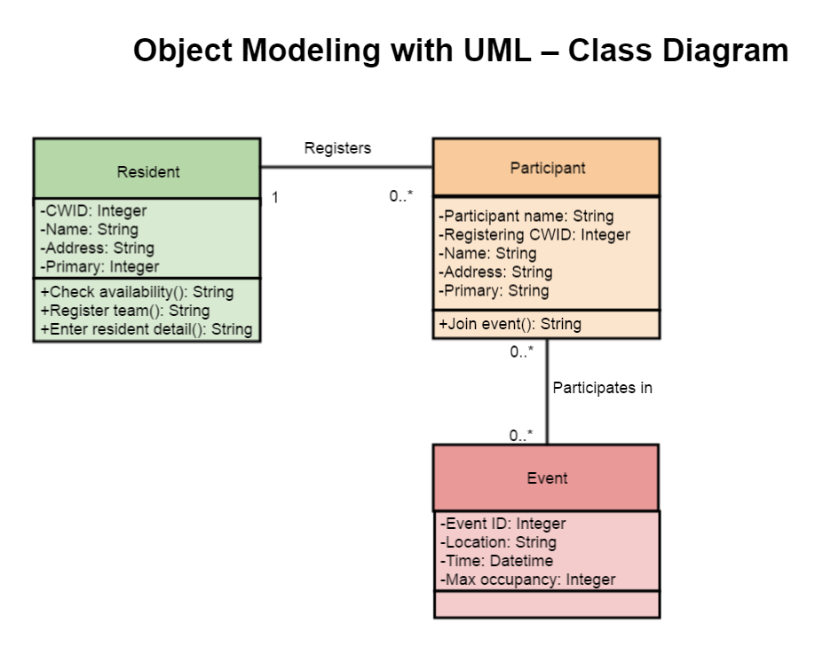

1. **Conclusion**

The user requirements set the direction for us to complete the next steps including logical design, decision analysis, and implementation phase. This plan is in line with the expectation of the client, Family Resource Center, to use the system for the Field Trip event in June. Although the requirements are identified clearly in this phase, there are always the risks of scope creep and delay in building the system. As there are a lot of registration issues at FRC that our system can handle, such as registration for garden plots, air conditioning system, the scope is subjective to increase. However, we will try to talk frequently with the client to limit the first version of the system to be used for event registration only. In addition, setting priority and early decision on system design will minimize the risk of implementation delay.