**Requirements Specification**

**for**

QNTU

**Version 1.0**

**IBL**

**03-15-2018**

**Table of Contents**

**Introduction** **4**

**Purpose** **4**

**Product Scope** **4**

**References** **4**

**Overall Description** **4**

**QNTU Functions Description** **10**

**transferOwnership(address _newOwner)** **10**

**changeTokenInformation(string _name, string _symbol)** **10**

**transfer(address _to, uint _value)** **10**

**transferFrom(address _from, address _to, uint _value)** **11**

**approve(address _spender, uint _value)** **11**

**increaseApproval(address _spender, uint _addedValue)** **12**

**decreaseApproval(address _spender, uint _subtractedValue)** **12**

**allowance(address _owner, address _spender)** **13**

**freezeTransfer()** **13**

**unfreezeTransfer()** **13**

**freezeUpgrade()** **13**

**unfreezeUpgrade()** **14**

**changeUpgradeMaster(address _newMaster)** **14**

**changeUpgradeAgent(address _newAgent)** **14**

**upgrade()** **15**

**forceUpgrade(address[] _holders)** **15**

**transferToContract(address _to, uint _value)** **16**

**Revision History**

|  |  |  |  |
| --- | --- | --- | --- |
| **Name** | **Date** | **Reason For Changes** | **Version** |
|  |  |  |  |
|  |  |  |  |

# **Introduction**

## **Purpose**

*This document is for designing and developing QNTU. A ERC20 standard token smart contract on Ethereum.*

## **Product Scope**

*QNTU is the utility token of the Quanta ecosystem that the various participants will be able to put up as collateral. QNTU forms the basis of an internal econonomy that ensures the security of the network.*

## **References**

*Quanta White Paper: https://www.quantaplc.im/Quanta.pdf*

# **Overall Description**

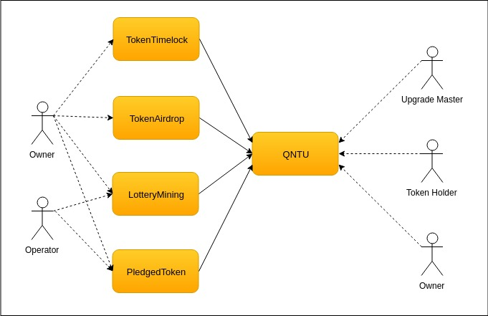

# QNTU Functions Description

## transferOwnership(address _newOwner)

* Description  
  - Allows the current Owner to transfer control of the smart contract to a new Owner.

- Caller is only Owner.

## changeTokenInformation(string _name, string _symbol)

* Description  
  - Change token name and symbol.

- Caller is only Owner.

## transfer(address _to, uint _value)

* Description  
  - Token Holder transfer their own tokens to another address.

## transferFrom(address _from, address _to, uint _value)

* Description  
  - The person who are authorised can transfer tokens from the authorised address to another address.

## approve(address _spender, uint _value)

* Description  
  - Token Holder authorise another address to own a specific amount of their tokens.

## increaseApproval(address _spender, uint _addedValue)

* Description  
  - Token Holder increase the amount of tokens that the person who are authorised can transfer.

## decreaseApproval(address _spender, uint _subtractedValue)

* Description  
  - Token Holder decrease the amount of tokens that the person who are authorised can transfer.

## allowance(address _owner, address _spender)

* Description  
  - Get the remaining amount of tokens that the person who are authorised can transfer.

## freezeTransfer()

* Description  
  - Disallow to transfer token from an address to other address.

- Caller is only Owner.

## unfreezeTransfer()

* Description  
  - Allow to transfer token from an address to other address.

- Caller is only Owner.

## freezeUpgrade()

* Description  
  - Disallow to upgrade token to new smart contract.

- Caller is only Owner.

## unfreezeUpgrade()

* Description  
  - Allow to upgrade token to new smart contract.

- Caller is only Owner.

## changeUpgradeMaster(address _newMaster)

* Description  
  - Change the Upgrade Master who perform to upgrade token to new smart contract.

- Caller is only Owner.

## changeUpgradeAgent(address _newAgent)

* Description  
  - Change the new address of Upgrade Agent (new QNTU smart contract that tokens will be upgraded to it).

- Caller is only Owner.

## upgrade()

* Description  
  - Token Holder use this function for upgrade their tokens to a new smart contract.

## forceUpgrade(address[] _holders)

* Description  
  - Upgrade Master force to upgrade token of holders to a new smart contract.

- Caller is only Upgrade Master.

## transferToContract(address _to, uint _value)

* Description  
  - Token Holder use this function to transfer their own tokens to specified ReceivingContract smart contract.