Clumpiness calculation
Publication, GitHub

$$C\left(L\right)={\frac{1}{n}(\prod_{i=1}^{n}{\frac{x}{y^{i}})}}^{\frac{1}{n}}$$
$$n$$ - Number of unique labels.
$$y_{i}$$ - Frequency of label i in the tree
$$y_{i}=\frac{\left|L_{i}\right|}{\left|T\right|}$$
$L_{i}$ - Number of leaves with label i
$T$ - total number of relevant leaves

$x$ - the weighted “average” of inner verticles in the tree
$$x=\frac{1}{|I|}\sum_{vϵ1}{δ(v)ω(v)}$$
$\left|I\right|$ -Total number of inner (non-leaf) nodes, excluding the root node.
$δ\left(v\right)$ -A viability indicator. It equals 1 if the inner vertex ‘v’ has at least one of each label in its downstream descendant leaves. If it is missing any label among its descendants, it equals to 0.
$ω\left(v\right)$ - A weight applied to a viable vertex based on how many branching steps away its descendant leaves are. Every time a branch splits, the weight of the path is divided by the number of children (e.g., multiplied by ‘1/2’ for a binary tree).

Example – Clumpiness Calculation
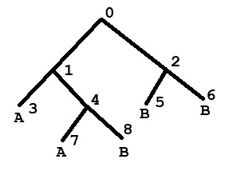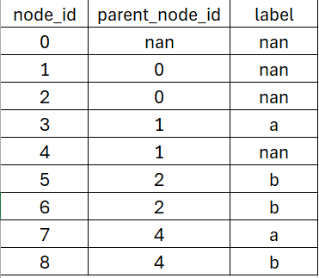

$$C\left(L\right)={\frac{1}{n}(\prod_{i=1}^{n}{\frac{x}{y^{i}})}}^{\frac{1}{n}}$$

$n=2$ (number of unique labels)

$$y_{A}=\frac{\left|L_{i}\right|}{\left|T\right|}=\frac{2}{5}=0.4$$
$$y_{B}=\frac{\left|L_{i}\right|}{\left|T\right|}=\frac{3}{5}=0.6$$

$δ\left(1\right)=1$
$$ω\left(1\right)=\frac{1}{2}+\left(\frac{1}{2}*\frac{1}{2}\right)+\left(\frac{1}{2}*\frac{1}{2}\right)=\frac{2}{4}+\frac{1}{4}+\frac{1}{4}=1$$

$$δ\left(2\right)=0$$
$$ω\left(2\right)=\frac{1}{2}+\frac{1}{2}=1$$

$$δ\left(4\right)=1$$
$$ω\left(4\right)=\frac{1}{2}+\frac{1}{2}=1$$

$$x=\frac{1}{|I|}\sum_{vϵ1}{δ(v)ω(v)}=\frac{1}{3}\left[\left(1*1\right)+\left(1*0\right)+\left(1*1\right)\right]=\frac{1}{3}*\frac{2}{1}=\frac{2}{3}≈0.667$$

$$C\left(A,B\right)={\frac{1}{n}(\prod_{i=1}^{n}{\frac{x}{y^{i}})}}^{\frac{1}{n}}=\frac{1}{2}{(\frac{\frac{2}{3}}{\frac{2}{5}}*\frac{\frac{2}{3}}{\frac{3}{5}})}^{\frac{1}{2}}=\frac{1}{2}*{\left(\frac{5}{3}*\frac{10}{9}\right)}^{\frac{1}{2}}≅0.680$$

Find clumpiness results output:
property1 | property2 | value
a | a | 0.319586
a | b | 0.680414
b | a | 0.680414
b | b | 0.319586

