TITLE OF YOUR PAPER, IN CAPITAL LETTERS

CENTERED ON PAGE, USING ONE OR MORE LINES AS NECESSARY

Author(s) in upper and lower case letters

Organization

Short address

City, State, Zip, Country

e-mail: yourname@yourorganization.xxx

# ABSTRACT

This file provides a template for the preparation of papers .

I can write this section, let me do it

Papers should follow standard technical paper format, an abstract followed by the more detailed presentation. The abstract should be typed on this area of the first page, with the presentation following after two blank lines.

# LENGTH OF PAPER

The length is up to n pages. This length includes all figures and tables. If your paper is going to extend beyond this limitation, please contact the organizers.

.

# FIGURES, TABLES, AND EQUATIONS

If possible, include figures in electronic format directly into the document. Color figures are acceptable.

Figures and tables should immediately follow first mention of them in the text and can be placed in one column, or can cover two columns usually at the top or bottom of the page. (Insert section breaks to switch between one and two columns.) Place the table caption *before* the table using 10 point Times New Roman typeface; place the figure caption *after* the figure using 10 point Times New Roman typeface.

Table 1. Use 10 pt Times New Roman typeface.

|  |  |  |
| --- | --- | --- |
| Data Type | Location | Std. Dev. |
| Pressure | Inj/Pro/W1/W2 | 2.00 bar |
| Temperature | Pro/W1/W2 | 5.00 ºC |
| Liquid flow rate | Pro | 1.60 kg/s |
| Vapor flow rate | Pro | 0.08 kg/s |

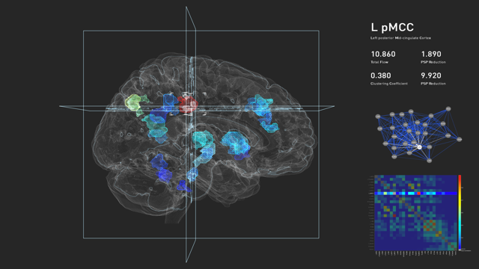

Figure 1. Illustration of placement of figure and caption. Use 10 point Times New Roman for figure caption typeface.

# Acknowledgment

Thank you very much.

# REFERENCES

Reference format for a report or book – check standards.

# 