Team 68

Jooyoung Whang

Phillip Hrinko

Julian Nguyen

UML Change Prose

* Changed the statArray (which represented the poll data for a song) length from 8 to 16, since it had to account for no-response polls.
* Each student now stores every song in their hashMap, no matter if they heard the song or not. The keyValue type for the hashMap is now an integer array of length 2, each to store an integer representing the student’s response for the song. (0 = yes, 1 = no, 2 = no response) (index 0 = heard, index 1 = liked)



* At the same time while changing the student’s way of storing the poll data, the getter methods for heard and liked data changed their return types to integers.
* Added a fileReader (named Input) to read the input files and instantiate the SongCollection and StudentCollection classes instead of having each classes read from the input file themselves to instantiate.
* Iterators are now implemented in the LinkedList, so that both StudentCollection and SongCollection can use freely to iterate through their elements.
* Some of the methods were not implemented since it was not needed.
* Added DEFAULT for both Enumerators in order to test default cases for switch statements.
* Comparators now compare with Objects instead of Strings or Integers.



* LinkedList implements ListInterface instead of general List.
* Everything written in red in the UML are changes made.

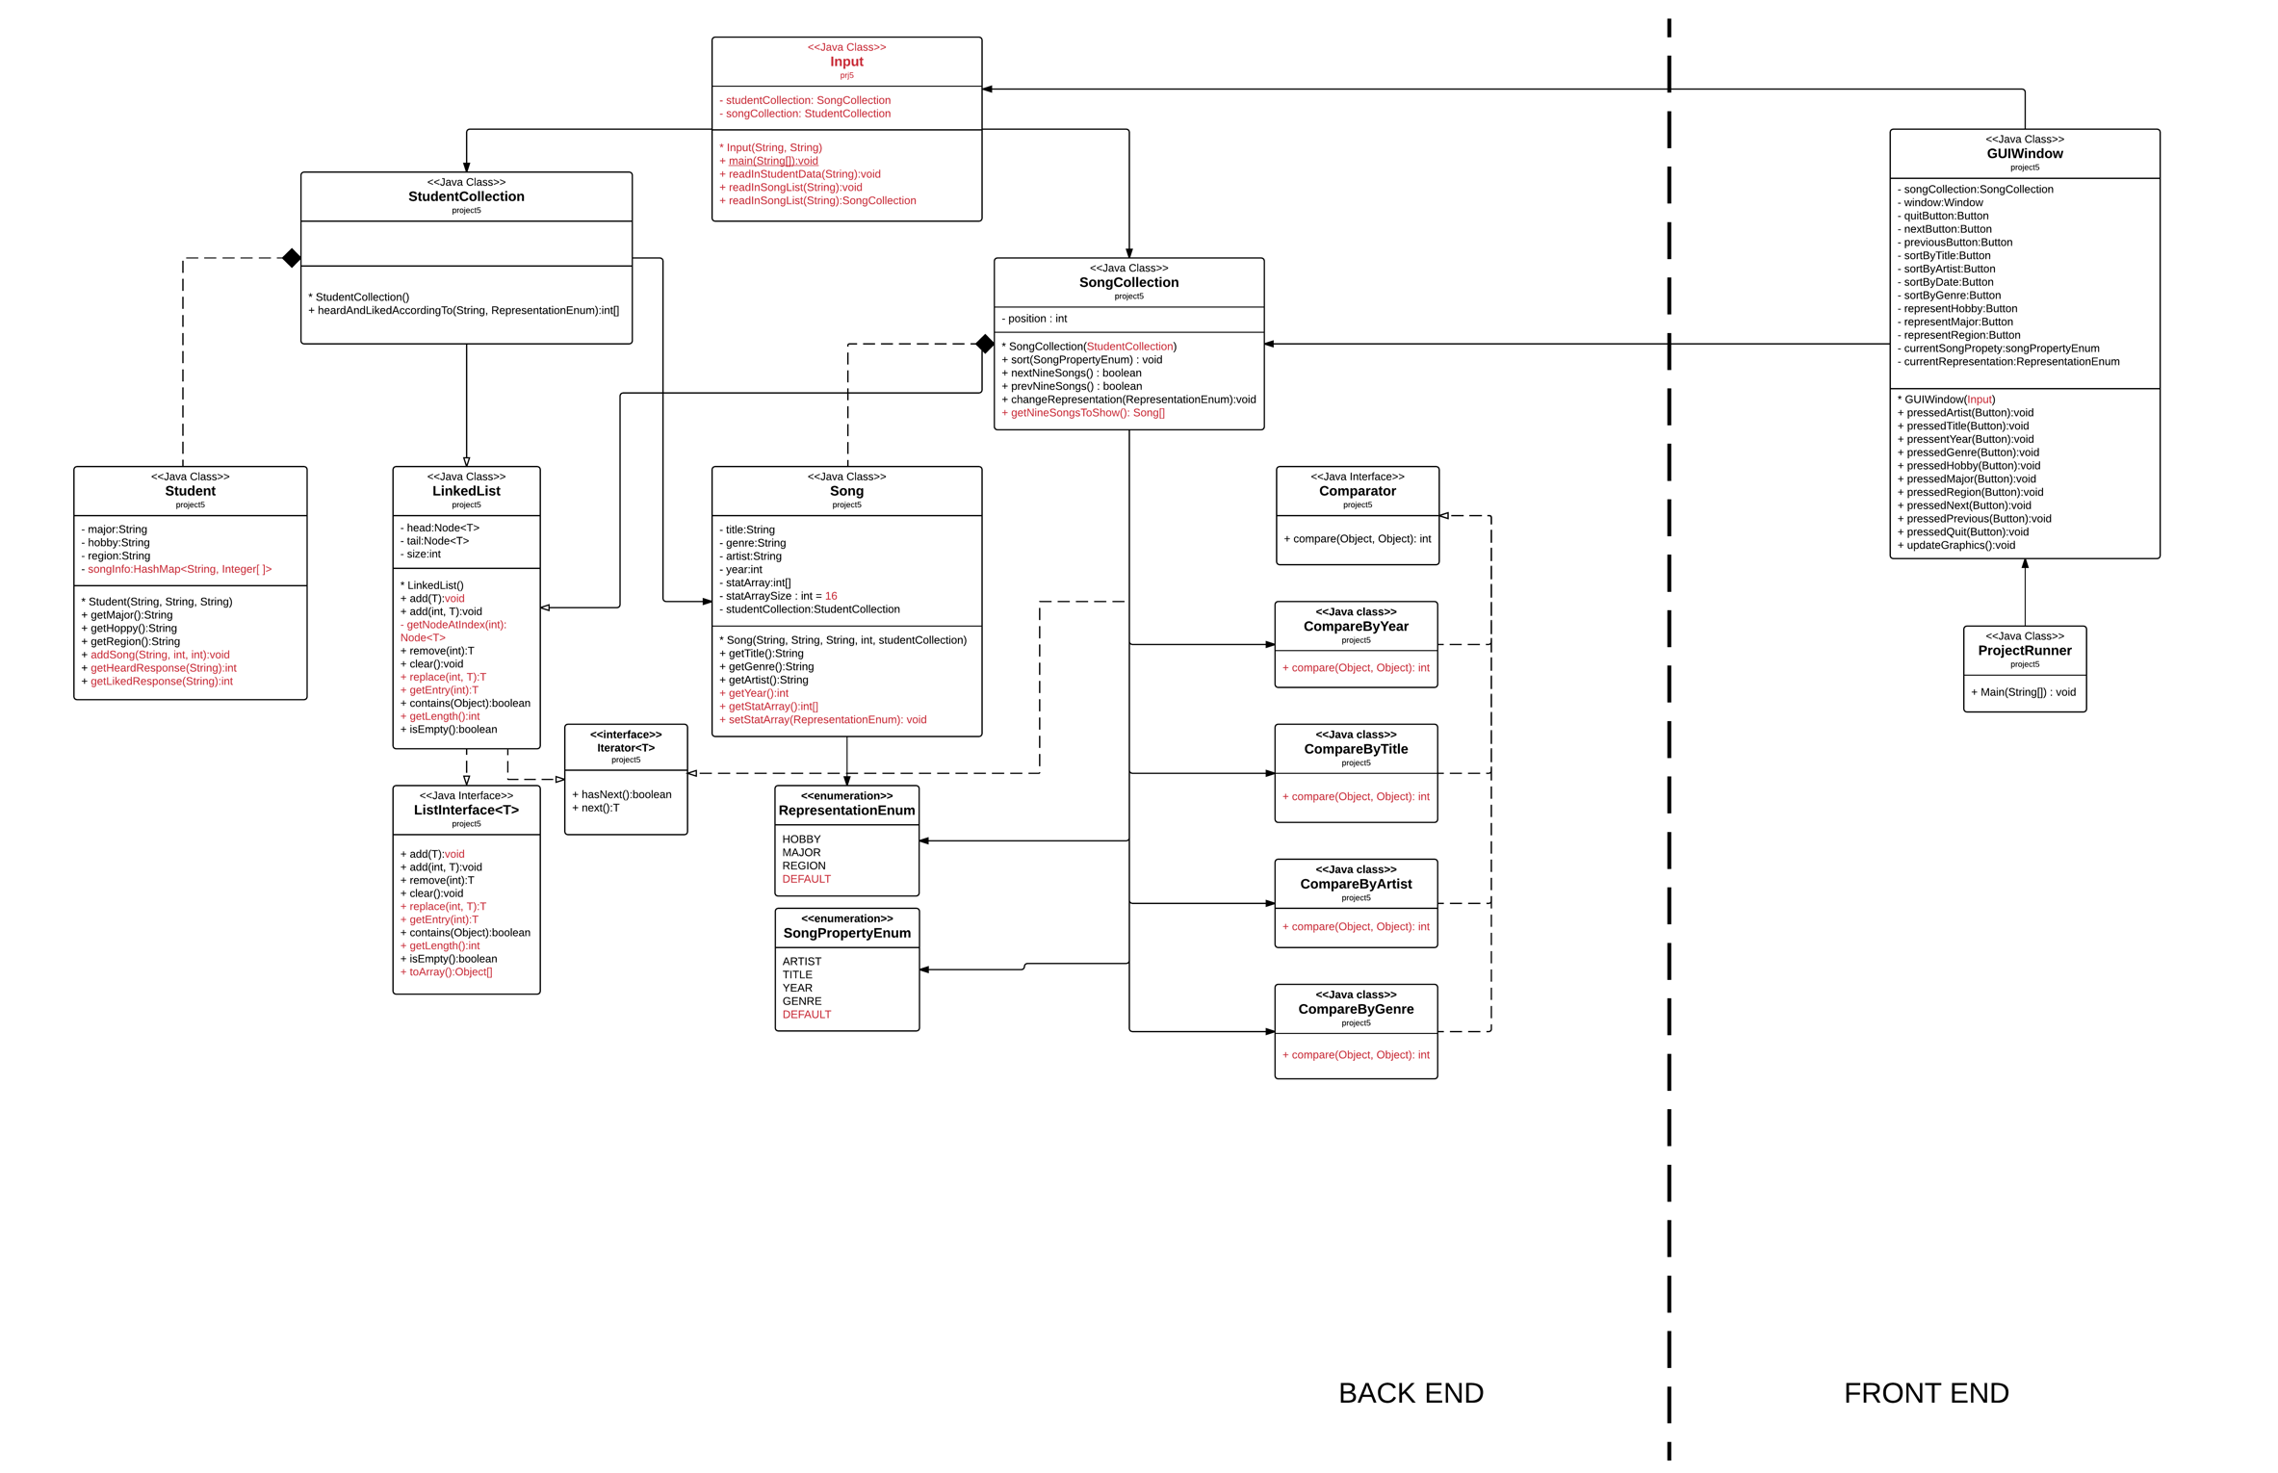**Updated information in red**

* 