**CS2114 Project 5 Design Submission**

Group 68 - Phil Hrinko (philh97), Julian Nguyen (julian18), Jooyoung Whang (joo918)

Overall Design Idea

The front end solely manages displaying data to the user and requesting some process to the back end. The back end’s StudentCollection is the main class that stores the survey data, and SongCollection is the main class that stores the data to show on the screen. SongCollection’s songs each have access to the StudentCollection, in order to update a song’s data. Both of the collection classes implements Iterator so that it can iterate through the data easily.

Back End Design

**Classes:**

* Student: A class to store a student’s survey information.
* StudentCollection: Implements Iterator interface. Extends LinkedList. Stores the entire survey information of students by storing Student classes. Has methods to poll through the Students and gather heard and liked data according to a song’s title and the representation type.
* Song: A class to store a song’s information. The data inside can change when representation type of the data change. Since for each representation type, there are fixed number of 4 variances, (i.e. for Hobby there are read, art, sports, music) the data for each variances (number of heard and number of liked) can be stored in a single integer array of length 8. (4 variances * (heard and likes (2)))
* SongCollection: Implements Iterator interface. Extends LinkedList. Stores all the Song classes and each of their associated data. Has methods to sort the stored Song classes by using certain comparing methods, (Comparators) and request data changes to each of the Song class in the list. These methods are called when buttons in the GUIWindow are pressed.
* LinkedList<T>: Implements List with linked Nodes. Will be the main data structure to store and process the program’s data.

**Enumerations**

* RepresentationEnum: Enumeration used to show the representation type of the students in the GUIWindow (Hobby, Major, Region).
* SongPropertyEnum: Enumeration used to indicate by what song properties to change the Song classes’ data by (title, artist name, year, genre).

**Comparators**

* CompareByArtist: Compare by Artist names in alphabetical order
* CompareByTitle: Compare by Title in alphabetical order
* CompareByYear: Compare by Year in chronilogical ascending order.
* CompareByGenre: Compare by Genre in alphabetical order.

Front End Design

**Classes:**

* GUIWindow: Gets the back end working. Instantiates one SongCollection and one StudentCollection. Initialize and place each button on the graphic window. The data is sorted and represented by title of the songs and hobby by default. Every press of a button requests some information from or modification of the song collection.
* ProjectRunner: Runs the whole program by instantiating a GraphicWindow.

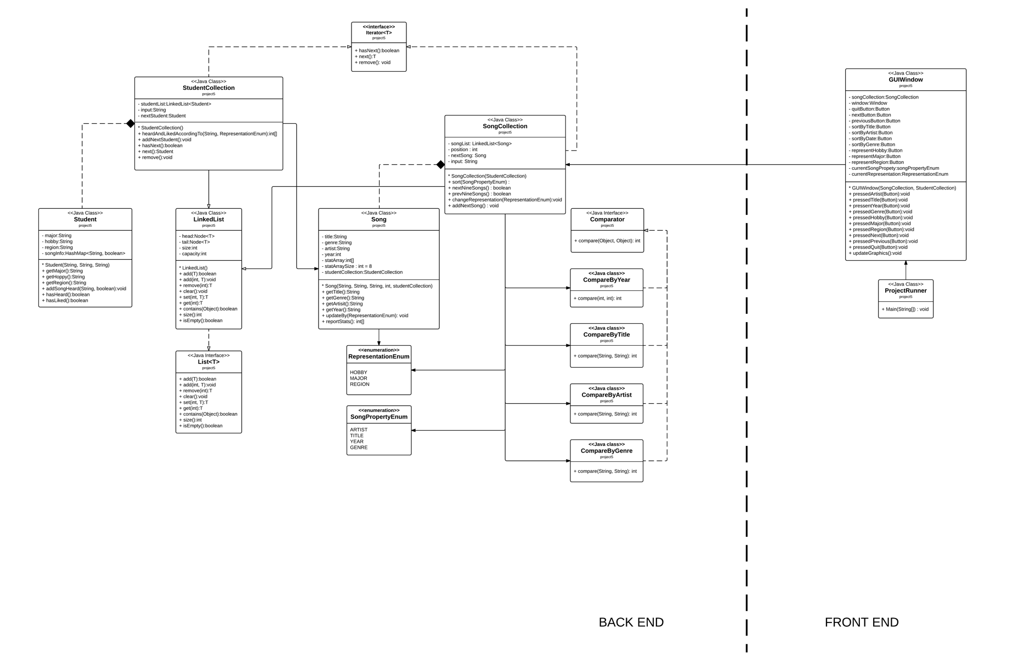Project UML