DHA Suffa University
Department of Computer Science
Final Year Project



VORLAN – Versatile Operations of Residential Linkage and Automated Networking
(P61F25)

Software Design Specifications
Submitted by
Daniyal Naeem – SE 221088
M Umair Shaykh – SE 221094
Sarim Khan – SE 221086
Syeda Mirha Ali – SE 221058
Supervisor(s)
Arsal Ahmed
Dr Najeeeb Ur Rehman

Fall 2023

Document Sign off Sheet

Document Information
Project Title | Vorlan
Project Code | P61F25
Document Name | Software Design Specifications
Document Version | 1.0
Document Identifier | P61F25-SDS
Document Status | Draft
Author(s) | Sarim Khan
Approver(s) | Arsal Ahmed
Issue Date | 21-Jan-2026

Name | Role | Signature | Date
Daniyal Naeem | Team Lead
Sarim Khan | Team Member
Syeda Mirha Ali | Team Member
M Umair Shaykh | Team Member
Arsal Ahmed | Supervisor
Dr Najeeb Ur Rehman | Co-Supervisor
Arsal Ahmed | Project Coordinator

Revision History

Date | Version | Description | Author
15-Jan-2026 | 1.0 | Initial draft of the document inincluding project overview and objectives | Project Team
20-Jan-2026 | 1.1 | Added SRS,SDS structure and system design sections | Project Team
25-Jan-2026 | 1.2 | Updated architecture, diagrams  and database design | Project Team
30-Jan-2026 | 1.3 | Final review, formatting, and corrections before submission | Project Team

Definition of Terms, Acronyms, and Abbreviations

[This section should provide the definitions of all terms, acronyms, and abbreviations required to interpret the terms used in the document properly.]

Term | Description
VORLAN | A smart home system project designed to provide offline AI assistance, home automation, and local network with a focus on privacy and security.
AI (Artificial Intelligence) | Technology that enables the system to understand user commands and make intelligent decisions based on predefined rules
Smart Home | A home environment where devices and services are automated and controlled using a centralized systems.
Offline Mode | Functionality of the system without an active internet connection.
Online Mode | Operation of system while internet is active.
Automation Rule | Time-based or sensor-based events are example of specified conditions that automatically initiate an action.

Table of Contents

1. Introduction 8
1.1 Purpose of Document 8
1.2 Intended Audience 8
1.3 Abbreviations 8
2. Overall System Description 9
2.1 Project Background 9
2.2 Problem Statement 9
2.3 Project Scope 9
2.4 Not In Scope 9
2.5 Project Objectives 9
2.6 Stakeholders & Affected Groups 9
2.7 Operating Environment 9
2.8 System Constraints 9
2.9 Assumptions & Dependencies 9
3. External Interface Requirements 10
3.1 Hardware Interfaces 10
3.2 Software Interfaces 10
3.3 Communications Interfaces 10
4. System Functions / Functional Requirements 11
4.1 System Functions 11
4.2 Use Cases 12
4.2.1 List of Actors 12
4.2.2 List of Use Cases 12
4.2.3 Use Case Diagram 13
4.2.4 Description of Use Cases 13
5. Non - Functional Requirements 16
5.1 Performance Requirements 16
5.2 Safety Requirements 16
5.3 Security Requirements 16
5.4 Reliability Requirements 16
5.5 Usability Requirements 16
5.6 Supportability Requirements 16
5.7 User Documentation 16
6. References 17

Introduction

Purpose of Document
This document contains a detailed Software Requirements Specification (SRS) for the VORLAN Smart Home Core System. The aim of this document is to define the functional and non-functional requirements, scope, constraints, and overall behavior of the system. This document can be used as a formal reference to ensure a common understanding of the system among all stakeholders.

The intended audience of this document includes:

- Project supervisor and examiners assessing the Final Year Project
- Developers who designed and implemented the system
- Future developers or researchers who may develop the system

This project adopts an Object-Oriented Design (OOD) methodology because it enables the design of the system using reusable objects, classes, and modules. Object-oriented design enhances scalability, maintainability, and modularity, which is ideal for a complex system such as VORLAN that involves the integration of various software and hardware components.

Intended Audience
This document is meant for individuals and groups who are involved in the development, evaluation, and future enhancement of the VORLAN Smart Home Core System. The main target audience includes:
- Project Supervisor and Examiners: To review, evaluate, and assess the scope, feasibility, and technical depth of the Final Year Project.
- Developers: To understand system requirements clearly for design, implementation, and testing purposes.
- System Designers: To use the documented requirements as a basis for architectural and object-oriented design decisions.
- Future Maintainers or Researchers: To facilitate system maintenance, upgrades, or further research and development based on VORLAN.
This document ensures that all stakeholders have a common and clear understanding of the system requirements.

Document Convention
This document is formatted in a standard way to make it clear and easy to read. The formatting rules used in this document are as follows:
- Font Name: Calibri
- Heading Font Size: 16
- Sub-heading Font Size: 14
- Normal Text Font Size: 12
- Line Spacing: 1.0

These conventions are applied uniformly across all sections of the document to maintain a professional and academic presentation suitable for Final Year Project submission.

Project Overview
The VORLAN Smart Home Core System is an intelligent, privacy-centric smart home solution aimed at integrating and simplifying home interactions on a daily basis. The main features of the system include a locally integrated AI assistant that can be controlled through WhatsApp, a motion sensor-based home security system, a private file-sharing cloud for local devices, a multi-functional smart screen, voice and time-based automation, and a smart Wi-Fi router.

The system is designed to operate primarily offline to ensure privacy and reliability while providing intelligent automation and user interaction. The basic design approach follows an Object-Oriented Design (OOD) methodology, enabling modular development through classes and objects representing various system components such as security, AI assistant, smart screen, and network management. This approach promotes scalability, maintainability, and reusability of the software modules, allowing the system to be extended or enhanced in the future without major architectural changes.

Scope
The VORLAN Smart Home Core System is scoped to clearly define the functionalities and limits of the project.

Included in Scope:

- Motion-detecting home security system with notifications
- Local cloud file-sharing system for connected devices
- Offline AI assistant accessible throught WhatsApp
- Smart screen with multiple functional modes such as mirror, recipe display, exercise guidance, YouTube video watching, and notice board
- Voice control and time-based automation for home functions

Excluded from Scope:

- Cloud-based hosting or cloud-dependent operations
- Face recognition or biometric identification features
- Integration with third-party smart home devices or external IoT ecosystems

Design Considerations
This section presents the essential considerations and constraints that need to be addressed before a complete design solution for the VORLAN Smart Home Core System can be developed. The aim is to provide a formal foundation for system design, ensuring that all essential issues are addressed early on in the development phase.

Essential design considerations include:

Privacy and Security: Given the offline nature of the VORLAN system and the sensitive user information it processes, all design choices must be driven by the need for local data storage, security, and encryption.
Offline Functionality: The core system components, such as the AI assistant, file-sharing cloud, and smart screen, need to be functional even when they are not connected to the internet.
Modularity and Scalability: The system should be designed in an object-oriented manner to enable seamless integration of future modules and devices without the need for significant changes.
Hardware Constraints: The system should make efficient use of available hardware resources such as embedded processors, memory, storage, cameras, sensors, and display units.
User Interface and Usability: The system should offer a user-friendly interface for all users, including voice commands, touch screens, and WhatsApp functionality.
Interoperability: Although the system will not integrate with third-party devices, it should be flexible enough to accommodate future integration if required.
Reliability and Fault Tolerance: The system should be able to function despite hardware or software component failures, ensuring uninterrupted home automation and security.
Energy Efficiency: Design should ensure low power consumption of devices and sensors for use in the home environment.

Assumptions and Dependencies
This section highlights additional assumptions and dependencies specifically relevant to the design and simulation of the VORLAN Smart Home Core System. These issues are distinct from those captured in earlier sections of the SRS.

Simulation Environment: It is assumed that a stable software simulation environment with necessary APIs and GUI frameworks will be available to emulate hardware components.

Hardware Simulation Accuracy: Virtual sensors, cameras, and network interactions in the simulation will sufficiently represent real hardware behavior for testing purposes.

Performance Metrics: The simulation is assumed to provide accurate estimates of system response times and resource utilization under normal operating conditions.

Software Integration: All required simulation libraries, WhatsApp API access, and local network emulation tools are assumed to be compatible and functional.

User Interaction: Simulated user inputs (voice commands, WhatsApp messages, GUI actions) are assumed to closely reflect real-world interactions to validate system logic.

Design Verification: Simulation results will be relied upon to validate design assumptions and functionality before potential future hardware deployment.

Risks and Volatile Areas
This section identifies potential risks and volatile areas that may impact the design and simulation of the VORLAN Smart Home Core System and outlines strategies to address them.

Potential Risks:

Technology Changes: Updates or changes in software libraries, APIs (such as WhatsApp API), or simulation frameworks may require adjustments to system design.

Simulation Accuracy: The simulated behavior of sensors, cameras, or network communication may not perfectly reflect real-world hardware, potentially affecting performance evaluation.

Requirement Changes: New or evolving user requirements may necessitate redesign of modules or integration of additional features.

Integration Challenges: Coordinating multiple simulated modules (AI assistant, security, smart screen, file-sharing) may lead to unforeseen conflicts or performance issues.

Performance Bottlenecks: Resource constraints in the simulation environment could affect timing, response, or concurrent processing of modules.

Mitigation and Contingency Strategies:

- Modular design using Object-Oriented principles allows individual modules to be updated or replaced without major impact on the overall system.
- Maintaining clear interface specifications between modules ensures easier adaptation to changes in technology or requirements.
- Testing and validation of each module separately before system integration reduces the impact of integration challenges.
- Regular backup of code and simulation configuration helps recover from unexpected failures or changes.
- Monitoring performance metrics during simulation helps identify bottlenecks early and adjust design accordingly.

System Architecture
The system architecture of the VORLAN Smart Home Core System provides a high-level overview of how its functionality is decomposed into subsystems and how these subsystems interact to deliver the desired functionality. The architecture is designed for modularity, scalability, and simulation-based testing.

High-Level Components:

AI Assistant Subsystem:

- Handles natural language processing and user interactions via WhatsApp.
- Processes commands and generates responses locally.
- Interacts with other subsystems to trigger actions (e.g., security alerts, smart screen updates).

Security Subsystem:

- Monitors home using simulated cameras and motion sensors.
- Generates alerts and notifications when security events are detected.
- Provides event logs and interacts with the smart screen and AI assistant for notifications.

Local File-Sharing Cloud Subsystem:

- Facilitates file storage and transfer among local devices in the simulation.
- Manages user permissions and ensures data privacy.
- Interacts with AI assistant for commands and notifications.

Smart Screen Subsystem:

- Displays different modes including mirror, recipe, workout, YouTube, and notice board.
- Receives updates from AI assistant, security, and file-sharing subsystems.
- Supports user input via touch simulation.

Voice Control & Automation Subsystem:

- Processes voice commands and schedules time-based automated tasks.
- Interfaces with other subsystems to control devices and trigger events.

Core Integration Layer:

- Serves as the communication backbone among all subsystems.
- Manages data flow, events, and coordination in the simulation environment.

Architecture Highlights:

Modular Design: Each subsystem is developed as an independent module with clear interfaces.
Object-Oriented Approach: Classes and objects represent system components for simulation and future expansion.

Offline Simulation: All subsystems operate locally, reflecting the offline functionality of the real system.

Extensibility: The architecture allows additional modules to be added without affecting existing functionality.

This high-level architecture provides a clear understanding of the decomposition of VORLAN and how individual subsystems work together to achieve intelligent, privacy-focused home automation.

System Level Architecture
System Decomposition into Elements

VORLAN is divided into six top-level subsystems:

- AI Assistant (WhatsApp integration)
- Security Module (motion detection & camera alerts)
- Local File-Sharing Cloud
- Smart Screen (multiple modes)
- Voice Control & Automation
- Core Integration Layer (communication backbone)

Relationship Between the Elements

- The Core Integration Layer manages communication between all subsystems.
- The AI Assistant can trigger actions in security, smart screen, or file-sharing modules.
- Security and File-Sharing modules send alerts and status updates to the smart screen and AI Assistant.
- Voice Control interacts with all subsystems to execute commands or schedule automation.

Interfaces to External Systems

- Primary external interface: WhatsApp API for AI Assistant.
- No cloud integration or third-party IoT devices (outside the scope).

Major Physical Design Issues

- All elements are simulated locally on a standard PC.
- Subsystems execute as independent modules in the simulation environment.
- Resource allocation focuses on CPU and memory efficiency for concurrent operation.

Global Design Strategies

- Error Handling: Each subsystem includes exception handling to prevent simulation crashes.
- Modularity: Independent module design allows replacement or updates without affecting other modules.
- Offline-first Operation: All core logic runs locally, reflecting privacy-focused design.
- Scalability: Architecture allows adding new modules or simulated devices without major redesign.

Software Architecture
The software architecture of VORLAN follows a three-tier architecture:

User Interface Layer (UI Layer)

- Provides all user interactions.
Includes:
- Smart Screen GUI
- WhatsApp Chat Interface
- Voice Command Interface

Middle Tier (Business Logic Layer)

- Handles core logic and processing.
Includes:
- AI Assistant Module
- Security Module Controller
- File-Sharing Controller
- Automation & Scheduler

Data Access Layer (Database Layer)

- Manages storage and retrieval of data.
Includes:
- Local File Storage
- Event Logs Database
- User Preferences Storage

Interaction Flow:

- Users interact with the UI Layer (e.g., touch screen, WhatsApp messages, voice commands).
- UI requests are sent to the Middle Tier, where the business logic processes commands and interacts with the appropriate subsystem.
- Any data that needs to be stored or retrieved is handled through the Data Access Layer.
- Responses and status updates are returned back to the UI Layer via the Middle Tier.

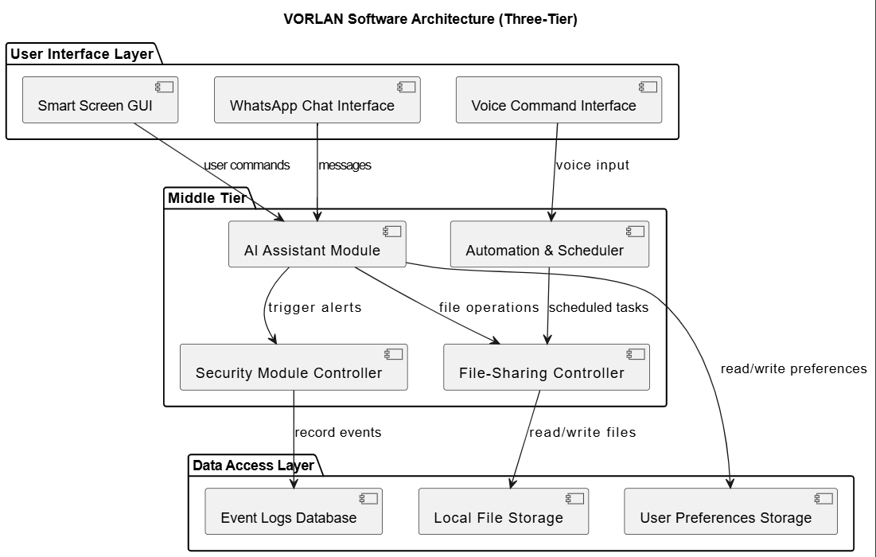

Design Strategy
The design strategy for the VORLAN Smart Home Core System focuses on modularity, scalability, maintainability, and privacy, ensuring that the system meets its functional goals while remaining flexible for future enhancements. The system is designed using an object-oriented methodology, where each subsystem and module is represented by classes and objects that encapsulate functionality and data.

Key Design Strategies and Decisions:

Future System Extension or Enhancement

- The system is designed using modular subsystems (AI Assistant, Security, Smart Screen, File-Sharing, Voice Control & Automation, Core Integration Layer).
- Clear interface definitions between modules allow additional subsystems or features to be integrated with minimal changes to existing code.
- Trade-off: Slightly higher initial design complexity to ensure extensibility.

System Reuse

- Reusable modules (e.g., AI processing, file handling, motion detection) are implemented as independent classes.
- Promotes code reuse in future projects or additional smart home applications.
- Trade-off: Initial abstraction requires more planning but reduces long-term maintenance costs.

User Interface Paradigms

- Supports multiple UI interactions: Smart Screen GUI, WhatsApp interface, and voice commands.
- Uses event-driven interaction patterns to ensure responsiveness and a consistent user experience across different input modes.
- Trade-off: Requires integration of diverse UI modalities, which adds complexity to the middle tier.

Data Management (Storage, Distribution, Persistence)

- All data is stored locally, including files, logs, and user preferences, ensuring privacy.
- Data access is abstracted via the Data Access Layer, allowing simulated persistence across all modules.
- Trade-off: Offline data storage limits remote accessibility, but this aligns with the project’s privacy-focused design goals.

Concurrency and Synchronization

- Subsystems such as the AI assistant, security module, and file-sharing operate concurrently within the simulation environment.
- Thread-safe mechanisms and event queues are employed to prevent data conflicts and ensure synchronized operations.
- Trade-off: Concurrency control adds implementation complexity but ensures reliable and responsive system behavior.

Design Rationale:

- The overall design emphasizes offline-first operation, privacy, modularity, and extensibility.
- Object-oriented design and layered software architecture allow clear separation of concerns and provide a foundation for future hardware integration or expansion of system features.
- Trade-offs made (e.g., modularity vs. initial complexity, offline storage vs. cloud accessibility) are guided by the project’s primary goals of privacy, reliability, and maintainability.

Detailed System Design
The detailed system design of the VORLAN Smart Home Core System provides a comprehensive blueprint for implementing the simulation-based solution. The design focuses on object-oriented modularity, offline operation, and privacy-focused data management.

Design Class Diagram
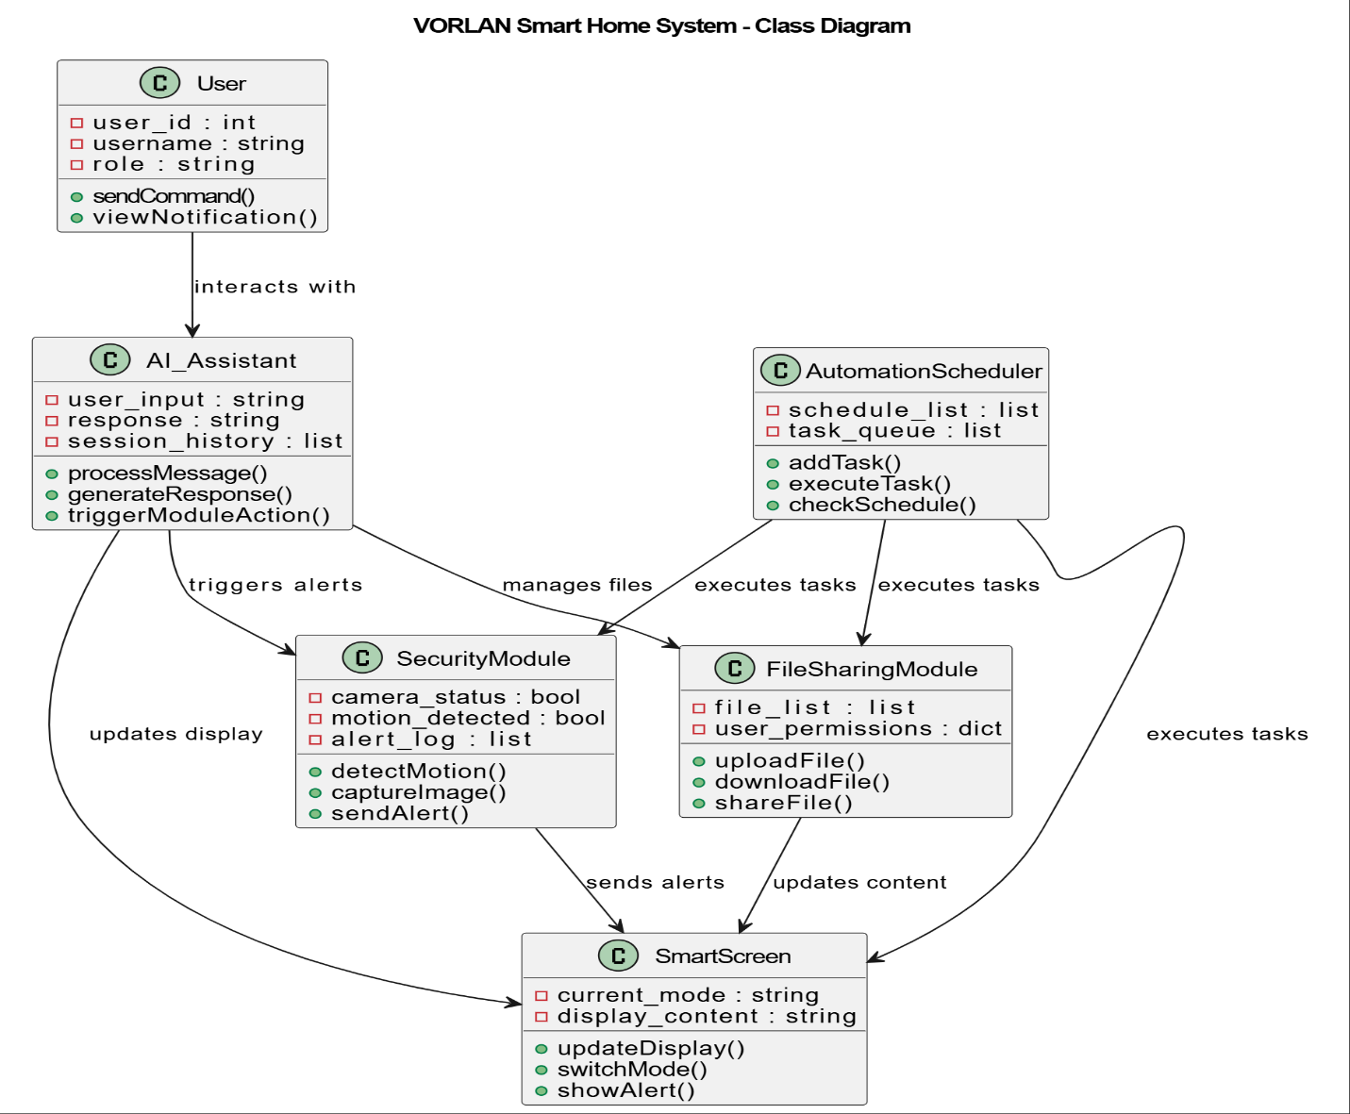

Database Design
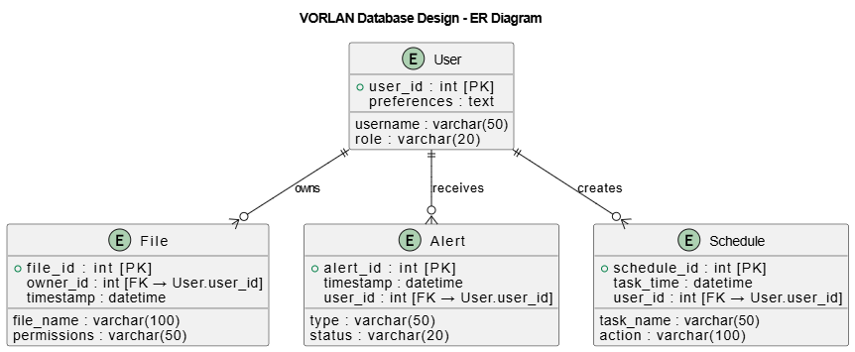

ER Diagram
The Entity-Relationship (ER) diagram represents the logical structure of the VORLAN system’s local database. It shows key entities, their attributes, and relationships, which are essential for managing user data, files, alerts, and automation schedules in the simulation environment.

Entities and Relationships:

User:
- Stores user information such as username, role, and preferences.
- Each user can own multiple files, receive multiple alerts, and create multiple schedules.

File:
- Represents files stored in the local file-sharing module.
- Attributes include file name, permissions, owner, and timestamp.
- Each file belongs to a single user.

Alert:
- Represents security or system alerts generated by the SecurityModule.
- Each alert is associated with a user who receives it.

Schedule:
- Represents scheduled tasks handled by the AutomationScheduler.
- Attributes include task name, execution time, action, and associated user.

The relationships are:
- User owns File (one-to-many)
- User receives Alert (one-to-many)
- User creates Schedule (one-to-many)
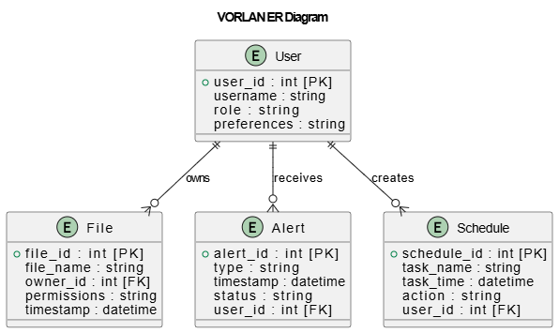

Data Dictionary
Every data entity, data repository, and data piece utilized in the VORLAN system is described in depth in the data dictionary. To guarantee uniformity and clarity throughout the design and development process, it specifies each entity's usage, content, and structure. The following conventions are used to describe each entity:

- Name: The primary name of the table or data entity.
- Alias: Other names for the entity.
- Where-used/How-used: Modules or processes that make use of this item, indicating storage, input, or output.
- Content Description: The entity's structure is represented in formal notation using:
- =: consists of
- +: order (and)
- [|]: choice (either-or)
- {}: recurrence
- (): optional * — *: remarks or comments
- Column Table: The entity's attributes, such as the name, description, data type, length, nullable, default value, and key type (Primary/Foreign).
The data dictionary ensures that all entities, relationships, and attributes are clearly defined, making the database design consistent and easier to implement, maintain, and extend.

Data 1 - User
Every person who communicates with the VORLAN system is represented by the User entity. It includes the data required for customisation, access control, and identification. Every user has a distinct ID (user_id), a username for display and login, a role that specifies system access (such as admin or regular user), and optional preferences that hold customized settings. Several modules use the User entity: the Automation Scheduler uses it to assign tasks, the Security module uses it to determine who receives warnings, the AI Assistant uses it to deliver customized responses, and the File Sharing module uses it to manage file ownership.

Data 2 - File
All uploaded, shared, and controlled files in the VORLAN system are stored in the File entity. Every file contains a timestamp that records the time of creation or upload, a unique identifier (file_id), a name (file_name), an owner ID (owner_id) that links it to a user, and access rights that specify who can read or edit it. This organization makes ensuring that files are appropriately tracked, protected, and distributed among system users. For functions including file access, sharing, and initiating automated operations, the File entity communicates with the Automation Scheduler, AI Assistant, and SmartScreen display..
.

Data 3 – Alert
Notifications produced by the system, particularly by the Security module, are represented by the Alert entity. Motion detection, security events, and other significant system events trigger the generation of alerts. Every alert has a distinct ID (alert_id), a type that indicates whether it is a security or motion alert, a date that indicates when it was generated, a status that indicates whether it is active or resolved, and a user_id that identifies the recipient. In order to provide prompt notice and user awareness of important occurrences, alerts are shown on the SmartScreen, forwarded to the AI Assistant, and logged for tracking reasons.

Data 4 – Schedule
In the VORLAN system, all automated or time-based tasks are represented by the Schedule entity. A distinct ID (schedule_id), a descriptive task name (task_name), the execution time (task_time), the action that will be carried out (action), and the user_id of the person who created it are all included in each scheduled task. Users can effectively automate their smart home environment by using the Automation Scheduler to leverage the Schedule entity to initiate activities on the SmartScreen, File Sharing module, or Security module at the specified time.

User
Name |  | User
Alias |  | System User, Account
Where-used/how-used |  | Input: Registration/login,  Store: Local database,  Output: Accessed by AI_Assistant, FileSharingModule, SecurityModule, AutomationScheduler
Content description |  | User = user_id + username + role + preferences  user_id = int  username = string  role = string
Column Name | Description |  | Type | Length | Null able | Default Value | Key Type
user_id | Unique identifier for the file |  | int | 4 | No | Auto-increment | PK
username | Name of the user |  | varchar | 50 | No | None | -
role | User role (admin/regular) |  | varchar | 20 | No | ‘regular’ | -
preferences | User-specific settings |  | text | - | Yes | NULL | -

File
Name |  | File
Alias |  | Local File, Shared File
Where-used/how-used |  | Input: File upload,  Store: File metadata table  Output: Accessed by AI_Assistant, FileSharingModule, SecurityModule, AutomationScheduler
Content description |  | file= file_id + file_name + permissions + timestamps  file_id = int  file_name = string  owner_id = int  permissions = string  timestamp = datetime
Column Name | Description |  | Type | Length | Null able | Default Value | Key Type
file_id | Unique identifier for the file |  | int | 4 | No | Auto-increment | PK
file_name | Name of the user |  | varchar | 100 | No | None | -
owner_id | User ID who owns the file |  | int | 4 | No | None | FK
permissions | File access level (public/private) |  | varchar | 50 | No | ‘private’ | -
Timestamp | File creation/upload time |  | datetime | - | No | Current Time | -

Alert
Name |  | Alert
Alias |  | Notification, Security Alert
Where-used/how-used |  | Input: SecurityModule detects events  Store: Alert table  Output: displayed on SmartScreen and AI_Assistant
Content description |  | Alert = alert_id + type + timestamp + status + user_id  Type = string [motion | security]  Status = string [active | resolved]  User_id = int
Column Name | Description |  | Type | Length | Null able | Default Value | Key Type
alert_id | Unique identifier for the file |  | int | 4 | No | Auto-increment | PK
type | Type of alert (motion/security) |  | varchar | 50 | No | ‘motion’ | -
timestamp | Time the alert was generated |  | datetime | - | No | Current time | -
status | Status of the alert (active/resolved) |  | varchar | 20 | No | ‘active’ | -
user_id | User ID who receives the alert |  | int | 4 | No | None | FK

Schedule
Name |  | Schedule
Alias |  | Task, Automation Schedule
Where-used/how-used |  | Input: AutomationSchedular tasks,  Store: Schedule table,  Output: triggers actions on SmartScreen, FileSharingModule, SecurityModule
Content description |  | Schedule = schedule_id + task_name + task_time + action + user_id  schedule_id = int  task_name = string  task_time = datetime  action = string  user_id = int
Column Name | Description |  | Type | Length | Null able | Default Value | Key Type
schedule_id | Unique identifier for the file |  | int | 4 | No | Auto-increment | PK
task_name | Name of the scheduled task |  | varchar | 50 | No | None | -
task_time | Time when task should execute |  | datetime | - | No | None | -
actions | Action performed by the task |  | varchar | 100 | No | None | -
user_id | User ID who created the task |  | Int | 4 | No | None | FK

Application Design

Sequence Diagram

Sequence Diagram 1 – File Request via AI Assistant
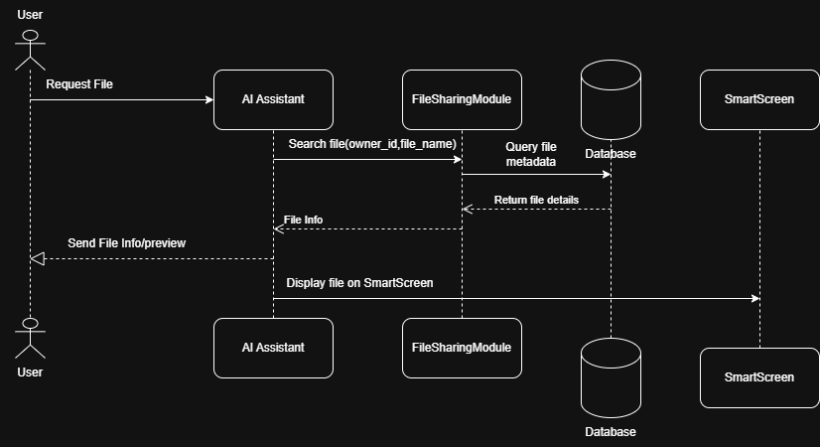

- The user requests a file via WhatsApp or SmartScreen.
- The AI Assistant forwards the request to the FileSharingModule.
- FileSharingModule queries the Database for the file metadata.
- File info is returned to the AI Assistant and sent to the user.
- If needed, the SmartScreen displays the file.
- This diagram shows interaction flow between user, AI, file module, database, and SmartScreen.

Sequence Diagram 2 – Motion Alert Notification
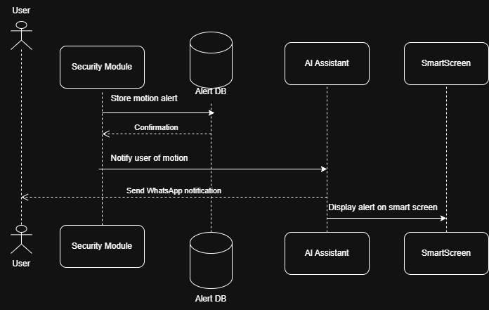

- Security Module detects motion and stores alert in Alert DB.
- AI Assistant retrieves the alert and notifies the user via WhatsApp.
- SmartScreen displays the alert visually.
- This diagram demonstrates offline alert handling and multi-channel notification.

Sequence Diagram 3 – Schedule Task Execution
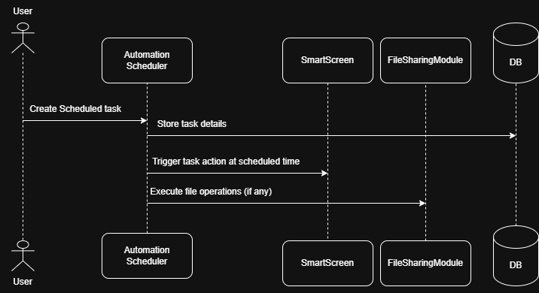

- User creates a scheduled task (e.g., play video, show recipe, share file).
- Scheduler stores the task in the database.
- At the scheduled time, Scheduler triggers actions on SmartScreen or FileSharingModule.
- Shows time-based automation flow in VORLAN.

State Diagram

State Diagram 1 – AI Assistant State Diagram
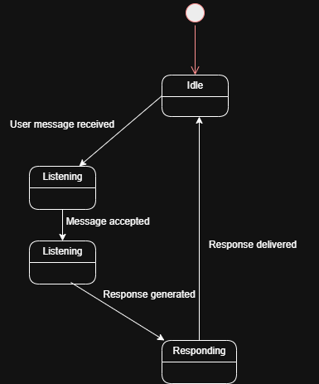

This state diagram represents the operational behavior of the AI Assistant in the VORLAN system. Initially, the AI Assistant remains in the Idle state. When a user sends a message through WhatsApp or SmartScreen, the system transitions to the Listening state. After receiving the message, it moves to the Processing state where the request is analyzed locally. Once the response is generated, the AI Assistant enters the Responding state and delivers the output to the user. After completing the interaction, the system returns to the Idle state, waiting for the next request.

State Diagram 2 – Security System State Diagram
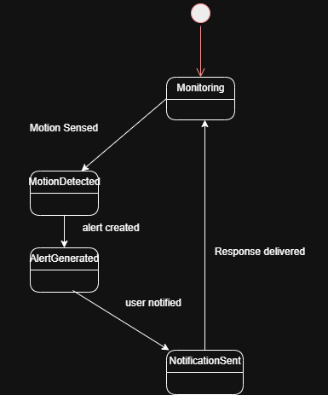

This diagram illustrates the behavior of the Security Module in VORLAN. The system normally operates in the Monitoring state, continuously observing motion sensors. When motion is detected, it transitions to the MotionDetected state. An alert is then generated and stored in the local database, moving the system to the AlertGenerated state. After notifying the user via the AI Assistant and SmartScreen, the system enters the NotificationSent state and finally returns to Monitoring, ensuring continuous security coverage.

GUI Design

File Management - Mock Screen 1
The File Management interface of the VORLAN system is depicted in this mock screen. Files kept in the local cloud can be viewed, uploaded, shared, and managed by users. Along with basic information like file name, file type, and access permissions, the interface shows a list of files that are available. Opening, sharing, and deleting files are among the actions that users can take. The design prioritizes quick access to frequently used files and ease of navigation.

Main Components:
- File list panel
- Upload file button
- File access permissions indicator
- Search bar
- Action buttons (Open, Share, Delete)
User Interaction:
The user selects a file from the list and chooses an action. The request is processed locally and reflected instantly on the Smart Screen.

Security Alert - Mock Screen 2
The VORLAN system's Security Alert interface is depicted in this mock screen. It shows notifications that are produced in real time by the security and motion detection modules. The alert type, timestamp, and current status are all included in each alert. Alerts can be dismissed or acknowledged by users right from the screen. This interface guarantees that consumers are instantly notified of any incidents pertaining to home security.

Main Components:
- Alert notification panel
- Alert type and timestamp
- Alert status indicator (Active/Resolved)
- Acknowledge/Dismiss button
- Alert history section
User Interaction:
When a motion event occurs, the alert is displayed automatically. The user can view details and take appropriate action, after which the alert status is updated.

AI Assistant Interaction - Mock Screen 3
The VORLAN system's AI Assistant interaction interface is depicted in this mock screen. It enables users to use voice or text commands to interact with the locally hosted AI assistant. The interface presents system responses to user requests in a conversational style. Without requiring continuous internet connectivity, the AI Assistant handles requests like file access, security status queries, automation commands, and general support. To guarantee seamless interaction across both Smart Screen and WhatsApp-based interfaces, the design places an emphasis on clarity and simplicity.
Main Components:
- Conversation window (user messages and AI responses)
- Text input field
- Voice command button
- Status indicator (Listening / Processing / Responding)
- Action suggestions or quick command buttons

User Interaction:
The user enters a text command or uses voice input to interact with the AI Assistant. The system processes the request locally and displays the response in real time. Relevant actions such as file retrieval, alert display, or automation execution are triggered based on the user’s command

References
- IEEE Computer Society, IEEE Recommended Practice for Software Requirements Specifications (IEEE Std 830-1998), IEEE, 1998.
Available from: IEEE Xplore Digital Library.
- ISO/IEC, ISO/IEC 25010:2011 – Systems and Software Engineering: System and Software Quality Models, International Organization for Standardization, 2011.
Available from: ISO official website.
- PlantUML, PlantUML Language Reference Guide, 2024.
Available from: https://plantuml.com
- WhatsApp Inc., WhatsApp Business Platform Documentation, Meta Platforms Inc., 2024.
Available from: https://developers.facebook.com/docs/whatsapp
- Raspberry Pi Foundation, Raspberry Pi Documentation, 2024.
Available from: https://www.raspberrypi.com/documentation/
- OpenAI, Artificial Intelligence Concepts and Local AI Processing, OpenAI Technical Documentation, 2024.
Available from: https://platform.openai.com/docs
- Stallings, W., Operating Systems: Internals and Design Principles, 9th Edition, Pearson Education, 2018.
- Pressman, R. S., Software Engineering: A Practitioner’s Approach, 8th Edition, McGraw-Hill Education, 2014.

Appendices
Although it is too specific or supplemental to be included in the document's main body, this part includes extra information that supports the VORLAN system design. The appendices offer resources that could help readers comprehend the technical conventions, system behavior, and design choices made throughout the work.
Appendix A – Notation and Symbols
This appendix describes the notations and symbols used in UML diagrams, Data Flow Diagrams (DFD), and content descriptions within the data dictionary. It ensures consistent interpretation of models and diagrams presented in the document.
Appendix B – Assumptions and Constraints
This appendix lists system assumptions and constraints related to the simulation environment, offline functionality, and hardware limitations. These assumptions guided the design and implementation approach of the VORLAN system.

Appendix C – Abbreviations and Acronyms
This appendix provides definitions of abbreviations and acronyms used throughout the document, such as AI (Artificial Intelligence), DFD (Data Flow Diagram), and GUI (Graphical User Interface).
Appendix D – Future Enhancements (Optional)
This appendix outlines potential future enhancements that are outside the current project scope, including cloud-based services, face recognition, and integration with third-party smart devices.

