DHA Suffa University
Department of Computer Science
Final Year Project



VORLAN
(Versatile Operations for Residential Linkage and Automated Networking)

Software Requirements Specifications
Submitted by
Daniyal Naeem (SE221088)-Team Lead
Syeda Mirha Ali (SE221058)
M UMAIR SHAYKH (SE221094)
SARIM KHAN (SE221086)

Supervisor(s)
Arsal Ahmed
Co-Supervisor: Dr Najeeb Ur Rehman

Fall 2025

Document Sign off Sheet

Document Information
Project Title | Vorlan
Project Code | P61F25
Document Name | Software Requirements Specifications
Document Version | 1.0
Document Identifier | P61F25-SRS
Document Status | Draft
Author(s) | M Umair Shaykh
Approver(s) | Arsal Ahmed
Issue Date | 21-Jan-2026

Name | Role | Signature | Date
Daniyal Naeem | Team Lead
Syeda Mirha Ali | Team Member 2
M Umair Shaykh | Team Member 3
Sarim Khan | Team Member 4
Arsal Ahmed | Supervisor
Dr Najeeb Ur Rehman | Co-Supervisor
Arsal Ahmed | Project Coordinator

Revision History

Date | Version | Description | Author
<dd/mmm/yyyy> | <x.x> | <details of the changes made> | <name>

Definition of Terms, Acronyms, and Abbreviations

Term | Description
VORLAN | Versatile Operations for Residential Linkage and Automated Networking
PIR Sensor | Motion sensor that detects heat/movement.
Onboarding | Adding a new device to the system so it’s ready to use
Boundary Constraints | Constraints on the system’s performance or desired behavior.
LM Studio | For Ai model operating on local device not cloud
Private Local Cloud Storage | Cloud storage insides home

Table of Contents

1. Introduction 8
1.1 Purpose of Document 8
1.2 Intended Audience 8
1.3 Abbreviations 8
2. Overall System Description 9
2.1 Project Background 9
2.2 Problem Statement 9
2.3 Project Scope 9
2.4 Not In Scope 9
2.5 Project Objectives 9
2.6 Stakeholders & Affected Groups 9
2.7 Operating Environment 9
2.8 System Constraints 9
2.9 Assumptions & Dependencies 9
3. External Interface Requirements 10
3.1 Hardware Interfaces 10
3.2 Software Interfaces 10
3.3 Communications Interfaces 10
4. System Functions / Functional Requirements 11
4.1 System Functions 11
4.2 Use Cases 12
4.2.1 List of Actors 12
4.2.2 List of Use Cases 12
4.2.3 Use Case Diagram 13
4.2.4 Description of Use Cases 13
5. Non - Functional Requirements 16
5.1 Performance Requirements 16
5.2 Safety Requirements 16
5.3 Security Requirements 16
5.4 Reliability Requirements 16
5.5 Usability Requirements 16
5.6 Supportability Requirements 16
5.7 User Documentation 16
6. References 17

Introduction

Purpose of Document
The purpose of this SRS is to show the functional requirements of VORLAN, a smart home core security system, it is used to support its design, implementations well as evaluation.

Intended Audience
This document is intended for project supervisors, development team, stakeholders, and end users who wants an understanding of the system requirements and functionality like how it’s working.

Overall System Description

Project Background
VORLAN (Versatile Operations for Residential Linkage and Automated Networking) is an affordable, privacy-focused smart home system designed for operating without continuous internet access and connectivity. It provides secure connectivity between home gadgets and prioritize data protection and security and local control on it. The system provides a safe local cloud storage environment without requiring paid subscriptions and integrates an AI assistant to support user interaction and automate whole process. VORLAN is primarily is for households with limited or unreliable internet access in Pakistan and similar regions, aligning with the approved project proposal and scope.

Problem Statement
Currently Existing smart home systems are largely subscription-based, require continuous internet connectivity, and often unsecure user data and privacy. These limitations lower accessibility and trust, especially in regions with unreliable internet services. VORLAN addresses these issues by offering a locally hosted, cost-effective, and provides privacy for smart home solution that operates offline and supports user interaction through commonly used messaging platforms

Project Scope
WhatsApp AI chatbot offline
Motion security + camera
Home file-sharing cloud
Smart Wi-Fi + display
Voice control + automation
Power-cut alerts
Local + remote access

Not In Scope
Cloud / subscription
Facial recognition
Third-party smart home integration
Internet exposure / tracking

Project Objectives
Offline-first prototype with main features
User data stays local + encrypted
Low-cost hardware for Pakistani homes
Simple interface + WhatsApp assistant

Stakeholders & Affected Groups
Homeowners / residents
Development team + supervisors
Family members / guests
University examiners / evaluators

Operating Environment
Target hardware: Raspberry Pi / mini-PC running Linux, router, CCTV cameras, PIR sensors, microphones, smart display
Software stack: Python backend, Flask APIs, LM Studio for local AI, Vosk for offline STT, Coqui TTS, SQLite/JSON storage

System Constraints
Mostly offline, optional internet
Limited compute + memory on low-cost devices
Real-time camera depends on hardware acceleration
WhatsApp needs API/gateway + registered number

Assumptions & Dependencies
At least one smartphone on local network for WhatsApp
Household has basic Wi-Fi
Hardware (camera, PIR, speaker, mic) works with chosen SBC
Internet used only if user enables it

External Interface Requirements

Hardware Interfaces
Camera (USB/CSI) – motion detection + local recording
PIR sensors – detect movement, trigger alerts/recording
Mic – local voice commands (STT)
Speaker – TTS responses + alerts
Storage (USB/SSD) – local cloud + recordings
Wi-Fi / router – local network + DHCP

Software Interfaces
Internal APIs + optional third-party connectors – owned by VORLAN team
LM Studio – LM Studio Dev Team – local AI model hosting + inference
Flask REST API – VORLAN team – UI, device control, automation
Vosk STT – Alpha Cephei – offline speech recognition
Coqui TTS – Coqui.ai – offline speech output
WhatsApp interface – Meta (Facebook) – Business API / gateway for chatbot messaging + commands

Communications Interfaces
Local network protocols: TCP/IP over Wi‑Fi, HTTP/HTTPS for internal API calls, WebSocket for real-time alerts, MQTT (optional) for lightweight device messaging.

System Functions / Functional Requirements

System Functions

Ref # | Functions | Category | Attribute | Details & Boundary Constraints
R1.1 | User onboarding &  device pairing | Evident | System Response time | Device registration completes within 30 seconds.
R1.2 | Motion detection and local recording | Evident | Device registration | Motion alerts sent within 5 seconds of detection.
R1.3 | Local AI chatbot via WhatsApp | Evident | Motion alerts | Respond to basic queries within 3 seconds (local inference).
R1.4 | Local file-sharing private cloud | Evident | Response time | Files accessible to authorized local users on LAN.
R1.5 | Voice control and STT | Evident | File access | Common voice commands recognized with 88% accuracy in quiet environments.
R1.6 | Time-based  automation | Hidden | Command recognition | Scheduled actions execute within 10 seconds of time.
R1.7 | Power-cut alert & UPS handling | Evident | Backup & notification | System switches to battery backup and notifies user about it.
R1.8 | Smart display modes (mirror, recipe, workout, noticeboard) | Frill | Mode loading | Modes load within 2 seconds on modern hardware.
System Attributes/ Nonfunctional Requirements

Attribute | Details and Boundary Constraints | Category
Response time | System responds to WhatsApp requests or voice commands within 3 seconds to provide smooth user experience. | Mandatory
Concurrent User Load | Supports a minimum of 10 concurrent users on the local network without performance reduction. | Mandatory
Device Registration | Pairing completes within 30 seconds under casual conditions. | Mandatory
Motion Alert Latency | Motion detection triggers alerts within 5 seconds of event. | Mandatory
Recording Availability | Cameras start recording within 2 seconds of motion detection; data stored locally. | Mandatory
Voice Command Accuracy | Offline STT recognizes common commands with ≥88% accuracy in quiet environments. | Mandatory
Scheduled Action Timing | Time-based automation tasks execute within 10 seconds of scheduled trigger. | Mandatory
Data Residency & Encryption | All sensitive data remains local and encrypted using domain-standard algorithms. | Mandatory
Power-Fail Response | System switches to UPS/battery and inform about power-cut alert within 30 seconds. | Mandatory
Storage Capacity | Local storage supports at least 24 hours of continuous camera recording or overwrites oldest data automatically. | Mandatory
Hardware Cost Target | Core hardware designed to remain affordable for Pakistani households. | Optional
WhatsApp Integration | Requires registered number and Business API or gateway; message throughput subject to provider limits. | Mandatory

Use Cases

List of Actors
Resident – primary user, controls system and monitors home
Guest – secondary user, limited access to system features
System Administrator – technically skilled homeowner, manages setup and configuration
Sensor – PIR or camera modules, acts as hardware actor for motion detection
External Service – WhatsApp gateway/API, optional for chatbot messaging

List of Use Cases
UC1 – Device Onboarding & Pairing – register & pair devices fast
UC2 – Motion Detection & Alert – detect movement & send alerts
UC3 – Local File Sharing – share files securely on LAN
UC4 – Offline AI Chatbot via WhatsApp – answer queries offline
UC5 – Voice Command Execution – run commands using voice offline
UC6 – Smart Display Mode Selection – switch screen: mirror, recipe, workout, notice board
UC7 – Schedule Automation – auto actions like Wi-Fi control or device triggers
UC8 – Power-Cut Alert & Backup – notify user & switch to battery
UC9 – Remote Access Over LAN – control system remotely within local network

Use Case Diagram
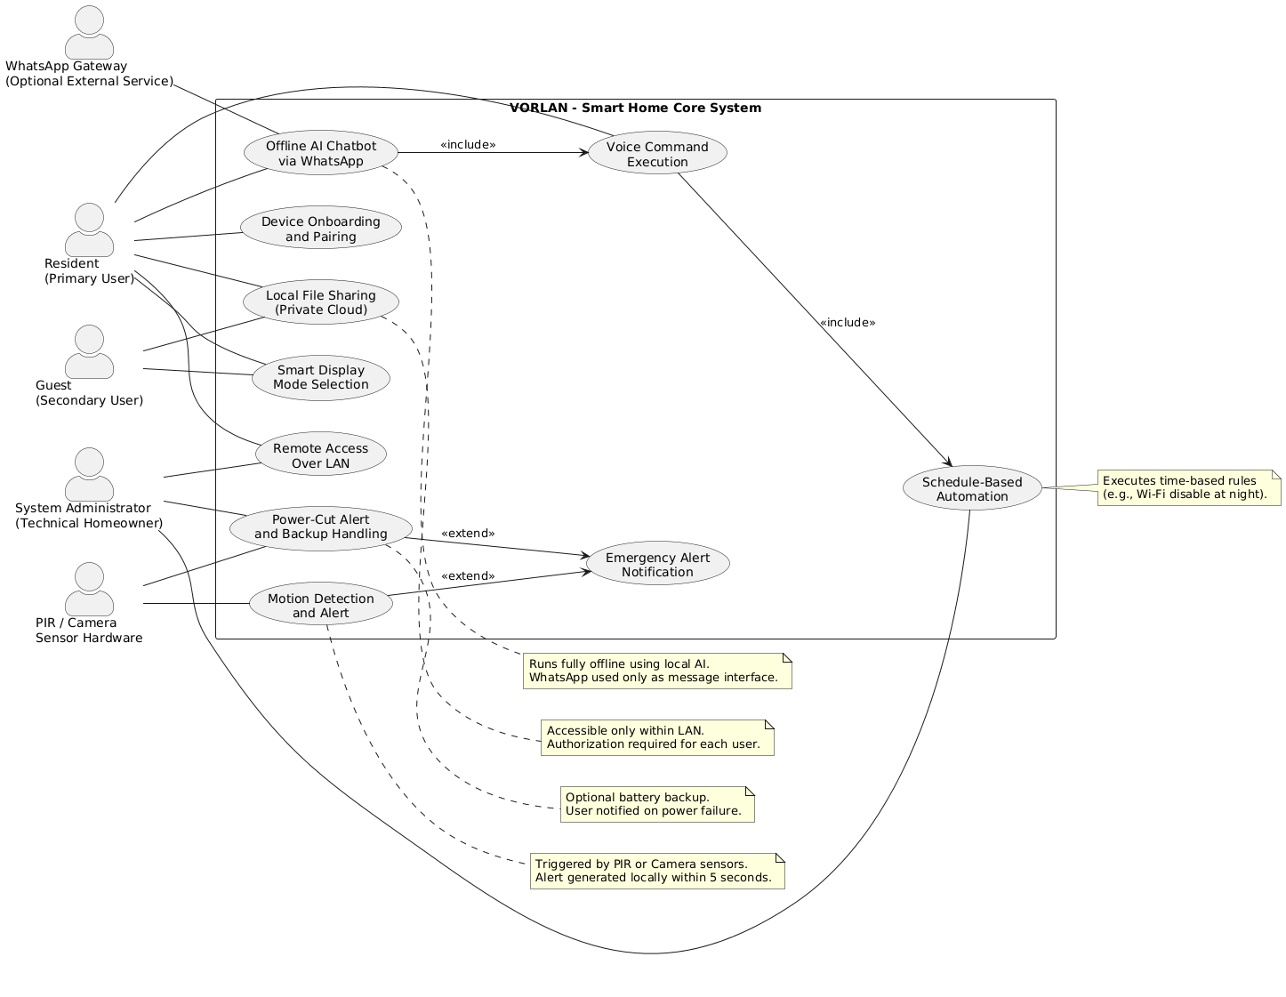

Description of Use Cases

Use Case Name: Device Onboarding and Pairing
Unique ID: UC01
Area: System Setup & Configuration
Actor(s): Resident (Primary User), System Administrator
Stakeholder: Homeowner, Project Evaluator
Description: Allows the user to register and pair VORLAN devices in the system for initial use
Triggering Event: User powers on a new device and starts setup
Steps Performed (Main Path) | Information for Steps
- User initiates onboarding | System enters pairing mode
- Device is detected  - Device is registered | System verifies device identity  Device added to local system
Preconditions: System is powered on and local network is available.
Post conditions: Device is successfully paired and ready for operation
Assumptions: User has physical access to the device
Success Guarantee: Device appears in the system dashboard
Requirements Met: Secure onboarding, offline operation
Outstanding Issues: None
Priority: high
Risks: Incorrect pairing due to network issues

Use Case Name: Motion Detection and Alert
Unique ID: UC02
Area: Home Security
Actor(s): PIR Sensor, Camera, Resident
Stakeholder: Homeowner
Description: Detects motion and sends a local alert to the user.
Triggering Event: Movement detected by sensor or camera.
Steps Performed (Main Path) | Information for Steps
- Sensor detects motion | Signal sent to system
- System verifies event  - Alert generated | Avoids false trigger  Notification sent to user
Preconditions: Sensors are active and configured.
Post conditions: User receives motion alert.
Assumptions: Sensors are functioning correctly
Success Guarantee: Alert delivered within defined time
Requirements Met: Local security monitoring
Outstanding Issues: Low-light camera accuracy
Priority: High
Risks: False positives

Use Case Name: Local File Sharing
Unique ID: UC03
Area: Data & Storage
Actor(s): Resident, Guest
Stakeholder: Household Users
Description: Enables secure file sharing across devices on the local network.
Triggering Event: User uploads or requests a file.
Steps Performed (Main Path) | Information for Steps
- User selects file | File chosen from device
- File stored locally  - Access granted | Saved in private storage  Authorized users can view
Preconditions: User is connected to LAN
Post conditions: File is accessible locally
Assumptions: Sufficient storage is available
Success Guarantee: File shared without internet
Requirements Met: Private local cloud
Outstanding Issues: Large file transfer speed
Priority: Medium
Risks: Unauthorized access if misconfigured

Use Case Name: Offline AI Chatbot via WhatsApp
Unique ID: UC04
Area: AI Interaction
Actor(s): Resident, WhatsApp Gateway (Optional)
Stakeholder: Homeowner
Description: Responds to user queries using a locally hosted AI model.
Triggering Event: User sends a WhatsApp message.
Steps Performed (Main Path) | Information for Steps
- Message received | WhatsApp gateway forwards text
- AI processes query  - Response sent | Local inference executed  Reply delivered to user
Preconditions: Local AI model is running.
Post conditions: User receives response.
Assumptions: WhatsApp number is registered.
Success Guarantee: Query answered offline.
Requirements Met: Offline AI assistance
Outstanding Issues: Complex query handling
Priority: High
Risks: Gateway dependency

Use Case Name: Voice Command Execution
Unique ID: UC05
Area: Voice Control
Actor(s): Resident, Microphone
Stakeholder: Homeowner
Description: Executes spoken commands without internet dependency.
Triggering Event: User speaks a command.
Steps Performed (Main Path) | Information for Steps
- Voice captured | Audio input recorded
- Speech recognized  - Command executed | Offline STT used  Action performed
Preconditions: Microphone is active
Post conditions: Requested action is completed.
Assumptions: Environment is reasonably quiet
Success Guarantee: Command executed correctly.
Requirements Met: Offline voice control
Outstanding Issues: Accent variations
Priority: Medium
Risks: Misinterpretation

Use Case Name: Smart Display Mode Selection
Unique ID: UC06
Area: User Interface
Actor(s): Resident, Guest
Stakeholder: Household Users
Description: Allows switching between different smart display modes.
Triggering Event: User selects a display option.
Steps Performed (Main Path) | Information for Steps
- Mode selected | User input received
- UI loads | Selected mode displayed
Preconditions: Display is powered on.
Post conditions: Desired mode is active.
Assumptions: Display hardware is functional
Success Guarantee: Mode loads successfully.
Requirements Met: Smart display functionality
Outstanding Issues: Performance on low hardware
Priority: Low
Risks: UI lag

Use Case Name: Schedule Automation
Unique ID: UC07
Area: Automation
Actor(s): System Administrator
Stakeholder: Homeowner
Description: Executes predefined actions based on time schedules.
Triggering Event: Scheduled time is reached.
Steps Performed (Main Path) | Information for Steps
- Schedule checked | System clock verified
- Action triggered | Automation executed
Preconditions: Schedule is defined.
Post conditions: Action is completed.
Assumptions: System time is accurate.
Success Guarantee: Automation runs as planned.
Requirements Met: Time-based control
Outstanding Issues: Clock drift
Priority: Medium
Risks: Incorrect timing

Use Case Name: Power-Cut Alert and Backup
Unique ID: UC08
Area: System Reliability
Actor(s): Sensor, Resident
Stakeholder: Homeowner
Description: Detects power failure and alerts the user.
Triggering Event: Electricity supply is interrupted.
Steps Performed (Main Path) | Information for Steps
- Power loss detected | System switches mode
- Alert sent | User notified
Preconditions: Backup power is available (optional).
Post conditions: System runs on backup or shuts down safe
Assumptions: Battery is charged
Success Guarantee: User is informed.
Requirements Met: Reliability and alerts
Outstanding Issues: Battery capacity
Priority: High
Risks: Backup failure

Use Case Name: Remote Access Over LAN
Unique ID: UC09
Area: Network Access
Actor(s): Resident, System Administrator
Stakeholder: Homeowner
Description: Allows secure access to the system within the local network.
Triggering Event: User initiates remote connection.
Steps Performed (Main Path) | Information for Steps
- Connection request | LAN authentication
- Access granted | System interface shown
Preconditions: User is on local network.
Post conditions: Remote control session active.
Assumptions: User credentials are valid.
Success Guarantee: System controlled remotely.
Requirements Met: Local remote access
Outstanding Issues: Session timeout handling
Priority: Medium
Risks: Unauthorized access

Non - Functional Requirements

Performance Requirements
Motion alert within 5 sec
Chatbot reply within 3 sec
Screen actions load within 2 sec

Safety Requirements
Cameras and sensors installed safely
System strictly not to show private data to unauthorized users

Security Requirements
All local data encrypted where possible
Device pairing and admin tasks secured with credentials & authentication
WhatsApp credentials stored securely and used only when enabled

Reliability Requirements
System tolerates power interruptions and recovers on reboot
Local recordings reserved across restarts if not altered

Usability Requirements
Simple onboarding for low digital literacy users
WhatsApp assistant available for users unfamiliar with user interface

Supportability Requirements
Logs and diagnostic endpoints available for troubleshooting
Clear user manual and quick-start guide included

User Documentation
User manual included
Quick start guide for device installation and pairing

References
Non-functional requirements in this project follow the IEEE recommended structure for SRS documentation (IEEE Std 830-1998), and are framed according to the ISO/IEC 25010 quality model which defines key quality attributes such as performance, reliability, usability, and security (ISO, 2011). Security requirements are informed by best practices outlined in ISO/IEC 27001. Standard software engineering textbooks (Wiegerts & Beatty, 2013; Sommerville, 2016) further guide the classification and documentation of these requirements.

