EdBook

Table of Content

Product Name 1
Software Requirements Specification Document 1
1 Introduction 3
1.1 System Overview 3
1.2 Operating Environment 3
1.3 Conceptual Model 3
2 Functional Requirements 4
2.1 Specific Functional Requirements 4
2.2 User Interface Specifications 4
2.3 External Interfaces and Database Requirements 4
2.4 Error Handling 4
2.5 Foreseeable Functional Changes and Enhancements 4
3 Non-Functional Requirements 5
3.1 Specific Non-Functional Requirements 5
3.2 Error Handling 5
3.3 Development Requirements 5
3.4 Foreseeable Non-Functional Changes 5
4 Glossary and Index 6

Introduction

System Overview
A web-based application which provides an educational purpose social network, where students can communicate and share material in order to assist each other.

Operating Environment
Operating System:
- Windows
- Macintosh

Integrated Development Environment:
- Brackets (HTML, CSS, Bootstrap Framework, React JS)
- IntelliJ IDEA (Java)

Database:
- MySQL

Software Development Method:
- Spiral Development Model

This application is platform-independent and therefore does not require any special system configurations.

Conceptual Model

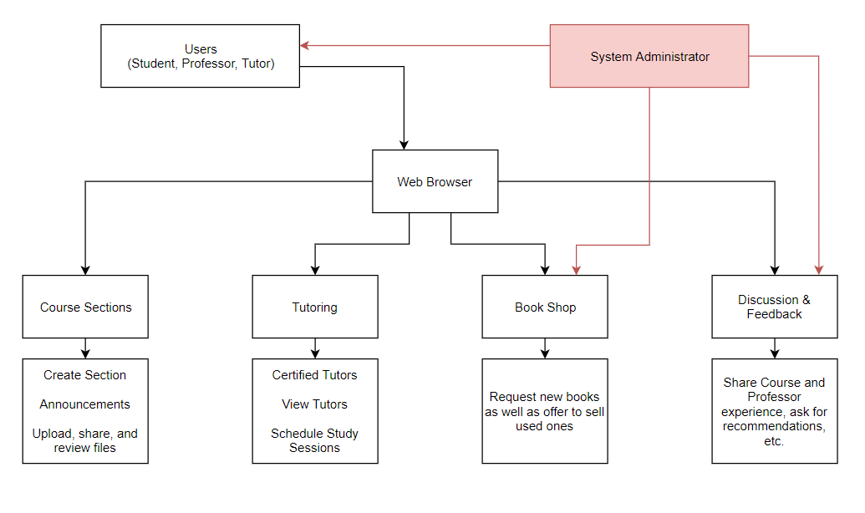

Functional Requirements

Specific Functional Requirements

2.1.1 Registration

2.1.1.1 Validate user by checking if registering using AUS email address (@aus.edu)

2.1.1.2 Users types

2.1.1.2.1 Student

2.1.1.2.2 Professor

2.1.1.2.3 Tutor

2.1.1.2.4 Administrator

2.1.2 Course Sections

2.1.2.1 Professors have the choice to take advantage of provided application and create a section where students are registered

2.1.2.2 Professors have the ability to send announcements to all students in registered section(s)

2.1.2.3 Professors have the ability to upload and share files to the students in registered section(s)

2.1.2.4 Students have the ability to upload and share files (class notes & material) in registered section(s)

2.1.2.4.1 Professor responsible of section will be notified and must approve the shared files

2.1.2.4.2 Professor can disapprove the upload, student will be notified with comments & feedback from professor

2.1.2.4.3 Students are able to comment on shared files in case of discussion and questions

2.1.3 Tutoring

2.1.3.1 Certified tutors will be registered into the system by system Admin

2.1.3.1.1 Tutors must be certified through university in order to ensure successful student-tutor session, and establish set pay-rates

2.1.3.2 Tutors will have a profile description of what course(s) they offer to tutor

2.1.3.3 Students will be able to view available tutors

2.1.3.4 Students will be able to contact tutor in order to take an appointment for student-tutor study session

2.1.4 Book Shop

2.1.4.1 A post & comment section (similar to a Facebook page) where students can ask for books & offer to sell their used-books

2.1.5

2.1.5.1 A post & comment section (similar to a Facebook page) where students can share their experiences in courses, with professors, ask for recommendations, etc…

2.1.6 User Permissions

2.1.6.1 Student

2.1.6.1.1 Can access registered courses

2.1.6.1.2 Can access Tutoring

2.1.6.1.3 Can access Book Shop

2.1.6.1.4 Can access Discussion & Feedback

2.1.6.2 Professor

2.1.6.2.1 Can access and create, edit, manage sections

2.1.6.2.1.1 Can approve files shared by students to section(s)

2.1.6.3 Tutor

2.1.6.3.1 Can edit personal profile details

2.1.6.3.2 Must be certified, then a system admin will register the user

2.1.6.4 Administrator

2.1.6.4.1 Full access and permission

2.1.6.4.2 Can create, edit and manage users

2.1.6.4.3 Can create, edit and manage all posts and comments

User Interface Specifications
Describe and sketch the screens, windows, graphics, and other visual aspects of the product. Specify the interaction or dialog conventions governing the user interface.

External Interfaces and Database Requirements
Describe the interfaces to other systems or the environment.
Also, if applicable describe the logical organization of databases used by the system.

Error Handling
Catalog exceptional conditions and error conditions as well as the responses to these conditions, as completely as possible.

Foreseeable Functional Changes and Enhancements
State any foreseeable changes and enhancements in the functionality that might impact the decisions of the designers and programmers. These are not the functionality mentioned in the Business Requirements document, but any potential new business ideas/ requirements.

Non-Functional Requirements

Specific Non-Functional Requirements
Non-functional requirements describe the constraints under which the deliverables must operate, the environment in which they must operate on, standards they must conform to, etc. These requirements can be categorized using the following subsections. All requirements must be numbered using the following scheme:

Non-Functional requirement 1:
describe the requirement completely and precisely

Non-Functional requirement 1.1:
describe the requirement completely and precisely

Non-Functional requirement 1.2:
describe the requirement completely and precisely

Non-Functional requirement 2:
describe the requirement

Non-Functional requirement 2.1:
describe the requirement completely and precisely

Error Handling
Catalog exceptional conditions and error conditions as well as the responses to these conditions, as completely as possible.

Development Requirements
State any quality standards or guidelines, independent verification and validation requirements, testing strategies, development methods, tools, techniques, or other development constraints imposed by the customer or the development organization.

Foreseeable Non-Functional Changes
List any foreseeable changes in non-functional requirements for the benefit of the design and implementation teams. Such changes generally arise from platform and infrastructure evolution, and changing user needs in product requirements.

Glossary and Index

